**The script «The picture with a story»**

***(voice-over)***

The video starts with a group of students going to the Novgorod State Museum through the Kremlin Park, they are going upstairs and get to the Art Hall. They admire the paintings of the famous artists on the walls. Finally, the students stop besides the portrait of Alexey Arakcheev.

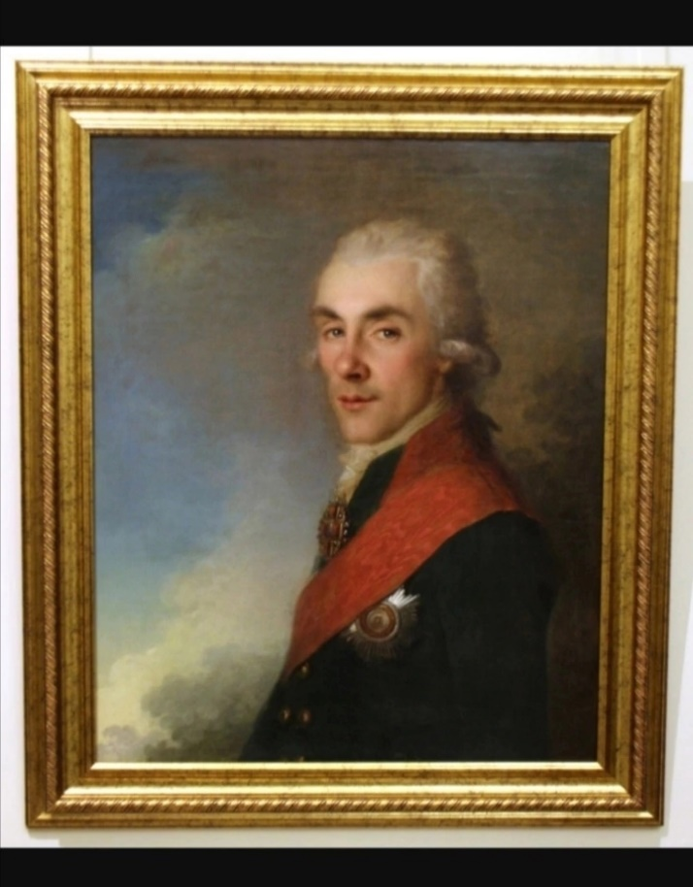

**The dialogue**

**N:** What do you think, who is in this picture?

**L1:** I`m not sure. He looks like an official. Am I right?

**N:** Not really. He was a commander of the Russian army.

**L2:** I know, he is Kutuzov!!!

**N:** I give you a hint. He was a leader of the artillery.

**L1:** We really don`t know.

**N:** It`s Alexey Arakcheev. He built the military barracks in our Novgorod region.

**L1:** And hadn't they been built earlier?

**N:** No, they hadn't been built before Arakcheev. The Emperor Alexander the first and Alexey Arakcheev decided that it was necessary to build barracks, so that the soldiers could do their household chores and spend their leisure time. Previously, the military men stayed in citizens' houses and many of them did not like this.

**L2:** How interesting!

**N:** So, six military settlements were created in our region. They are: Selichi, Crechevitsi, Medved, Novoselitsi, Muravi and the territory near Staraya Russa.

**L1:** And I wonder what Arakcheev was like?

**N:** His contemporaries describe him differently. Some people considered him to be a saldafon and a monkey in a uniform. Someone thought him to be intelligent and severe. Someone remembered his kindness and sympathy.

**L2:** How differently a person can be judged.

**N:** Do you know that he was born in Novgorod region?

**L1:** He is our compatriot, isn't he?

**N:** Yes, but now the place of his birth is known as Tver region, but before the revolution it was Novgorod Guberniya. Nowadays only five people live there.

***(voice-over)***

The Arakcheev dynasty is an ancient Novgorod noble military family. Alexey Arakcheev continued the military service of his family. The Emperor Pavel the first liked him for his Then Pavel presented him some lands in Gruzino, that is near Chudovo. Then he received the title of duke.

**The dialogue**

**L2:** What a great success!!!

**N:** He was appointed a Minister of Defence. He began to teach officers and military men. Unfortunately, Arakcheev was dismissed by Nikolai the first and so he went abroad. Arakcheev died in his estate Gruzino. He was dying looking at the portrait of the emperor. "Cursed death!" were the last words of the great military chief.

**L1:** Great, you know really a lot about Arakcheev's life. But let me tell you about the artist who painted this portrait.

**N:** Well, tell us, please.

**L1:** This portrait was painted by Johan Baptist the Elder. He was invited by Catherine the second and painted all court portraits.

***(voice-over)***

He was born in the family of an artist and his first toy was a brush. At the age of 25 he became famous thanks to his icons. In Vienna, he painted a portrait of the Emperor Joseph. Shortly, before the death of the Empress Catherine the second, he painted a portrait of Alexei Arakcheev.

**The dialogue**

**N:** So, we have learnt about two talented people with such different lives. let's go...

**L2:** But don`t you want to learn about the portrait itself?

**N:** Do you know something?

**L2:** Yes. This portrait was painted in 1790 the time of the Catherine the second reign. It was a pair portrait to the portrait of Andrei Arakcheev's brother. Earlier, this portrait belonged to the museum in the Arakcheev`s estate. Later it was brought to the Novgorod State Museum. Johann Baptist painted mainly the portraits of the courtiers. And Arakcheev was at the court of Pavel the first. Therefore, Johann Baptist made a pair portrait of two brothers Arakcheevs. The artist did not hide the coldly arrogant expression of Alexey Arakcheev's face and his special attentively unfriendly gaze. The author emphasized Arakcheev's pedantic attitude to the wearing of a uniform and the orders. This quality really admired Pavel the first.

**L.1:** The story was so impressive that's why I'd like to share it.

**N:** It`s really a Great idea!

***(voice-over)***

The portrait of Alexey Arakcheev made by Johan Baptist the Elder was chosen not by chance. Among the great variety of other works of famous artists, we decided to choose this particular picture. Just because we believe that the figure of Alexey Arakcheev is very significant for our town. He is a bright and well-known person, he was born on the territory of Novgorod and his life is closely connected with these lands.