 [Translated from Russian to English - www.onlinedoctranslator.com](https://www.onlinedoctranslator.com/en/?utm_source=onlinedoctranslator&utm_medium=docx&utm_campaign=attribution)

Private professional educational institution

"Krasnoyarsk Cooperative College of Economics, Commerce and Law"

Interdisciplinary educational project on the subjects "Public order, concept, structure, legal regulation" and "Foreign language"

Interdisciplinary educational project in the disciplines of "Public order, concept, structure, legal regulation" and "Foreign language"

Completed by a student of the groupPDG-1

Cheskidova V.A. Specialty: "Law enforcement

activity"Project manager: teacher of the highest qualification category

Panasyuk T.V.

Krasnoyarsk 2025

Content:

Instructions on the fundamentals of legal regulation of public order protection in the Russian Federation

Annotation ...3

Introduction 4

Main part 5

1.Purpose and composition of the instruction, public order, concept, structure, legal regulation…………………………………….. 5

1.1 The role of the instruction……………………………………………….5

2.Procedure for development and execution……………………………………7

2.1Algorithm for working on instructions on public order…………………………………………………………………….7

2.2Reasons for developing instructions on public order…………………………………………………………………………….8

Conclusion……………………………………………………………14

List of used literature…………………………………....15

# Annotation

"Public Order: Concept, Structure, and Legal Regulation" examines the formation and maintenance of public order through norms and rules. Key aspects include legal regulation, legislative acts, and the role of law enforcement agencies in ensuring public safety. The study emphasizes the importance of an integrated approach to regulation in the context of social changes caused by globalization and digitalization.

Keywords: (4)

Public order, legal regulation, security, civil society.

Introduction

**Relevance**:is due to the fact that it is an integral part of any modern state, without which it can lose its sovereignty and integrity. The state is always

is interested in ensuring the vital interests of its citizens in accordance with the law imposed on itself

responsibilities.

**Project goal**: consists of studying and developing a comprehensive understanding of public order

# Project objectives:

1. To study the concept and structure of public order.
2. Learn measures impacts states on society Forensuring and protecting public order.
3. Describe the system of bodies that implement measures to ensure public order.

**Hypothesis**: action is the main feature of the concept's characteristics

"public order

**Object of study**:social relations that develop in the process of ensuring public order in the Russian Federation

Federation

Main part

* 1. Purpose and composition of the instruction, public order, concept, structure, legal regulation
     1. The role of instructions

Public order is a system of relations between people, rules of mutual cohabitation and behavior, which are regulated by legislation, traditions, customs, and norms.

of a moral nature.

The structure of public order includes several categories of public places:

1. Public places of permanent use: streets, squares, parks, transport highways.
2. Public places for temporary use: shops, theaters, stadiums.
3. Occasional public places: forest, mountain slope, lake, river, when, for example, certain events are held there.

Public order can be considered in a broad and narrow sense:

* + In a broad sense, these are all connections and relationships in society, its entire structure.
  + In a narrow sense, only certain sets of social relations that develop in various areas of socio-political life and everyday life, but above all in public places.

The purpose of establishing and maintaining public order is to ensure the safety of the individual, public safety, and the creation of favorable conditions for the normal functioning of organizations and public associations, for the work and rest of citizens, respect for their honor, human dignity, and public morality.

The means of regulating relations in the sphere of public order are the norms of law and other social norms of a non-legal nature (moral norms, customs, rules of cultural behavior). By means of legal norms, generally binding rules of behavior are established, prohibitions on the commission of certain actions are introduced, liability for offenses is established, the tasks, functions, powers, forms and methods of activity of state bodies, their officials, public formations for the protection of public order are determined.

* 1. The procedure for development and registration
     1. Algorithm for working on instructions on public order.

Public order in a broad sense is a set of social connections and relations that develop in society at a specific historical stage of its development under the influence of social norms (law, morality, customs and traditions, religion, etc.). In a narrow sense, it is a system of social relations that develop mainly in public places, as well as those that develop outside public places, but that ensure the protection of life, health, honor and dignity of citizens and public peace. Legal regulation of public order is carried out by various and different-sectoral legal norms.

Some of them are:

* + Norms that determine the legal status of citizens in the sphere of public order and establish their rights, duties and responsibilities in this sphere.
  + Norms defining the competence of state bodies and their officials in the sphere of public order protection. They establish the goals, objectives, functions, duties, rights, responsibility of bodies and their officials, forms and methods of their activities, mechanisms of their interaction with each other.
  + Standards governing the activities of public structures involved in maintaining public order. They establish the rights and obligations of public formations, their tasks and functions, the procedure for the formation and organization of work, forms and methods of work, mechanisms for their interaction with citizens, state authorities and administration, and local governments.

Public order is ensured by legal norms that establish rules of conduct in public places.

The regulatory legal framework governing the entire system of ensuring public order is a multi-level set of legislative acts, including the Constitution of the Russian Federation, codified acts (the Code of Administrative Offenses of the Russian Federation, the Criminal Code of the Russian Federation), federal laws, by-laws, legislation of the constituent entities of the Russian Federation and departmental regulatory acts of executive authorities.

* + 1. Reasons for developing instructions on public order

The concept of public order can be interpreted in different ways. In a broad sense, public order is a set of social connections and relations that develop in society at a specific historical stage of its development under the influence of social norms (law, morality, customs and traditions, religion, etc.). In a narrow sense, it is a system of social relations that develop mainly in public places, as well as those that develop outside public places, but ensure the protection of life, health, honor and dignity of citizens and public peace.

The structure of public order includes several elements:

* + Material content. The economic structure of society, the political structure of state power, the needs and interests of members of society.
  + Legal content. Establishment of legal rights by the statenorms that determine the behavior of citizens in the sphere of public order. Establishing certain rules of conduct that secure proper or possible behavior, establishing prohibitions and measures of responsibility.
  + Volitional content. The behavior of participants in legal relations, where the will is a mental reaction of a person or a social group. Legal regulation of public order is carried out by various and multi-branch legal norms.

Some of them are:

* + Norms that determine the legal status of citizens in the sphere of public order and establish their rights, duties and responsibilities in this sphere.
  + Norms defining the competence of state bodies and their officials in the sphere of public order protection. They establish the goals, objectives, functions, duties, rights, responsibility of bodies and their officials, forms and methods of their activities, mechanisms of their interaction with each other.
  + Standards governing the activities of public structures involved in maintaining public order. They establish the rights and obligations of public formations, their tasks and functions, the procedure for the formation and organization of work, forms and methods of work, mechanisms for their interaction with citizens, state authorities and administration, and local governments.

The mechanism of legal regulation as a system consists of interacting elements that ensure the implementation of the functions of the state and law. The structure of the mechanism of legal regulation consists of methods and ways of legal regulation.

The method of legal regulation is a set of legal methods and means of influencing the law on social relations, determined by their nature.

In this regard, each branch of law has its own method or combination of methods of legal regulation. In the theory of legal regulation, it is customary to distinguish two methods of legal influence:

* The method of decentralized regulation (optional method), based on the coordination of goals and interests of the parties in public relations and applied in the sphere of private law branches (in civil, family, labor law);
* A method of centralized, imperative regulation (authoritarian method), based on subordination relations between participants in social relations and used in public law branches (in constitutional, administrative, criminal law).

Structure of the mechanism of legal regulation. Legal regimes

The mechanism of legal regulation as a system consists of interacting elements that ensure the implementation of the functions of the state and law. The structure of the mechanism of legal regulation consists of methods and ways of legal regulation.

The method of legal regulation is a set of legal methods and means of influencing the law on social relations, determined by their nature.

In this regard, each branch of law has its own method or combination of methods of legal regulation. In the theory of legal regulation, it is customary to distinguish two methods of legal influence:

• the method of decentralized regulation (the optional method), based on the coordination of the goals and interests of the parties in public relations and applied in the sphere of private law branches (in civil, family, labor law);

• a method of centralized, imperative regulation (authoritarian method), based on subordination relations between participants in social relations and used in public law branches (in constitutional, administrative, criminal law).

Methods of legal regulation are understood as methods of legal influence expressed in legal norms and other elements of the legal system.

In legal science, three main methods of legal regulation are usually distinguished: permission (authorization), prohibition, and positive obligation.

Depending on the nature of the performance of legal obligations (either voluntarily or under duress), various authors arrange the methods of legal regulation in a certain sequence. Thus, S. S. Alekseev, depending on the sphere of regulation, identifies the following main methods of legal regulation:

• permission - granting individuals the right to their own active actions;

• prohibition - imposing on persons the obligation to refrain from committing actions of a certain kind;

• positive obligation – imposing on persons the duty of active behavior (to do something, transfer something, pay, etc.).

Another sequence of these same methods of legal regulation, conditioned by the nature of the performance of legal obligations, is presented by the famous legal scholar V. V. Lazarev. He arranges them as follows: a) positive obligation; b) permission; c) prohibition.

A number of legal scholars distinguish recommendation (advice) as an independent method of legal regulation:

Depending on the direction and nature of the legal impact, which are determined by the predominance of a specific method of legal regulation (either permission or prohibition), two types of legal regulation are distinguished:

• generally permissive, based on the formula - everything is permitted except for the prohibited. Consequently, an individual has the right to perform any actions not included in the category of prohibited. This type of legal regulation stimulates initiative, independence of legal entities in solving issues that are relevant to them. Thus, in civil law, an individual can perform any actions: conclude various transactions, contracts, except for those that are not directly prohibited by law;

• permissive, proceeding from the opposite - everything is prohibited except what is permitted. This means that an individual can perform only those actions that are directly permitted by law. In this case, a decision of a competent state body is required to carry out these actions. This type of legal regulation is inherent in those branches of law that, such as administrative law, are related to public administration. Thus, the exercise of the right to hold manifestations, demonstrations, processions that affect public order requires permission from executive authorities.

Since different types of social relations are regulated by different legal means and methods, the concept of “legal regime” was introduced into science to reflect the specifics of regulation in the industry.

The legal regime is a set of methods, techniques and types of legal regulation that determine the characteristics and nature of legal impact and develop within each branch of law.

The most obvious differences between legal regimes in the branches of private and public law are due to the predominance of the optional method and the permissive type of legal regulation in the former case and the dominance of the imperative method and the permissive type of legal regulation in public law.

The choice of the form of legal regulation has not only theoretical but also great practical significance, since it affects the effectiveness and efficiency of legal influence. Methods and ways of legal regulation, their specific combination (legal regime) show only the general direction and nature of the impact on social relations.

The materialization and objectification of this impact, i.e. the translation of the requirements of general rules formulated in law into the limitedness and orderliness of social relations is achieved thanks to five basic elements of the mechanism of legal regulation (Fig. 1).

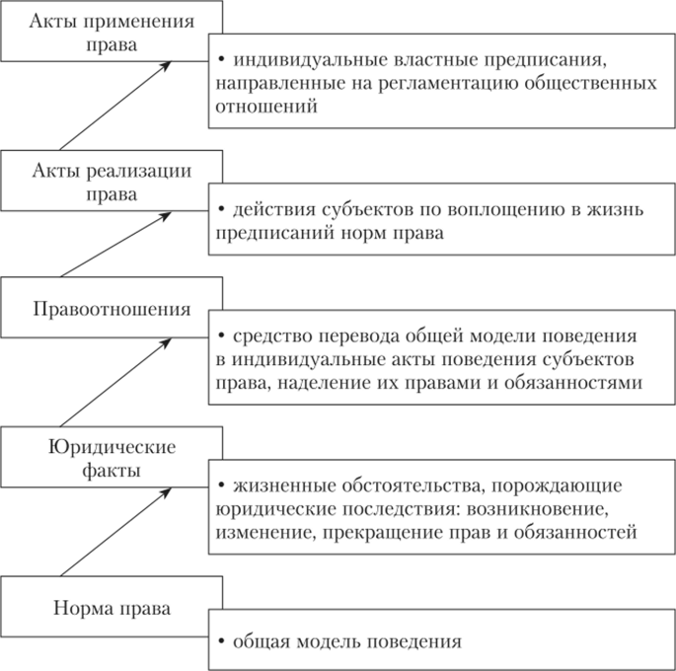

Figure 1.**Interaction of elements of the legal regulation mechanism**

Conclusion

Public order is a complex and multifaceted phenomenon that requires deep analysis and understanding. It includes a wide range of social interactions, covering not only legal norms, but also moral, cultural and social institutions.

The structure of public order includes several elements:

1. Material content. These are real existing social relations. The material basis of social order is the economic structure of society, the political structure of state power, the system of social relations and the need for their ordering, the real needs and interests of members of society.
2. Volitional content. The behavior of participants in social relations is volitional. In this case, the will appears in the form of a mental reaction of a person (the will of an individual) and public will (the will of social groups, classes, the state).
3. Legal content. Legal provisions established by the statenorms define the proper behavior of people in the sphere

public order.

Legal regulation of public order in Russia is carried out through a number of legislative acts and regulatory documents that define the basic approaches and mechanisms for ensuring security and stability in society.

Some important documents: Federal Law of December 28, 2010 No. 390-FZ "On Security", as well as Federal Law of April 2, 2014 No. 44-FZ "On the Participation of Citizens in Security

"public order".

In conclusion, it can be said that public order is the main stability and security in society, its maintenance requires joint efforts from both the state and citizens. It is important that all participants are aware of their responsibility for compliance with the norms of public order and actively contribute to its strengthening.

List of sources used

1. Sidorova E. V. "Theoretical Foundations of Comprehensive Legal Regulation", Moscow: Justice, 2017.
2. [Theory of State and Law) (1997, V.M.Korelsky) [Books, Handbook encyclopedia] / Download for free](https://a8.ru.kniga.me/2/19/teoriya-gosudarstva-i-prava-1997-v-m-korelskiy.html?ysclid=makwtf4avx453977627)
3. [4285_-_Teoria_gosudarstva_i_prava_-_Cherdantsev_A_F_-_Uchebnik_-_2002_-_432s.pdf](https://psv4.userapi.com/s/v1/d/ik9pZDTdh5Er4j5f-QKnktkUJpSh6-TK_x262Xg8L8NvKB-Wolxj5JtJa4lEPnWR4NRI3pGpDuopeSOjV8QZRw6bK3Iv2pwIvnFUWVRNZIZXqQHjU_YkPQ/4285_-_Teoria_gosudarstva_i_prava_-_Cherdantsev_A_F_-_Uchebnik_-_2002_-_432s.pdf)
4. English-Russian dictionary of legal vocabulary. Author: Vitlinskaya Tatyana Dmitrievna, Golovina Natalya Mikhailovna, Degtyareva Ekaterina Andreevna. Publisher: Prospect, 2023.