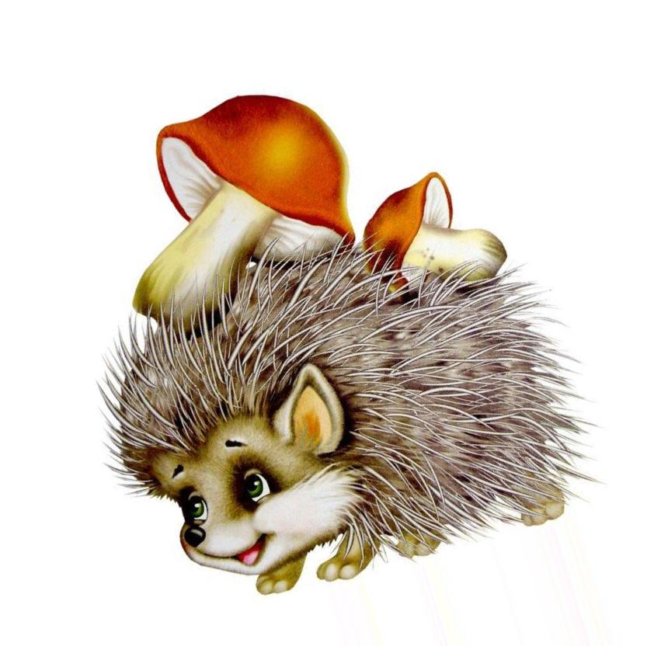

43

37+6

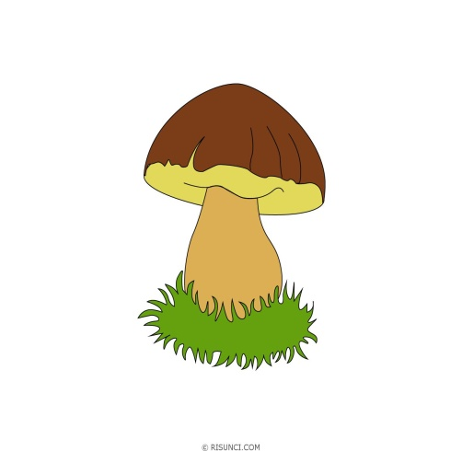

32+11

33+10

39+4

38+5

37+6

36+7

35+8

34+9



47-4

48-5

50-7

49-6

51-8

52-9

53-10

30+13



57-14

58-15

59-16

60-17

61-18

62-19

63-20

46-3

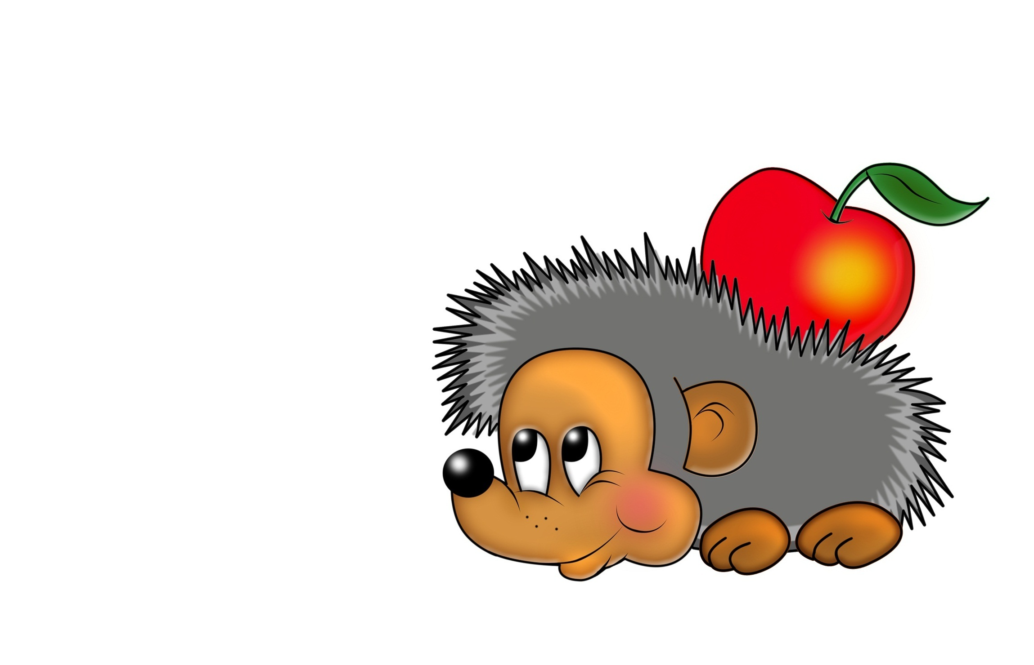

56



47+9

46+10

45+11

44+12

43+13

42+14

41+15

40+16

72-16

50+6

49+7

48+8

68-12

69-13

70-14

71-15

64-8

65-9

66-10

67-11

60-4

61-5

62-6

63-7