Private professional educational institution "Krasnoyarsk Cooperative College of Economics, Commerce and Law".

Interdisciplinary educational project on the disciplines "Peculiarities of collecting evidence during the preliminary investigation" and "Foreign language"

Performed by: student of the PDV-1 group

Dobrovolskaya V.V.

Specialty: "Law enforcement Activities"

Project manager: teacher of the highest qualification category

Panasyuk T.V.

2025

Content

Content….................................................................................................................. 2 Annotation ................................................................................................................ 3

Introduction .............................................................................................................. 4

1. The legal basis for collecting evidence.................................................................. 5

2. Methods of collecting evidence............................................................................ 6

3. Practical recommendations for lawyers............................................................... 11

Conclusion ............................................................................................................. 12

List of materials used.............................................................................................. 13

Annotation

This project is devoted to a detailed study of the collection of evidence at the stage of preliminary investigation in criminal proceedings.

The key aspects of this procedure are considered, including the legal norms governing the actions of investigators, prosecutors and defenders.

It examines how evidence is collected, analyzed, and evaluated, as well as the rights of the defense attorney to participate in this process.

During the research, important attention is paid to the observance of legality, procedural requirements, as well as methods of analyzing the collected materials, which is crucial for establishing justice and protecting the rights of all participants. The project is designed to emphasize the role of the law and defenders in the preliminary investigation phase.

Keywords

Proof, proof, preliminary investigation, inquiry, investigator, inspection of the scene, expert, specialist, evidence, packaging, forensic examination, investigation, investigator (13).

Introduction

**Relevance:** The preliminary investigation is the most important stage of criminal proceedings, which lays the foundations for further judicial proceedings. As part of this process, special attention is paid to the collection of evidence. Collecting evidence is not just a formal procedure, but a complex process involving various actors: investigators, prosecutors, defense lawyers, and others involved in the case.

The purpose of the project is to study the specifics of collecting evidence during a preliminary investigation.

**Project objectives:**

1. To consider the key aspects related to the legal basis of the collection of evidence at the stage of preliminary investigation in criminal proceedings.

2. To analyze the current legislation in the process of collecting evidence at the stage of preliminary investigation in criminal proceedings.

3. To study the approaches and techniques used by investigative authorities in the process of collecting evidence at the stage of preliminary investigation in criminal proceedings. The object of the study: collecting evidence (the stage of the preliminary investigation of the crime)

4. To complete the vocabulary of professional vocabulary in English.

**Hypothesis:** A deep understanding of the specifics of collecting evidence during a preliminary investigation will help improve law enforcement practices and protect the rights of all participants in the criminal process.

1. The legal basis for collecting evidence

The collection of evidence during the preliminary investigation is carried out within the framework of pre-established legal norms and principles. These norms form the basis for the conduct of judicial proceedings and ensure the legality of the actions of the investigative authorities. The most important acts regulating this process are the Criminal Procedure Code and other legislative initiatives that detail the rights and obligations of the parties, as well as procedural mechanisms for working with evidence.

It is difficult to overestimate the importance of the legal foundations of the collection of evidence, since they not only determine the procedure for the actions of investigators and other participants in the criminal process, but also act as guarantors of the observance of citizens' rights. Evidence collected with violations cannot be used in the future, which requires the investigative authorities to be responsible and attentive in the course of their activities.

In the framework of criminal proceedings, all actions related to the collection of evidence must comply with the requirements of the law. Every procedural step, from the initiation of an investigation to the completion of evidence collection, is based on strict rules, which helps protect the rights of all participants.

The principles of legality and expediency permeate all stages of the investigation. Legality obliges investigators to act only within the limits established by the criminal procedure legislation.

The practical application of the legal framework for the collection of evidence requires knowledge not only of legal norms, but also of appropriate techniques that will help in the collection and analysis of data. The standards established by law must be followed at every stage of the investigation.

The problem of possible violations of the legal rights of the participants in the investigation remains relevant. Investigative actions carried out in violation of procedural rules can significantly complicate the case, cause risks to the validity of the charge and, possibly, lead to its cancellation.

One of the aspects of the legal basis for the collection of evidence is the need to comply with the principle of adequacy and timeliness of fees. Therefore, investigators should focus on the promptness of their actions, observing the established norms.

Collecting evidence also requires careful attention to documenting all actions. Logging is a tool that allows you to ensure compliance with all procedural rules and document the results of the actions performed.

Proper and strict adherence to these standards is the key not only to the effectiveness of the investigative authorities, but also to respect for the rights of all parties, which ultimately contributes to increasing public confidence in the legal system.

The preliminary investigation is a key phase of the criminal process, where the evidence necessary for further investigation of the case is collected and analyzed. In this context, the role of the defender becomes particularly important, as it becomes a guarantee of the rights and legitimate interests of the suspect or the accused. The defender not only defends his client, but also actively participates in the procedural actions, which allows for balanced observance of the rights of all participants in criminal proceedings.

2. Methods of collecting evidence

Collecting evidence during a preliminary investigation requires the use of a variety of methods, each of which has its own characteristics and limitations. Depending on the circumstances of the case, the type of alleged crime and other factors, the most effective ways of collecting information are selected to ensure the legal significance and relevance of the collected data.

One of the main methods is the interrogation of witnesses and suspects. The interrogation can be conducted in various forms, including personal presence, written documents and video recordings. It is important to take into account that the quality of the testimony obtained depends on the proper preparation and conduct of the interrogation. Questions should be as neutral and open as possible in order to minimize the risk of bias. In addition, it is necessary to observe the principles of legal and moral pressure in order to ensure the integrity of the interrogation.

An equally important method is the seizure of objects and documents that can be used as evidence. This process is quite formalized and requires guaranteed legality. The seizure procedure should be recorded in a protocol that contains detailed information about the discovered items, their condition, and how they were obtained.

Expert research also occupies a significant place among the methods of collecting evidence. The expert can obtain information in the field of his specialization, which allows him to assess the circumstances of the case from a scientific or technical point of view. Expertise can be assigned in various fields, including criminology, psychiatry, and forensic medicine.

The collection of evidence during a preliminary investigation is a complex and multi-level process. Each of the methodological approaches has its advantages and disadvantages, and the choice of method depends on the specific circumstances. Specialists have to balance between the effectiveness of evidence collection and compliance with procedural requirements, which requires them to have a high level of qualifications and experience. The availability of a variety of training methods and opportunities for their application can significantly increase the quality of investigative work and increase the chances of successful crime detection.

Analysis of the collected evidence:

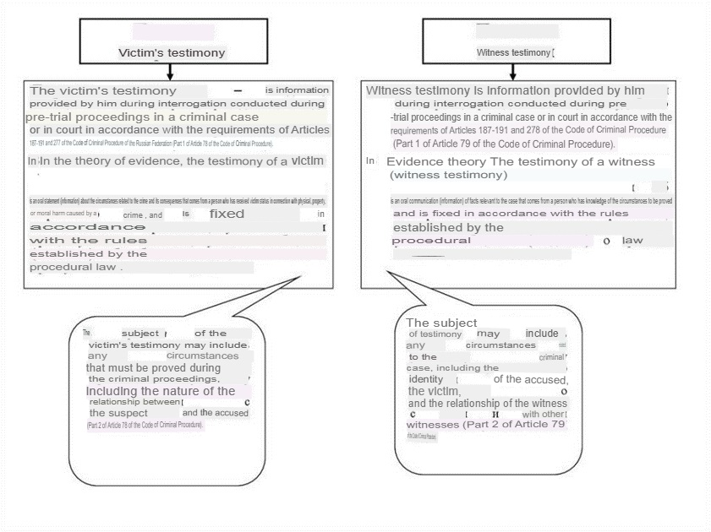

Figure 1. Diagrams and tables for analyzing the collected evidence

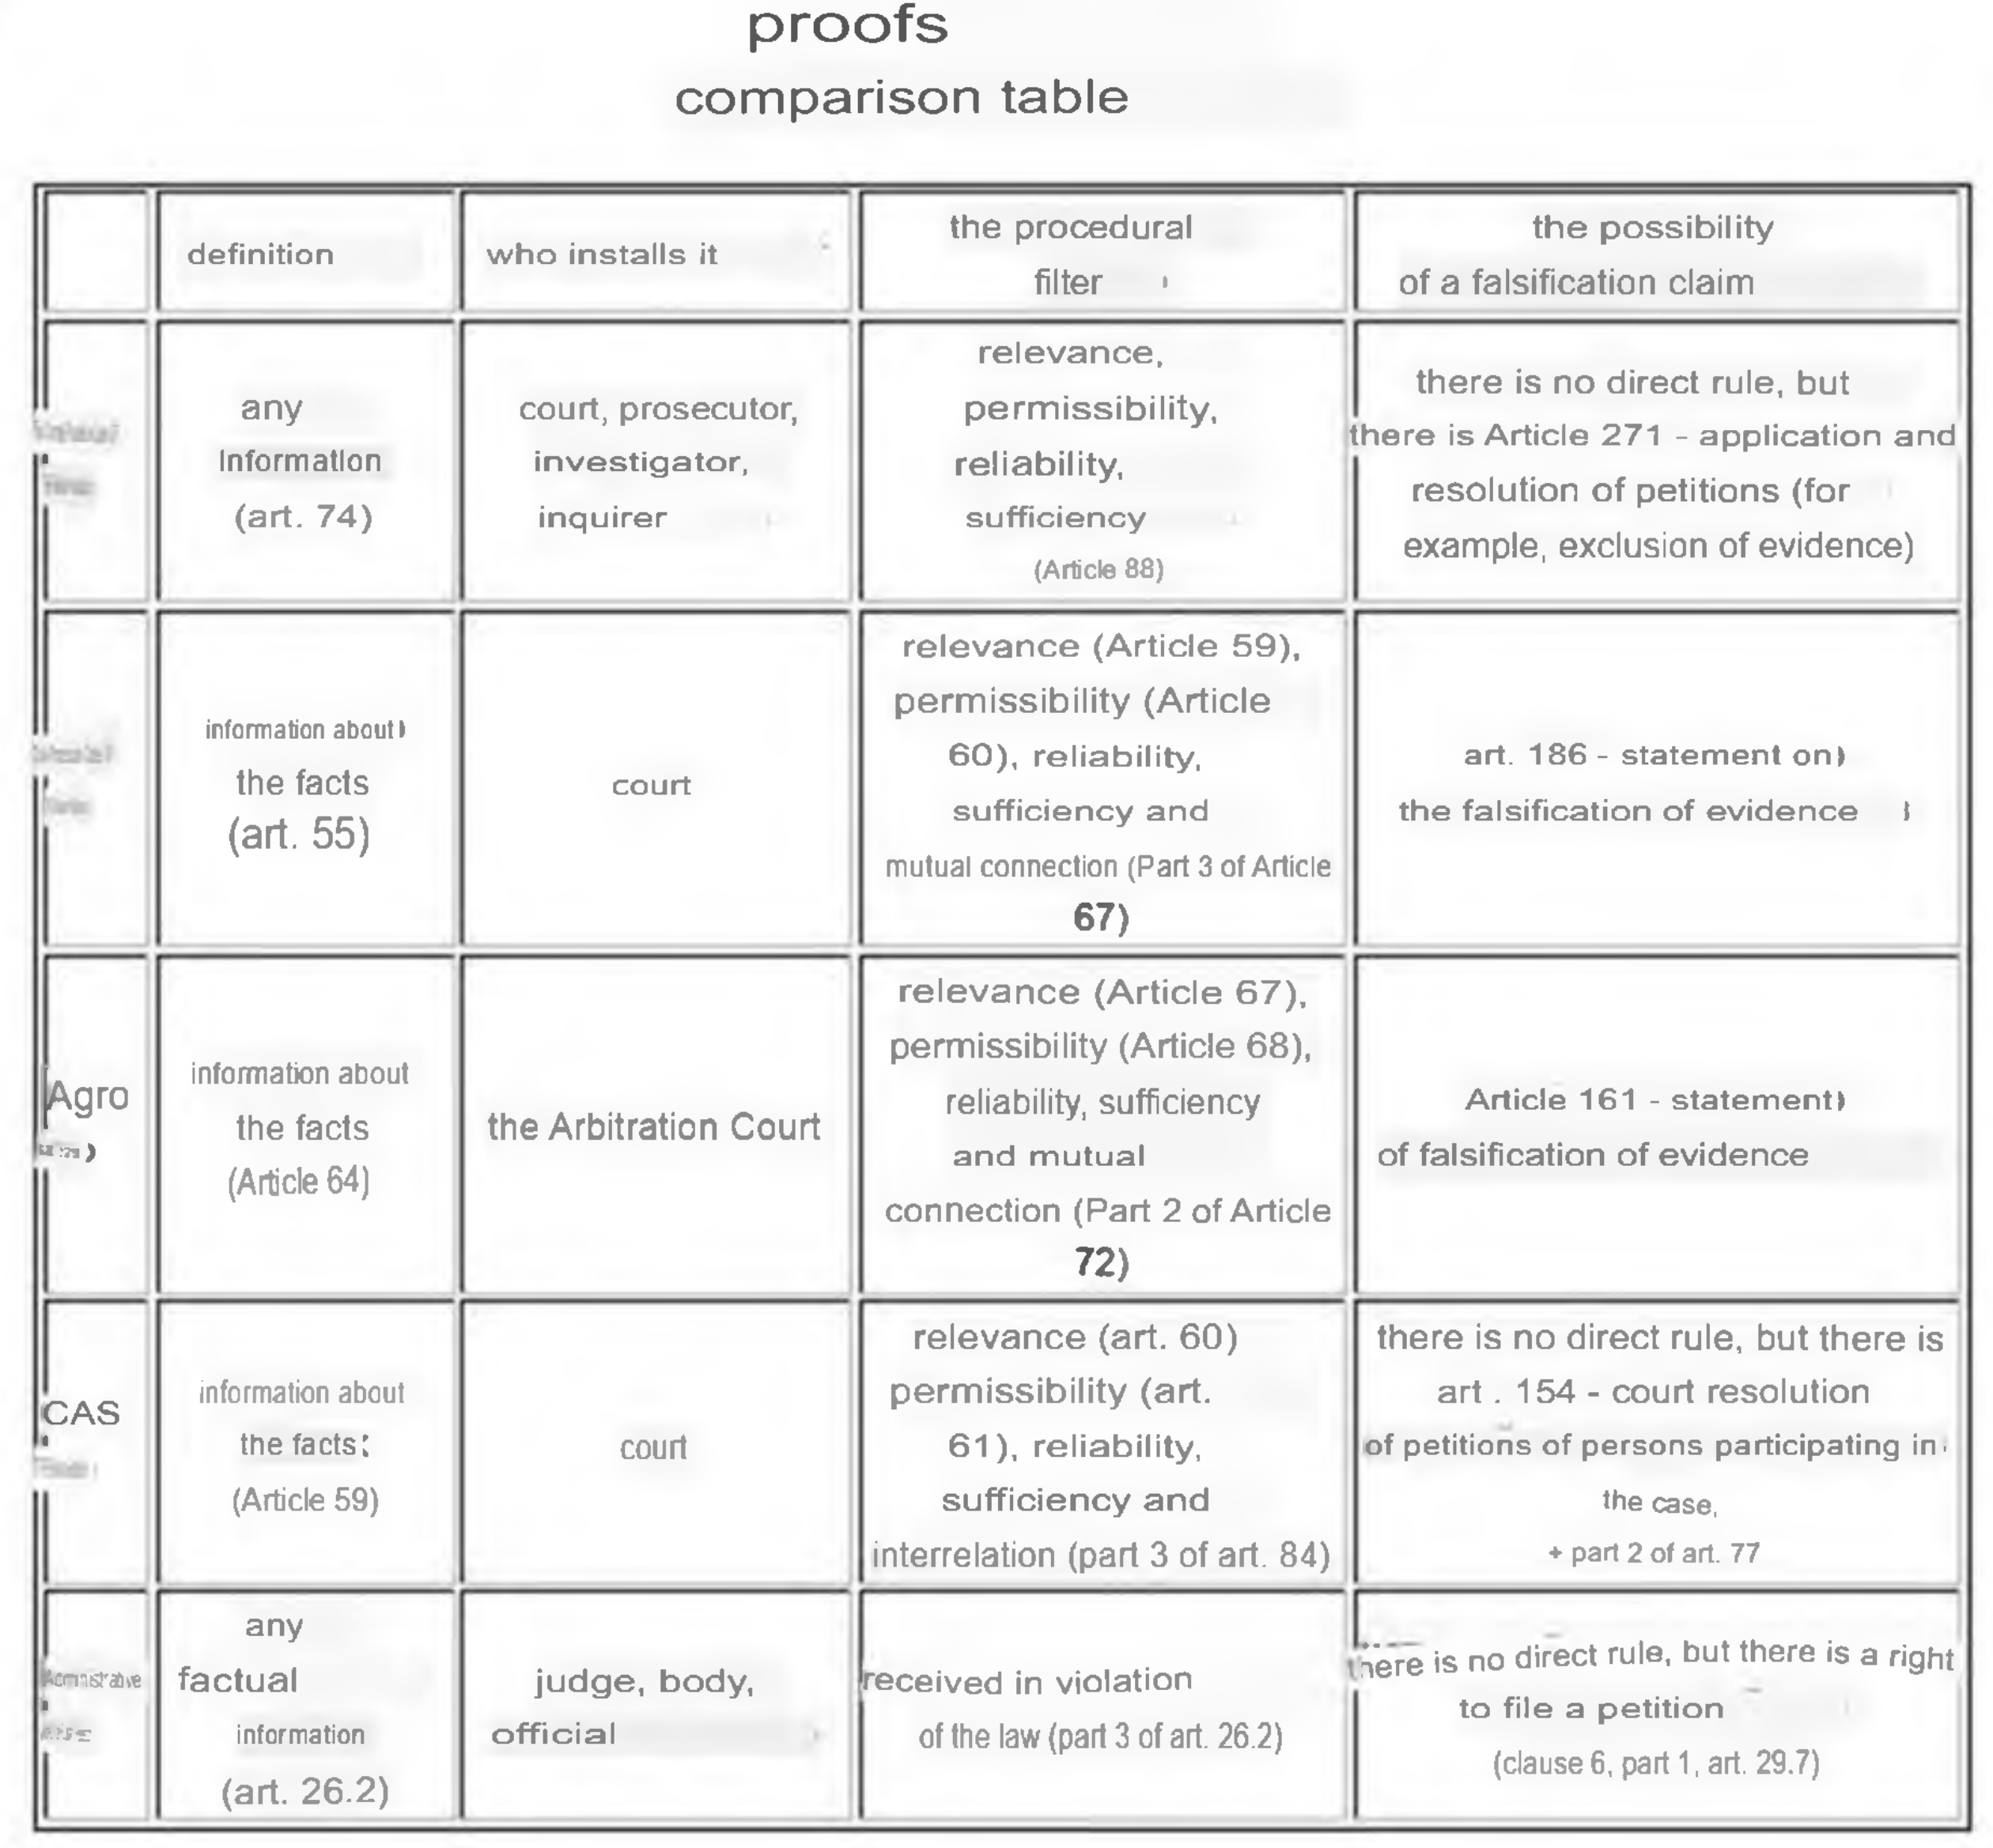

Figure 2. Diagrams and tables for analyzing the collected evidence

The collection of evidence in the framework of a preliminary investigation is a multi-level process that requires a thorough analysis of the information received. This process is limited not only by technical and legal aspects, but also depends on the quality of interaction between the participants in the investigation.

The analysis of the collected evidence is an important step in the preliminary investigation. This analysis should begin with an initial assessment of the reliability and significance of the information received. The evidence may be direct or indirect and, depending on the study, its importance may vary. Direct evidence, as a rule, looks more authoritative, as it can directly confirm the fact of a crime. Indirect evidence, in turn, requires in-depth interpretation and, possibly, additional confirmation by other evidence.

One of the critical aspects of analyzing evidence is following the procedure for obtaining it. Violation of procedural rules may lead to the need to exclude evidence from the case file, which, in turn, complicates the work of investigative authorities and may negatively affect the outcome of the investigation. Particular attention should be paid to the quantity and quality of the evidence collected. There is a risk of overestimating some of them, while neglecting other equally significant facts.

To summarize, the analysis of the evidence gathered in the framework of the preliminary investigation deserves special attention. Understanding the importance of each detail, compliance with procedural rules and the ability to interpret the results of work externally are the factors that can significantly affect the outcome of the case.

One of the important problems is the lack of compliance with procedural rules. Law enforcement agencies often come under pressure, which can lead to mistakes, such as conducting searches without the necessary permission or in the absence of legitimate grounds.

Evidence collection mechanisms can also become a source of incorrect actions. Methods based on the use of clandestine means of surveillance or eavesdropping must strictly comply with the established boundaries of the law.

All the risks described above emphasize the need for strict compliance with the rules of law and the process at every stage of evidence collection. The importance of developing ethics in the work of investigative bodies should not be underestimated, as it lays the foundation for a State governed by the rule of law.

3. Practical recommendations for lawyers

The practical work of lawyers at the preliminary investigation stage requires a special approach to collecting evidence. It is important to take into account not only the legal norms, but also the specifics of a particular case, as well as the interaction between the participants in the process.

The first thing to pay attention to is careful preparation for the collection of evidence. A lawyer should review all the case materials in advance to determine which evidence may be relevant. This allows you not only to focus on the key elements of the case, but also to respond appropriately to the actions of the opposing side.

The analysis of the collected evidence is also important. Conclusions based on the analysis of the collected evidence should be clearly formulated and justified. This will contribute to the formation of a successful defensive strategy.

The main task of a lawyer at the stage of a preliminary investigation is to create the most reliable evidence base. Careful adherence to procedural rules, ethical principles and continuous improvement of skills significantly increase the likelihood of successful client protection in the future.

Thus, compliance with all the above recommendations will help lawyers to perform their functions as efficiently as possible. Each case is unique and requires an individual approach, and only careful observance of all norms and principles leads to a successful end result.

Conclusion

In conclusion of this work, it is necessary to summarize the results of the study of the features of collecting evidence during the preliminary investigation in criminal proceedings. During the analysis of the legal norms governing this area, it was found that compliance with legality and procedural requirements is a fundamental condition for ensuring justice and protecting the rights of all participants in the criminal process. In addition, it was revealed that the presence of a qualified defense lawyer significantly increases the chances of a fair trial, as he is able to identify violations and shortcomings in the actions of investigators, as well as offer alternative versions of events.

The evidence collection methods used by investigative authorities range from traditional interrogations and searches to more modern approaches such as using technology to analyze digital data. It is important that these methods comply with the requirements established by law, which avoids violations of citizens' rights and ensures the legality of the collected materials.

In conclusion, in order to improve the quality of the preliminary investigation and protect the rights of all participants in the criminal process, it is necessary to develop and implement practical recommendations for lawyers that will be aimed at improving methods of collecting and analyzing evidence, as well as ensuring compliance with procedural requirements. This will not only improve the efficiency of the investigative authorities, but also strengthen public confidence in justice, which is an important aspect for the functioning of the rule of law.

List of materials used

1. Vlasov I.A. Features of collecting evidence during the preliminary investigation // Criminal law. – 2019. – No. 3. – pp. 22-30.

2. Stepanov P.V. Methods of collecting evidence in criminal proceedings // Law and order. 2020. No. 7. pp. 11-17.

3. Kulikov S.B. The significance of evidence in the framework of the preliminary investigation // Russian Law Journal. – 2018. – No. 4. – pp. 45-52.

4. Sidorov A.N. The procedure for obtaining and verifying evidence in the process of investigating crimes // Law and Law. – 2017. – No. 2. – pp. 34-40.

5. Tikhomirov Yu.V. The role of the prosecutor in collecting evidence during the preliminary investigation // Modern Russian law. – 2021. – No. 6. – pp. 75-82.

6. Nikolaev M.E. Actual issues of collecting evidence in criminal proceedings // Legal world. – 2019. – No. 5. – pp. 50-58.

7. Petrova L.Ya. Objective and subjective aspects of collecting evidence // Criminal justice. 2020. No. 1. pp. 13-21.

8. Mikhailov D.A. Tactics of collecting evidence during investigative actions // Science and law and order. - 2018. – No. 9. – pp. 99-104.

9. Gromov V.P. Problems of the practice of collecting evidence in criminal proceedings // Criminal justice. 2017. No. 8. pp. 30-37.

10. Ryabova N.S. Innovative methods in collecting evidence during the preliminary investigation // Actual issues of legal science. - 2021. – No. 12. – pp. 87-92.

11. https://67.мвд.рф/citizens/PRAVINF/JUridicheskij_slovar general Legal Dictionary

12. https://www.klerk.ru/tool/slovar/law / general Legal Dictionary

13. https://gufo.me/dict/law general Legal Dictionary