**Crime and punishment Worksheets**

|  |  |
| --- | --- |
| **WORD** | **DEFINITION** |
| arson | *to intentionally start a fire, intended to hurt people or buildings* |
| assault | *to attack or attempt to attack and physically hurt a person, with or without a weapon* |
| bullying | *to tease, upset, hurt physically, socially and emotionally another person* |
| burglary | *to enter unlawfully to a place to commit a felony or a theft* |
| counterfeiting | *to falsify, with intention to use, money or other paper documents* |
| crime scene | *the place where the illegal act took place* |
| evidence | *proof of the crime taking place and who did it* |
| fraud | *to convert or obtain money or properties under false pretense for example bad checks* |
| homicide | *to kill another human being* |
| kidnapping | *to illegally restrain someone against their will, with the intention of getting money for their release* |
| mugging | *to illegaly obtain another person's posessions in an open public place. Can include violence* |
| murder | *to kill intentionally another person* |
| music piracy | *to buy music (online or physically) which is not produced by the recording company* |
| pickpocketing | *to take out things like phones, iPods, wallets, from the clothing pockets of someone without them noticing* |
| robbery | *to take, or attempt to take anything of value from somebody else by force or threat of violence* |
| shoplifting | *to take something from a shop knowingly without paying for it* |
| steal | *to take someone's property without their consent* |
| vandalism | *to willfully and maliciously destroy or injury any sort of public or private property without the owner's consent* |
| witness | *the person who sees a crime and who did it and can verify it* |

**Task 1. Match the words on the left with their meaning on the right:**

|  |  |  |
| --- | --- | --- |
| **Nr.** | **Word** | **Meaning** |
| 1. | To stab | a) when someone is removed from their job |
| 2. | A prison | b) the lawyers in a trial who try to prove that a person accused of committing a crime is guilty of that crime |
| 3. | To sack | c) a building where trials and other legal cases happen |
| 4. | Prosecution | d) a building where criminals are forced to live as a punishment |
| 5. | Judgement | e) when someone is punished |
| 6. | Court | f) to give freedom or free movement to someone or something |
| 7. | Punishment | g) to injure someone with a sharp pointed object such as a knife |
| 8. | To release | h) an official legal decision |

**Task 2. Find 7 words on the topic “Crime and the law”. What do we call the people who commit these crimes?**

GIFTLHOPSNI _______________________ _______________________

NORSA _______________________ _______________________

GNIKPANDPI _______________________ _______________________

DERRUM _______________________ _______________________

GIGGLMSUN _______________________ _______________________

GARLBURY _______________________ _______________________

BERBORY _______________________ _______________________

**Task 3. Match the pictures and the words.**

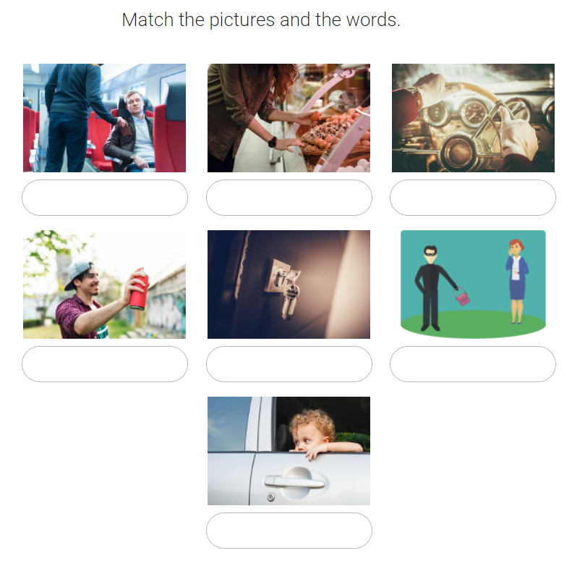

A pickpocket A thief A shoplifter

A burglar A vandal A kidnapper

A smuggler A robber

# Task 4. Underline the correct item.

1. If you don’t want someone to **burgle \ steal** your house, you should keep the doors and windows locked.
2. He keeps his bicycle securely chained so that no one will **steal \ rob** it.
3. Two men attempted to **burgle \ rob** the local bank, but the police arrived before they got away.
4. Instead of fining the man, the judge sent him to prison because he was a repeat **offender \ convict**.
5. That terrorist is one of the world’s most wanted **criminals \ suspects**.
6. The **offender \ suspect** was set free because there was no evidence to prove that he was guilty.
7. The **suspect \ convict** had been in prison for twenty years when he died.

**Task 5. Translate into English, using steal / rob in the right form.**

1. Они __ дорогие ювелирные украшения.

2. Мэри была ___, когда возвращалась домой.

3. Этот магазин ___ на прошлой неделе.

4. Он не заметил, как кто-то ___ его часы.

5. Я знаю, что это он ___ мои сережки.

6. Кто-то ___ три банка в этом городе.   
________________________________________________________________________________________________________________________________________________________________________________________________________________________________________________________________________________________________________________________________________________________________________________________________________________________________________________________________________________________________________________________________________________________________________________________________________________________________________________________________________________________________________________________________

**Task 6. Match the phrasal verbs with their meanings.**

1. be sent to prison a. get away with
2. punish lightly b. lock up
3. not be punished for smth c. let off
4. leave and take smth with you d. make off
5. leave quickly e. run off with
6. do smth wrong and not get caught f. get off

**Task 7. Make up your own sentences using the phrasal verbs from ex.5.**

**________________________________________________________________________________________________________________________________________________________________________________________________________________________________________________________________________________________________________________________________________________________________________________________________________________________________________________________________________________________________________________________________________________________________________________________________________________________________________________________________________________________________________________________________________________________________________________________________________________________________________________________________________________________________________________________________________________________________________________________________________________________________________________________________________________________________**