***Внеклассное мероприятие для учащихся 5-А класса***

Учитель: Каравацкая Инна Анатольевна

ГБОУ «Лицей № 37 г.о. Донецк»

**Тема**: ***«A Mad Tea Party»***

*After “Alice's Adventures*

*In Wonderland” by Lewis Carroll*

**Цель:**обобщение лингвострановедческих знаний учащихся, полученных на уроках английского языка и актуализация новых знаний.  
**Задачи:**

***Воспитательные***

* воспитывать нравственно-эстетическое отношение к миру;
* художественный вкус;
* творческую активность;

***Развивающие:***

* развивать творческую активность;
* воображение;
* образное представление;
* развивать  внимание, восприятие.

***Формирующие:***

* формировать навыки работы с художественными материалами, аккуратность;
* формировать интерес к изучению предмета.  
    
  **Оснащение:** компьютер ,аудио - и видеозаписи; чайный сервиз, салфетки и муляжи продуктов питания.

**Форма организации:** инсценизация сказки

**Alice:** Hello, boys and girls. My name is Alice. Do you remember me? I follow the White Rabbit down the rabid – house. Oh, what is this? I can see a house! It is the March Hare’s house. Because the chimneys look like ears, and the roof made from fur. Look through the window, please. I can see the March Hare and the Hatter. They are having tea at the table. A Dormouse is sitting between them. He is sleeping. So, I’m coming.

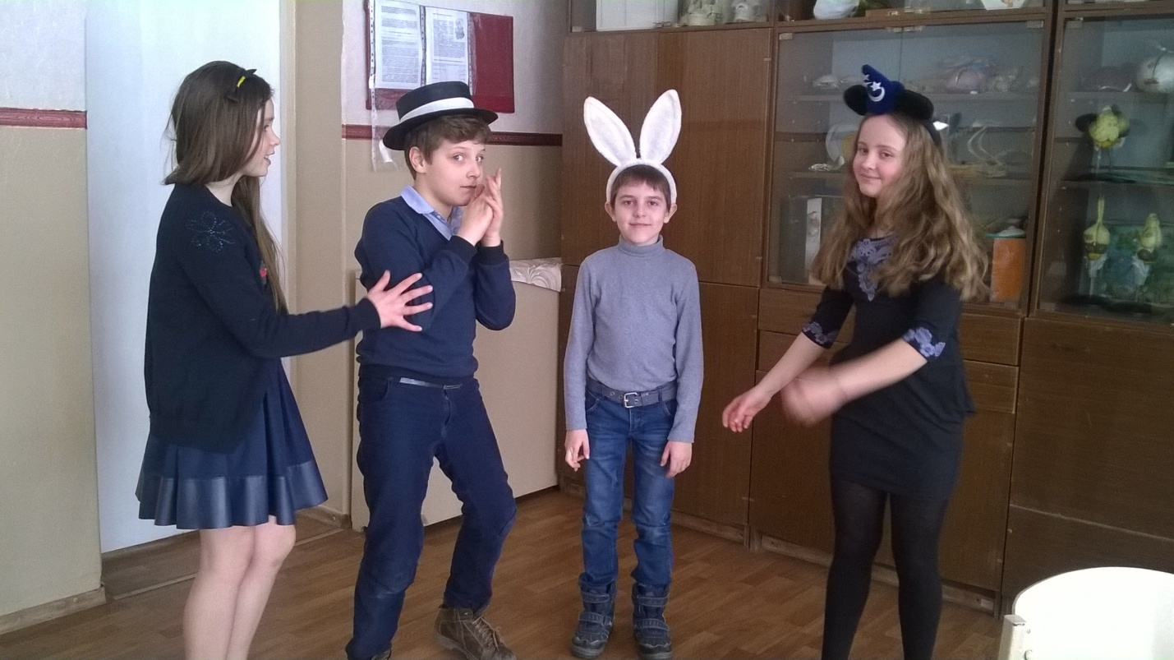

**March Hare:** No room! No room!

**Hatter:** No room! No room!

**Alice:** But there is plenty of room!

**March Hare:** Do you like more tea?

**Alice:** But I didn’t drink the tea yet! So I can’t have more tea!

**Hatter:** Do toy like less tea?

**Alice:** No, thank you.

**Hatter:** What day of the month is it today?

**Alice:** The fourth.

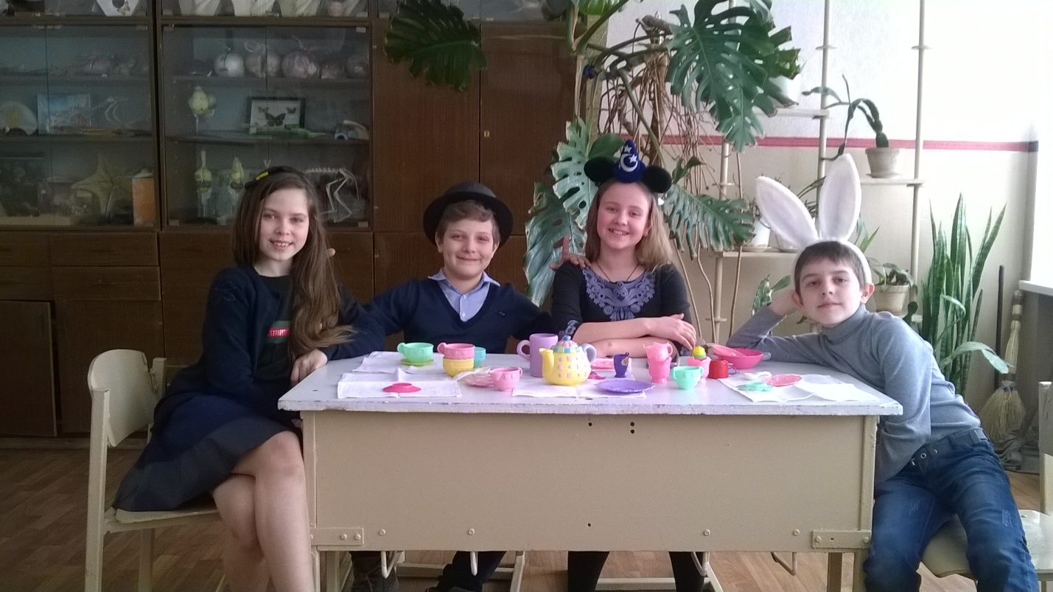

**Hatter:** Oh, my watch is two days wrong!

**Alice:** What a funny watch! It tells the day of the month, and doesn’t tell what (o’clock it is) time is it.

**Hatter:** Does your watch tell you what year it is?

**Alice:** Of course not.

**Hatter:** Two days wrong! It’s always six o’clock now.

**Alice:** Oh, I have a bright idea!!! There are many tea – things on the table (many tea-cups, spoons…)

**Hatter:** Yes, you are right. It is always tea-time. And we have not time to wash the things between these tea-parties.

**Alice:** But what do you do, when you begin tea-time again?

Поют песню «Hockey-Pockey»

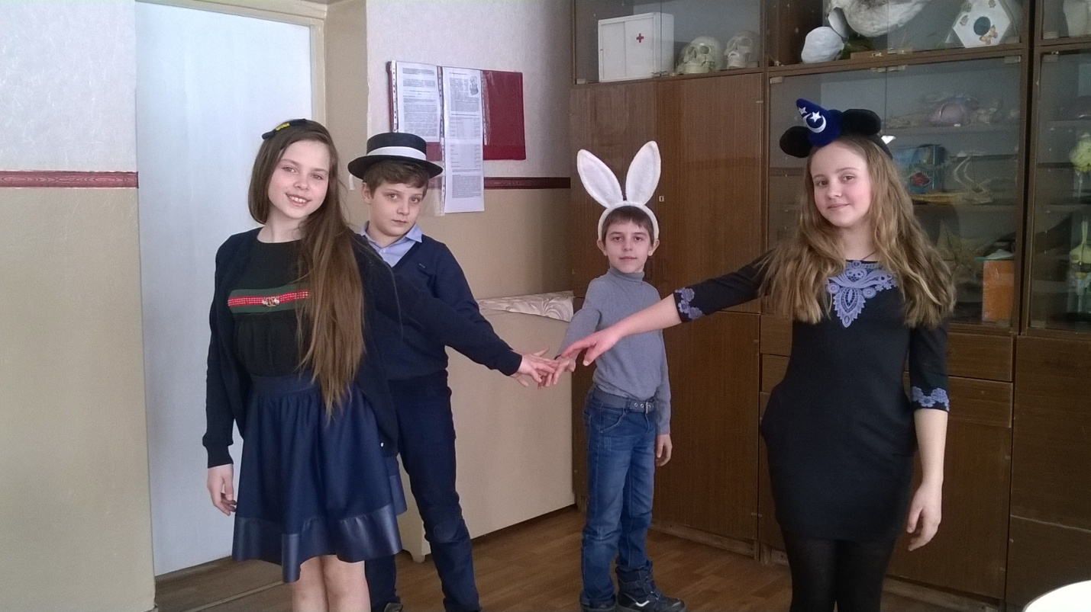

**Hatter:** Of course, we change the tea-things.

**March Hare:** The young Lady, tell us a story, please!

**Alice:** But I don’t know any stories.

**Hatter:** All right, then the Dormouse do it. (*Обращаясь к мышке.)* Wake up, Dormouse!

**Dormouse:** *(еле-еле открывая глаза).* I am not sleeping!

**March Hare:**  Tell us a story!

**Alice:** Yes, tell us a story, please!

**Hatter:** Tell the story quickly. Don’t sleep.

**Dormouse:** Once upon a time there lived three little sisters (*мышь начинает быстро рассказывать)*, and their names were Elsie, Lacie and Jillie. And they lived it the cup very well.

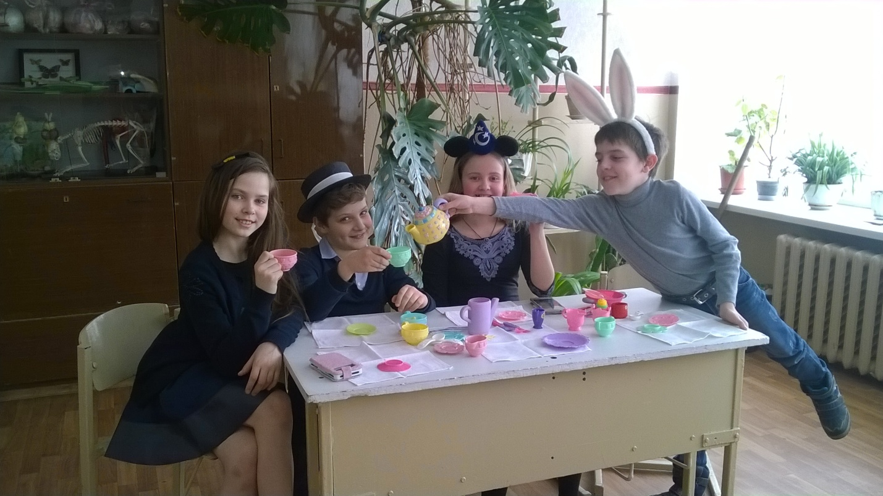

**Alice:** Where did they live?

**Dormouse:** They lived incup… (*сделав паузу, добавляет)*… very well.

**Alice:** No, they cannot live in the cup, or they were ill.

**Dormouse:** So, they were very ill

**Alice:** But why did they live in the cup very well?

**March Hare:** Take some more tea.

**Alice:** But I did not drink the tea. So I cannot have more tea!

**Hatter:** So, then take some less tea.

**Alice:**  I don’t ask you about tea. So, why did they live in a cup very well?

**Dormouse:** Sh! Sh! You are a good girl. Finish this story for yourself.

**Alice:** No, please go on!

**Dormouse:** All right. And so these three little sisters – they were learning to draw.

**Alice:** What did they draw?

**Dormouse:** Cups. So they drew everything.

**Alice:** Why – everything?

**March Hare:** Why not?

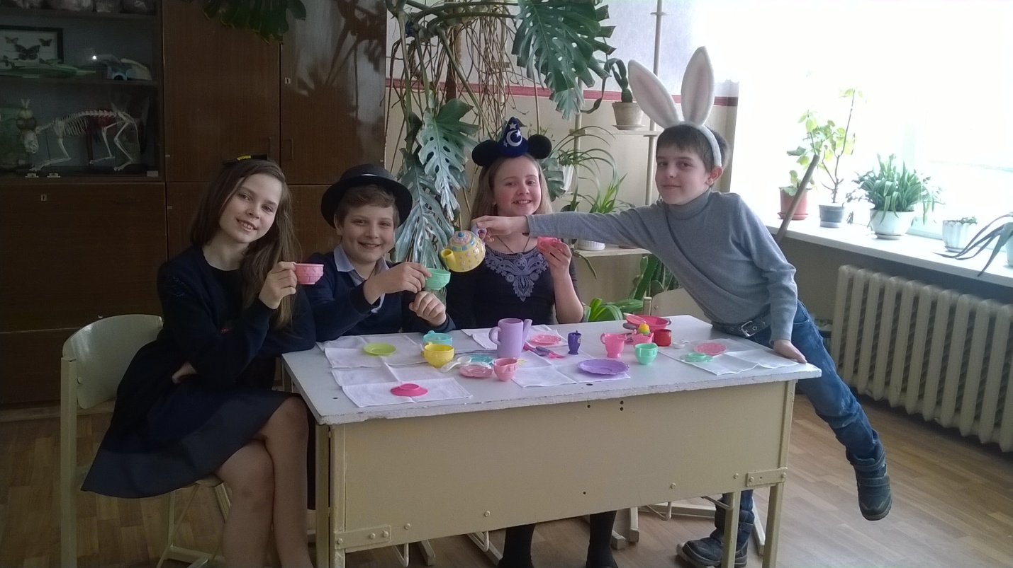

Мышь в это время закрыла глаза и задремала.

**Alice:** I don’t understand you. It is the stupid tea-party. I don’t want to go there again! (*Она выходит из домика и закрывает за собой дверь.)* That is very bad tea-party, it is mad. But everything is mad today.

Oh, I’m sorry, my dear boys and girls. But I must go. I have many adventures today. See you later in the next adventure.

***To be continued…***

***Поют песню «If you are happy»***