"Рождество в Великобритании"
Тип урока: обобщающий с элементами введения нового материала.

Задачи
Обучающие:
Организовать повторение лексического и страноведческого материала по данной теме.
Учить учащихся правильно строить предложения на английском языке по теме, организовать практику устной речи на английском языке.
Познакомить учащихся с некоторыми традициями и обычаями празднования Рождества в Великобритании.
Способствовать формированию у учащихся навыков социолингвистической и лингвострановедческой компетенций.
Развивающие:
Развивать творческую фантазию, познавательный интерес, инициативу в осуществлении иноязычной речевой деятельности.
Развивать межпредметную связь с музыкой, изобразительным искусством.
Воспитательные:
Воспитывать у учащихся чувство прекрасного и уважение к культуре и традициям других народов.
Воспитывать чувство взаимной ответственности, прививать навыки работы в коллективе.

Оборудование: Раздаточный материал: 3 вида елочных игрушек (например, шары, конфеты и колокольчики), заготовки рождественских открыток. Карточки с заданиями, карточки со словами-опорами, общее панно «рождественская ель», аудиозапись песни «Jingle Bells», цветные карандаши, клей.

Примечание: Урок проводится накануне католического Рождества. Класс украшен в соответствие с праздником, на доске число the 24-th of December. Учащиеся предварительно разделены на три группы.

Ход урока:

Teacher: Good morning, dear boys and girls. Glad to see you again! We start our lesson, which is connected with a beautiful holiday, the most popular holiday in Great Britain. This holiday is the favourite holiday of all English children and grown-up persons. We will speak and read about this holiday, have a competition, write cards, and sing a song. I hope you’ll enjoy our English lesson and be friendly to each other. I wish you good luck! Let’s start!

But first of all, I want you to listen to a short poem and guess what holiday we are going to speak about. This is mix of Russian and English. Listen to me!

Teacher: Учитель читает стихотворение, которое представляет собой смесь английского и русского языков, что помогает догадаться, о чем пойдет речь и вспомнить некоторые ключевые слова по теме.

Santa Clause стучит к нам в дверь:
“Open, open поскорей!”
Ему дети говорят: «Please, come in»
Он очень рад.
Видит он a Christmas tree,
И гирлянды, и шары.
А на самом на верху
Видит он a star – звезду.
“Do you like it?” – “Yes, I do!
Merry Christmas to you!”

Teacher: Учащиеся слушают и отвечают на вопрос: What holiday are we going to speak about?

P1. We’ll speak about Christmas.

Teacher: What words helped you to guess?

P1. Santa Clause

P2. Christmas tree

P2. Merry Christmas to you!

Teacher: Why will we speak about Christmas today?

P1. We will speak about Christmas because today is the 24th of December.

Teacher: Look at the picture. (На картине изображение рождественской елки). This is а traditional “Christmas tree”. There are а lot of symbols, things and words, which are connected with this holiday. What are they? (Ученики называют некоторые символы Рождества: рождественские открытки, подарки и т.д. Ответы сопровождаются появлением опор: Santa Clause, Christmas tree, Merry Christmas, Christmas cards, presents, stocking.)

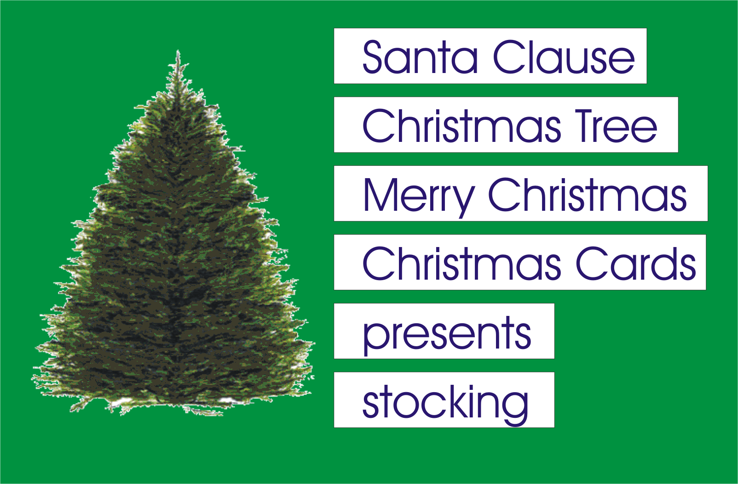

Teacher: What do you know about Christmas?

Предполагаемые ответы учащихся:

P1: We know that Christmas is a favourite holiday for English people, especially for children.

P2: Christmas is a religious holiday. They celebrate the birth of Jesus Christ.

P3: I think Christmas is a family holiday. Families gather for traditional Christmas dinner. They exchange presents and congratulate each other.

P4: People decorate Christmas tree and their houses; send Christmas cards to their relatives and friends.

Teacher: Today is the Christmas Eve, the 24-th of December. We need to get ready for the greatest English holiday of the year, so we will decorate a Christmas tree, write Christmas cards, and sing a song. We have 3 teams for a competition. You can get some of these decorations. We need 3 persons who will decorate our Christmas tree. P1, P2, P3.

Task 1

Teacher: I give you cards. Match the pictures and the words. (Команды получают карточки с рисунками и соответствующими словами, находят им пару и приклеивают на лист. Результаты вывешиваются на доску. За каждый правильный ответ команды получают одно украшение для елки и приклеивают их на общее панно.)

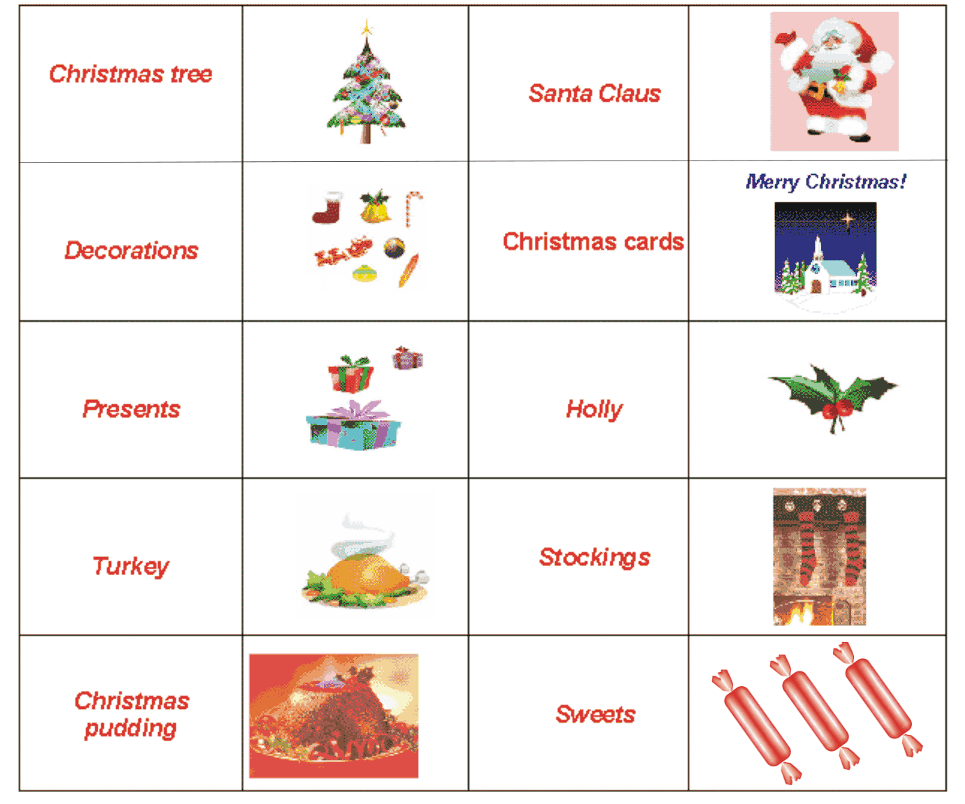

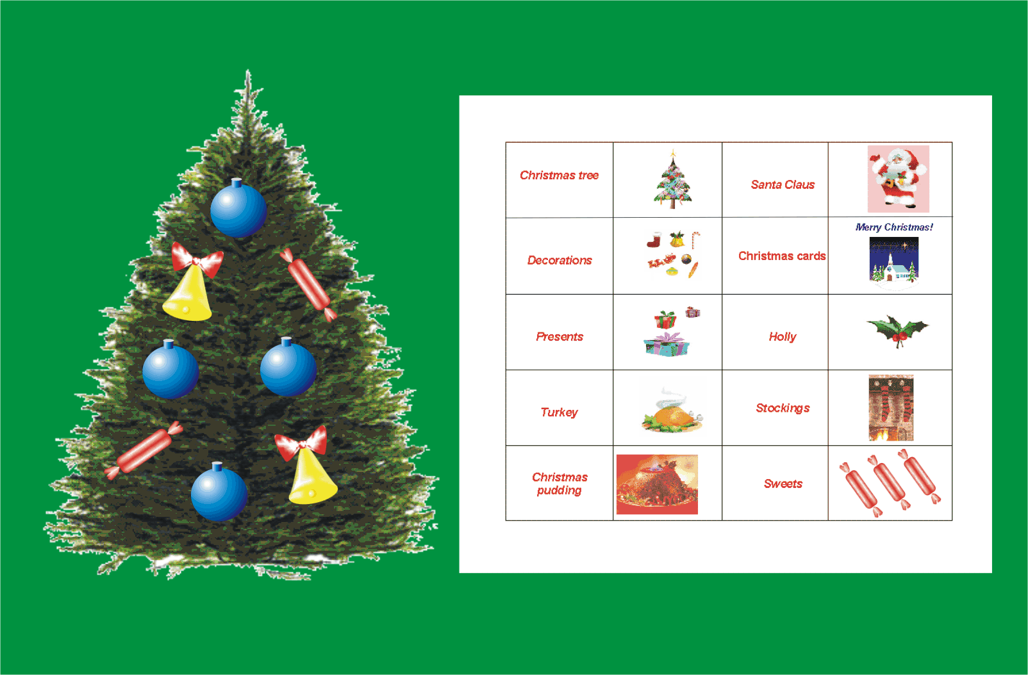

Task 2

Teacher: Read the text and answer the questions. (Команды получают задания. Время на подготовку – 5 мин. Отвечают на вопросы учителя. За правильный ответ получают украшение для елки).

1.

The most popular holiday in Great Britain is Christmas. They celebrate Christmas on the 25th of December. There are a lot of traditions connected with Christmas. Every year the people of Norway give the city of London a present. It’s a big Christmas tree and it stands in Trafalgar Square. Most families decorate their houses with a Christmas tree; buy presents for the family and friends, write Christmas cards. In England almost every family receives more than 60 Christmas cards.

Questions:

1.Who gives the city of London a Christmas tree every year?
2. Where does the Christmas tree stand?
3. What do English people do before Christmas?

2.

The traditional Christmas dinner is roast turkey with vegetables and Christmas pudding. In England people make Christmas pudding before Christmas. Everyone in family stirs the pudding and makes a wish. It’s a traditional meal, which people cook for Christmas party. When the pudding is hot they put 5-penny pieces in it, and sometimes a little silver horseshoe, a button and a ring. If you find a button in your piece of pudding you will be rich, a horseshoe means happiness and good luck, a ring - marriage.

Questions:
What is the traditional Christmas dinner?
What do people put into the pudding?
What does it mean if you find a button (a horseshoe, a ring) in your piece of pudding?

3.

The fun starts the night before, on the 24th of December, Christmas Eve. Traditionally this is the day when people decorate their trees. Children hang stockings at the end of their beds hopping that Farther Christmas will fill them with toys and sweets. Christmas is family holiday. Relatives usually meet for the big Christmas dinner. The 26th December – Boxing Day is an extra holiday after Christmas. This day people usually give and receive presents. This is time to visit friends and relatives or to sit at home and watch football.

Questions:
When does the celebration of Christmas start?
What do children do on the Christmas Eve?
What is Boxing Day? What do people usually do on that day?

Task 3

Teacher: And now listen to the groups of words. In each group there is a word, which does not go with others. Find this word, please! Name the odd word. Orally. (Учащиеся выбирают «лишнее» слово и получают одно украшение для елки за каждый правильный ответ.)
Turkey, pudding, pumpkin pie, vegetables.
Santa Clause, holiday, Christmas tree, birch tree.
Christmas pudding, Easter, ring, horseshoe.
Trousers, stockings, presents, socks.
23rd December, 24th December, 25th December, 26th December.
Christmas Eve, Boxing Day, Thanksgiving Day, Christmas.

Task 4

Teacher: Solve the rebuses. If you do it you will know what presents Santa Claus brings for children. Write the words. (Группы получают ребусы и разгадывают их. За каждое правильно разгаданное слово получают украшение для елки.)

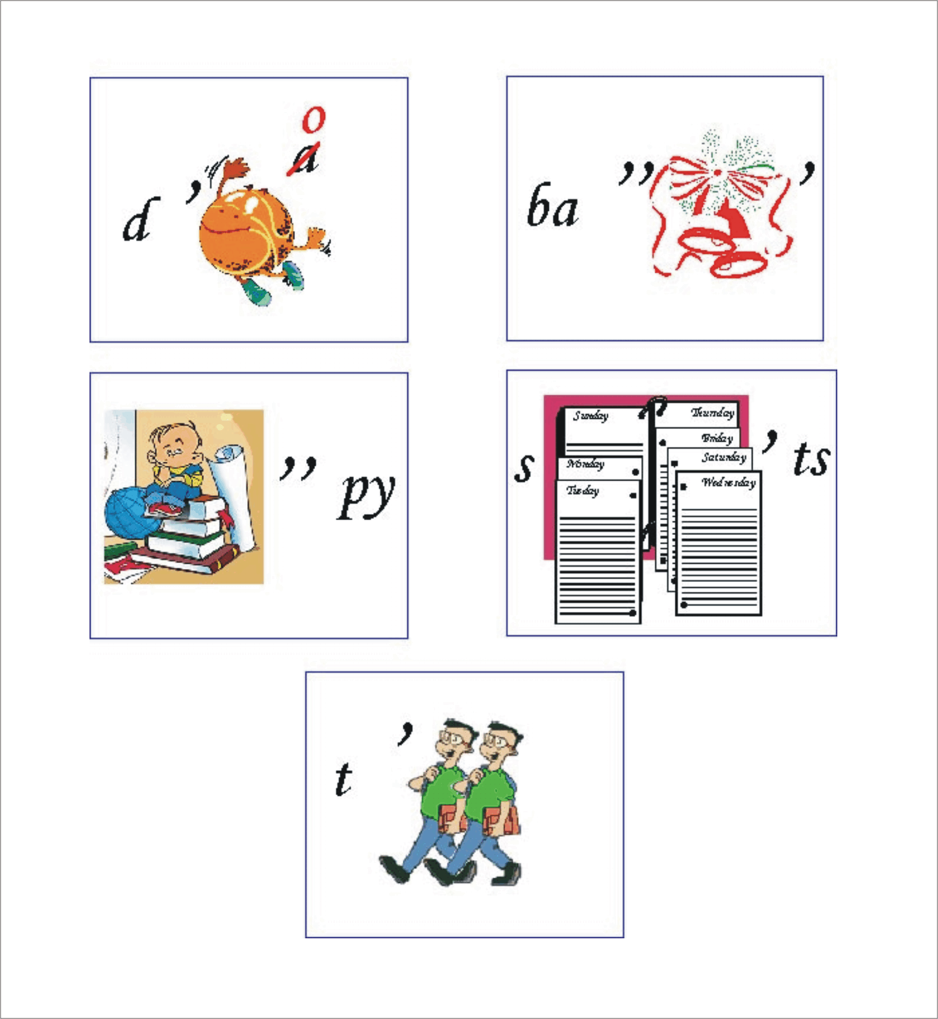

Teacher: We have decorated our Christmas tree together. It’s very beautiful. Now it’s time to write Christmas cards. Look at them. You had to colour them, because they are black and white. (Учащиеся выбирают понравившееся заготовки рождественских открыток и раскрашивают их).

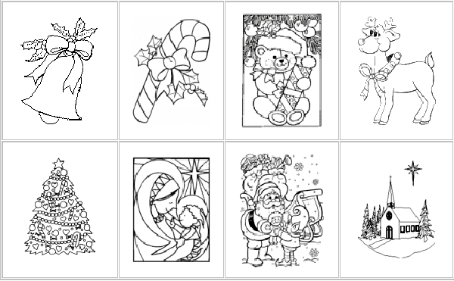

Teacher: Let’s remember what you can write on the cards. (Ученики вспоминают некоторые варианты поздравлений, учитель предлагает другие. Ребята выбирают один из вариантов и записывают его на своей открытке.)

Teacher: Your cards are very nice. You may give them to your parents or friends.

Teacher: And now let’s sing a song about Christmas. (Работа с песней: прослушивание, чтение текста, разбор незнакомой лексики, тренировка чтения и исполнение песни под фонограмму).

Jingle Bells

Dashing through the snow
In a one-horse open sleigh
Over the fields we go,
Laughing all the way.
Bells on bobtail ring,
Making spirits bright
What fun it is to ride and sing
A sleighing song tonight!

Refrain:
Jingle bells, jingle bells!
Jingle all the way!
Oh! What fun it is to ride
In a one-horse open sleigh! Oh!
Jingle bells, jingle bells!
Jingle all the way!
Oh! What fun it is to ride
In a one-horse open sleigh! Hey!

Teacher: So, it’s time to finish our lesson. You have decorated our Christmas Tree and write Christmas cards. You have learnt some interesting facts about Christmas. You had some fun: you have solved the rebuses, sung the song. And what do you think about our lesson? (Рефлексия. Учащиеся высказывают свое мнение.)

Teacher: Thank you for your work. The lesson is over. Good luck and Merry Christmas!

If your answer is right, you can take the toy and decorate the tree.

Riddles

1What is another name of father Christmas? ( Santa Claus)

2 We decorate the tree with pretty ...... ( lights)

3 What do Englishmen eat for lunch on Christmas day? ( turkey)

4 What day is after Christmas day? (the Boxing day)

5 What do we usually give each other on Christmas day? (presents)

6 What does Santa Claus fiil with presents? (Stocking)

7 In what month do we celebrate Christmas? ( December)

8 Who helped tree kings to find Jesus? ( Angel)

9 Whose birthday do the people celebrate on Christmas day? ( Christ )

10 What do you usually put on the top of the Christmas tree? ( star )

11 What do Englishmen usually send to the friends at Christmas? ( cards)

12 How do people call the day before Christmas? (Eve.)

13 What do usually ring in the church on Christmas day? ( Bells)

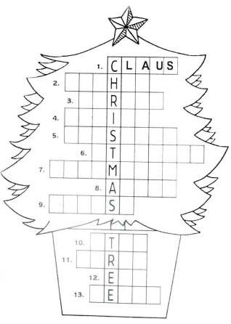

Advent calendars are very popular in December. You can count the days from the 1st of December to the 25th of December - Christmas day using this calendar. Every day you open a window and find a picture. Inside of every window you also can find a sweet, a small chocolate, or may be a toy.

Ведущий 2: We suggest you to take part in the contest “Advent Calendar”. The winner will be a team that has more symbols than the other one.

Сценарий урока-праздника "Christmas" на английском языке в 5-м и 6-м классах спецшколы

Праздник Christmas
5 класс

Цели и задачи:
развитие памяти, мышления, воображения, внимания;
закрепление лексических единиц и речевых образцов, которые были изучены за 1 полугодие и должны знать учащиеся согласно требованиям программы;
приобретение страноведческих знаний.

Данный урок базируется на эпизоде ‘Christmas’ из видео курса ‘We`re Kids in Britain’ (English life and festivals) ‘Longman’, что повышает познавательный интерес к изучению английского языка.

Вот примеры заданий для каждой команды.

1. Make an emblem and give a name for your team according to the topic of today`s lesson. Watch Sequence 1.

Sequence 1

Narrator. Christmas.

Children.

We wish you a merry Christmas,
And a happy New Year.
Good tidings we bring
To you and your kin.
We wish you a merry Christmas
And a happy New Year.

Luke. It` s Christmas and there`s lots to do!

Teach children Christmas Carol. Which team sings better? (You may give the words of this song on a piece of paper). (Рисунок 1).
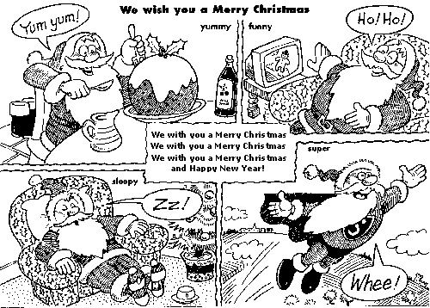
Рисунок 1

2. Make your poems.

Be merry and ... (charming)
... and wise, (nice)
... and everything `s twice (happy).

I hope... (year)
Your Christmas this ... (fantastic)
Will be ... (sincerely)
Be happy, my ...! (dear)

What do you usually do to get ready for Christmas? Watch Sequence 2 and 3.

Sequence 2.

Narrator. Decorate the Christmas tree, make the snowflakes, open the Christmas cards, wrap the Christmas presents, make the mince pies.

Sequence 3.

Mum. Phew! That`s finished! The Christmas tree. The snowflakes, the cards, the presents, the mince pies... All done!

3. Match the pictures to the words. (A postcard, Christmas tree, presents, a stocking, mince pies, a snowflake).

4. Write sentences about what they have already done (use Present Perfect).

5. Make a snowflake to decorate the classroom.

6. Watch Sequence 4.

Sequence 4.

Narrator. It` s Christmas Eve, the night before Christmas. Jenny and Luke are going to bed. They are putting out their stockings. It` s Christmas morning. Luke is opening his stocking. What has Luke got? A game, a stapler, a pencil case, and sweets. Look at Jenny! What has she got in her stocking? An address book, bracelets, a torch, sweets and an orange. And say what will happen if you hang a stoking on your bed (use Conditional 1).

7. Watch Sequence 5.

Sequence 5.

Narrator. It` s time to open the Christmas presents.

Jenny. Here is one for you Tim. That` s a heavy one ...

Narrator. It` s lunch time! What` s for lunch? Turkey, carrots, peas, potatoes.

Luke. Let` s pull the crackers!

Narrator. What` s in the crackers? Paper hats and small presents, And now for Christmas pudding!

All.

We all want some figgy pudding
So bring some out here.
Good tidings we bring, etc

Dad. Who`s for Christmas pudding then?

All. Yes, please!

Jenny. Look I got 10p!

Dad. That`s good luck. Well done!

Children. Now it`s your turn to answer the questions! Merry Christmas!

8. What was in the children` s crackers? What is in yours? Task 2. Draw a cracker and falling out mixed letters of the words: present, sweet, snowman, etc.

9. Now show Father Christmas the way to his sack (or the cook where to put Christmas pudding). Task 3.

10.What do you remember about Christmas traditions in England? Task 4.

Christmas Traditions in England

1. People send Christmas ... to greet each other.
letters,
cards,
faxes,
presents.

2. They wish “... Christmas and Happy New Year!”
Funny,
Brilliant,
Merry,
Busy.

3. Father Christmas “comes” to every house through ...
the door,
the window,
the chimney.

4. Father Christmas arrives from ...
the North Pole,
Alaska,
Russia,
Africa.

5. He brings ...
a snow girl,
snow,
a New Year tree,
presents.

6. He is wearing ...
a rain coat,
jeans,
a suit,
a fur coat.

7. He puts little presents ...
under children` s beds,
into children` s shoes,
into children` s stockings,
under their pillows.

11. Если команды набрали одинаковое количество баллов, можно предложить задание на общий кругозор. Task 5.

Holidays in BritainHolidays Christmas Mother`s Day St. Valentine`s Day New Year`s Easter
N

This day people usually visit their friends. There is a lot of dancing and eating. People bring a piece of coal for good luck.
People decorate trees with toys, send greeting cards and find presents in their stockings.
People send cards to people they love. They don` t write their names. Those who get them must guess who sent them.
All people eat chocolate eggs. Sometimes parents hide eggs in the house or in the garden and children look for them.
This day children help at home and give or send cards and presents. Mothers like this holiday.

В конце игры подводятся итоги и команды награждаются призами. Все поют песню “ Merry Christmas”.

Праздник Christmas
6 класс

На первом этапе подготовки ребята нарисовали елку, которая и станет игровым полем, украшенную шарами (всего 21) и звездой на верхушке.

Также с ребятами на уроках изучались “Рождественские праздники” (Исп. “EST Teacher’s Holiday Activities KIT” by Elizabeth Claire (Приложение 1), песня “Mary’s boy child” (Приложение 2), а также лингвострановедческий словарь).

На следующем этапе, используя полученные знания, готовились кроссворды, загадки для команд соперников, и номера художественной самодеятельности. И вот, все готово: актовый зал украшен, игровое поле – елка в центре, все участники в карнавальных костюмах. Праздник начался. Команды представили эмблемы и капитанов.

Попеременно бросая кубик, команды двигались к “звезде”, выполняя предложенные задания, за которые начислялись баллы.

Далее приведем перечень заданий для шаров на елке:

1, 8, 15 — Christmas vocabulary (Рисунок 2, 3).

Рисунок 2

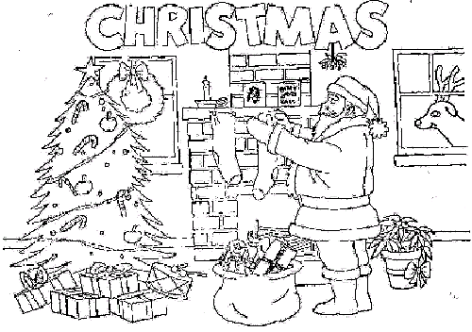

Рисунок 3

II. YES or NO?
December 22 is Christmas.
People decorate their houses.
It is a time to remember poor people.
Children write letters to Christopher Columbus.
People sing Christmas carols.
On Christmas Eve many peple go to school.
Children hang up their shoes.III. Match:
Christmas tree
stocking
gift
Christmas card
Santa Claus

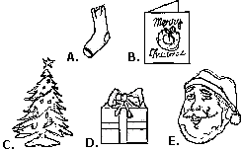

2, 9, 16 — sing a song.

(Fill in the gaps. Then sing the song).

Mary’s boy child ... was born on Christmas Day.
And man will live for evermore, because of Christmas Day.

Long time ago in Bethlehem, so ... says,
Mary’s boy child Jesus Christ was born on Christmas Day.

Hark, now hear the ... sing, a king was born today,
And man will live for evermore, because of Christmas Day.
Mary’s boy child Jesus Christ was born on Christmas Day.

While ... watch their flocks by night,
They see a bright new shining star,
They hear a choir sing a song, the music seems to come from afar.

Hark, now hear the angels sing, a king ... today,
And man will live for evermore, because of Christmas Day.

For a moment the world was aglow, all the ... rang out,

There were tears of ... and laughter, people shouted:
‘Let everyone now, there is ... for all to find peace.’

Oh, my Lord, You sent your son to ... us,
Oh, my Lord, Your very self you gave us,
Oh, My Lord, that sin may not enslave us.
And love may reign once more.

3, 10, 17 — crossword (используются кроссворды, приготовленные учащимися на этапе подготовки к празднику).

4, 11, 18 — comparisons (make sentences using words: exciting, bad, happy, fat).

5, 12, 19 — find a correct mistakes.

Correct the false information about how Christmas is celebrated in the world.
Holly is an ever green plant with sharp-pointed leaves and white berries.
Mistletoe is an evergreen plant with small leaves and red berries.
On Christmas Eve there is a bunch of holly in every house. Under this bunch boys kiss girls.
Father Christmas brings Christmas Trees to every house.
Children put a candle on top of the Christmas Tree.
A Jule Log is a piece of wood which people burn in the fireplace on the 26th of December.
British children usually get their Christmas presents in their new gloves.
The highlight of Christmas Dinner is a turkey with a coin inside it.

6, 13, 20 — Christmas party (номера художественной самодеятельности, подготовленные учащимися).

7, 14, 21 — Riddles.

В конце игры подводятся итоги и команды награждаются призами.

В заключение хотелось бы отметить, что проведение лингвострановедческих праздников органически влились в общую систему обучения иностранному языку и являются очень эффективным способом проверки знаний и овладения иностранным языком.

