***An Integrated study is in which children broadly explores knowledge in various subjects related to certain aspects of their environment.***

*By Humphreys post and Ellis 1981*

An integrated lesson is a special type of lesson that combines teaching in several disciplines simultaneously while studying a single concept or topic. In a such lesson we can distinguish: the leading discipline and auxiliary disciplines which intensify, expand and refine the material of the main discipline.

Today we are going to answer some questions.

**The English language can integrate with other subjects.** Brainstorm and list activities around the theme you have selected. You should then focus on the English language learning in activities. Choose suitable activities and collectively decide on the vocabulary and communication skills that you want students to develop.

**What are the benefits of integrating English with other subjects?**

Students can solve various interesting tasks in order to develop their thinking skills and their English vocabulary. The other purpose of integration between English and other subjects is that students can learn them as connecting topics and not seperately.

**What is integrated subject English?**

Integrated subject, which means there are various elements that link with each other and with other subjects. Every skill learned is related to the others. In addition, you need those same skills in order to learn in any other subject area.

**What is integrated approach in teaching?**

An integrated approach creates learning experiences that call on more than one discipline or subject such as cross-discipline assignments or units, project-based learning experiences, curriculum developed across a number of disciplines, and/or curriculum tied together with overarching themes and questions.

**What is integration in the classroom?**

Integration refers to exceptional students being partially taught in a mainstream classroom. Activities are adapted so the student can “fit in” with their mainstream peers while learning skills that may be better practiced in a room with more age-appropriate peers.

**What is integration among subjects in teaching?**

An integrated curriculum is described as one that connects different areas of study by cutting across subject-matter lines and emphasizing unifying concepts. Integration focuses on making connections for students, allowing them to engage in relevant, meaningful activities that can be connected to real life.

## PRINCIPLE OF INTEGRATED LEARNING.

## Integrated learning helps the children to expand the knowledge . Then build and extend their previous knowledge and experiences.

* Open ended learning style.
* Helps to develop problem solving ability.
* Collaboration

**CHARACTERISTICS OF INTEGRATED LEARNING.**

It refers to a holistic way of learning. ( We don’t just focus on cognitive development but all four areas of development: Emotional development, Cognitive development, Physical development, Social development

Encouraging peer group work.

* Develop problem solving ability.
* Help to develop the social skills of the children.
* It is directly connected with the real world.
* An emphasis on projects that goes beyond text.
* Refers to combinations of the subjects.
* To helps the child to think creatively as well critically.
* Collaboration is the main feature of integrated learning
* Ensures the active participation of the learners.

## NOW LET’S DISCUSS THE APPROACH OR TYPES OF INTEGRATED LEARNING.

## C:\Users\muwr\Downloads\Integrated-lear1.jpg

## Within-subject areas integration approach. Under this head comes an intra-disciplinary approach: Let’s learn about it.

## 1.INTRA- DISCIPLINARY APPROACH :

## It is a process of learning where the particular subject has different concepts. Then within that subject, it connects different concepts with several topics.

## In this type of approach, we combine knowledge and skills of the same subjects during the classroom. Which helps to make teaching a learning process effective.

## This process of combining various concepts. Different topics in the same subjects make the learning process effective.

Example: 1

The subject is English. Where you can learn different competencies within that subject area only. During the language learning process, you can combine reading, writing. creative writing, spelling through storytelling activity or poem recitation activity.

**Storytelling**-Oral communication is one of the concepts of the language subject. But to make it more interesting. You instruct the students to apply their previous knowledge and experiences. And instruct them to write a story using that knowledge. Further, you can say to read the story and underline the new words. Then ask related questions. And tell them to write the answer from the story.

In a way to combine one concept with inter topics of the same subjects. And try to make the learning holistic for children.

|  |  |  |  |
| --- | --- | --- | --- |
| Subject Language | Topic Reading | Another topic : Writing or Spelling | **Concept :** Oral communication through Storytelling. |

**2. INTEGRATION BETWEEN THE SUBJECT AREAS. :**

Integration between subject areas is divided into two approaches.

* Multidisciplinary approach
* Interdisciplinary approach

Let’s understand both approaches in detail with examples.

**1.MULTIDISCIPLINARY APPROACH:**

In this type of approach, the outcome of the subject area remains distinct. But because some meaningful linkages are connected during the teaching-learning process. It allows students to combine different subjects during teaching one lesson.  Now let us understand with an example.

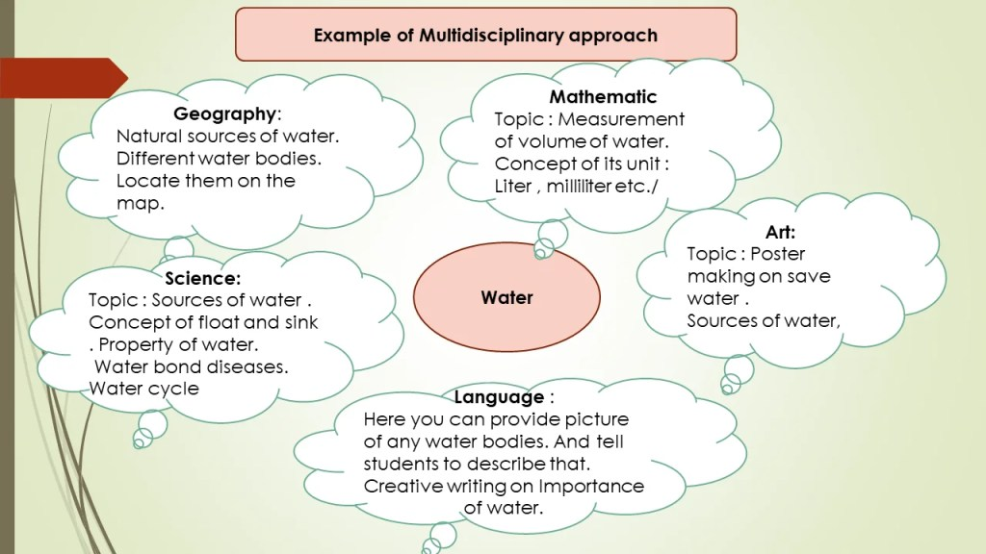

So As you can see above the example of  Theme Water. Water is the theme or topic of science. But using integrated learning, we can teach many subjects to the children. And try to make the teaching-learning process holistic. Now Let’s understand What is multidisciplinary integrated learning is.

**THEME IS WATER.**

|  |  |
| --- | --- |
| **Co relate with different subjects** | **Topics** |
| **Mathematics** | Using water as a theme teacher can teach the topic like measuring units such as liters and milliliters.   Take examples of bottles, glass, jugs, and mugs, Buckets, etc. And can teach the topic easily.   For example, to fill a bottle how much glass of water is required? Ask 1 liter is how much milliliter?   And then give more examples for conversion of units.  Volume of water |
| **Art** | The teacher can instruct the students to make a poster on: “ Save the water “ “water is our life.”  On the same topic, the teacher can arrange the Roleplay or street drama. |
| **Language** | Can arrange creative writing on the topic of the importance of water.   Write five uses of water, debate on why we should conserve the water? |
| **Science** | Discuss the properties of water. Uses of water.  Sources of water.Concept of float and sink.  Concept of dissolve or do not dissolve in water. |
| **Geography** | Discuss natural sources of water and their origin.  Map recording- River, sea, and ocean. |

Examples

You saw on the above-mentioned examples how we can connect and combine various subjects with one topic.

**INTERDISCIPLINARY APPROACH:**

Multidisciplinary and interdisciplinary approaches are almost the same. As an interdisciplinary approach, connect one subject to many other subjects during the teaching-learning process.

 Let’s see examples of this integrated learning approach:

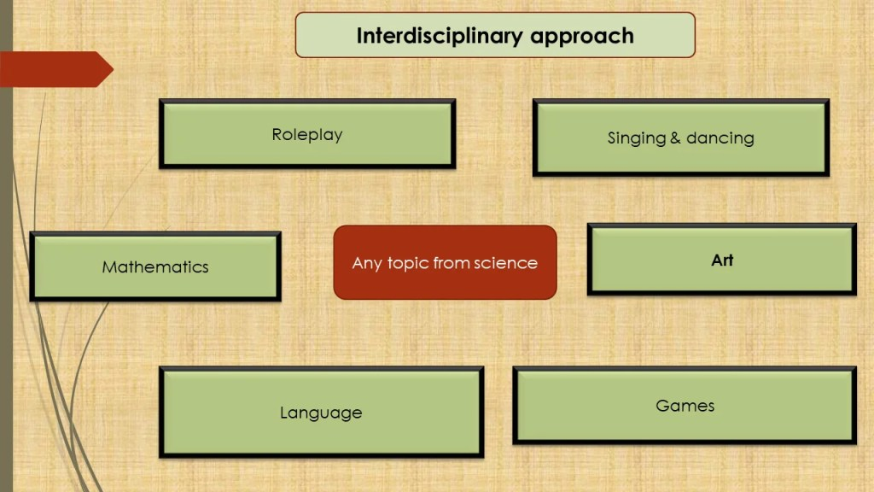

Like a multidisciplinary approach here also, you can take any subject. And combine that subject with:

* dancing
* singing
* art
* language
* life skills and social skills
* mathematics
* games

Try to give kids a holistic way of teaching. Now, here I give you an example of food in the chart below.

## C:\Users\muwr\Downloads\Integrated-lear-6.jpg

As you can see above concept food of Science Or EVS can combine with:

* **Roleplay :** Roleplay on food cultural diversity can show.
* **Singing :** Folk song competition can arrange
* **Mathematics:** Concept of measuring units can teach.
* **Language :**Creative writing or essay writing on food.
* **Science :**   Sources of food.
  + Method of cooking
  + Types of utensils
  + Raw and cooked food concepts
  + Listing of vegetables and Spices
* **Art**: Drawing and painting
  + Street play
* **Social skills :** Save food .
  + help the needed people.
  + Help orphans or old people.

As you see above example how we integrate different subjects area with one subject area. The above example is the best example of an interdisciplinary approach to integrated learning.

**3. INTEGRATION IS BEYOND THE SUBJECT AREAS**

Last but not least, the third type of integration is Beyond the subject areas. Beyond the subject areas means students can connect this knowledge with the real world. And learn from real-life experiences. The students connect their day-to-day life experiences with subject areas.

The key feature of these integrated learning is knowledge and experiences of day-to-day life. Students have vast experiences. So connect that experience and knowledge with the teaching-learning process. And try to acquire a new learning situation for them. That way it helps to establish a holistic way of learning.

Project-based learning is the best example of beyond subject areas integrated learning. Where the students have given the real-life problems as a project. They research it. Explore it and come to a conclusion and acquire new knowledge.

Here is the above process using a project-based method. Students acquire new knowledge which are beyond the textbooks. Students develop life skills and social skills as well. Two routes i.e disciplinary and interdisciplinary approaches lead to the transdisciplinary approach.

Example of buying things from any supermarket. Here a child can apply his previous knowledge. And if he bought earlier from anywhere. Or observe anyone buying things.

* **Listing items to buy** : correlate with language
* **Reading shop name or items name : Again language area**
* **Money : counting and concept of m**oney : Mathematics.
* **Social skills/ life skills.**: Don’t cheat or hide things from the store . value of money.
* Try to give kids a holistic way of teaching. Now, here I give you an example of food in the chart below. Mathematics
* Food items : Science and EVS.

So you can see how using the transdisciplinary approach in a real-life a child can learn holistically. He has knowledge of buying things which helps him to acquire new knowledge using a disciplinary and interdisciplinary approach.

**The Practical ParT**

And today I’m going to demonstrate one of the types of integrated learning which I use on my extracurricular classes. It is an interdisciplinary approach. I can say it is a course of extracurricular activity. You know that Robotics, Computer Programming, Virtual and Augmented Reality are current offered as an extracurricular activity at the gymnasium. It is no wonder that we have chosen this course as nowadays Engineering has closely integrated into our lives and we should comprehensively develop our students. How do we work? Firstly, we decided what it would be. And now it is a project. But we don’t want only to read texts, learn new words, analyze and discuss different topics. We want to take a creative approach to this case. And we decided to create a big project in which we would create a series of educational videos. The next step – we chose interesting topics that we would like to discuss on our TV show. They are: Engineering and Space, Engineering and Medicine, Engineering and Agriculture, Digital Technologies, Transportation System, Human and Nature.

And then we started our preparations. We searched for information, chose the best one, assigned roles, and taught them. We looked for suitable pictures, thought about the screensaver. After we've done all this work we set off the shooting out first video. After that the video editing was followed. And if you go back to the beginning and determine the type of integrated learning, we can say it is an interdisciplinary approach as I mentioned earlier.

**CONCLUSION :**

1. So now you have clear ideas about what is integrated learning and the types of art integrated learning. Here I try to give you more clacification with examples so that you have clear ideas about integrated learning. And you can easily use these ideas in your day-to-day teaching-learning process. And make the learning process holistic and everlasting. Projects: Assign group or individual projects that require students to research, write, and present on a subject matter. This provides students with opportunities to apply their language skills in a practical way while demonstrating their understanding of the subject matter.
2. Multimedia: Utilize multimedia resources such as videos, podcasts, and online resources to provide students with engaging and interactive content related to the subject matter. This can help students improve their listening and comprehension skills.

By integrating English into different subjects, teachers can help students improve their language skills while enhancing their understanding of various topics. This can lead to improved academic performance, better communication skills, and greater confidence in their abilities.