**Составитель: Шеповалова Александра Александровна, учитель английского языка ГБОУ школа №47 им.Д.С.Лихачева с углубленным изучением ряда предметов Петроградского района Санкт-Петербурга**

**Reading and Vocabulary Tasks based on**

**‘A Christmas Carol’ by Charles Dickens (adapted by Lesley Sims)**

**CONTENT**

|  |  |
| --- | --- |
| Tasks for Chapter 1 | page 1 |
| Tasks for Chapter 2 | page 2 |
| Tasks for Chapter 3 | page 3 |
| Tasks for Chapters 4-5 | page 4 |
| Tasks for Chapter 6 | page 5 |
| KEYS | page 7 |

**Chapter 1. Scrooge and Marley**

**Task 1. Match the words with their definitions:**

|  |  |
| --- | --- |
| a. a place where poor people live and work to earn help. | 1. poor |
| b. feeling very unhappy and uncomfortable. | 2. grasping |
| c. a place where people count money and keep records of it. | 3. miserable |
| d. having little or no money or things. | 4. counting house |
| e. very shocking and scary to see or think about. | 5. gruesome |
| f. wanting to take as much as possible for yourself. | 6. workhouse |
| g. wanting more food, money, or things than you need. | 7. icy heart |
| h. someone who does not show kindness or care for others | 8. greedy |

**Task 2. Fill in the gaps with *poor, greedy, workhouse, icy heart, counting house, miserable, grasping, gruesome***

In the town of London, there was a man named Ebenezer Scrooge. He was known to be very _______________(1), always _______________(2) for more money. His _______________(3) was cold, just like his _______________(4). He didn't care for the _______________(5) and thought the _______________(6) was where the _______________(7) should go. One night, he had a _______________(8) dream that changed everything.

**Task 3. Choose the correct answer to the questions.**

*1. What was Ebenezer Scrooge's job?*

A. He was a banker.

B. He was a shopkeeper.

C. He was a teacher.

D. He was a businessman.

*2. How did Scrooge feel about the poor people?*

A. He wanted to help them.

B. He didn't care about them.

C. He thought they were lazy.

D. He was scared of them.

*3. What happened to Scrooge one night?*

A. He had a happy dream.

B. He went to a party.

C. He had a gruesome dream.

D. He decided to change his ways.

*4. What was the weather like in Scrooge's counting house?*

A. It was warm and cosy.

B. It was cold and gloomy.

C. It was sunny and bright.

D. It was rainy and stormy.

*5. What was the overall mood of the passage?*

A. Joyful and uplifting.

B. Sad and melancholic.

C. Funny and lighthearted.

D. Gloomy and serious.

**Chapter 2. Marley’s ghost**

**Task 1.**

**Match the words and their opposites:**

|  |  |
| --- | --- |
| suffer | future |
| greedy | now |
| Nonsense | helped with |
| Punishment | mercy |
| Past | kind |
| Former | be happy |
| burdened by | fact |

**Task 2. Read the dialogue between Scrooge and Marley’s ghost. Answer the questions below the dialogue.**

1. Who is Marley?
2. Why is Marley in chains?
3. Did Scrooge believe in the ghost?
4. What did Marley the ghost about the future of Scrooge?

Ghost: Scrooge…

Scrooge: Who's there?

Ghost: It is I, Marley, your **former** business partner.

Scrooge: Impossible! You've been dead these pastseven years!

Ghost: And yet here I am, **burdened by** these heavy chains.

Scrooge: Bah! Humbug! This cannot be happening. I must have had too much eggnog tonight.

Ghost: Scrooge, do not deny what your eyes see. These chains are **a punishment** for my **greedy** ways in life. And now, I have come to warn you. Listen my words or you shall **suffer** the same fate.

Scrooge: **Nonsense**. Leave me be, spirit!

Ghost: Tonight, you will be visited by three ghosts. Learn from them or suffer an eternity in chains.

**Chapter 3. The First Spirit**

**Before you start, match the Russian and English crosswords to translate the words**

**APPRENTICE**

**BRIGHT**

**CANDLE**

**DIMMER**

**FOGGY**

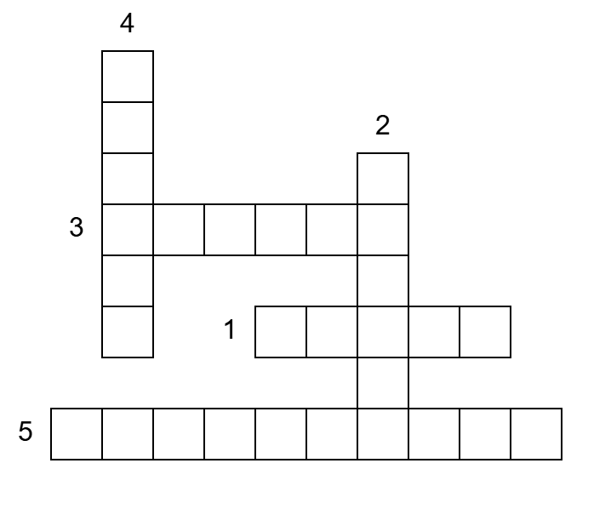 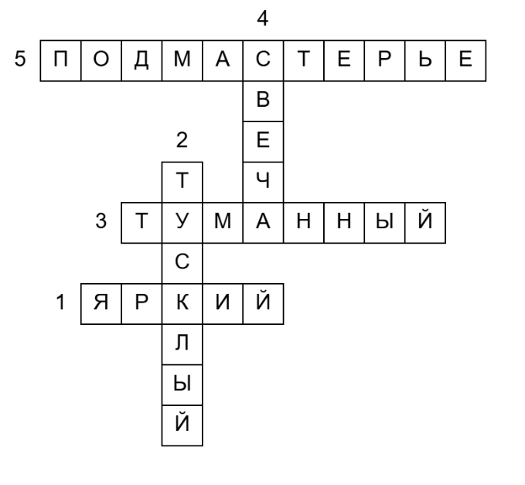

**Task 2. Are the statements TRUE of FALSE?**

1. Scrooge woke up in a bright room.

2. The spirit that visited Scrooge was called the Ghost of Christmas Past.

3. Scrooge was happy to see his old schoolroom.

4. Scrooge's master, Fezziwig, was known for making his apprentices unhappy.

5. The spirit showed Scrooge a scene with a girl who wanted to marry him.

6. Scrooge struggled with the spirit because he wanted to see more of his past.

7. The spirit's light became dimmer when Scrooge pressed the cap over it.

**Chapters 4-5 The second and the last Spirits**

**Task 1. Find the answers in the text of Christmas Carol (Chapters 4 and 5)**

1. How did Scrooge react when he woke up and found the second spirit in his room?

______________________________________________________________________________

2. What did the Ghost of Christmas Present show Scrooge at the Cratchit family's home?

______________________________________________________________________________

3. How did Scrooge's nephew Fred and his guests react to Scrooge's dislike of Christmas?

______________________________________________________________________________

4. What did the Ghost of Christmas Present reveal to Scrooge about the two miserable children hidden in his robes?

______________________________________________________________________________

5. What did Scrooge see when the Ghost of Christmas Yet to Come took him to the junk store?

______________________________________________________________________________

6. How did the people Scrooge saw in the bedroom react to the death of the man on the bed?

______________________________________________________________________________

7. What did Scrooge see when the Ghost of Christmas Yet to Come took him to the Cratchit family's home?

______________________________________________________________________________

**Task 2. Choose the right summary. Explain your choice.**

**1** The story is about Jacob Marley's strange disappearance. Scrooge looks into it and finds secrets and lies that make him doubt what he knew about Marley. He finds hidden money, leading to an exciting adventure with surprises.

**2** The story shows Ebenezer Scrooge as a greedy businessman who only cares about money. He and Jacob Marley got rich by taking from others. Scrooge's heart was cold until Marley's ghost visits him, warning him to change or have a bad future.

**3** The story shows Ebenezer Scrooge as a kind businessman who cares for his workers. He is friendly and puts others first. His office is warm and cosy, with a big fire in winter. Even though he is rich, Scrooge is humble and treats everyone well.

***Use some of these words to explain your choice:*** I guess number … matches\doesn’t match the story, the information about … is correct\incorrect because…; Scrooge was\wasn’t … .

______________________________________________________________________________

______________________________________________________________________________

**Task 3. Read these opinions. Which one do you agree with the most and why? Write what you think. The beginning is done for you. Add 2-3 sentences with your own ideas.**

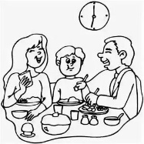**Tom**: "I think Scrooge is just being silly. Christmas is a time for enjoying with family and friends, not for being greedy and gruesome. I remember when my family had a big meal last Christmas, and we laughed and shared stories together. Scrooge should really be with other people instead of pushing everyone away!"

****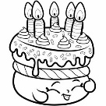

**Emily**: "I totally believe that everyone should have the chance to change like Scrooge did. One year, I forgot about my friend's birthday, but when I realised, I made a surprise party for her, and she was over the moon! If Scrooge can turn things around, then anyone can!"



**Jake**: "I'm not sure what to think about Scrooge. Part of me feels sorry for him because he seems so lonely. But then again, I also wonder if it's too late for him to be happy. It's confusing, you know? Like when I wanted to join the football team, but I wasn't sure if I'd be good or if people would even like me."

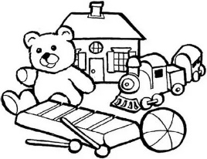

**Lily**: "When I saw how sad Tiny Tim was, it really broke my heart! It makes me feel all warm inside when I think about helping others. Last Christmas, I donated some toys to kids who didn't have any. I just wish Scrooge could see the joy he could bring to others if he opened his heart!"

*I have read four different opinions about Ebenezer Scrooge’s life. I mostly agree with _____________ way*

*of thinking. _____________________________________________________________________________*

*_______________________________________________________________________________________*

*_______________________________________________________________________________________*

*_______________________________________________________________________________________*

*_______________________________________________________________________________________*

**Chapter 6. Merry Christmas**

**Task 1. Fill in the gaps of the summary with the given sentences.**

1. "I'm going to raise your salary."
2. "I'll keep Christmas in my heart all year round," he promised himself with a smile.
3. The stars twinkled above, and he knew this Christmas was the beginning of something wonderful.
4. He was dressed in his best and outside.
5. "Uncle Scrooge!" he exclaimed and welcomed him to the party with such delight.

Scrooge sat by the window, watching the snow gently fall outside. It was Christmas morning, and something was different this year. He could feel it in the air. The usually cold-hearted man was now filled with warmth and joy. 1) _____ .

Scrooge had decided to visit his nephew, Fred. He stepped outside, where the snow crunched underfoot.

2) _____. As he approached Fred's house, he was nervous. Was this Scrooge? Nervous about visiting family? But he knew he had to make amends for the past.

When he arrived, Fred threw open the door with surprise and joy. 3) _____. Scrooge felt at home in five minutes, surrounded by laughter, music, and smiles. It was such a lovely change from his usual lonely holidays.

Later that evening, as everyone sat down to dinner, Scrooge turned solemnly to Bob Cratchit, his clerk. With a twinkle in his eye, he announced, 4) _____. Bob's happiness was clear, and Scrooge felt lighter seeing it. Tiny Tim, sitting nearby, looked up and said with his small voice, "God bless us!"

The evening continued with much laughter and fun, and as Scrooge walked home, he realised he had never felt so at peace. 5) _____ . He was determined never to forget how this day made him feel.

**Task 2. Choose the best title for the summary of Chapter 6 in the Task 1. Explain your choice.**

1. Scrooge's Transformation on Christmas Day

2. The Snowy Weather of Christmas

3. Fred's Surprise Party for Uncle Scrooge

*I think the best tittle for the summary of Chapter 6 is _________________. In the text I can find some words to prove my choice, such as ________________________________________________________________*

______________________________________________________________________________________.

**KEYS**

**Chapter 1.**

**Task 1. Correct matches:**

1. D 2. F 3. B 4. C 5. E 6. A 7. H 8. G

**Task 2. Correct answers:**

1. greedy

2. grasping

3. counting house

4. icy heart

5. poor

6. workhouse

7. miserable

8. gruesome

**Task 3. Correct answers:**

1. D 2. B 3. C 4. B 5. D

**Chapter 2.**

**Task 1. Correct matches:**

|  |  |
| --- | --- |
| former | future |
| past | now |
| burdened by | helped with |
| punishment | mercy |
| greedy | kind |
| suffer | be happy |
| nonsense | fact |

**Task 2. Answers to the questions:**

1. Who was Marley? – Marley was a Scrooge’s business partner. 2. Why was Marley in chains? – Marley was greedy in his life and those chains are a punishment for it. 3. Did Scrooge believe in the ghost? – No, he didn’t. He said “Nonsense.” 4. What did Marley the ghost say about the future of Scrooge? – Marley the ghost told Scrooge about the visits of three ghosts.

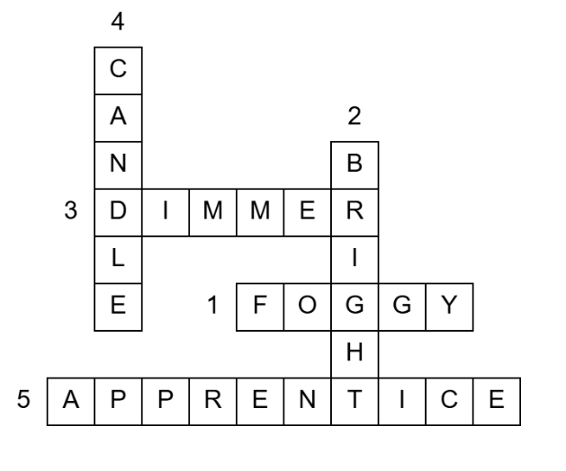**Chapter 3. Correct answers:**

**Task 1 Crossword**

**Task 2. Correct answers**

1. False - The text states that Scrooge awoke in total darkness.

2. True - The text mentions that the spirit is called the Ghost of Christmas Past.

3. True - The text indicates that Scrooge cried out that he was a boy there, showing his happiness.

4. False - The text states that Fezziwig made them happy, not unhappy.

5. True - The text describes a scene where a girl tells Scrooge that she cannot marry him.

6. True - The text shows that Scrooge began to struggle with the spirit as he wanted to see more.

7. False - The text states that the light on the spirit's head burned even more brightly when Scrooge struggled.

**Chapters 4-5**

**Task 1. Correct answers:**

1. Scrooge followed the Ghost of Christmas Present, who had appeared in his room, and they went through the streets full of people preparing for Christmas.

2. The Ghost of Christmas Present showed Scrooge the Cratchit family enjoying their Christmas feast, including Bob Cratchit and his son Tiny Tim.

3. Scrooge's nephew Fred and his guests reacted with disapproval and pity towards Scrooge's dislike of Christmas, wishing him a Merry Christmas despite his attitude.

4. The Ghost of Christmas Present revealed to Scrooge that the two miserable children hidden in his robes were Ignorance and Want, warning Scrooge to beware of them.

5. Scrooge saw people in the junk store selling items that had been stolen from the dead man's house, suggesting that Scrooge himself might have been the dead man.

6. The people Scrooge saw in the bedroom reacted with indifference and even cheerfulness to the death of the man on the bed, suggesting that he was not a well-liked person.

7. Scrooge saw the Cratchit family in a state of sadness, suggesting that Tiny Tim had died, which deeply affected Scrooge.

**Chapter 6.**

**Task 1. Answers:**

1. B "I'll keep Christmas in my heart all year round," he promised himself with a smile.
2. D He was dressed in his best and outside.
3. E "Uncle Scrooge!" he exclaimed and welcomed him to the party with such delight.
4. A "I'm going to raise your salary."
5. C The stars twinkled above, and he knew this Christmas was the beginning of something wonderful.

**Task 2.**

Correct answer – 1.