Министерство образования и науки Самарской области

Государственное бюджетное профессиональное

образовательное учреждение Самарской области

«Октябрьский техникум строительных и сервисных технологий им. В.Г. Кубасова»

**Методические рекомендации**

**по выполнению практических работ**

**учебного предмета**

**ОУП 03. Иностранный язык**

**(английский язык)**

общеобразовательного цикла

основной образовательной программы

**39.01.01 Социальный работник**

Октябрьск, 2022 г.

**Содержание**

1.Введение

2.Правила выполнения работ

***Название практических работ***

**Практическая работа № 1.**

Составление диалога по теме «Мое расписание»

**Практическая работа № 2.**

Заполнить анкету о родителях. Составить резюме будущей профессии.

**Практическая работа № 3.**

Составить мини- проект «Традиции и праздники в Англии».

**Практическая работа № 4.**

Составить монолог по тексту. Подготовить пересказ текста.

**Практическая работа № 5.**

Подготовить рассказ о своем городе. Составить монолог «Достопримечательности моего города» с показом фото.

**Практическая работа № 6.**

Написать сочинение о своем хобби.

**Практическая работа № 7.**

Составить диалог по теме «Моя семья»

**Практическая работа № 8.**

Сделать таблицы спряжения глаголов to be, to have. Составить тест на глаголы to be, to have. Составить тест на 3 формы неправильных глаголов.

**Практическая работа № 9.**

Составить диалог по теме «Зимние каникулы», «Мои выходные».

**Практическая работа № 10.**

Подготовить мини-проект по теме «Культура и традиции в США».

**Практическая работа № 11.**

Подготовить мини-проект по теме «Культура и традиции в России».

**Практическая работа № 12.**

Записать и выучить активную лексику. Составить рассказ на тему: «Манеры и этикет в США»

**Практическая работа № 13.**

Написать ответы на вопросы к тексту (о своем дне) письменно. Подготовить рассказ о своем рабочем дне.

**Практическая работа № 14.**

Подготовить мини-проект по теме «Мой дом» Подготовить рассказ на тему «Условия жизни»

**Практическая работа № 15.**

Составить описание внешности своих близких. Подготовить мини-проект по теме «Я и мои близкие». Оформить мини-проект по теме «Внешность».

**Практическая работа № 16.**

Подготовить мини-проект по теме «Окружающая среда». Составить вопросы к тексту «Кислотный дождь».

**1.ВВЕДЕНИЕ**

Методические рекомендации по выполнению практических работ дисциплины ОГСЭ.03 Иностранный язык в профессиональной деятельности являются частью программы подготовки специалистов среднего звена по специальности 39.01.01. Социальный работник.

В рамках программы учебной дисциплины обучающимися осваиваются умения и знания.

ОК 01. Выбирать способы решения задач профессиональной деятельности применительно к различным контекстам.

ОК 02. Осуществлять поиск, анализ и интерпретацию информации, необходимой для выполнения задач профессиональной деятельности.

ОК 03. Планировать и реализовывать собственное профессиональное и личностное развитие.

ОК 04. Работать в коллективе и команде, эффективно взаимодействовать с коллегами, руководством, клиентами.

ОК 05. Осуществлять устную и письменную коммуникацию на государственном языке Российской Федерации с учетом особенностей социального и культурного контекста.

ОК 06. Проявлять гражданско-патриотическую позицию, демонстрировать осознанное поведение на основе традиционных общечеловеческих ценностей.

ОК 07. Содействовать сохранению окружающей среды, ресурсосбережению, эффективно действовать в чрезвычайных ситуациях.

ОК 08. Использовать средства физической культуры для сохранения и укрепления здоровья в процессе профессиональной деятельности и поддержания необходимого уровня физической подготовленности.

ОК 09. Использовать информационные технологии в профессиональной деятельности.

ОК 10. Пользоваться профессиональной документацией на государственном и иностранном языках.

ОК 11. Использовать знания по финансовой грамотности, планировать предпринимательскую деятельность в профессиональной сфере.

2. **ПРАВИЛА ВЫПОЛНЕНИЯ РАБОТ**

Перед тем как приступить к выполнению практического занятия студент должен пройти инструктаж по технике безопасности, усвоить краткие теоретические сведения по теме, методику выполнения работы, а также способы представления полученных данных.

Для выполнения практических занятий необходимы:

1) тетрадь в клетку;

2) ручка, простой карандаш;

3) учебно-методическая и справочная литература (см. Учебные и справочно-информационные материалы, интернет-ресурсы, используемые на практических занятиях);

4) англо-русский и русско-английский словарь.

В ходе выполнения практических заданий студент должен уметь:

1) работать с текстом (выделить основную мысль, выбрать главные факты из текста, пользоваться в процессе работы с текстом словарем.);

2) использовать знания фонетики, грамматики и орфографии в упражнениях;

3) употреблять изученный лексический и грамматический материал в устной и письменной речи.

**Практическая работа № 1.**

**Составление диалога по теме «Мое расписание»**

**Цель работы:** Изучение нового грамматического и лексического материала, умение

использовать полученные знания в разговорной речи;

**Ход работы**: Изучение нового грамматического и лексического материала. Работа с

текстом.

**1. Прочитайте и запомните следующие правила обозначения времени в английском**

**языке:**

Спросить время по-английски можно так:

What time is it? (Сколько времени?)

36

Do you have the time? (Время / часы есть?)

Could you please tell me the time? (Время не подскажете?)

At what time? (Когда, во сколько?)

В английском языке время обычно измеряется по 12 часов, и к конкретному времени добавляется нужное пояснение:

in the morning (утра)

in the afternoon (дня)

in the evening (вечера)

in the night (ночи)

Также можно добавлять вот эти два сокращения:

a.m. — [ei em], ante meridiem, до полудня.

p.m. — [pi em], post meridiem, после полудня.

К целым часам (и только к ним) добавляется слово "o'clock", которое имеет значение

"ровно". Например, можно сказать так:

It's 7 o'clock in the morning / It's 7 a.m. — "Сейчас 7 утра"

It's at 9 in the evening / It's at 9 p.m. — "Это в 9 вечера"

Если время неровное, с минутами, то нужно будет указать, куда эти минуты относятся.

Например, если 10 минут прошло после ровного часа, то так и говорится:

It's 10 minutes past 3 — 10 минут после трех, 10 минут четвертого.

Если же 20 минут осталось до ровного часа, то вместо "past/after" будет

использоваться частица "to":

It's 20 minutes to 7 — 20 минут до семи, без двадцати семь.

Если минут 15 или 30, то используются слова "a quarter" и "half" (четверть и половина).

Однако, с половиной никогда не используется частица "to", не может быть "без

половины 8", может быть только "половина после семи":

It's a quarter after one — четверть после часа, час пятнадцать.

It's a quarter to four — четверть до четырех, без пятнадцати 4.

It's half past six — половина после шести, 6:30.

Можно также ограничиться точными цифрами и указанием половины дня:

It's seven-thirty a.m. — 7:30 утра.

It's ten-forty-five p.m. — 10:45 вечера.

It's eight-twenty a.m. — 8:20 утра.

В случае, когда нужно указать некий период времени, используется предлог "in",

который в данном случае переводится как "через":

I'll be back in an hour — Я вернусь через час.

Turn off the oven in 20 minutes — Выключи духовку через 20 минут.

The copies will be ready in a moment — Через минуту копии будут готовы.

**2. Прочитайте и переведите следующие тексты. Ответьте на вопросы:**

**My Week-day**

I get up at a quarter to seven. I jump out of bed, switch on the radio and do my morning exercises to the radio music. Then I go to the bathroom, wash myself and clean my teeth with, a tooth-brush.

This does not take me much time, not more than ten or fifteen minutes. Then I dress and sit down to table to have my breakfast. I usually have a cup of tea or coffee, an egg and bread and butter.

After breakfast I go to the technical school. As I live far away, I go by bus or by metro. It takes me more time to go by bus. If I have little time, I go by metro. My lessons begin at 9 o'clock. We have six lessons every day. At a quarter to one we have a lunch hour. As I cannot get home for lunch, I take it at the diningroom of our technical school. For lunch I have meat or fish with potatoes and a cup of strong tea or coffee with a pie. At ten minutes to three the lessons are over, and I go home. When I get home from the technical school, I have dinner. My dinner usually consists of three courses. For the first course I have some soup, then some meat or fish. For dessert I have stewed fruit or ice-cream. After dinner I help my mother to wash up the dishes. Then I do my lessons. This usually takes me about two hours. At eight or nine о'clock I have supper. I have some salad, a slice of sausage and bread, sour milk or cereal. In the evening I listen to the radio or watch TV. If the programme is not interesting, I go to the cinema or to the theatre. Sometimes, I go for a walk with my friends. We talk about different things and usually have a good time. At 11 o'clock I go to bed.

**Questions:**

1. When do you get up?

2. What do you do in the bathroom?

3. What do you have for breakfast?

4. When do you get home after classes?

5. When do you go to bed?

6. What do you do after dinner?

**Vocabulary:**

to switch on (off) the radio — включать (выключать)

радио

to do morning exercises — делать утреннюю гимнастику

bathroom — ванная комната

to clean one's teeth — чистить зубы

to have breakfast (dinner, supper) — завтракать (обедать,

ужинать)

lunch — второй завтрак

dining-room — столовая

to consist of — состоять из...

course — блюдо

for the first course — на первое

soup — суп

dessert — десерт

to wash up dishes — мыть посуду

slice — кусок, ломтик

sausage — колбаса

sour milk — кислое молоко

cereal — каша

**My Week-day**

I am very busy on my week-days.

My week-days do not differ much one from another.

On week-days my working day begins early in the morning.

My school starts at 8 o'clock, so I have to get up at 7, to be ready in time.

I never wake up myself, my mother always wakes me up.

Sometimes I do my morning exercises, then I rush to the bathroom.

I clean my teeth, wash my face.

The cold water makes me feel not so sleepy.

Then I go back to my room, make the bed.

I switch on my radio, usually I listen to radio.

I put on my clothes, comb my hair, put a little make-ups.

By that time my breakfast is ready (my mother cooks it for me).

At a quarter to eight I grab my bag and rush to my school.

My school starts at 8 o'clock and I don't like to be late.

Usually I have six or seven lessons a day, it lasts till 3 o'clock.

After each lesson there is a break, so I can talk to my friends or eat my sandwich.

When school is over I go home.

First of all I need to walk my dog.

Then I have my dinner and a little rest.

The teachers give us a lot of homework, so I start doing it about 16.30 or 17.00.

As a rule it takes me two or three hours to do my home assignments.

My parents get home about six o'clock.

We watch soapopera on TV, have supper together.

We share all the news, I tell about the lessons and school.

After it, I help my mother to do some work about the house — wash dishes, sweep the floor,

clean the room.

Twice a week in evenings I go play tennis.

When I do not go to play tennis, I stay home and watch TV, listen to the music, read

magazines.

Sometimes my friends call me and we go for a walk.

At eleven o'clock tired after a long working day I go to bed and fall asleep.

**Questions:**

1. What time do you get up on your week-days?

2. Do you usually do your morning exercises?

3. Who cooks your breakfast?

4. What time do you leave your house to go to school?

5. How many lessons do you have a day?

6. Do you usually do your homework?

7. What do you do in the evening?

8. What time do you go to bed?

**Практическая работа № 2.**

**Заполнить анкету о родителях. Составить резюме будущей профессии.**

|  |
| --- |
| **Требования к заполнению анкеты.** |
| **1.Полное имя Full name**  Пишется сначала имя, потом фамилия. Отчество можно не указывать, если оно не выделено в специальную графу.  Tamara ( Aleksandrovna) Kovalenko **2.Домашний адрес Home address**   1. В принятом в Великобритании порядке: номер квартиры, корпуса, дома, улица, город,( почтовый индекс факультативно), страна. 2. Слова Flat, Block, Street, Avenue, Ulitsa, Prospect пишутся с заглавной буквы. 3. Можно использовать общепринятые сокращения, которые следует писать с заглавной буквы.   Flat 29 Block 1  7 Sofiiskaya Street  St Petersburg 19703 Russian  Fl, Art, St, Ave, Ul, Pr  **3.Дата Data**   1. Может быть написана словами или цифрами 2. Названия месяцев пишутся с заглавной буквой 3. В зависимости от задания (адресата) может использоваться британский вариант: дата/месяц/год или американский вариант: месяц/дата/год   British: 4January 1999, 4Jan1999, 4thJan 1999, 4/1/1999, 04/01/2001 04/01/1999, 04-01-1999,04.01.1999, 4.1.2001  American: January4,1999; Jan 4, 1999: Jan 4th 1999; 1/4/1999; 01/04/1999; 01-04-  1999;04.01.1999   1. **Школа** |

**Структура резюме**

**1. Personal information – личные данные**

|  |  |
| --- | --- |
| **Name** | Имя и фамилия на английском языке. Будьте предельно внимательны! Советуем сверить правильное написание в загранпаспорте. |
| **Address** | Адрес на английском языке. Чаще всего он пишется в следующем порядке: номер дома – название улицы – номер квартиры – город – почтовый индекс – страна. Пример: 15 Pushkina Street, apt. 5, Moscow, 205637, Russia. |
| **Phone number** | Телефон. Желательно указать номер в международном формате, начиная с кода страны. |
| **Marital status** | Семейное положение. Здесь есть несколько вариантов: married (замужем, женат), single (не замужем, не женат) и divorced (разведен, разведена). |
| **Date of birth** | Дата рождения. Обратите внимание, что название месяца пишется с большой буквы. Например, вы можете обозначить дату так: 12th November, 1990. |
| **Email** | Адрес электронной почты. Лучшим международным почтовым сервисом считается gmail. |

Человека встречают по одежке, а резюме соискателя – по фотографии. Как правило, фото вставляют в верхний правый угол документа. Слева от снимка идет информация о себе:

При желании вы также можете включить nationality (национальность) и дополнительные способы связи (например, Skype или Facebook).

**2. Objective – цель**

В этом разделе необходимо сформулировать цель резюме — обозначить, какую должность вы хотите занять. Многие эксперты советуют не просто указать интересующую вас позицию, но и очень кратко объяснить, почему именно вы являетесь подходящим кандидатом.

|  |  |
| --- | --- |
| I am looking for a position as a procurement manager for a distributive company. | Я ищу должность менеджера по закупкам в дистрибьюторской компании. |
| I want to obtain a position as a marketing assistant in your company. | Я хочу устроиться на должность помощника по маркетингу в вашу компанию. |
| I am seeking a position as a sales manager in a large fast growing company. | Я ищу работу менеджера по продажам в крупной быстроразвивающейся компании. |
| I would like to get a position of translator to use my professional skills and advanced knowledge of English and German. | Я бы хотел устроиться на должность переводчика, чтобы иметь возможность применять свои профессиональные навыки и продвинутые знания английского и немецкого языков. |
| Hard working business management graduate with proven leadership and organizational skills seeking to apply my abilities to the position of junior assistant to the CEO at …. | Трудолюбивый выпускник факультета бизнес-менеджмента с хорошими лидерскими и организаторскими способностями хотел бы устроиться на должность младшего помощника в компании…. |

**3. Education – образование**

В этом пункте нужно написать, где и когда вы учились после школы. Укажите полное название заведения, в котором вы проходили обучение, факультет, специальность, свой образовательно-квалификационный уровень и годы обучения. При наличии красного диплома (diploma with honour), сделайте необходимую пометку в резюме.

Если вы окончили два или больше учебных заведений, укажите их в обратном хронологическом порядке — от последнего к первому.

|  |  |
| --- | --- |
| The Bauman Moscow State Technical University, department of Informatics an control systems, Master’s degree in Computer Systems, Complexes and Networks (2011—2016) | Московский государственный технический университет имени Н.Э.Баумана, факультет информатики и систем управления, степень магистра по направлению «компьютерные системы и сети» (2011—2017) |
| Lomonosov Moscow State University, Law department, Bachelor’s degree in International Law (2006—2010) | Московский государственный университет имени М.В.Ломоносова, юридический факультет, степень бакалавра по направлению «международное право» (2000—2005) |

В том случае, если учеба еще не окончена, на помощь придут следующие выражения:

|  |  |
| --- | --- |
| expected/anticipated graduation: July 2019 | окончу университет в июле 2019 г. |
| Bachelor’s degree in progress | в настоящий момент учусь на бакалавра |
| pending Master’s (Bachelor’s) degree | неполное высшее образование (ожидается получение степени специалиста или бакалавра) |

**4. Qualifications – дополнительная квалификация**

Данный раздел предназначен для указания различных курсов, специальных семинаров и конференций, которые вы посетили с целью профессионального роста и повышения квалификации.

Например:

|  |  |
| --- | --- |
| Copywriting courses at the Russian State University for the Humanities – October– December 2015 | Прохождение курсов копирайтинга при Московском Государственном Гуманитарном Университете – октябрь – декабрь 2015 г. |
| Marketing Specialist courses at the Plekhanov Russian University of Economics, started in 2017 up to present | Курсы специалистов по маркетингу в РЭУ имени Г.В. Плеханова – 2017 – по настоящее время |

**5. Work experience / Employment History – опыт работы**

Пожалуй, это один их ключевых разделов резюме. Очень важно преподнести свой опыт в положительном свете, описать его так, чтобы сотрудник отдела кадров захотел пригласить на собеседование именно вас.

Обязательно укажите должность, которую вы до этого занимали, а также свои рабочие обязанности. Не стоит «лить воду»– никому не интересно читать длинные рассказы о том, чем вы занимались. Пишите ясно и по возможности кратко. Например, вы можете описать свои обязанности при помощи герундия: monitoring the market – мониторинг рынка, communicating with our suppliers – коммуникация с поставщиками, preparing business plans – подготовка бизнес-планов и т.д.

Что же делать, если вы вчерашний выпускник или у вас нет официального места работы? В таком случае вы можете написать про производственную практику в университете, стажировку в какой-либо компании, репетиторскую деятельность или выполнение заказов на бирже фрилансеров.

В этом же разделе вы можете сделать акцент на своих достижениях. Обратите внимание: все формулировки должны быть предельно четкими. Говорите о своих успехах конкретно. Скажем, вам удалось привлечь 50 новых клиентов, вы ежемесячно перевыполняли план KPI в 2 раза или написали 100 статей для крупной компании. Здесь будет уместным использовать время Past Simple, например: wrote 100 articles for a large company.

Итак, заполняя этот пункт, укажите название компании, страну и город, где она расположена, временной период, когда вы там работали, а также название вашей должности. Далее перечислите свои обязанности и самые важные, с вашей точки зрения, достижения. Лучше всего перечислять все места работы в обратном хронологическом порядке, то есть от последнего к первому.

|  |  |
| --- | --- |
| *Company name, Moscow, Russia* **Sales manager** 2015 – up to now | * Managing the sales cycle from inception to execution * Writing formal responses to RFQ/RFPs * Building and retaining long-term friendships/relationships with customers * Negotiating contracts from year to year etc.   **Key achievements:**   * increased sales by 10% * won the Rising Star Award (date) * attracted 25 new clients * Won Top Seller Prize for two consecutive months, securing 155% and 203% of monthly targets * Achieved record-breaking sales of … rubles. Consistently brought in half of the overall monthly sales target |
| *Company Name, Moscow, Russia* **Secretary** 2013–2015 | * Performing administrative duties such as scheduling, typing, photocopying, etc. * Speaking with clients on the phone * Arranging the details of special events * Booking tickets * Managing capital purchases * Maintaining a clean and safe environment in the office, etc. |

**6. Skills – специальные навыки**

Данный раздел – еще один шанс рассказать потенциальному работодателю о своих конкурентных преимуществах, то есть специальных навыках, которыми вы владеете:

1. **Умение решать какие-либо сложные вопросы.**Например, выполнять несколько заданий одновременно (multitasking) или всегда сдавать работу строго в срок (ability to meet deadlines).

Как правило, соискатели апеллируют следующими выражениями:

* + Strong time management skills – прекрасный навык тайм-менеджмента (умение планировать свое рабочее время)
  + Willingness to learn – желание учиться
  + Ability to work efficiently in a team – способность эффективно работать в команде
  + Good at quick decision making – умение быстро принимать решения
  + Excellent verbal and written communication skills – отличные навыки устной и письменной речи
  + Problem-solving skills – способность решать проблемы
  + Analytical thinking – аналитическое мышление
  + In-depth knowledge of…– глубокие познания в…
  + Have broad experience in …– обладаю обширным опытом в…

1. **Знание иностранных языков.** Для описания своего уровня советуем пользоваться терминами международной шкалы CEFR: beginner(A1), elementary(A2), intermediate(B1), upper-intermediate(B2), advanced(C1), proficient (C2).
2. **Компьютерная грамотность.** Укажите перечень компьютерных программ, которыми вы владеете. Например, Microsoft Word, Microsoft Excel, Outlook Express, Adobe Photoshop, 1C: Enterprise и т.д.
3. **Наличие водительских прав.**
4. **Хобби**.

Приведем пример:

**Skills:**

* + Strategic thinking, quick learning skills, ability to work under pressure
  + English – upper-intermediate(B2)
  + French – elementary (A2)
  + Computer literacy – Microsoft Word, Microsoft Power Point, Paint.NET, Adobe Photoshop
  + Driving license – category B
  + Hobbies – travelling, reading, boxing

**7. Personal qualities –личные качества**

|  |  |
| --- | --- |
| Active | Активный |
| Adaptable | Легко приспосабливающийся к обстоятельствам |
| Ambitious | Целеустремленный, амбициозный |
| Articulate | Четко выражающий свои мысли |
| Calm | Спокойный |
| Collaborative | Умеющий работать в команде |
| Communicative | Коммуникабельный |
| Confident | Уверенный |
| Cooperative | Готовый помочь/умеющий ладить с людьми |
| Creative | Творческий |
| Decisive | Решительный |
| Determined | Целеустремленный |
| Detail-oriented | Внимательный к деталям |
| Devoted | Преданный делу |
| Diligent | Усердный, старательный |
| Diplomatic | Дипломатичный |
| Energetic | Энергичный |
| Enthusiastic | Увлеченный, работающий с энтузиазмом |
| Flexible | Умеющий приспосабливаться к обстоятельствам |
| Focused | Целеустремленный |
| Hard-working | Трудолюбивый |
| Industrious | Работящий, трудолюбивый |
| Initiative | Проявляющий инициативу |
| Insightful | Проницательный |
| Meticulous | Скрупулезный, педантичный, тщательно выполняющий свою работу |
| Open-minded | Непредвзятый, человек широких взглядов |
| Optimistic | Оптимистично настроенный |
| Patient | Терпеливый |
| Persuasive | Умеющий убеждать |
| Positive | Позитивный |
| Practical | Практичный |
| Punctual | Пунктуальный |
| Rational | Рациональный |
| Reflective | Рефлективный, способный анализировать |
| Responsible | Ответственный |
| Self-motivated | Заинтересованный, мотивированный |
| Sociable | Общительный |
| Stress-resistant | Стрессоустойчивый |
| Technological | Технически подкованный |
| Versatile | Разносторонне развитый, с широким кругозором |

**Практическая работа № 3.**

**Составить мини- проект «Традиции и праздники в Англии».**

**The United Kingdom of Great Britain and Northern Ireland**

1. Which one is the official name of the country?

a) England

b) Great Britain

c) The United Kingdom oа Great Britain and Northern Ireland

2. What channel separates the United Kingdom of Great Britain and Northern Ireland from the

continent?

a) North Channel

b) English Channel

c) St. George’s Channel

3. What seas is the UK washed by?

a) North Sea

b) Irish Sea

c) Caribbean Sea

4. How many countries does the UK consist of?

a) 3

b) 4

c) 2

5. Match the country of the UK and its capital:

1. England

2. Wales

3. Northern Ireland

4. Scotland

1. Belfast

2. Edinburgh

3. London

4. Cardiff

6. Which is the highest mountain in the UK?

a) Cape Horn

b) Ben Nevis

c) Everest

7. What are the most important rivers for the UK?

a) the Thames

b) the Ohio

c) the Severn

8. Who rules Britain officially?

a) the Queen

b) Prime Minister

c) the King

9. How many chambers does the British Parliament have?

a) 3

b) 5

c) 2

10. The capital of the UK is:

a) Dublin

b) London

c) Newcastle

11. Who rebuilt St. Paul’s Cathedral?

a) Edward the Confessor

b) Lord Mayor

c) Sir Christopher Wren

12. Traditionally London is divided into … parts.

a) 6

b) 4

c) 3

13. The Tower has served as …

a) citadel

b) palace

c) prison

14. What is Buckingham Palace famous for?

a) It is the biggest museum in London

b) It is the Queen’s official London residence.

c) There are memorials to Wellington and Nelson.

15. Match the name of the famous English writer and his work:

1) J. Swift

2) R. Burns

3) J. London

4) G. Chaucer

a) “The Canterbury Tales”

b) “Martin Eden”

c) “My heart’s in the Highlands”

d) “Gulliver’s Travels”

16. What holiday do the English celebrate on October, 31?

a) Boxing day

b) Halloween

c) Thanksgiving day

17. For breakfast Englishman always have …

a) porridge

b) haggis

c) omelet

18. Who sits in the British Parliament on a wool-sack covered with red cloth?

a) the Queen

b) the Lord-Chancellor

c) Prime Minister

19. According to the tradition the faces of Big Ben are light when …

a) New Year comes

b) the weather changes

c) the Parliament works

20. What park is the most famous in London?

a) Kensington Gardens

b) St. Jame’s Park

c) Hyde Park

**The United Kingdom of Great Britain and Northern Ireland.**

The United Kingdom of Great Britain and Northern Ireland is situated on two large islands called the British Isles. The larger island is Great Britain, which consists of three parts: England, Scotland and Wales. The smaller island is Ireland and there are about five thousand small islands.

The country’s shores are washed by the Atlantic Ocean, the North Sea and the Irish Sea. The English channel separate Great Britain from the continent. he total area of the U.K. is 244.00 square kilometers with a population of 56 million. It is one of the most populated countries in the world. The average density of population is very high: about 220 people per square kilometer. The greater part of the population is urban.

About 80 percent of people live in numerous towns and cities. More then seven million

people live in London area. Very often the inhabitants of The United Kingdom and Northern

Ireland are called English.

The surface of the British Isles varies very mach. There are many mountains in

Scotland, Wales and northwest of England but they are not very high. Ben Nevis in Scotland

is the highest mountain. The northern part of Scotland is mountainous and is called the

Highlands. Scotland is also famous for its beautiful lakes, which are called Lochs.

The mountains in G.B. are not very high. There are many rivers in G.B., but they are

not very long. The Themes is the deepest, the longest and the most important river in

England.

**The British Parliament**

The British Parliament is the oldest in the world. It originated in the 12th century as Witenagemot, the body of wise councellers whom the King needed to consult pursuing his policy. The British Parliament consists of the House of Lords and the House of Commons and the Queen as its head. The House of Commons plays the major role in law-making. It consists of Members of Parliament (called MPs for short). Each of them represents an area in England, Scotland, Wales and Ireland. MPs are elected either at a general election or at a by-election following the death or retirement. Parliamentary elections are held every 5 years and it is the Prime Minister who decides on the exact day of the election. The minimum voting age is 18. And the voting is taken by secret ballot. The election campaign lasts about 3 weeks, The British parliamentary system depends on political parties. The party which wins the majority of seats forms the government and its leader usually becomes Prime Minister. The Prime Minister chooses about 20 MPs from his party to become the cabinet of ministers. Each minister is responsible for a particular area in the government. The second largest party becomes the official opposition with its own leader and "shadow cabinet".

**London**

London dominates the life of Britain. And it is the greatest and nicest town in the world. Also, the nature of this city is very picturesque. There are a lot of sites and places of interest here. Many parks and theatres, museums and halls, which are always ready to surprise tourists and English with it’s beauty and charm. There are about 40 theatres, several concert halls, many museums including the British Museum, and the best art galleries. Speaking about parks we can always see many people here listening to others or just heaving their rest. Hide Park with its Speaker's Corner is also in London. Among other parks are Kensington Gardens, St. James Park. In the West End is Buckingham Palace, which is the Queen's Residence, and the Palace of Westminster the seat of Parliament.

**Exercises.**

***Task 1.*** Imagine that you happened to be in the United Kingdom. What country would you like to visit – Scotland or Wales?

70

***Example:***

P1: I would like to visit Scotland, because Scotland is the land of myths and mysteries. And I want to know more about them.

P2: I would like to visit Wales, because it is famous for its castles. I want to see them. Task 2. You came to visit your friend in England. He/she invited you to make a bus-tour round the London. Study the list of the sights and ask your friend about some places of interest. Then swap the roles.

The Tower of London

St. Paul's Cathedral

The British Museum

The British Museum Library

The Trafalgar Square

The Houses of Parliament

The Westminster Abbey

The National Gallery

The Buckingham Palace

The Victoria and Albert Museum

The Shakespeare’s Globe

St. James’s Park

Piccadilly Circus

Hyde Park

Royal Albert Hall

Baker Street

***Example:***

P1: Do you know why the National Gallery so famous is?

P2: Its collection covers all schools and periods of painting, but it is especially famous for it's examples of Rembrandt and Rubens.

Task 3. The pupils are divided into 4 groups. Each group gets a text, reads it and makes 3-4 questions to it. Then groups exchange lists of questions and ask each other what they got to know about the countries.

**England**

England is the largest country in the United Kingdom of Great Britain and Northern Ireland. The capital of England is London. Its land is 130,000 sq. km. The population of England is 48 mln. people. The largest cities are Manchester, Liverpool, Birmingham and Nottingham, Sheffield and others. People who live in England are called the English. They speak only English. The famous River Thames runs through London. The national emblem of England is the red rose. The national flag of England represents a red cross — on a white field. It's Saint George's Cross of England. England is the heart of Great Britain.

**Практическая работа № 4.**

**Составить монолог по тексту. Подготовить пересказ текста.**

**THE USA. States and symbols.**

The USA is a federal republic. It consists of 50 states. The five biggest states are: Alaska, Texas, California, Montana and New Mexico. The capital city – Washington – is situated in a special district — the District of Columbia.

One of the national symbols of the country is the flag. It is also called STARS AND STRIPES. There are 50 stars on the flag – one for each state. There are also 13 stripes. The 13 stripes represent the 13 original colonies of the US.

The national bird of the USA is the Bald Eagle. The National mammal is the bison – just like in Belarus. The national flower is the rose like in England, and the national tree is an oak.

**Answer the questions:**

1. How is the national US flag called?

2. What do the 50 stars on the flag stand for?

3. What do the 13 stripes stand for?

4. What does the USA have in common with Belarus and with England?

5. What is the national tree of the USA?

6. What is the national bird of the USA?

**Read the following texts and rpepare one of them for retelling Washington**

Washington, the capital of the United States of America, is situated on the Potomac River in the District of Columbia. The district is a piece of land ten miles square and it does not belong to any separate state but to all the states. The district is named in honour of Columbus, the discoverer of America. The capital owes much to the first President of the USA — George Washington. It was G. Washington, who chose the place for the District and laid in 1790 the corner-stone of the Capitol, where Congress sits. Washington is not the largest city in the USA. It has a population of 900 000 people. Washington is a one-industry town. That industry is government. It does not produce anything except very much scrap paper. Every day 25 railway cars leave Washington loaded with scrap paper. Washington has many historical places. The largest and tallest among the buildings is the Capitol with its great House of Representatives and the Senate chamber. There are no skyscrapers in Washington becauseno other building must be taller than the Capitol. The White House is the President's resiaence. All American presidents except George Washington (the White House was not yet built in his time), have lived in the White House. It was built in 1799. It is a two- storied, white building. Not far from the Capitol is the Washington Monument, which looks like a very big pencil. It rises 160 metres and is hollow inside. A special lift brings visitors to the top in 70 seconds from where they can enjoy a wonderful view of the whole city. The Jefferson Memorial was built in memory of the third President of the USA, Thomas Jefferson, who was also the author of the Declaration of Independence. The memorial is surrounded by cherry-trees. The Lincoln Memorial is devoted to the memory of the 16th President of the US, the author of the Emancipation Proclamation, which gave freedom to Negro slaves in America. On the other bank of the Potomac lies the Arlington National Cemetery where President Kennedy was buried. American soldiers and officers, who died in World Wars I and II are buried there too.

**Questions:**

1. What city is the capital of the USA?

2. Where is Washington situated?

3. To which state does the city of Washington belong?

4. In whose honour is the district of Columbia named?

5. Who was the first President of the USA?

6. Who chose the place for the District?

7. Is Washington the largest city in the USA?

8. What is the population of Washington?

9. What industries are situated in the city?

10. What do 25 railway cars leave Washington loaded with?

11. Why are there no sky-scrapers in Washington?

12. Where is the President's residence?

13. When was the White House built?

14. In whose memory was the Jefferson Memorial built?

15. Who is the author of the Declaration of Independence?

16. Which document gave freedom to Negro slaves in America?

17. Who was buried at the Arlington National Cemetery?

**Vocabulary:**

separate — отдельный

to be named in honour — быть названным в честь except — кроме, за исключением

scrap paper — макулатура hollow — полый, пустой

to enjoy a wonderful view of — любоваться прекрас- ным видом

cherry-trees — вишневые деревья

on the other bank — на другом берегу

**New York**

New York is the largest city in the USA and the biggest seaport. It is the business centre of the United States. New York is situated in the mouth of the Hudson river. In comparison with such ancient historical cities as, say, Rome, London, Moscow or Paris, New York is quite young. It was founded in 1613 by Dutch settlers. There are five districts in the city: Manhattan, the Bronx, Queens, Brooklyn and Richmond. Manhattan is the central and the oldest part of the city. It is the district of business and finance. It is here in Wall Street that many business offices, banks and the world famous New York stock exchange are situated.

The New York stock exchange dominates business life of many countries. The total area of New York is 365 square miles or 900 square kilometres. Its population together with the population of its suburbs amounts to 16 million people. Among the inhabitants of New York one can meet people of almost all nationalities. They settled here during the immigration in the 19th and at the beginning of the 20th century. A traveller who visits New York for the first time wonders at the modern architecture. The Statue of Liberty, which is on Liberty Island, was a present from France in 1876 on the occasion of the 100th anniversary of

American independence. This statue and a few 18th and 19th century churches, hospitals, newspaper offices and other buildings are the only examples of "old" architecture in New York. Wherever your eyes travel, everywhere you can see sky-scrapers. New York, one of the USA leading manufacturing cities, is the home of great firms and banks. The most important branches of industry are those producing vehicles, glass, chemicals and all kinds of machinery. The city has very busy traffic. Its streets and highways are full of cars and buses. The mouth of the Hudson river makes an excellent harbour for numerous passengers and cargo ships from all over the world. Speaking about New York one can't but mention the outstanding role, the city plays, in the cultural life of the country. New York has many museums and art galleries which have collected works of art of many peoples and of all times. Many of them are on constant display in the Metropolitan Museum of Art, the Whitney Museum of Art. Most of the theatres and cinemas are in or near Broadway, the longest street and the biggest shopping district in Ne\ York. The Metropolitan and Modern Arts Museums attract many visitors.

Questions:

1. What is the largest city in the USA?

2. Where is New York situated?

3. When was the city founded?

4. How many districts are there in New York?

5. What is the central and the oldest part of New York?

6. In which district are many offices situated?

7. What is the population of New York?

8. People of how many nationalities live in the city?

9. What does a traveller who comes to New York for the first time wonder at?

10. How and when did the Statue of Liberty appear in New York?

11. Which industries are situated in New York?

12. What is situated in the mouth of the Hudson river?

13. What are the names of art museums situated in New York?

14. In what street are most of the theatres and cinemas situated?

Vocabulary:

to be founded — быть основанным Dutch settlers — датские поселенцы stock exchange — биржа

the total area — общая площадь suburbs — пригороды

to amount to — составлять to settle — поселиться

to wonder at smth. — любоваться чем-либо sky-scrapers — небоскребы

vehicle — автомобиль, средство передвижения highway — автострада

harbour — пристань

cargo ships — грузовые корабли

to be on constant display — постоянно экспонироваться

**San Francisco**

San Francisco is a special place, very different from most American cities. It lies on a small finger of land with the Pacific Ocean on one side and a huge harbour on the other. San Francisco's population is only about 700 000 but it is the biggest business center in the west of the USA. It is also America's most international city with newspapers in thirty different languages. The city is known as "the Paris of the West". Most people enjoy the climate in San Francisco. It's never too hot and never really cold. The sea winds are healthy and they make you hungry. And it's good to be hungry in San Francisco because the food is fabulous with more than 2600 restaurants serving food from all over the world. There are at least three small cities in San Francisco: "Little Italy", with its pizzerias and restaurants, "Chinatown" with wonderful shops and exciting food and "Japantown". And everywhere you go you will see boats out on the sea, smell fresh and salt and feel the sea wind on your face. If you live in San Francisco you get plenty of exercise, because it's a city of hills. Perhaps that's why the famous cablecars are so popular. And of course the views from the hills are spectacular.

**Questions:**

1. Where does San Francisco lie?

2. What is the population of this city?

3. Most people enjoy the climate in San Francisco, don't they?

4. How many small cities are there in San Francisco?

5. What is San Francisco famous for?

**Vocabulary:**

finger of land — участок земли harbour — гавань

fabulous — потрясающий pizzeria — пиццерия cablecar — фуникулер

spectacular — захватывающий

**Практическая работа № 5.**

**Подготовить рассказ о своем городе. Составить монолог «Достопримечательности моего города» с показом фото.**

**LIVING IN THE CITY AND IN THE COUNTRY**

As you know, some people enjoy big city life, others prefer to live in the suburbs or even on a farm in the country.

The city is the place where all industrial, cultural and educational centres are situated. People live in cities because all necessary objects are nearby. For example, if you get sick, a hospital or a chemist’s shop will be situated near your home in the city. Houses in the city are generally provided with modern conveniences such as electricity, running water, telephones and all sorts of labour-saving devices. There are plenty of means of transport: buses, trolley buses, mini-buses, trams, taxi-cabs and the underground.

City dwellers have more means of broadening their cultural outlook than country people: day schools and evening courses, public and private libraries, societies and exhibitions. There are many places in the city where you can get a bite or a drink: restaurants, cafes, pizzerias, tearooms, fast-food restaurants, quick-service restaurants and food bars. Besides, in big cities you can find all kinds of entertainment such as playgrounds and football pitches, tennis and basketball courts, rinks, museums, cinemas, theatres, concert halls, clubs, parks, and what not. Many people like to spend their free time there because it helps them to relax and brings them a lot of pleasure. All in all, city life is full of bustle and variety and you never feel bored.

At first glance all that is really very comfortable, but nowadays in big cities there is a great amount of cars and factories. Big cities suffer from overpopulation, dirty air and water, the streets are noisy and full of traffic jams, and after a hard working day people cannot relax.

In the country we can live in the midst of nature. Countryside houses are spread out and there is plenty of greenery. The beautiful surroundings with trees and shrubs are pleasing to our eyes. The air is fresh and cool, which is good for a healthy living. Country life is full of charms. The rippling rivers, the grazing cows and the chirping birds give us great pleasure in life. Moreover, country life is cheaper than town life. People living in the country seem to be good-natured and have a warm heart. They share any difficulties, happiness, sadness in order to overcome everything.

However, country people can’t find a proper job with high income. There are no state supported farms any more. Now there are agricultural joint-stock companies and individual farming. Russian agriculture has undergone the process of economic changes. It is rather difficult to survive in the conditions of deep economic crisis, especially for individual farmers.

Thus, living in the country as well as that in the city has both advantages and disadvantages. Not without reason it is said that the grass is always greener on the other side of the fence.

So, every person should live in the place where he or she feels comfortable and happy.

2. Ответьте на вопросы.

1) Do people prefer living in the country or in the city?

2) Why do people live in cities?

3) What are houses in the city provided with?

4) What means of transport are there in the city?

5) How can city dwellers broaden their cultural outlook?

6) Where can people get a bite or a drink in the city?

7) What kinds of entertainment can people find in big cities?

8) What do big cities suffer from?

9) What is pleasing to our eyes in the countryside?

10) Why is country life good for a healthy living?

11) What are country people like?

12) What are the disadvantages of living in the country?

13) Do you find the English proverb “The grass is always greener on the other side of the fence” true to life?

3. Дайте русские эквиваленты данным словам и выражениям.

to live in the suburbs, to live on a farm, industrial centre, cultural centre, educational centre, to be situated, to get sick, to be provided with smth, to bring a lot of pleasure, bustle, in the midst of nature, to be spread out, to be pleasing to one’s eyes, healthy living, to be full of charms, proper job, state supported farm, agricultural joint-stock company.

4. Дайте английские эквиваленты данным словам и выражениям.

Наслаждаться жизнью большого города; современные удобства; водопровод; бытовые приборы; городские жители; сельские жители; перекусить; на первый взгляд; страдать от загрязнения; здоровый образ жизни; журчащие реки; пасущиеся коровы; щебечущие птицы; высокий

доход; подвергаться процессу экономических преобразований; преимущества и недостатки.

5. Соотнесите слово с его значением.

1) nearby a) a long line of vehicles that cannot move forward because there is too much traffic, or

because the road is blocked by smth

2) chemist’s shop b) naturally friendly and warm-hearted

3) traffic jam c) close at hand, not far away

4) feel bored d) a place where people can buy medicines, medical goods, toilet articles, etc.

5) feel comfortable e) to be confident and relaxed, feel at home

6) good-natured f) to be tired and not enthusiastic, for example, because you have had too much of

the same thing

6. Пользуясь текстом, определите преимущества и недостатки городского и сельского образа жизни. Заполните таблицу.

**Практическая работа № 6.**

**Написать сочинение о своем хобби.**

**A Hobby Makes Your Life Much More Interesting**

Our life would be hard without rest and recreation. People have quite different ideas of how to spend their free time. For some of them the only way to relax is watching TV or drinking beer. But other people use their spare time getting maximum benefit from it. If you enjoy doing some activity in your free time, than you have a hobby. A person's hobbies are not connected with his profession, but they are practiced for fun and enjoyment. A hobby gives one the opportunity of acquiring substantial skill, knowledge and experience. A hobby is a kind of self-expression and the way to understand other people and the whole world. A person's hobbies depend on his age, intelligence level, character and personal interests. What is interesting to one person can be trivial or boring to another. That's why some people prefer reading, cooking, knitting, collecting, playing a musical instrument, painting, photography, fishkeeping or playing computer games while others prefer dancing, travelling, camping or sports.

Collecting things is a very popular hobby and it may deal with almost any subject. Some people collect stamps, coins, badges, books, clocks or toys. Other people collect beer cans, key rings, stones, matchboxes, thimbles and all sorts of things. Once you've got a small collection you keep adding to it. Some people don't even remember how their collection started but now their house is crammed full of different knick-knacks which they can't use but keep for the sake of having them. But some people collect valuable and rare things as they consider it to be a good investment of their money.

Ecotourism is becoming popular and fashionable all over the world, especially with people who try to damage the environment as little as possible. Tourists visit places of natural beauty and they usually travel on foot, by bicycle or boat so that there is no pollution. They stay in local houses or hotels and eat local food. Their aim is to enjoy nature, to experience the local culture and to get unforgettable impressions without polluting and wasting or destroying natural resources. They must keep places that they visit clean and safe. The principles of eco-tourism are 'Leave nothing behind you except footprints and take nothing away except photographs' and 'Take as much care of the places that you visit as you take of your own home'. If people remember these simple rules, we will be able to save our planet and to conserve the wildlife.

A hobby plays a very important educational, simulational and psychological role, makes you stronger physically and mentally, helps you escape from reality, improve your knowledge, broaden your mind, develop your skills and gain a better understanding of how the world works.

**1. Complete each sentence (A— H) with one of the endings (1—8):**

A. If you enjoy doing some activity in your free time, than

B. A hobby gives one the opportunity of

C. A person's hobbies depend on his

D. What is interesting to one person

E. Some people collect valuable and rare things as they consider it

F. Camping is a cheap way

G. Ecotourism is popular with people who

H. A hobby plays a very important

1. age, intelligence level, character and personal interests.

2. educational, simulational and psychological role.

3. acquiring substantial skill, knowledge and experience.

4. try to damage the environment as little as possible.

5. you have a hobby.

6. can be trivial or boring to another.

7. to rest, to improve your health, to train yourself physically and to enjoy nature.

8. to be a good investment of their money.

**2. Give the definitions of the following words**

• recreation • self-reliance

• self-expression • pollution

• knick-knack • simulation

**3 Answer the questions**

1) How does a hobby influence a person's life?

2) What kinds of hobbies do you know?

3) Why do people collect different things?

4) What is your attitude to extreme camping?

5) Why is ecotourism fashionable today?

6) What are the principles of eco-tourism?

7) Why is it important to everybody to have a hobby?

8) How do you spend your spare time?

**4. Read what other people say about their hobbies and fill in the table below**

Kate, 43, bank manager

I can say that my hobby is dog training. I have a dog Jerry and we are best friends. Jerry follows all my commands and performs some simple tricks. We understand each other perfectly. I spend 2-3 hours a day training Jerry and it takes me a lot of effort but it's so much fun! Dogs are very devoted and understanding creatures and it is a great pleasure and entertainment to communicate with them. When Jerry is disobedient I never punish him but ignore his bad behaviour. And I often give him sweets and cookies as a reward.

Adam, 72, pensioner

I started collecting milk-jugs 12 years ago. At first my collection was small but today I have more than 200 items in it. I like drinking tea with milk and I have all sorts of milk-jugs in my collection. Most of them are attractively displayed on the shelves in my living-room. My relatives and friends know about my passion and they often add to my collection. My granddaughter often travels abroad on business and for pleasure and she always presents milk-jugs to me. I also collect antique clocks and icons, but my collection is still very small.

Simon, 25, messenger

Parkour teaches you to move quickly and efficiently and to overcome obstacles such as concrete walls, high fences or rocks. It has no set of rules or competitiveness. Parkour helps me develop my body and mind and gives me much energy. I learn to trust myself and to be strong. Parkour teaches me to overcome everyday difficulties and to approach problems differently. My friends and I practice in parks and abandoned structures. We try to avoid injuries but of course everything happens. You need no particular equipment: just a T-shirt, light trousers and comfortable athletic shoes. I think parkour has changed my life and my attitude to everything.

**5. Read the quotations below. Choose any statement and comment on it**

• 'Life's a hobby.' (Joshua Lederberg)

• A hobby a day keeps the doldrums away.' (Phyllis McGinley)

• 'Making money is a hobby that will complement any other hobbies you have, beautifully.' (Scott Alexander)

• 'People are spending more on their hobbies to make their free time more enjoyable.' (Steve Wagner)

Make the most of today. Get interested in something. Shake yourself awake. Develop a hobby. Let the winds of enthusiasm sweep through you. Live today with gusto.' (Dale Carnegie)

Choose any topic and make up a short composition on it. Find some extra information on the subject.

1. My hobby.

2. As many people as many hobbies.

3. Strange hobbies.

***Read the text 'A Hobby Makes Your Life Much More Interesting' and say if you agree with the title.***

**Практическая работа № 7.**

**Составить диалог по теме «Моя семья»**

**Текст 1. About Myself**

First of all let me introduce myself. My name is Taras. I'm seventeen years old. I'm at 11-th grade.

There are two more kids in the family besides me — my elder brother Oleg and my younger sister Marija. Oleg is twenty-one, he attends a University, he will be a dentist. Marija is only twelve, she is a schoolgirl. I forgot to mention one more member of our family. It's our favourite poodle Tim.

My parents are not old at all. My Mum is forty, she works for a newspaper. My Dad is forty-four, he is an engineer in computers. My parents love their jobs very much. I'm doing quite well at school. My parents are proud of my marks. I go in for sports. I play basket-ball. In summer time I like yachting and windsurfing. I take part in different basket-ball competitions. In a year I shall finish my school and I have to decide what occupation to choose. I have been studying English for seven years. I want to be a military interpreter. My grandparents are already retired. They like gardening and spend all their time growing tomatoes, potatoes, onions, strawberries, raspberries.

**Questions:**

1. Do you go to school?

2. What grade are you at?

3. How old are your parents?

4. Are you the only child in the family?

5. Do you have a pet?

6. Are your grandparents still alive?

7. Do you go in for sports?

8. Do you like reading?

**Vocabulary:**

to introduce — представлять

let me introduce myself — разрешите представиться residential — жилой

residential areas — жилые районы grade — класс в школе

to attend university — ходить в университет kid — ребенок

favourite — любимец, любимый poodle — пудель

to forget — забывать job — работа

proud — гордый

to be proud of smth — гордиться чем-то to go in for sports — увлекаться спортом

occupation — занятие, род занятий, профессия military — военный

interpreter — переводчик to retire — быть на пенсии

**Текст 2 about My Family**

My family is not very big, just a typical family: Dad, Mom, me, my brother and sister and our cat. My Mummy is forty-one; she is a teacher of Spanish at the University. She is a born teacher. She has teaching abilities. My Dad is forty-two, he is a professional painter, and he works for a design company. My parents both like their work very much. My elder sister Natasha is nineteen, she goes to the University, and she wants to be a teacher of history. She is fond of reading books on history and fiction. My younger brother Igor is only six years old, he goes to the kindergarten. He is very funny; I like to spend my free time teaching him something. Igor likes to play with our cat. My grandparents are retired. They like gardening. They spend a lot of their time in the garden. They grow vegetables and fruits. We enjoy having fresh vegetables and green on our dinner table. I love my family very much. We always help each other. Everyone in my family is my best friend.

**Questions:**

1. How many are there in the family?

2. Do you have a brother or a sister?

3. Where do your parents work?

4. Do your parents understand you?

5. In what way do you help your parents?

6. How old are your grandparents?

7. How do you get along with your family?

8. Which of the parents do you want to be like?

**Vocabulary:**

typical — типичный Spanish — испанский ability — способность painter — художник

fiction — художественная литература funny — смешной

to spend — проводить to grow — выращивать

to enjoy — наслаждаться green — зелень

to be fond of smth. — нравиться кому-либо

**Family and Relatives**

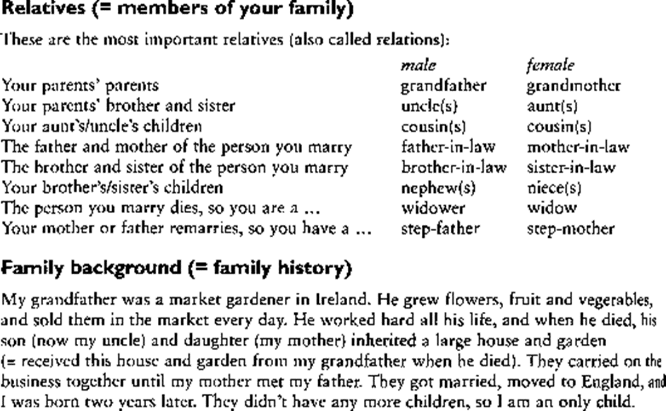

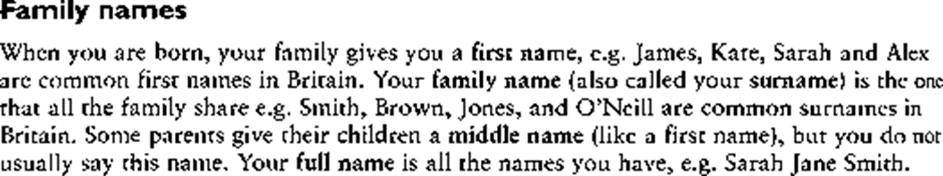

**Практическая работа № 8.**

**Сделать таблицы спряжения глаголов to be, to have. Составить тест на глаголы to be, to have. Составить тест на 3 формы неправильных глаголов.**

**Глагол to be в английском языке**

Значение глагола to be - "быть, находиться". В отличие от других английских глаголов, глагол to be спрягается (т.е. изменяется по лицам и числам).

В отличие от русского языка, в английском языке глагол-связка никогда не опускается, поскольку английское предложение имеет строго фиксированный порядок слов:

подлежащее (subject) + сказуемое (verb) + дополнение (object) I am a doctor. Я врач. (Я есть врач.)

The weather is bad. Погода плохая. They are from Paris. Они из Парижа.

Глагол to be не требует вспомогательного глагола для образования вопросительной или отрицательной формы.

Чтобы задать вопрос нужно поставить глагол to be перед подлежащим:

Am I happy? Is the book interesting? Is he our teacher?

Для образования отрицательной формы достаточно поставить отрицательную частицу not после глагола to be:

I am not happy. The book is not interesting. He is not our teacher.

**Спряжение глагола to be в настоящем времени Present Simple**:

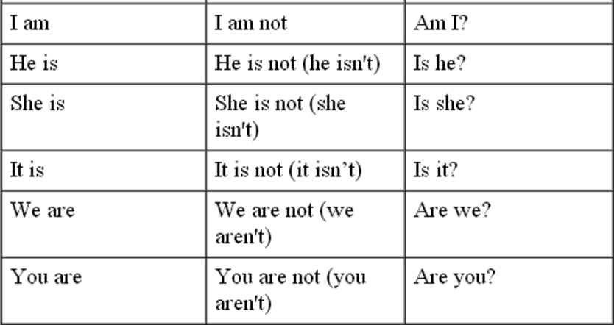

**Спряжение глагола to be в прошедшем времени Past Simple:**

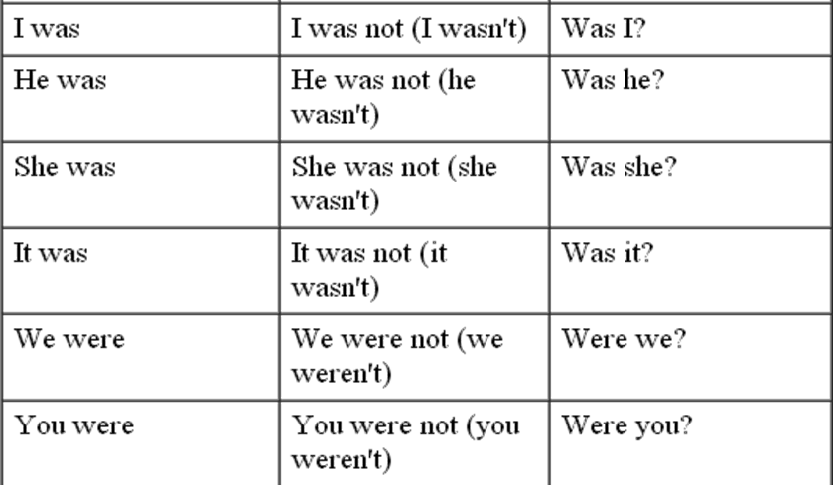

**Спряжение глагола to be в будущем времени Future Simple:**

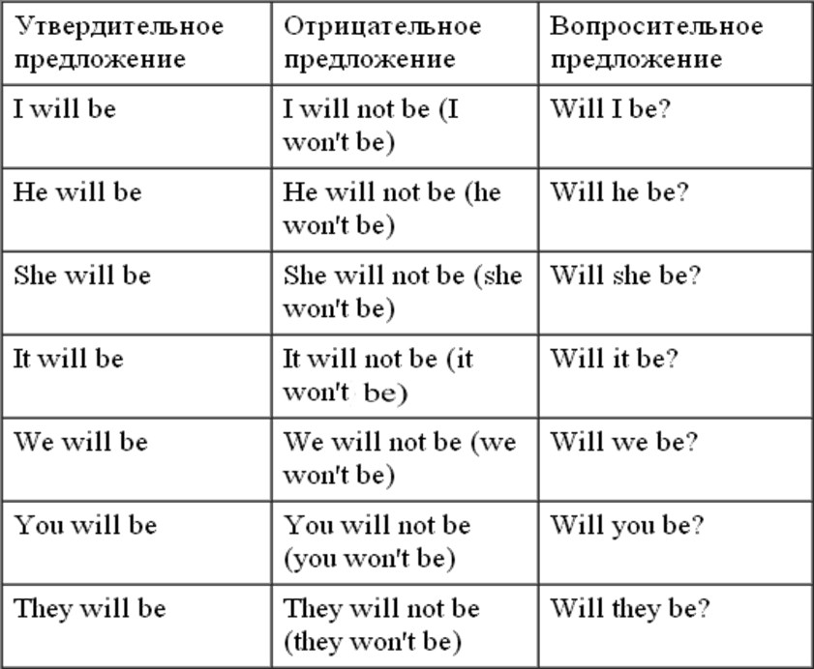

**Exercises.**

**1. Переведите на английский язык, употребляя глагол to be в Present или Past Simple**,

1. Я ученик. 2. Он летчик. 3. Она доктор. 4. Мы школьники. 5. Вы рабочие. 6. Ты рабо- чий. 7. Они ученики. 8. Я дома. 9. Он в школе. 10. Она в кино? 11. Мы в парке. 12. Они в театре? 13.Она молодая? 14. Он старый. 15. Она не старая. 16. Они сильные. 17. Она больна. 18. Вы больны? 19. Он болен? 20. Я не болен. 21. Я был болен вчера. 22. Она не была больна. 23. Мы были в кино. 24. Они не были в кино. 25. Они не в школе. 26. Они дома. 27. Вы были в парке вчера? 28. Он был в школе вчера? 29. Он был рабочим. 30. Она была учительницей.

**2. Вставьте глагол to be в Present, Past или Future Simple.**

1, My father ... a teacher. 2. He ... a pupil twenty years ago. 3.1... a doctor when I grow up. 4. My sister ... not ... at home tomorrow. 5. She ... at school tomorrow. 6. ... you ... at home tomorrow? 7,... your father at work yesterday? 8. My sister ... ill last week. 9. She ... not ill now. 10. Yesterday we... at the theatre. 11. Where ... your mother now? — She ... in the kitchen. 12. Where ... you yesterday? — I ... at the cinema. 13. When I come home tomorrow, all my family ... at home. 14. ... your little sister in bed now? — Yes, she ... 15. ...you... at school tomorrow? — Yes I ... . 16. When my granny... young, she ... an actress. 17. My friend K,,. in Moscow now. 18. He ... in St. Petersburg tomorrow. 19. Where your books now? -- They in my bag.

**3. Переведите на английский язык, употребляя глагол to be в Present, Past или**

**Future Simple.**

1. Мой брат сейчас в школе. 2. Мой брат был вчера в кино. 3. Мой брат будет завтра дома. 4. Ты будешь дома завтра? 5. Она была вчера в парке? 6 Он сейчас во дворе? 7. Где папа? 8. Где выбыли вчера? 9. Где он будет завтра? 10. Мои книги были на столе. Где они сейчас? 11. Моя мама вчера не была на работе. Она была дома. 12, Мой друг не в парке. Он в школе. 13. Завтра в три часа Коля и Миша будут во дворе. 14. Мы не были на юге прошлым летом. Мы были в Москве. 15. Завтра мой дедушка будет в деревне. 16. Когда твоя сестра будет дома? 17. Ты будешь летчиком? — Нет, я буду моряком. 18. Моя

сестра была студенткой в прошлом году, a eel час она врач. — Ты тоже будешь врачом? — Нет, я не буду врачом. Я буду инженером.

**4. Вставьте is или are.**

There two cups of tea on the table. There some milk in the cup.

There an orange in the salad. There six balls in the box.

There some cheese on the plate. There a blue chair at the door.

There five chicks and a hen on the farm. There a table and nine desks in the classroom. There a big window to the left of the door.

There three rooms in our country house.

there three cups on the coffee-table?

there a carpet on the floor?

There no cats in the sitting room. There a cat on the table.

There 3 dogs in the box

There 4 hens in the house. There a pot on the table.

there a bathroom near the kitchen?

there four rooms in the house? there a kitchen under your bedroom?

**5. Составь и запиши предложения.**

1. pears / there / ten / in the / are / bag / .

2. aren’t / pupils / there / classroom / in the / .

3. an egg / on the / there / plate / is / ?

4. on the / there / a / cat / chair / is / white / .

5. a turtle / on / there / isn’t / farm / this / .

6. at the / two / bikes / door / are / there / ?

6. Вставьте is/are, was/were.

There two banks in our street.

There a cafe behind the supermarket last year. Now there a museum there. There a cinema and a sports centre to the right of the park.

Five years ago there two shops in Central Square. Now there two cafes, a theatre and a cinema.

**7. Переведите предложения.**

1. Рядом с отелем есть чистый пляж.

2. На диване три кошки.

3. В холодильнике есть бутылка молока.

4. В корзине нет клубники.

5. На автобусной остановке есть люди?

6. В твоей сумке есть зеркало?

7. В этом парке нет туалета.

8. В нашем саду много цветов.

9. Под столом зеленый мяч. 10.За дверью никого нет.

**8. Задайте к предложениям вопросы, начиная с предлагаемых слов.**

1. There are four elephants in the zoo. (How many …?)

2. There is a lot of snow in February. (Is …?)

3. There is some fish on the plate. (What … ?)

4. There are no cars in the car park. (Are … ?)

5. There are ancient walls around the city. (What … ?)

**9. Переведите пословицы и поговорки.**

1. There is no place like home.

2. Where there is love there is life.

3. There is no bad weather, there are bad clothes.

4. There are plenty of other fish in the sea.

5. There are two sides to every question.

**Практическая работа № 9.**

**Составить диалог по теме «Зимние каникулы», «Мои выходные».**

Every year schoolchildren have their winter holidays. They usually last for 2 weeks: from the New Year’s Day till the 12th of January. I am sure that all of us look forward to this time because it’s a great chance not to get up early and to do what we want. As for me I always sleep till 9 a.m. during my winter holidays. Then I turn on my TV and lie in my bed for another hour.

Winter holidays are even more exciting because we celebrate New Year and Christmas. Our mood is joyful. The whole atmosphere is full of magic. People exchange presents, decorate their homes, cook delicious food, visit each other and have parties.

If the weather is cold I prefer to stay at home or visit my friends. They can also come to my place. We play computer games, surf the Internet or watch TV. The programmes on TV are really interesting during our holidays, so we watch plenty of cool films. In warm weather we go to the cinema or a café, play ice-hockey or go skiing to the park. Hockey and skiing are my hobbies. We can even play snowballs and make funny snowmen.

In the evening my mother often asks me to help her about the house. My duty is washing up, watering plants and taking the rubbish out. As I don’t have to get up early during my holidays my parents allow me to watch TV and read books till midnight.

I enjoy my winter holidays. It’s a nice time to relax and take a short rest from my studies. It’s a pity that winter holidays always pass so quickly.

|  |  |  |
| --- | --- | --- |
| below zero | bɪˈləʊ ˈzɪərəʊ | ниже нуля |
| bitter cold | ˈbɪtə kəʊld | мороз |
| blizzard | ˈblɪzəd | метель |
| chill | ʧɪl | простуда, прохлада, холодок |
| cold | kəʊld | холод |
| freezing | ˈfriːzɪŋ | морозный |
| frosty | ˈfrɒsti | морозный |
| frozen | ˈfrəʊzn | замороженный |
| gust | gʌst | порыв ветра |
| hail | heɪl | град |
| heavy snowfall | ˈhɛvi ˈsnəʊfɔːl | сильный снегопад |
| ice | aɪs | лед |
| ice cap | aɪs ˈkæp | ледяной покров |
| ice crust | aɪs krʌst | ледяная корка |
| melt | mɛlt | таять |
| sleet | sliːt | дождь со снегом |
| slippery | ˈslɪpəri | скользкий |
| snowfall | ˈsnəʊfɔːl | снегопад |
| snowstorm | ˈsnəʊstɔːm | метель |
| snowy | ˈsnəʊi | снежный |
| storm | stɔːm | снегопад |
| windy | ˈwɪndi | ветреный |
| zero degrees | ˈzɪərəʊ dɪˈgriːz | ноль градусов |
| ice fishing | aɪs ˈfɪʃɪŋ | подледная рыбалка |
| make a snowman | meɪk ə ˈsnəʊmən | делать снеговика |
| play snowballs | pleɪ ˈsnəʊbɔːlz | играть в снежки |
| skate | skeɪt | кататься на коньках |
| ski | skiː | кататься на лыжах |
| sled | slɛd | кататься на санках |
| heater | ˈhiːtə | обогреватель |
| icicle | ˈaɪsɪkl | сосулька |
| ice rink | aɪs rɪŋk | каток |
| snowball | ˈsnəʊbɔːl | снежок |
| snowboard | ˈsnəʊˌbɔːd | сноуборд |
| snowflake | ˈsnəʊfleɪk | снежинка |
| snowman | ˈsnəʊmən | снеговик |
| frostbite | ˈfrɒstbaɪt | обморозить |
| woolen | ˈwʊlən | шерстяной |

**Практическая работа № 10.**

**Подготовить мини-проект по теме «Культура и традиции в США»**

**Содержание**

**Введение**

**Глава 1. Праздники в России и США.**

1.1             Праздники в России…………………………………

1.2             Праздники в США…………………………………..

1.3             Сравнение похожих праздников………………….

**Глава 2. Практическая часть**

**Заключение**

**Список литературы**…………………………………..

**Оформление:** Шрифт Times New Roman 14, ориентация листа книжная, Поля: 1,5 см для верхнего, 3 см для нижнего, 1,5 см для правого и 2,5 см для левого

**Traditions of English speaking countries. holidays in the USA.**

Every country has its own holidays. They reflect the history of the country and its cultural and religious traditions. Some religious holidays are common in different countries. They are Christmas and Easter.

Americans celebrate Christmas on the 25th of Decem¬ber. They buy a lot of presents for each other, for their parents, children and friends.

The New Year's day, the 1st of January is not so wide¬ly celebrated in the United States as we do it in Russia.

Of course, the most important holiday in America is the 4th of July, The Independence Day. People like to watch colourful fireworks in the evening. The 4th of July is the day-off and people don't go to work.

The holidays when people don't go to work are: Martin Luther King's day on the 20th of January, Labour Day on the 7th of September and Thanksgiving on the last Fri-Pday of November. On Thanksgiving Americans usually leat turkey. This holiday reminds the time when the first icolonists (pilgrims) from England came to America in 11620 and could survive in the unknown land. There is still a big white stone on the shore in Plymouth in Massachusetts, that the pilgrims landed on. It is called «The Plymouth Rock».

The 31st of October is the children's most favourite holiday — Halloween. On this day children, dressed in funny dresses visit their neighbours and say «Trick or treat!» and get sweets.

The rest of the holidays are usually on weekends. They are: the Flag's Day, Mother's Day, Armed Forces Day. Americans also celebrate Lincoln's birthday, Washing¬ton's birthday, President's Day in February.

The 14th of February is Valentine's day or as it is called «All lovers day».

**Практическая работа № 11.**

**Подготовить мини-проект по теме «Культура и традиции в России»**

**Содержание**

**Введение**

**Глава 1. Праздники в России и США.**

1.1             Праздники в России…………………………………

1.2             Праздники в США…………………………………..

1.3             Сравнение похожих праздников………………….

**Глава 2. Практическая часть**

**Заключение**

**Список литературы**…………………………………..

**Оформление:** Шрифт Times New Roman 14, ориентация листа книжная, Поля: 1,5 см для верхнего, 3 см для нижнего, 1,5 см для правого и 2,5 см для левого

**Traditions of English speaking countries. holidays in the USA.**

Every country has its own holidays. They reflect the history of the country and its cultural and religious traditions. Some religious holidays are common in different countries. They are Christmas and Easter.

Americans celebrate Christmas on the 25th of Decem¬ber. They buy a lot of presents for each other, for their parents, children and friends.

The New Year's day, the 1st of January is not so wide¬ly celebrated in the United States as we do it in Russia.

Of course, the most important holiday in America is the 4th of July, The Independence Day. People like to watch colourful fireworks in the evening. The 4th of July is the day-off and people don't go to work.

The holidays when people don't go to work are: Martin Luther King's day on the 20th of January, Labour Day on the 7th of September and Thanksgiving on the last Fri-Pday of November. On Thanksgiving Americans usually leat turkey. This holiday reminds the time when the first icolonists (pilgrims) from England came to America in 11620 and could survive in the unknown land. There is still a big white stone on the shore in Plymouth in Massachusetts, that the pilgrims landed on. It is called «The Plymouth Rock».

The 31st of October is the children's most favourite holiday — Halloween. On this day children, dressed in funny dresses visit their neighbours and say «Trick or treat!» and get sweets.

The rest of the holidays are usually on weekends. They are: the Flag's Day, Mother's Day, Armed Forces Day. Americans also celebrate Lincoln's birthday, Washing¬ton's birthday, President's Day in February.

The 14th of February is Valentine's day or as it is called «All lovers day».

**Практическая работа № 12.**

**Записать и выучить активную лексику. Составить рассказ на тему: «Манеры и этикет в США»**

Характерными особенностями научно-технического стиля являются его информативность, логичность, точность и объективность. Отдельные тексты данного стиля обладают указанными свойствами в большей или меньшей степени, но во всех текстах научно-технического стиля обнаруживается преимущественное использование языковых средств, способствующих удовлетворению потребностей данной сферы общения.

В области лексики это прежде всего использование научно-технической терминологии и специальной лексики. Так, под терминами понимаются слова и словосочетания, которые обозначают определённые объекты и понятия какой-либо специальной области науки, техники, искусства. В качестве терминов могут использоваться как слова, употребляемые исключительно в рамках данного стиля, так и специальные значения общенародных слов. Например, такие лексические единицы английского языка, как

byte, desktop, hard disk,hard drive, macro, motherboard, operating system, software и др., широко употребляемые в области информационных технологий, трудно встретить за пределами научно-технических материалов. В то же время в данной области в качестве терминов могут использоваться и слова, которые имеют хорошо всем известные общеупотребительные значения, например,

bit,browse, crash, density, icon, list, memory, menu, mouse, save, window, wizard и др..

В значительной степени взаимопониманию специалистов способствует и широкое употребление так называемой специальной общетехнической лексики, включающей в себя всевозможные производные от терминов, а также слова, используемые при описании связей и отношений между терминологически обозначенными понятиями и объектами, их свойств и особенностей, и целый ряд общенародных слов, употребляемых однако в строго определенных сочетаниях и тем самым специализированных (в области телекоммуникаций, например, power distribution system (PDS) design –

проектирование системы разводки питания, the basic principles of

bypass or decoupling capacitors –основные положения о развязывающих конденсаторах; в компьютерных технологиях – configuration file – конфигурационный файл, peer-to-

peer protocols – пиринговые (одноранговые) протоколы, wildcard character – подстановочный символ; в физике –the voltage is applied – напряжение подается, the magnetic field is set up – магнитное поле создается и др.). Такая лексика не всегда фиксируется в терминологических словарях, но она не в меньшей степени характерна для научно-технического стиля, чем термины.

В английских научно-технических текстах отмечается широкое использование таких глаголов-операторов,

как effect, assure, perform, obtain, provide, give, involve, entail, imply,result in, lead to, to be a scribed to, to be attributed to, etc.,значение и перевод которых всецело зависит от существительных, несущих основную смысловую нагрузку в предложении. Например, By using multiple neurons simultaneously, the brain can perform its

functions(работать, функционировать) much faster than the fastest computers in existence today. Inspired by the mechanism for learning in biological neurons, artificial neurons and artificial neural networks can perform arithmetic

functions (считать, выполнять вычисления), with cells corresponding to neurons…. However, neural networks are far too simple to serve as realistic brain models on the cell level, but they might serve as very good models for the essential information processing tasks that organisms perform (выполняет).

Стремление к номинативности приводит также к замене наречий предложно- именными сочетаниями. Так, accurately становится with accuracy, very easily – with the greatest ease или the easy way, etc. Упорно сопротивляются этой тенденции лишь усилительные наречия, которые выступают в научно-технических текстах в качестве основного модально-экспрессивного средства. Таковы наречия: clearly, completely, considerably, efficiently, essentially, fairly, greatly, significantly, markedly, materially, perfectly, positively, reasonably, uniquely, etc. The message contains an address which uniquely identifies the slave for which it is intended. Since parasitic inductance for capacitors in a given package is essentially fixed, the inductance curve remains fixed. By comparison, a quantum computer could efficiently solve this problem using Shor’s algorithm to find its factors. Several physical implementations which approximate two-level systems to various degrees were successfully realized.

Разумеется, номинативный характер научно-технического стиля не означает, что в рассматриваемых материалах в английском языке полностью отсутствуют полнозначные глаголы в личных формах. Исследования показали, что в данном стиле отмечается преобладание пассивных форм и форм простого настоящего времени, что, несомненно, связано с основными характеристиками и целями научного изложения. Например, In the context of neural networks, learning is defined as a process by which the free parameters of a neural network are adapted through a continuous process of stimulation by the environment. The type of learning is determined by the manner in which the parameter changes take place. The above definition implies that (1) the network is stimulated by the environment; (2) the network changes as a result of stimulation; and (3) the network responds to the environment in a new way after the occurrence of change. Особое внимание заслуживает широко распространенное в специальных текстах использование переходных глаголов в непереходной форме с пассивным значением: The steel forges well.

В английских научно-технических текстах также наблюдается широкое использование простых двусоставных предложений с составным сказуемым, состоящим из глагола-связки и именной части

(предикатива): The network is two or more computers connected together. A Local Area Network (LAN) is a network in which the computers are connected directly…Computers are anessential feature of most instrumentation systems…

В качестве предикатива часто выступает прилагательное или предложный оборот: Commercial packages are readily available to support PC/workstation-based instrumentation systems. The nonrandom fractals’ essential failing is that theyare not symmetric enough. A first failing, stated in the vocabularies of different sciences, is that it is

inconceivable for a nonrandom fractal to be translationally invariant…The software component of any computerized instrumentation system can form a significant percentage of its total cost.

This isespecially true of on-off systems…

В стремлении к краткости и компактности изложения способствует широкое использование эллиптических конструкций. Неправильное понимание этих конструкций приводит к нелепым ошибкам в переводе, например, сочетания a liquid rocket, a web server, a web application – это эллиптические формы сочетаний a liquid-fuelled rocket, a web-based server, a web-basedapplication.

Указанная тенденция находит отражение и в ряде других грамматических особенностей. Для научно-технического стиля характерна, например, замена определительных придаточных предложений прилагательными в постпозиции (особенно с суффиксами – -ible, -able, -ive и др.): different notions of controllability available in the literature; the set of problems solvable with a polynomial-time algorithm; problems difficult with ordinary equipment; concepts are represented as a collection of the simplest elements available, surface-mount chip capacitors are the smallest capacitors available, etc. Та же цель может достигаться и использованием в функции определения форм инфинитива: the properties to be expected, promising cooperative and cognitive strategies to be applied within and across the layers of wireless networks, the product to be cooled, etc.

Для научно-технического стиля в английском языке характерно также широкое употребление множественного числа вещественных существительных

(fats, oils, steels, wools, etc.), множественного числа в названиях инструментов (clippers, jointers, compasses, etc.), распространенность атрибутивных сочетаний со

словамиtype, design, pattern, grade, etc. Наблюдается также повышенное использование причинно-следственных союзов и логических связок типа

since, therefore, it follows that, so, thus, it implies, involves, leads to, results in,etc. Например: Each stand-alone instrument and add-on card requires a piece of code called a device driver so that the operating system can access the hardware resources of the card and the

instrument. Therefore, the development of device drivers requires an intimate knowledge of both the hardware and the operating system.

Отметим, что некоторые особенности научно-технического стиля, отмеченные в английском языке, наблюдаются и в научно-технических материалах на русском языке. Прежде всего это относится к информативности текстов, а следовательно высокой частотности употребления специальной общетехнической лексики, терминов и их определений. В русском языке, как и в английском, в качестве терминов используются и слова, употребляемые исключительно в рамках научно-технического стиля (домен, интерпретатор, компилятор, конфигурация, хакер и др.) и специальные значения общенародных слов (память, программа, сеть, язык и др.). При этом заметим, что строгость в употреблении терминов и привычных формулировок, в целом, более свойственна русскому научно-техническому стилю, чем английскому.

Следует также заметить, что хотя в обоих языках для научно-технического стиля характерна объективно-описательная манера изложения, лишенная эмоциональности, в отличие от русских в английских научных текстах все же встречается использование эмоциональных эпитетов, риторических вопросов, образных выражений и тому подобных стилистических приемов.

**Практические задания**

|  |  |
| --- | --- |
| **Оригинал** | **Перевод** |
| Project Identification |  |
| Project Facilities |  |
| Roles and Responsibilities |  |
| General Design Requirements |  |
| Design Life |  |
| Operating Hours |  |
| Units for Design |  |
| Site Conditions |  |
| Service Conditions |  |
| Codes, Standards and Specifications |  |
| Design Codes and Standards |  |
| International Codes |  |
| Order of Precedence |  |
| Project Related Design Criteria |  |
| Area and Equipment Numbering |  |
| Hazardous Area Classification |  |
| Health Safety and Environment |  |
| General |  |
| Material Takeoff |  |
| Piping Flexibility Analysis |  |
| Flexibility Analysis Philosophy |  |
| Methodology and Acceptance Criteria |  |
| Design Considerations |  |
| General Layout |  |
| Layout and Piping HSE Considerations |  |
| Site Plans |  |
| General Arrangement Drawings |  |
| 3D CAD Design |  |

**Практическая работа № 13.**

**Написать ответы на вопросы к тексту (о своем дне) письменно. Подготовить рассказ о своем рабочем дне**

**1. Study the words**

-to be good at

-to cope with

-to get into the habit

-to choose

-to decide

-to enter a college

-to hire

-to be familiar with the latest definite in the future milestone goal achievement relevant experience a passion for the work possible carrier options job duties to my mind therefore you need job prospects technology

-to take to well educated

**Read the text p. 240 (Planet of English Безкоровайная Г.Т.), find this words and combinations.** **Translate the sentences.**

2. **p. 241 ex. 9 (Planet of English Безкоровайная Г.Т.)**

3. **Read about civil engineer profession. Find english equivalents:**

Social work is an established professional discipline with a distinctive part to play in promoting and securing the wellbeing of children, adults, families and communities. It operates within a framework of legislation and government policy, set out in Putting People First and the Children’s Plan, and contributes to the development of social policy, practice and service provision. It collaborates with other social care, health, education and related services to ensure people receive integrated support. It is a profession regulated by law.

4. **p. 241 ex. 11 (Planet of English Безкоровайная Г.Т.)**

**Практическая работа № 14.**

**Подготовить мини-проект по теме «Мой дом» Подготовить рассказ на тему «Условия жизни»**

**Теоретическое обоснование**

**Русско-английский глоссарий по теме "Семья и родственники"**

|  |  |  |
| --- | --- | --- |
| **Русское название** | **English name** | **Транскрипция** |
| **семья** | **family** | **[ ˈfæməli ]** |
| **родственник** | **relative, relation** | **[ ˈrelətɪv ] [ rɪˈleɪʃən ]** |
| **родители** | **parents** | **[ ˈpeərənts ]** |
| **мать (мама)** | **mother (mom, mum, mama, mamma, mummy, ma)** | **[ ˈmʌðə mɒm ] [ mʌm ] [ məˈmɑː ]  [ məˈmɑː ] [ ˈmʌmi ] [ mɑː ]** |
| **отец (папа)** | **father (dad, daddy, papa, pa)** | **[ ˈfɑːðə [ dæd ] [ ˈdædi ]  [ pəˈpɑː ] [ pɑː ]** |
| **жена** | **wife** | **[ waɪf ]** |
| **муж** | **husband** | **[ ˈhʌzbənd ]** |
| **супруг(а)** | **spouse** | **[ spaʊz ]** |
| **ребенок, дети** | **child, children** | **[ tʃaɪld ] [ ˈtʃɪldrən ]** |
| **дочь** | **daughter** | **[ ˈdɔːtə ]** |
| **сын** | **son** | **[ sʌn ]** |
| **сестра** | **sister** | **[ ˈsɪstə ]** |
| **брат** | **brother** | **[ ˈbrʌðə ]** |
| **единственный ребенок** | **only child** | **[ ˈəʊnli tʃaɪld ]** |
| **близнец** | **twin** | **[ twɪn ]** |
| **близнецы, двойняшки** | **twins** | **[ twɪnz ]** |
| **брат-близнец** | **twin brother** | **[ twɪn ˈbrʌðə ]** |
| **сестра-близнец** | **twin sister** | **[ twɪn ˈsɪstə ]** |
| **однояйцевые близнецы** | **identical twins** | **[ aɪˈdentɪkəl twɪnz ]** |
| **тройняшки** | **triplets** | **[ ˈtrɪpləts ]** |
| **бабушка и дедушка** | **grandparents** | **[ ˈɡrænpeərənts ]** |
| **бабушка** | **grandmother (grandma, granny, grandmamma)** | **[ ˈɡræn ˌmʌðə ˈɡrænmɑː ]  [ ˈɡræni ] [ ˈɡrænməˌmɑː ]** |
| **дедушка** | **grandfather (grandpa, granddad, grandpapa, gran-dad)** | **[ ˈɡrænfɑːðə ˈɡrænpɑː ]  [ ˈɡrændæd ] [ ˈɡrænpəˌpɑː ]  [ ˈɡrændæd ]** |
| **внуки** | **grandchildren** | **[ ˈɡræntʃɪldrən ]** |
| **внучка** | **granddaughter** | **[ ˈɡrændɔːtə ]** |
| **внук** | **grandson** | **[ ˈɡrænsʌn ]** |
| **прабабушка** | **great-grandmother** | **[ ˈɡreɪt ˈɡræn ˌmʌðə ]** |
| **прадедушка** | **great-grandfather** | **[ ˈɡreɪtˈɡrændˌfɑːðə ]** |
| **прабабушка и прадедушка** | **great-grandparents** | **[ ˈɡreɪt ˈɡrænpeərənts ]** |
| **правнуки** | **great-grandchildren** | **[ ˈɡreɪt ˈɡræntʃɪldrən ]** |
| **тётя** | **aunt** | **[ ɑːnt ]** |
| **дядя** | **uncle** | **[ ˈʌŋkəl ]** |
| **крестный (отец)** | **godfather** | **[ ˈɡɒdfɑːðə ]** |
| **крестная (мать)** | **godmother** | **[ ˈɡɒdmʌðə ]** |
| **отчим, приемный отец** | **stepfather** | **[ ˈstepfɑːðə ]** |
| **мачеха, приемная мать** | **stepmother** | **[ ˈstepmʌðə ]** |
| **сводный брат** | **stepbrother** | **[ ˈstep ˌbrʌðə ]** |
| **сводная сестра** | **stepsister** | **[ ˈstepsɪstə ]** |
| **брат по одному из родителей** | **half-brother** | **[ ˈhɑːf ˌbrʌðə ]** |
| **сестра по одному из родителей** | **half-sister** | **[ ˈhɑːf sɪstə ]** |
| **приемный, усыновленный сын** | **adopted son** | **[ əˈdɒptɪd sʌn ]** |
| **приемная, удочеренная дочь** | **adopted daughter** | **[ əˈdɒptɪd ˈdɔːtə ]** |
| **приемный ребенок** | **adopted child** | **[ əˈdɒptɪd tʃaɪld ]** |
| **патронатная семья, приемная семья** | **foster family** | **[ ˈfɒstə ˈfæməli ]** |
| **приемный отец** | **foster father** | **[ ˈfɒstə ˈfɑːðə ]** |
| **приемная мать** | **foster mother** | **[ ˈfɒstə ˈmʌðə ]** |
| **приемные родители** | **foster parents** | **[ ˈfɒstə ˈpeərənts ]** |
| **приемный сын** | **foster son** | **[ ˈfɒstə sʌn ]** |
| **приемная дочь** | **foster daughter** | **[ ˈfɒstə ˈdɔːtə ]** |
| **приемный ребенок** | **foster child** | **[ ˈfɒstə tʃaɪld ]** |
| **неполная семья (с одним родителем)** | **single-parent family** | **[ ˈsɪŋɡəl ˈpeərənt ˈfæməli ]** |
| **родня** | **the kin, the folks** | **[ ðə kɪn ] [ ðə fəʊks ]** |
| **племянница** | **niece** | **[ niːs ]** |
| **племянник** | **nephew** | **[ ˈnevjuː ]** |
| **двоюродный брат** | **cousin (male)** | **[ ˈkʌzən meɪl ]** |
| **двоюродная сестра** | **cousin (female)** | **[ ˈkʌzən ˈfiːmeɪl ]** |
| **двоюродный брат (сестра), кузен (кузина)** | **first cousin** | **[ ˈfɜːst ˈkʌzən ]** |
| **троюродный брат (сестра)** | **second cousin** | **[ ˈsekənd ˈkʌzən ]** |
| **четвероюродный брат (сестра)** | **third cousin** | **[ ˈθɜːd ˈkʌzən ]** |
| **родня со стороны мужа или жены** | **in-laws** | **[ ˈɪn lɔːz ]** |
| **свекровь** | **mother-in-law (husband's mother)** | **[ ˈmʌðərɪnˌlɔː ˈhəzbəndz ˈmʌðə ]** |
| **свёкор** | **father-in-law (husband's father)** | **[ ˈfɑːðər ɪnˌlɔː ˈhəzbəndz ˈfɑːðə ]** |
| **тёща** | **mother-in-law (wife's mother)** | **[ ˈmʌðərɪnˌlɔː waɪfs ˈmʌðə ]** |
| **тесть** | **father-in-law (wife's father)** | **[ ˈfɑːðər ɪnˌlɔː waɪfs ˈfɑːðə ]** |
| **невестка, сноха** | **daughter-in-law** | **[ ˈdɔːtərɪnˌlɔː ]** |
| **зять** | **son-in-law** | **[ ˈsʌnɪnˌlɔː ]** |
| **шурин, свояк, зять, деверь** | **brother-in-law** | **[ ˈbrʌðərɪnˌlɔː ]** |
| **свояченица, золовка, невестка** | **sister-in-law** | **[ ˈsɪstərɪnˌlɔː ]** |
| **семейное положение** | **marital status** | **[ ˈmærɪtəl ˈsteɪtəs ]** |
| **холостой, неженатый, незамужняя** | **single** | **[ ˈsɪŋɡəl ]** |
| **женатый, замужняя** | **married** | **[ ˈmærɪd ]** |
| **брак** | **marriage** | **[ ˈmærɪdʒ ]** |
| **помолвка** | **engagement** | **[ ɪnˈɡeɪdʒmənt ]** |
| **помолвленный, обрученный** | **engaged** | **[ ɪnˈɡeɪdʒd ]** |
| **развод** | **divorce** | **[ dɪˈvɔːs ]** |
| **разведенный** | **divorced** | **[ dɪˈvɔːst ]** |
| **бывший муж** | **ex-husband** | **[ ˈeks ˈhʌzbənd ]** |
| **бывшая жена** | **ex-wife** | **[ ˈeks waɪf ]** |
| **расставшиеся, не разведенные, но не проживающие одной семьей** | **separated** | **[ ˈsepəreɪtɪd ]** |
| **вдова** | **widow** | **[ ˈwɪdəʊ ]** |
| **вдовец** | **widower** | **[ ˈwɪdəʊə ]** |
| **подружка, невеста** | **girlfriend** | **[ ˈɡɜːlfrend ]** |
| **друг, парень, ухажер** | **boyfriend** | **[ ˈbɔɪfrend ]** |
| **любовник, любовница** | **lover** | **[ ˈlʌvə ]** |
| **ухажер, жених, подружка, невеста, обрученный** | **fiance** | **[ fiˈɒnseɪ ]** |
| **свадьба** | **wedding** | **[ ˈwedɪŋ ]** |
| **невеста на свадьбе** | **bride** | **[ braɪd ]** |
| **жених на свадьбе** | **(bride)groom** | **[ braɪd ɡruːm ]** |
| **медовый месяц** | **honeymoon** | **[ ˈhʌnɪmuːn ]** |

**Практическое задание**

**Задание 1: «Решить кроссворд»**

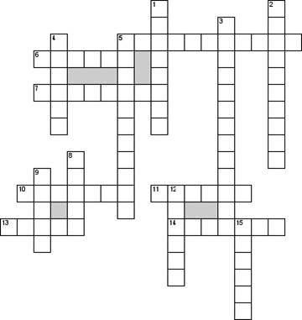

**По горизонтали**

5. Mothers mother

6. Отец

7. Brother and sister

10. Развестись

11. Aunts son

13. Mothers brother

14. Mother and father

**По вертикали**

1. Daughters son

2. Fathers second wife

3. Общительный

4. Заботливый

5. Дедушка

8. Закрытый

9. Brothers daughter

12. Child without parents

15. Sisters son

**Задание 2: «Составить семейное древо»**

**Задание 3: «Решить тест»**

Прочитайте текст и заполните пропуски A–E частями предложений, обозначенными цифрами 1–6. Одна из частей в списке 1–6 лишняя. Ответы зафиксируйте в специальном бланке.

Our family

1. We are a large and friendly family. There are six of us: grandfather, grandmother, father, mother, my younger sister and I. I have an elder sister too, she is 22 years old, but she doesn't live with our family. She is married. She has a little family of her own: a husband and a child – a two-year old boy.

2. Our grandpa is a scientist. He is on the wrong side of 60, but he does not want to retire. He works at the university. He works part-time. He goes to the university two or three times a week and delivers lecturers to students and does a scientific work. On the days when he is at home, he works in his study, A ________________.

3. Our grandma is retired. She was a teacher and worked at school. She is the recognized head of the family. She keeps house. Of course we help her about the house: all of us do our share in daily household chores. My sister washes the dishes, sweeps and washes the floor, washes the sink in the kitchen. My work is

B ________________. Our mother and father do most of the shopping. My mother and sister also do washing. But C ________________ is done by grandma. She is a wonderful cook, and all our family likes her cooking very much.

4. Father is a doctor. He works in a large hospital. Mum is an economist and she works at a bank. Both our parents are very busy. Father has a car. In the morning he drives mother to work, then he goes to his hospital. Father also always drives grandfather to work on his University days.

5. My sister and I go to school. We are both senior formers, so naturally school takes up a lot of our time. We spend most of the afternoons and the evenings

D ________________.

6. At the weekend we are not as busy as on week days, and we can relax: visit or receive friends or relations or just go for a walk. I also enjoy quiet Saturday evenings, when all members of our friendly family are at home and nobody is in a hurry and we are quietly sitting in our large and comfortable living-room, E ________________ and drinking nice hot cups of tea with something delicious prepared by grandmother.

1. talking, joking, discussing our everyday affairs

2. most of the cooking

3. driving me to school

4. preparing for his lectures and writing a book

5. doing our homework

6. emptying the dustbin, beating the carpet, dusting and vacuum cleaning

**Практическая работа № 15.**

**Составить описание внешности своих близких. Подготовить мини-проект по теме «Я и мои близкие». Оформить мини-проект по теме «Внешность»**

**Describing people’s appearance**

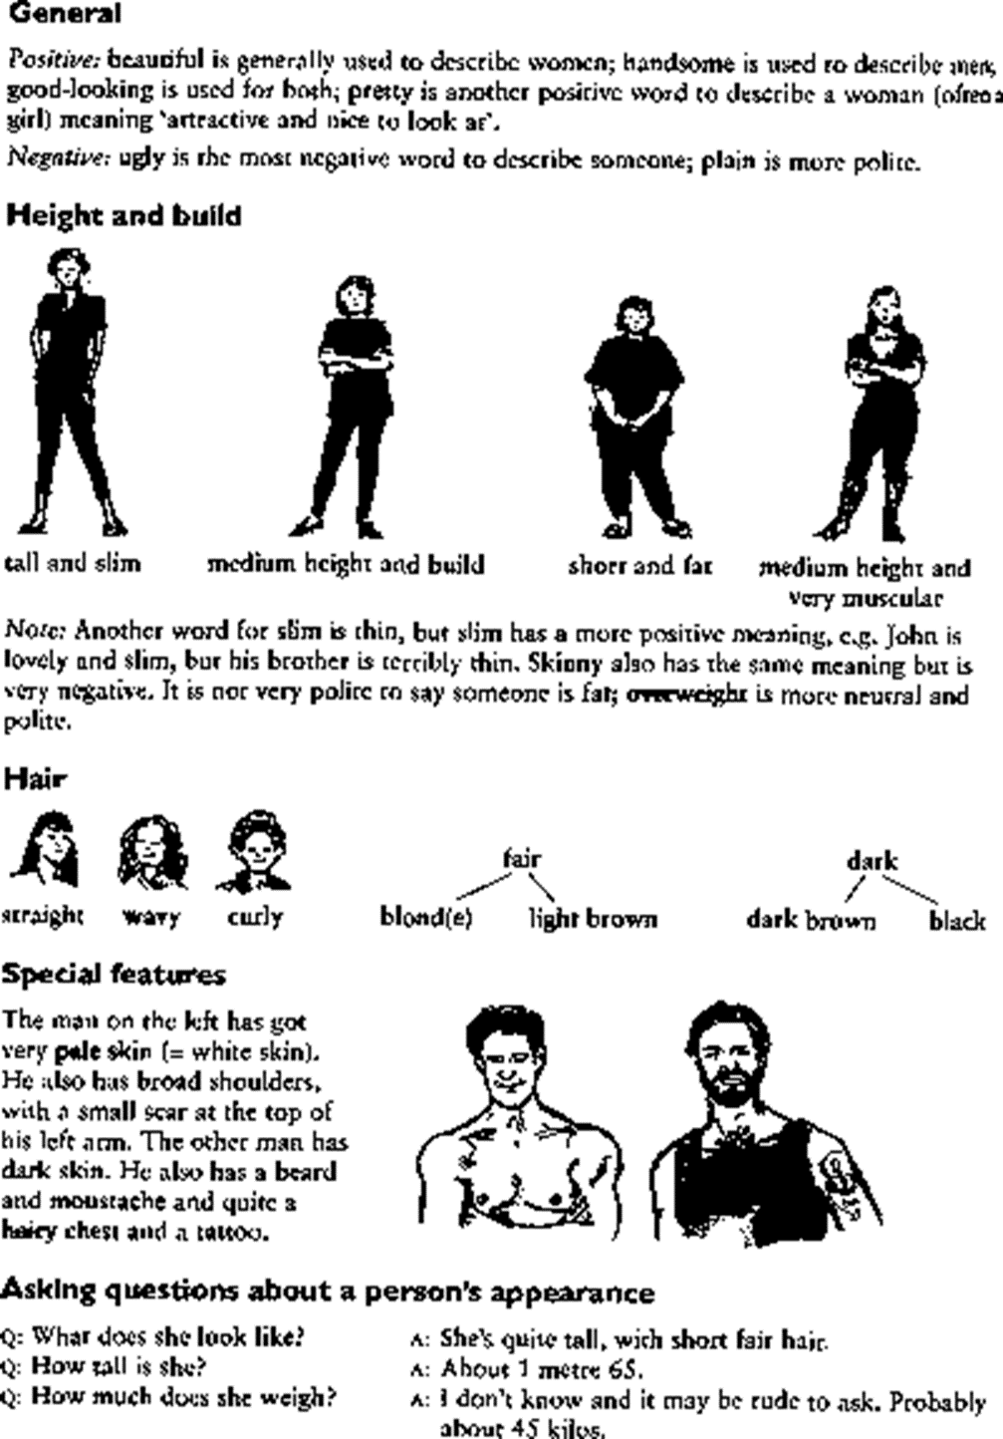

**Exercises**

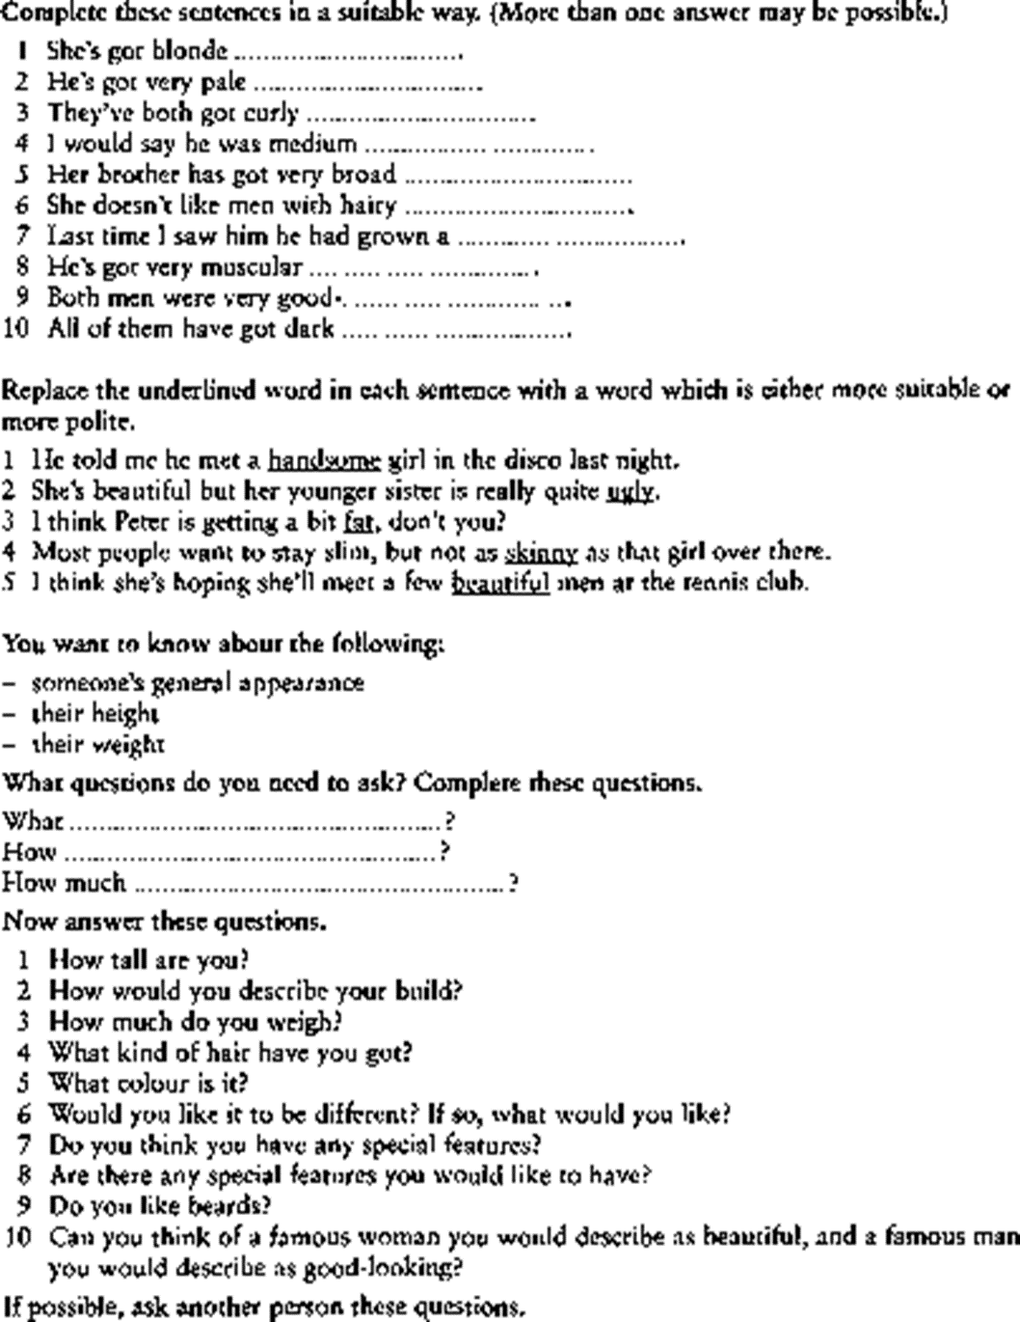

**Describing character**

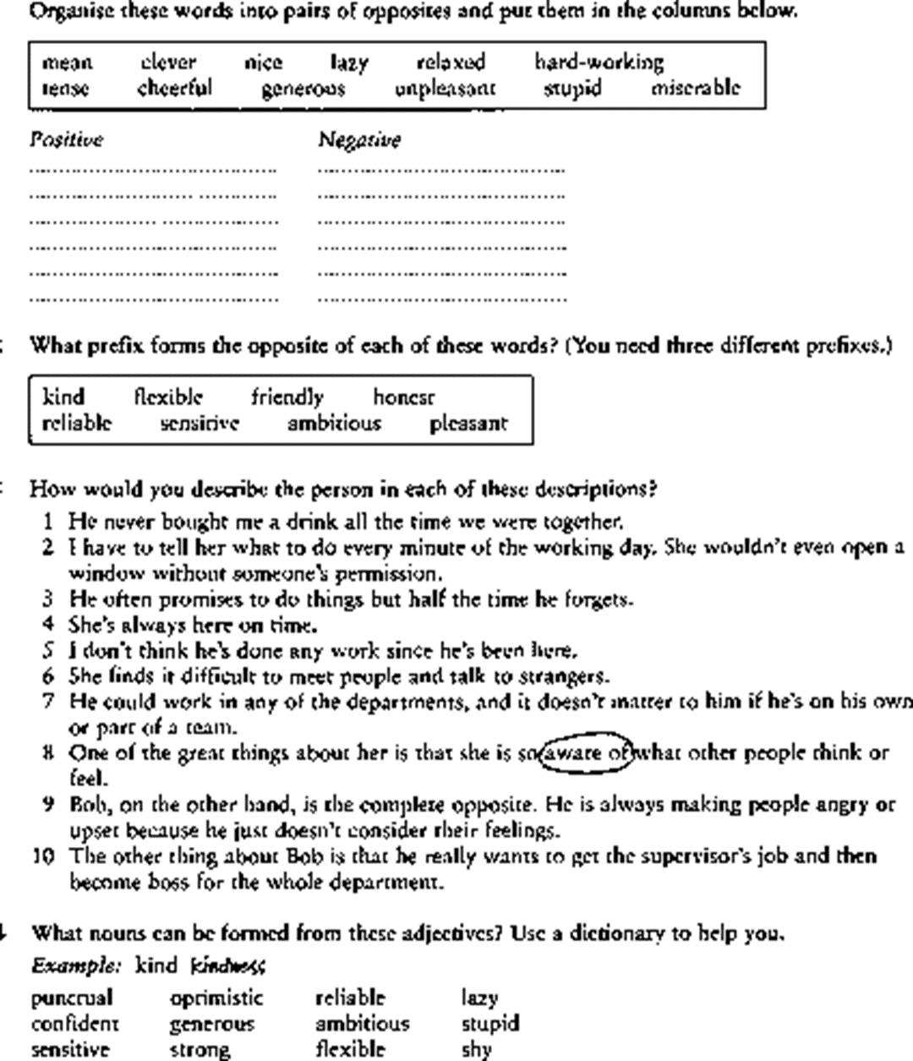

**Практическая работа № 16.**

**Подготовить мини-проект по теме «Окружающая среда». Составить вопросы к тексту «Кислотный дождь».**

**I. General Words**

**1. environment — окружающая среда**

a healthy environment

to protect the environment

to spoil the environment

**2. pollution — загрязнение**

to reduce pollution

Land pollution, air pollution, water pollution

Many scientists think about serious changes in the climate because of the pollution of the atmosphere.

**3. protection — защита**

protection of the environment

**4. environmental — связанные с окружающей средой (=ecological)**

environmental problems

environmental protection

Environmental pollution is becoming worse.

Pollution is among the main environmental problems.

**5. to protect the environment — защищать окружающую среду**

to protect the environment from pollution

**6. to pollute / to be polluted by — загрязнять / быть загрязненным чем-то**

to pollute the environment

To pollute the water, air, atmosphere means to make it dirty and dangerous for people and animals to live in or to use.

The air in the cities is polluted by car fumes (выхлопными газами).

**7. An influence = an effect — влияние (воздействие)**

to have a strong influence (effect) on

TV has a strong influence on people.

Climate has a very important influence on plants, animals and humans.

**8. to influence smth (greatly) — влиять (сильно)**

What influenced his decision?

His speech influenced me greatly.

Humans influence Nature.

**9. human influence — влияние человека**

Human influence on nature is negative.

**10. to destroy / to be destroyed — разрушить, уничтожить / быть уничтоженным**

to destroy buildings, to destroy hopes

to destroy wildlife, countryside beauty

The house was destroyed.

Fires often destroy forests.

The protection of the biosphere from destruction________________

A species which is in danger of becoming extinct________________

The very slow process by which living creatures change and become increasingly suited to the place where they live__________________

No longer in existence anywhere on the Earth___________________

The process by which the Earth is heated when the atmosphere traps heat from the Sun_________________

The place where a plant or animal naturally lives and grows____________

A chemical which is used by people to kill insects________________

An area of open land set aside by a government specially for the conservation of wildlife_________________

A mixture of gases in car exhausts which contribute to pollution and acid rain________________

An electricity-generating station which uses radioactive fuel to drive the generators______________

A gas in the Earth’s atmosphere produced in small quantities near the ground when sunlight shines on polluted air. It is more common very high up in the atmosphere______________

A person who kill wildlife illegally to make money__________________

The contamination of the environment by substances harmful to living creatures________________

A rich woodland habitat which occurs in regions of warm climate and high rainfall_________________

An area of land in which wildlife is protected from hunting and collecting__________________

Part of a dead animal used for decoration or exhibition_______________

Polluted air consisting of a mixture of fog, smoke and sulphur dioxide___________________

The part of the Earth which contains all living creatures________________

The mixture of gases which surrounds a planet or a star________________

Rain made acid by falling in polluted air_________________

**Перечень рекомендуемых учебных изданий, Интернет-ресурсов, дополнительной литературы**

Основные источники:

1. Голубев, А. П. Английский язык: учебное пособие/ А. П. Голубев, А. П. Коржавый, И. Б. Смирнова. - 7-е изд., стер. – М.: Академия, 2016. - 208 с.

Дополнительные источники:

1. Луговая, А.Л. Английский язык для строительных специальностей средних профессиональных учебных заведений: Учеб. пособие/ А.Л. Луговая. – М.: Высшая школа, 2006.- 166 с.

2. Конышева, А.В. Englishforbuilder = Английский для строителей: пособие для студентов строительных специальностей высших учебных заведений / А.В. Конышева. – Минск: БНТУ, 2005. – 89 с.

3. Попов, С.А. Технический перевод и деловая коммуникация на английском языке: учебное пособие / Новгор. Гос. Ун-т им. Ярослава Мудрого, - Великий Новгород, 2006 – 153 с.

Информационные ресурсы:

1. Macmillanenglish [электронный ресурс], режим доступа : www.macmillanenglish.com.

2. LEARNINGENGLIH, [электронный ресурс], режим доступа: www.bbc.co.uk/worldservice/learningenglish

3. BritishCouncil , [электронный ресурс], режим доступа: www.britishcouncil.org

4. Handouts Online, [электронный ресурс], режим доступа: www.handoutsonline.com

5. www.enlish-to-go.com (for teachers and students)

6. BBC - Video Nation – Christmas, [электронный ресурс], режим доступа: www.bbc.co.uk/videonation (authentic video clips on a variety of topics