**Increasing the efficiency of heat supply systems through the use of solar generation**

*Kaliev A.S., 1st year graduate student*

*S.Seifullin Kazakh Agrotechnical Research University,*

*Astana*

**Abstract**

The article considers the increase of efficiency of heat supply systems of autonomous buildings through the introduction of solar generation. The main focus is on the application of solar collectors, their types, technical and economic aspects, as well as control and heat storage systems. The paper discusses the different types of collectors (flat, vacuum and concentrating), the possibilities of using thermal storage, and the advantages of using modern control systems. The influence of geographical location, building insulation and collector orientation on efficiency is analyzed. The article emphasizes the importance of integrating solar systems with other energy sources and the prospects for further development of this technology to reduce operating costs and carbon dioxide emissions, increase energy efficiency and autonomy of buildings.

**Key words: solar generation, heat supply, energy efficiency, solar collectors, thermal energy.**

**Introduction**

The use of solar generation to convert it into heat allows to obtain a powerful energy-saving effect in heating and ventilation systems of residential and public buildings, including energy-autonomous in the case of heating at the expense of heat sources. Solar generation systems have several advantages compared to traditional heat energy sources, and first, it is environmentally friendly. Following the world trends within the framework of the action plan on the “Concept for the transition of the Republic of Kazakhstan to a ‘green economy’ for 2021 - 2030 years, approved by the Resolution of the Government of the Republic of Kazakhstan dated July 29, 2020 to the Law of the Republic of Kazakhstan dated January 13, 2012 № 541-IV ‘On energy saving and energy efficiency’ (with amendments and additions as of 29.06.2020)” is an important step towards combating climate change [1]. Solar generation systems are safe for the environment, as they completely lack fuel combustion technologies, and, accordingly, there are no emissions of toxic substances into the atmosphere. According to Akhmetkalieva S., today the issues of reducing pollutant emissions are of paramount importance not only for Kazakhstan, but also for the whole world [2]. The second, no less important factor in the relevance of the application of solar energy generation systems is their cost-effectiveness, T. A. Kornilov, E. G. Slobodchikov, D. N. Amosov evaluate the effectiveness of solar collectors, identify the disadvantages and advantages, and despite the sufficient cost of the installations themselves, the use of solar collector contributes to a significant reduction in energy costs for heat supply to the building even in winter [3]. Demirbas M.F. shows that solar energy is a renewable energy source that can generate electricity, provide hot water, heat and cool homes, and provide lighting for buildings [4]. Within the framework of solar generation development in the conditions of Northern Kazakhstan according to the Solar Atlas of Resources of Kazakhstan [5], the most promising is the use of solar collectors for energy-efficient individual residential houses with a combined scheme. In the period from September to March the use of traditional gas boilers for heating and hot water supply. In the period from March to September (warm period) solar collectors with direct heat transfer and orientation of collectors to the south.

Solar collectors are devices that convert solar energy into heat energy. Unlike photovoltaic panels, which generate electricity, solar collectors use solar radiation to heat liquids (most commonly water or antifreeze) or air. These systems are particularly popular in regions with high levels of solar insolation and are used for hot water, heating, and for use in industrial processes where heat is required.

The main types of solar collectors include flat plate collectors, vacuum tube collectors and air collectors. Flat-plate solar collectors are an absorber panel enclosed in a sealed box with a transparent cover, usually made of tempered glass. This panel absorbs solar radiation and transfers heat to the heat transfer medium circulating through it. The design of a flat-plate collector typically involves several key elements: a transparent cover to protect and improve light transmission, an absorber to capture solar energy, pipes to circulate the fluid, and insulation to minimize heat loss. The advantage of these collectors is their simplicity, low cost and efficiency in regions with mild climates and good sunlight. However, their efficiency decreases at low temperatures and on cloudy days [6].

Vacuum or tube collectors have a more complex design consisting of individual glass tubes with a vacuum between the outer and inner walls. The vacuum acts as an insulator, minimizing heat loss. Inside the tube is an absorber plate that absorbs solar radiation and heats the heat transfer medium. Thanks to vacuum insulation, these collectors remain efficient even at low outdoor temperatures, making them particularly useful in cold climates. They are more efficient than flat plate collectors but are more expensive and require more complex installation and maintenance [7].

The principle of operation of solar collectors is as follows: solar radiation hits the absorbing surface of the collector, which is heated. The heat is transferred to the circulating fluid or air, which moves through the system. The fluid transports the heat to a storage tank or heating system where it is used for water heating, space heating or industrial processes.

Solar collectors have a wide range of applications. They are used for hot water supply in both residential homes and industrial facilities. In heating systems, they can be combined with traditional heat sources such as gas boilers or heat pumps to increase efficiency. In industry, they are used for water heating and other processes where heat is required.

The main advantages of solar collectors are their environmental friendliness, as they use renewable solar energy, and cost-effectiveness, especially after installation, as the sun is a free energy source. T. A. Kornilov et al. state, modern collectors can operate for more than 20 years, which makes them a durable solution for heat supply. However, there are disadvantages: the efficiency of collectors depends on climatic conditions, especially on the number of sunny days per year, which makes them less suitable for use in regions with low insolation. Initial installation costs can be high, and the system requires free space, such as on the roof of a building, to accommodate it. In addition, additional heat sources may be required on cold or cloudy days [3].

**Methods and materials:**

The following approaches and methods will be used to address the objectives of the study:

1. Monitoring and analyzing the current state of research and the latest achievements in the field of scientific topic, namely the application of solar generation in heat supply systems using all available sources of information: libraries, databases on the Internet: Scopus, WoS, Taylor&Francis, ScienceDirect, IEEE Xplore, FIPS, Espacenet and others.

2. System analysis of the thermal needs of the building. This approach includes the calculation of heat loss through the building envelope such as walls, roofs and windows as well as heat loss due to ventilation. An important aspect is the selection of the type of solar collectors. It is advisable to use heat storage tanks to store excess heat generated during the warm period. Automation of the control system.

3. Calculated analytical method of determining the required capacity of the solar generator, considering the climatic conditions of its location.

**Results**

Thus, the task of providing energy efficient homes in Northern Kazakhstan can be solved by a combined heating and hot water system using solar collectors and gas boilers. The system will rely on gas boilers in the cold period and on solar energy in the warm period, which will reduce energy costs and environmental impact.

Modeling a solar collector for an HVAC system involves several key steps: selecting the collector type, collecting solar irradiation data, calculating the thermal capacity, assessing the thermal needs of the building, and integrating with conventional energy sources. The results of such modeling allow for the optimal design of a system that makes the most efficient use of available solar energy, reducing heating and hot water costs, as well as reducing the carbon footprint of the building.

**Discussion**

For effective use of solar collectors in the conditions of Northern Kazakhstan, especially for energy-efficient individual houses, it is advisable to consider a combined scheme that includes the use of solar energy in the warm season and traditional gas boilers for heating and hot water supply in the cold season. Shabgard H et al. show that such a scheme allows to optimally utilize natural resources and save energy [8].

In the conditions of Northern Kazakhstan in winter, solar activity is significantly lower, and the duration of daylight hours is shortened. This reduces the efficiency of solar collectors, since they directly depend on solar radiation to heat the coolant. In this case, the best solution is to use gas boilers for heating and hot water supply in the period from September to March. Gas boilers provide a stable and enough heat even during the colder months when temperatures can drop below freezing. These boilers can work automatically to maintain the right temperature in the house and heat water for domestic use.

During the warm season, from March through September, solar collectors become the main source of heat. Currently, solar activity increases, which allows solar collectors to efficiently heat the coolant for hot water and heating systems. Direct heat transfers solar collectors transfer heat directly to the water supply or heating system, which reduces heat loss and increases system efficiency. To maximize productivity, collectors should be installed in a south-facing orientation, which provides the longest and most direct exposure of the collector surface to solar radiation during the day.

A combined scheme that utilizes solar energy from March to September and conventional gas boilers from September to March not only saves on energy costs, but also significantly reduces greenhouse gas emissions by using a renewable energy source. During the period of active solar radiation, the system based on solar collectors almost completely covers the needs of the house in hot water supply and can also partially compensate for heating costs [8].

To realize such a scheme, several key aspects need to be considered. First, solar collectors must be properly selected depending on the climate of the region. Vacuum tube collectors may be preferred as they are more efficient in variable weather and can operate at low temperatures (fig.1). Second, proper installation and orientation of the collectors is important. They should be placed on the south side of the roof of the house at an angle that is optimal for capturing the sun's rays. This is usually an angle equal to the geographic latitude of the collector location.

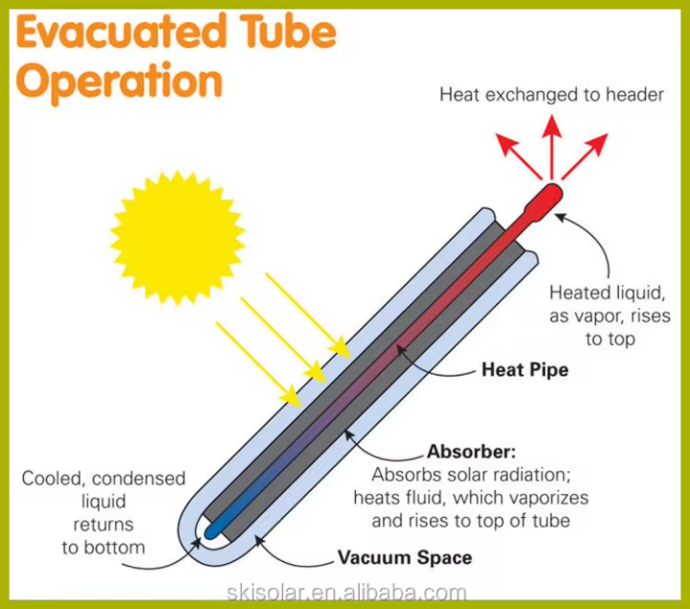

Fig. 1. The principle of operation of a vacuum solar collector with heat pipes.

You should also consider integrating the solar collector system with a traditional gas boiler. This will allow automatic switching between the two heat sources depending on weather conditions. For example, in the early spring or late fall, when solar energy may not be sufficient to fully provide heat, the system will be able to switch on the gas boiler to compensate for the heat deficit.

Another important element is a thermal storage tank that will store the excess heat generated by the solar collectors during the day for use at night or on cloudy days. Demirbas M.F. says that this will increase the efficiency of the system by allowing the stored heat to be utilized even if the solar irradiation is erratic during the day [4].

Modeling of solar collector for heating, ventilation and hot water system is an important step in the design of energy efficient buildings. The purpose of such modeling is to determine the optimal parameters of the system that can maximize the use of available solar energy to meet the thermal needs of the building. Simulation helps to understand how efficiently a solar collector can operate in different climatic conditions and how its integration with HVAC and hot water systems can minimize the cost of conventional energy sources.

The first step in modeling is to select the type of solar collector. Flat plate collectors, vacuum tube collectors, or air solar collectors can be used depending on the climate conditions and building needs. Liquid collectors are most often used for heating and hot water systems, as they can store and transfer heat through a heat transfer medium (usually water or antifreeze). Air collectors are more commonly used for ventilation systems as they directly heat the air, which can then be supplied to the ventilation system [6].

An important element of modeling is the collection of data on solar irradiation in a particular region. For an accurate calculation, it is necessary to know the insolation level - the amount of solar energy that falls on the collector surface during the year. This data can be obtained from meteorological stations or by using specialized databases such as Meteonorm or PVGIS, which contain information on solar irradiance for different regions. It is important to consider seasonal and diurnal variations in insolation to understand how much thermal energy can be obtained from the solar collector at different times of the year [5].

The next modeling step is to calculate the thermal capacity of the solar collector. For this purpose, the formula is used:

Q=A⋅G⋅η

Where:

- Q - thermal power received from the collector (W),

- A - absorbing surface area of the collector (m²),

- G - solar radiation intensity (W/m²),

- η - collector efficiency factor, which depends on its design and operating conditions.

The absorber area is selected based on the design heat load of the building. The efficiency factor η considers heat loss through radiation, convection and conduction. It varies depending on the temperature of the heat transfer medium, ambient temperature and collector design (e.g. vacuum tubes have higher efficiency in cold conditions) Papadimitratos A et al [10].

A heating and hot water system based on solar collectors requires the calculation of the heat demand of the building. These needs depend on climatic conditions, heat loss through the building envelope (walls, windows, roof), and the number of occupants and their hot water consumption habits. For heating and ventilation, it is also important to consider the need to supply air heating if a forced ventilation system is used.

Heating and hot water systems with solar collectors usually use thermal storage tanks. Modeling should include calculation of the volume of such a tank, which is able to accumulate excess heat from the solar collector during the day and give it away at night or on cloudy days (fig. 2). The important parameter here is the heat capacity and the degree of heat loss of the tank. The larger the volume of the tank, the more energy can be stored, but this increases the cost and requires space for placement [4].

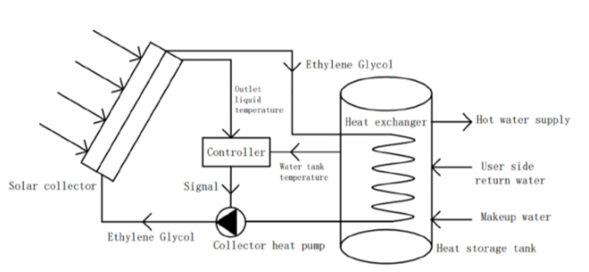

Fig. 2 Structural picture of solar hot water heating system.

Special attention should be paid to the integration of the solar collector with the traditional heating and hot water supply system, since solar energy cannot fully cover the thermal needs of the building all year round. The modeling should include a system of automatic switching between solar collectors and a backup heat source (gas boilers or electric heaters) depending on the availability of solar energy. For example, in the cold winter months, when insulation is low, traditional heat sources will be the main heat sources, and in the summer period solar collectors can provide almost 100% of the building's hot water needs [8].

For ventilation systems, solar collectors can include the use of air collectors to heat the outside air before it is supplied to the premises. This reduces the load on the main heating system and can improve the microclimate inside the building by increasing the supply air temperature.

**Conclusion**

As a result of the calculations of the heating, ventilation and hot water supply system with the use of solar generation, several important conclusions can be drawn. In the conditions of Northern Kazakhstan, where climatic features include cold winters and relatively warm summer months, the combined use of solar collectors and traditional heat sources, such as gas boilers, is the optimal solution to ensure energy efficiency of buildings.

One of the key factors in the successful operation of such a system is the correct determination of the heat losses of the building and the calculation of the heat requirements to maintain a comfortable room temperature. Heat losses, which depend on the characteristics of the building envelope (walls, windows, roof) and the amount of fresh air supplied through the ventilation system, must be carefully considered when designing the system. It is important to realize that during the cold season, heat losses increase significantly, and to compensate for these losses during the heating season it will be necessary to use a backup heat source - a traditional gas boiler.

In the cold season, from September to March, solar energy is usually insufficient to fully meet all the thermal needs of the building. In this case, the system automatically switches to a traditional heat source - a gas boiler. This makes it possible to maintain a stable level of indoor comfort despite the limited solar generation capacity during the winter months. Thus, the combined use of solar collectors and gas boiler provides reliable and stable operation of the system throughout the year, which is especially important in the harsh climate of Northern Kazakhstan.

A system based on solar collectors can significantly reduce fuel costs and greenhouse gas emissions through the use of renewable solar energy. Despite the relatively high initial costs of installing solar collectors and thermal storage, in the long term such systems provide significant economic and environmental benefits.

Thus, the design and calculation of a heating, ventilation and hot water supply system using solar energy in the conditions of Northern Kazakhstan show that this solution can be highly effective when properly integrated with traditional heat sources. The use of solar collectors in combination with heat accumulation and backup sources such as gas boilers can significantly save energy resources, improve the energy efficiency of buildings and reduce environmental impact.

**List of references**

1. On approval of the Action Plan for the implementation of the Concept for the transition of the Republic of Kazakhstan to a "green economy" for 2021-2030. Resolution of the Government of the Republic of Kazakhstan dated July 29, 2020 No. 479
2. Akhmetkalieva, S. “Perspective resource of green energy in Kazakhstan: solar energy”, 2020.
3. T. A. Kornilov, E. G. Slobodchikov, D. N. Amosov. The efficiency of using solar generation for engineering support of residential buildings in the climatic conditions of central Yakutia //Scientific, technical and production journal. Housing construction. 2019 No. (1-2) pp. 10-13
4. Demirbas M.F. Thermal Energy Storage and Phase Change Materials: An Overview. Energy Sources, Part B: Economics, Planning, and Policy. 2006 Jan 1 [2020 Jun 1];1(1):85–95
5. Solar Atlas of Kazakhstan's resources. The Ministry of Energy of the Republic of Kazakhstan and the United Nations Development Program. Department of Renewable Energy Sources of the Ministry of Energy of the Republic of Kazakhstan. 2019
6. Solar collectors for farms. https://optonimpex.com/pf12246-solnechnyj-kollektor-dlya.html
7. Vacuum solar collectors for home heating and hot water: https://avtonomnoeteplo.ru/altenergiya/232-vakuumnye-solnechnye-kollektory.html
8. Shabgard H, Song L, Zhu W. Heat transfer and exergy analysis of a novel solar-powered integrated heating, cooling, and hot water system with latent heat thermal energy storage. Energy Conversion and Management. 2018;
9. Bubenchikov A.A., Nurahmet E.E., Molodykh V.O., Rudenok A.I. Solar energy as a source of electrical energy // International Research Journal. 2016 № 5(47) Part 3. С. 59 - 62.
10. Papadimitratos A, Sobhansarbandi S, Pozdin V, Zakhidov A, Hassanipour F. Evacuated tube solar collectors integrated with phase change materials. Solar Energy.