**Centre of education №5**

**Project**

**AI: will it replace the profession of an interpreter in the future?**

**The project made by:**

**Milena Vorobyova**

**Yana Zaitseva**

**Teachers:**

**Shcherbakova T.O.**

**Noginsk**

**2024**

Catalog

The purpose of the work 3

Introduction 4

AI translators: successful and unsuccessful examples 5

The results of the survey 8

Sources: 10

# The purpose of the work:

To find out if AI can replace a real interpreter and whether people are ready for it.

**Objectives:**

* To find out more about the work of AI translators.
* To find successful and unsuccessful examples of the work of AI as an interpreter.
* To conduct a survey to find out whether people are ready to replace a human with an AI interpreter.
* To outline perspectives of AI translators in the future.

# Introduction

New technologies, like artificial intelligence (AI) that can think on their own, have changed our world a lot. These changes have also made a big difference in how we understand and translate languages. Because of this, it's important to know how clear communication is for everyone. That's why the need for translation services has grown so much with globalization.

Recently, there has been a trend to merge artificial intelligence (AI) with machine translation technology. This has resulted in the development of new models for machine translation that utilize neural networks. Platforms like Google Translate now offer AI-powered machine translation services. The main advantage of AI is its ability to translate large volumes of text and provide various translation options. However, machine translation also faces certain challenges. It often fails to keep pace with language changes and lacks an understanding of humor or sarcasm.

Human translators possess their own unique advantages. They possess knowledge of both language and culture, enabling them to adapt translations to different contexts and capture the intended meaning behind the words. They can also demonstrate creativity in their translations. One of the main problems is that currently machines lack emotional intelligence. Machine translation lacks intuition. And most importantly - it lacks imagination.

Ultimately, even if artificial intelligence is used to handle translations, there’s still a crucial role for human translators. The process operates similarly to trans-creation, with flesh-and-bone writers needed to ensure tone and intent are present in the final results. One thing is sure — AI translation, our future, very much needs real humans.[1]

In recent years, some researchers have suggested that the rapid growth of AI translation tool could hurt English professionals [2]

# AI translators: successful and unsuccessful examples

On the SHS Web of Conferences in 2023 scientists showed a result of the experiment they had conducted.

According to the experimental rules they designed, the translations were scored according to the criteria for judging the translations. **Application 1.**

As we can see from the table, AI is better at grasping language style than humans. This is mainly the case for business English translations and news types. This also shows that for texts requiring a strict language style, AI translations avoid colloquial expressions and are better than human translations. However, AI translations are not as good as human translations for the translation of literary works and emotive texts. Secondly, in terms of Logical Expression and Fidelity to the original text, and accurate translation of word meanings, we can see that humans win all three types of texts, i.e., 3:0. In other words, in these areas, AI is still lacking, and needs to be improved.[3]

In June 2023 another experiment was conducted. Professional interpreters Barry Slaughter Olsen and Walter Krochma took on an AI speech translator named Kudo to see how its translation compared to that of a human. Barry and Walter tested the AI on its ability to translate not only the words being said, but the emotions.[4]

The test involved analyzing a speech from King Felipe of Spain about the Covid crisis, focused on the emotional connection with the audience. The AI translator performed well in terms of content and completeness but struggled with word choice, leading to some inaccuracies in conveying the intended message. The AI interpreter was also able to accurately capture the content of the speech but had some difficulties with syntax, word choice, and grammar. Despite its completeness, there were errors in the AI's translation that a human interpreter would have avoided.

Overall, the test highlighted the challenges of achieving the same level of understanding and emotional connection through AI translation compared to human interpretation.

Both types of interpretations have their strengths and limitations.

**The Strengths of AI Interpretation**

Speed and Efficiency: AI interpretation is incredibly fast, capable of processing vast amounts of text or speech within seconds. This can be invaluable in scenarios where quick, simple translations are needed.

Cost-Effective: AI interpretation can be cost-effective and accessible to a broader audience, making it an attractive choice for businesses and individuals with limited budgets.

Consistency: AI systems provide consistent translations, reducing the risk of human errors and variations.

**The Limitations of AI Interpretation**

Lack of Cultural Competence: AI systems lack the ability to understand cultural nuances, context, and regional variations in language. This often leads to translations that are technically accurate but culturally inappropriate or insensitive.

Inability to Interpret Context: AI interpreters cannot always grasp the broader context of a conversation, making them ill-equipped to provide meaningful interpretations in more complex or nuanced discussions.

Limited Understanding of Idioms and Slang: AI systems struggle to comprehend idiomatic expressions and slang, which are prevalent in everyday language use.

No Emotional Intelligence: AI interpreters cannot detect or respond to emotions, tone, or non-verbal cues that play a crucial role in human communication.

**The Strengths of Human Interpreters**

Cultural Competence: Human interpreters possess a deep understanding of the cultures and societies they work with, allowing them to navigate cultural nuances effectively. This cultural competence is invaluable for international diplomacy, business negotiations, and health-care settings.

Contextual Understanding: Human interpreters can interpret language within the broader context of a conversation, facilitating more meaningful and accurate translations in complex discussions.

Adaptability: Human interpreters can adapt to different situations, including formal meetings, casual conversations, and emotional contexts, ensuring a more natural and appropriate interpretation.

Emotional Intelligence: Human interpreters can gauge the emotions and intentions of the speakers, allowing them to respond effectively and empathetically.

**The Importance of Cultural Competence**

One of the most significant distinctions between human interpreters and AI is the issue of cultural competence. Cultural competence is the ability to understand and respect cultural differences and nuances that can greatly impact communication. In an increasingly globalized world, bridging cultural gaps is paramount, as misunderstandings can lead to unintended consequences in various domains, including international diplomacy, business transactions, and health-care.

Human interpreters are uniquely equipped to navigate these cultural complexities. They have often spent years studying and immersing themselves in the languages and cultures they work with, enabling them to interpret not just words but also the intentions, beliefs, and values that underlie them. This level of insight is beyond the reach of AI.

While AI interpretation tools are becoming more sophisticated and convenient, they still have a long way to go before they can rival the skills and cultural competence of human interpreters. As AI develops, it will undoubtedly play an essential role in providing quick, simple translations for everyday use. However, when it comes to complex, culturally sensitive, or emotionally charged interactions, human interpreters remain the preferred choice.[5]

# The results of the survey.

To find out what people from our school think of AI interpreters, we conducted a survey. **Application 2**

The results of the survey, presented in the pie charts show that more than a half (54%) of the respondents use AI several times a week. It can also be seen that only 16% of people uses AI on a daily basis, which is actually surprising taking in account how often we face this kind of technology in our lives nowadays. According to the pie chart 75% of the respondents are under 18 years old what makes them probably really educated in the technology field. Only a few percent of people never uses AI in their lives.

The next question in the survey was who the surveyed are more likely to turn to for help with translation. The majority (75%) answered that they would be likely to search help in the technology and only 25% would ask a professional translator for help. The most popular explanation of choosing IA was “it is more convenient and fast”, some of the respondents highlighted that there probably wouldn’t be a professional nearby and that it is not only convenient at use but this way is a lot easier for people with ASPD ( Antisocial Personality Disorder). Those who would prefer to ask a professional translator argued their answer by saying that AI is not actually capable of recognizing human’s true emotions.

The final question was “Do you think that due to the development of AI, the profession of translator will be relevant in the future?”. Based on the previous answer it may seem obvious that people nowadays prefer Artificial Intelligence over the person and they think it will replace the profession of a translator in the future. Despite this being true the major part of the respondents does nor think so. A great percentage of the people which is 62% thinks that AI won’t really be able to replace translators, about 20% thinks that AI might partly replace the profession but only for those who are awful with modern technologies and finally only 16% of the respondents actually think that Artificial Intelligence will substitute translators in the future.

# Conclusion

AI has made machine translation tools far more reliable in recent years. We rely on the newest technology, use it almost every day and everywhere and yet we still are not ready for it to take over us. AI plays a huge role not only in translation but in our whole lives, we are taught to tolerate it and even little babies are now masters when it comes to the Internet and modern technologies. But at the same time we cannot say that AI even with it’s advanced knowledge in humans is even a half as good as real people in socialization.

As for the question whether AI can replace a profession of an interpreter in the future - we can say not exactly. When it comes to quick and easy ways to convey the general meaning to a foreigner, AI is a perfect means to help. When we want to convey our speech in emotions and particular features, AI cannot cope with the task. We needed other people to talk with us before, we need them now and we will need others to communicate with us face to face in the future.

# Sources:

1. Gu Yue & Zhang Jiayuan. (2020). The pros and cons of machine translation software for university students learning English. English Square, (28), pp.115-117
2. How is Artificial Intelligence Changing the Translation Services Industry? <https://www.getblend.com/blog/artificial-intelligence-changing-the-translation-services-industry/>
3. Interpreters vs. AI – The Key Differences <https://dayinterpreting.com/blog/interpreters-vs-ai-the-key-differences/>
4. Pro Interpreters vs. AI Challenge: Who Translates Faster and Better? <https://www.wired.com/video/watch/pro-interpreters-vs-ai-who-translates-faster-and-better>
5. The Impacts and Challenges of Artificial Intelligence Translation Tool on Translation Professionals <https://www.shs-conferences.org/articles/shsconf/pdf/2023/12/shsconf_icssed2023_02021.pdf>

**Application 1**

**Analysis of evaluation standards**

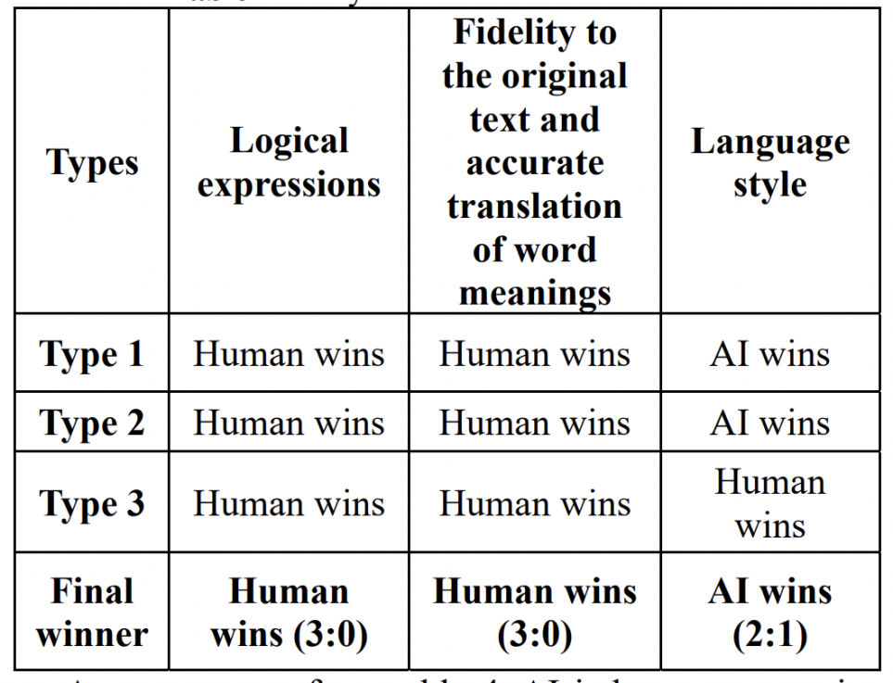

**Application 2**

**The results of the survey**

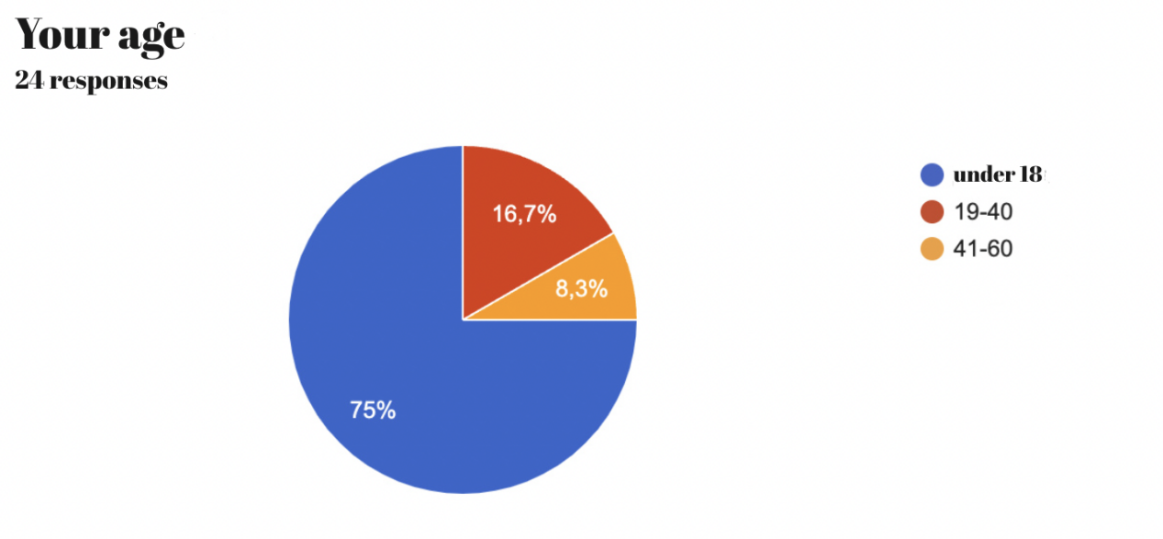

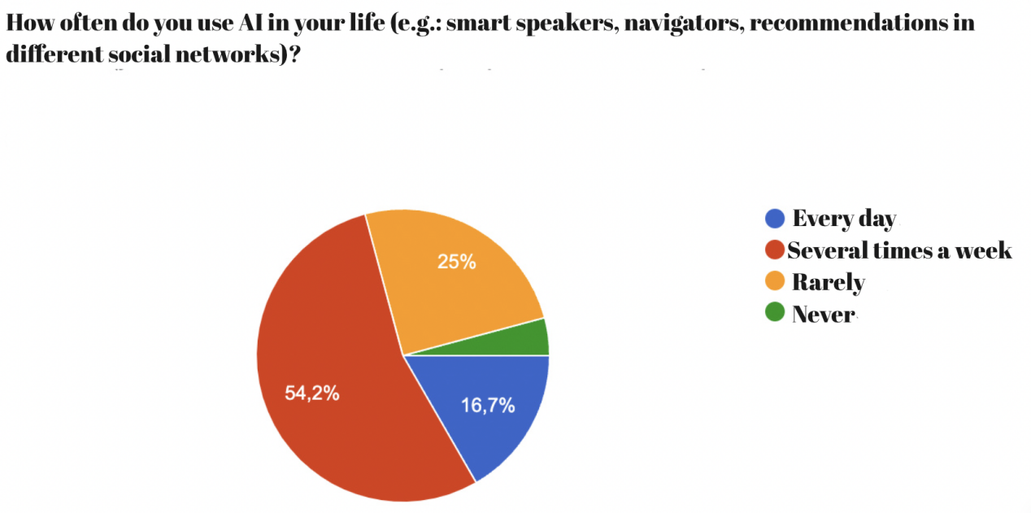

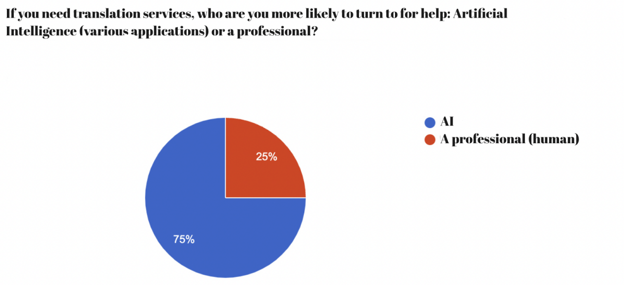

**Explain your choice:**

* It’s a faster way (AI)
* I want it this way, I suffer social anxiety disorder (AI)
* AI is always with me and I don't have to pay for it so much money (AI)
* **AI can't recognize the features of a particular language (a professional)**
* **The app on my phone will be enough for me to travel to other countries** (AI)
* **My knowledge of languages is enough for correct translation** (AI)
* **There is no opportunity for me to use a professional help** (AI)
* **I use a translator** (AI)
* **It's much faster and easier** (AI)
* **it is always at hand** (AI)
* **It's more convenient** (AI)
* **It's convenient and fast** (AI)
* **A person is able to understand emotions and interpret them in speech (a professional)**
* **A professional can’t be nearby all the time** (AI)
* **Intelligence is more accessible than a human translator** (AI)

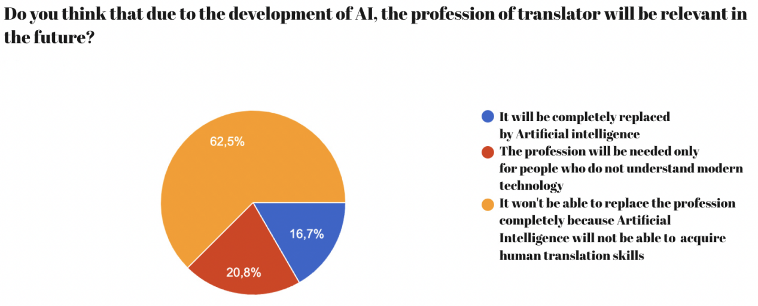

1. How is Artificial Intelligence Changing the Translation Services Industry? <https://www.getblend.com/blog/artificial-intelligence-changing-the-translation-services-industry/>
2. Gu Yue & Zhang Jiayuan. (2020). The pros and cons of machine translation software for university students learning English. English Square, (28), pp.115-117

  
3. The Impacts and Challenges of Artificial Intelligence Translation Tool on Translation Professionals <https://www.shs-conferences.org/articles/shsconf/pdf/2023/12/shsconf_icssed2023_02021.pdf>
4. Pro Interpreters vs. AI Challenge: Who Translates Faster and Better? <https://www.wired.com/video/watch/pro-interpreters-vs-ai-who-translates-faster-and-better>
5. Interpreters vs. AI – The Key Differences <https://dayinterpreting.com/blog/interpreters-vs-ai-the-key-differences/>