Министерство просвещения РФ

-------------------------------------*-------------------------------------

Федеральное государственное бюджетное профессиональное образовательное учреждение «Куртамышское специальное учебно-воспитательное учреждение закрытого типа»

ПЕДАГОГИЧЕСКИЙ ПРОЕКТ

Тема:

Формирование и развитие читательской грамотности на уроках английского языка

Выполнила: учитель английского языка

Печенежская Алла Витальевна

г.Куртамыш, 2024г.

Аннотация

Тема предлагаемого проекта «Формирование и развитие читательской грамотности на уроках английского языка». Педагогический проект является долгосрочным и направлен на развитие читательской грамотности на английском языке.

Актуальность проекта заключатся в том, что в современном мире знание английского языка становится все более важным и необходимым. Необходимость владения иностранным языком, в частности английским, обусловлена глобализацией, развитием информационных технологий и международными коммуникациями. Однако для успешного усвоения иноязычной информации необходимо не только уметь говорить и писать на английском, но и владеть навыками чтения на этом языке.

Реализация проекта предусматривает постановку проблемы, поиск её решения через применение различных методов и методик работы с текстами. Проект позволит развить у обучающихся читательскую грамотность, интерес к английскому языку, познавательную активность, творческое мышление, самостоятельность.

Продуктом проекта является сборник текстов с упражнениями по теме: «Выдающиеся люди родной страны и зарубежных стран». Проект предназначен для обучающихся образовательных школ.

Содержание

Введение 4шшш

1.Методы формирования читательской грамотности на уроках английского языка 5

2.Стратегии обучения чтению на уроках английского языка 7

3.Эффективные упражнения для развития читательской грамотности на уроках английского языка 9

4.Роль практических заданий в формировании читательской грамотности на уроках английского языка 10

5.Интерактивные методики для формирования читательской грамотности на уроках английского языка 12

6.Использование текстов разной сложности для развития читательской грамотности на уроках английского языка 14

7.Индивидуальный подход к формированию читательской грамотности на уроках английского языка 15

Заключение 17

Список литературы

Приложения

# Введение

В современном мире знание английского языка становится все более важным и необходимым. Необходимость владения иностранным языком, в частности английским, обусловлена глобализацией, развитием информационных технологий и международными коммуникациями. Однако, для успешного усвоения иноязычной информации необходимо не только умение говорить и писать на английском, но и владение навыками чтения на этом языке.

Проблема недостаточной читательской грамотности учащихся на уроках английского языка становится все более актуальной. Недостаточное внимание к развитию навыков чтения может препятствовать успешному усвоению учебного материала, а также пониманию иноязычных текстов в повседневной жизни.

Данный проект направлен на разработку методов и приемов, способствующих формированию читательской грамотности учащихся на уроках английского языка. В работе будут рассмотрены различные аспекты этой проблемы, такие как изучение опыта преподавателей и методистов, разработка упражнений и заданий.

Темы, которые будут освещены в данной работе, включают в себя методы формирования читательской грамотности, стратегии обучения чтению на английском языке, эффективные упражнения для развития читательской грамотности, роль практических заданий, использование текстов разной сложности, индивидуальный подход к обучению, интеграция технологий и оценка эффективности методов. Все эти аспекты будут рассмотрены с целью повышения уровня читательской грамотности учащихся на уроках английского языка и обеспечения им успешного усвоения иноязычной информации.

# Методы формирования читательской грамотности на уроках английского языка

Формирование читательской грамотности на уроках английского языка является одной из ключевых задач современного образования. Для успешного овладения иностранным языком необходимо не только умение говорить и писать на нем, но и умение читать и понимать тексты различной сложности. В данной главе рассмотрим разнообразные методы и приемы, которые помогут сформировать у учащихся навыки читательской грамотности на уроках английского языка.

Одним из эффективных методов формирования читательской грамотности является работа с текстами разной сложности. При этом важно подбирать материал, который соответствует уровню языковой подготовки учащихся. Начинать стоит с простых текстов, постепенно усложняя задания и увеличивая объем текста. Такой пошаговый подход позволяет учащимся чувствовать свой прогресс и не терять мотивацию.

Для развития навыков работы с текстом полезно использовать различные стратегии обучения чтению. Например, стратегия сканирования помогает быстро находить конкретную информацию в тексте, в то время как стратегия детального чтения позволяет понять текст в целом. Обучая учащихся различным стратегиям чтения, мы помогаем им стать более внимательными и критически мыслящими читателями.

Важным компонентом формирования читательской грамотности является использование эффективных упражнений. Например, после прочтения текста можно предложить учащимся ответить на вопросы по содержанию, сделать краткое изложение или обсудить текст в парах или группах. Такие упражнения не только помогают закрепить прочитанное, но и развивают навыки анализа и интерпретации текста.

Роль практических заданий в формировании читательской грамотности также необходимо подчеркнуть. Задания, которые требуют не только прочитать текст, но и выполнить определенные действия на его основе, способствуют более глубокому усвоению материала. Например, можно предложить учащимся написать резюме прочитанного текста, составить план статьи или выделить основные идеи.

Интерактивные методики играют важную роль в формировании читательской грамотности. Использование игр, дебатов, ролевых игр и других интерактивных форматов помогает сделать урок более увлекательным и запоминающимся. Кроме того, такие методики способствуют развитию коммуникативных навыков учащихся и улучшают их понимание текста через обсуждение и взаимодействие.

Индивидуальный подход к формированию читательской грамотности также играет важную роль. Учитывая индивидуальные особенности каждого ученика, можно подбирать материал и задания, которые будут соответствовать их уровню подготовки и интересам. Помимо этого, индивидуальные консультации и обратная связь помогают учащимся лучше понимать свои ошибки и работать над ними.

Интеграция технологий в процесс формирования читательской грамотности открывает новые возможности для обучения. Использование интерактивных онлайн-ресурсов, аудио и видеоматериалов позволяет сделать урок более разнообразным и интересным. Технологии также способствуют развитию мультимодального восприятия информации и улучшают усвоение материала.

Оценка эффективности методов формирования читательской грамотности играет важную роль в процессе обучения. Проведение регулярных проверочных работ, тестов, анализ результатов и обратная связь позволяют как учителю, так и учащимся оценить свой прогресс и внести коррективы в обучающий процесс.

Таким образом, формирование читательской грамотности на уроках английского языка требует комплексного подхода и использования разнообразных методов и приемов. Работа с текстами разной сложности, использование стратегий чтения, эффективные упражнения, практические задания, интерактивные методики, индивидуальный подход, интеграция технологий и оценка результатов – все это важные компоненты успешного формирования навыков чтения у учащихся.

# Стратегии обучения чтению на уроках английского языка

Чтение является одним из важнейших навыков, которые необходимо развивать у учащихся на уроках английского языка. Формирование читательской грамотности требует от преподавателей использования разнообразных стратегий и методов, которые способствуют эффективному усвоению текста, расширению словарного запаса, развитию навыков понимания и анализа прочитанного. В данной главе рассмотрим различные стратегии обучения чтению на уроках английского языка, которые помогут сделать процесс изучения более интересным, продуктивным и эффективным.

Одной из ключевых стратегий, способствующих формированию читательской грамотности, является активное чтение. Этот метод предполагает вовлечение учащихся в процесс чтения текста не только с целью понимания его содержания, но и для активного взаимодействия с материалом. Учитель может предложить учащимся анализировать текст, выделять основные идеи, делать выводы, высказывать свое мнение по поводу прочитанного. Такой подход позволяет развить критическое мышление, умение аргументировать свою точку зрения и обогатить словарный запас.

Другой важной стратегией является работа с незнакомыми словами. В процессе чтения учащиеся могут столкнуться с незнакомыми лексическими единицами, которые могут затруднить понимание текста. Преподаватель может предложить использовать контекст для определения значения слова, а также научить учащихся использовать словарь для расшифровки непонятных терминов. Такой подход поможет не только понять текст, но и запомнить новые слова для дальнейшего использования.

Также важным элементом обучения чтению является работа с различными типами текстов. Разнообразие жанров (от художественной литературы до научных статей) позволяет учащимся расширить свой кругозор, ознакомиться с разными стилями письма и освоить специфическую лексику. Преподаватель может предложить учащимся читать и анализировать тексты разной сложности, что способствует развитию навыков работы с различными источниками информации.

Не менее важным является использование визуальных средств в процессе чтения. Иллюстрации, схемы, графики могут значительно облегчить понимание текста, особенно если речь идет о сложных научных или технических материалах. Преподаватель может предложить учащимся анализировать визуальные материалы, делать выводы на основе картинок, что способствует более глубокому усвоению информации.

Важным аспектом формирования читательской грамотности является также развитие навыков скорочтения. Умение быстро находить ключевую информацию в тексте, выделять основные идеи и делать выводы помогает учащимся эффективно работать с большим объемом информации. Преподаватель может предложить учащимся различные упражнения на развитие скорочтения, что позволит им справляться с текстами более эффективно.

Таким образом, стратегии обучения чтению на уроках английского языка играют важную роль в формировании читательской грамотности учащихся. Активное чтение, работа с незнакомыми словами, использование различных типов текстов, визуальные средства и развитие навыков скорочтения – все эти методы способствуют не только улучшению понимания прочитанного, но и развитию критического мышления, расширению словарного запаса и формированию навыков работы с информацией. Правильно подобранные стратегии помогут сделать процесс изучения чтения более увлекательным и результативным для учащихся.

# 

# Эффективные упражнения для развития читательской грамотности на уроках английского языка

Развитие навыков чтения на английском языке играет важную роль в формировании общей грамотности учащихся. Для эффективного обучения чтению необходимо использовать разнообразные упражнения, которые способствуют развитию навыков понимания текста, анализа информации, а также активизации лексических и грамматических навыков.

Одним из ключевых упражнений, способствующих развитию читательской грамотности, является чтение с последующим обсуждением текста. Учащиеся могут читать тексты различной сложности и затем обсуждать их содержание, выражать свое мнение, делиться впечатлениями. Это упражнение не только помогает понять текст глубже, но и развивает навыки анализа и критического мышления.

Другим эффективным упражнением является работа с вопросами к тексту. После прочтения учащимся предлагается ответить на вопросы, касающиеся основной идеи текста, деталей, мнения автора. Это помогает учащимся выделить ключевую информацию, развивает навыки поиска ответов в тексте и формулирования собственных мыслей.

Для развития лексических навыков и расширения словарного запаса полезно проводить упражнения по работе с непонятными словами. Учащиеся могут выделять незнакомые слова в тексте, искать их значения в словаре, составлять глоссарий. Это способствует не только пониманию конкретного текста, но и обогащению лексики.

Одним из интересных упражнений, способствующих развитию навыков чтения, является чтение и анализ аутентичных текстов. Учащиеся могут изучать статьи из англоязычных журналов, газет, блогов, что поможет им погрузиться в языковую среду, расширить кругозор и понимание культурных особенностей стран, где используется английский язык.

Для развития навыков работы с текстом и активизации грамматических навыков полезно проводить упражнения по анализу грамматической структуры предложений в тексте. Учащиеся могут выделять различные типы предложений, определять времена глаголов, выявлять особенности употребления грамматических конструкций.

Важным аспектом развития читательской грамотности является также работа с различными жанрами текстов. Учащиеся могут читать и анализировать тексты различных жанров – от художественных произведений до научных статей. Это помогает им расширить кругозор, развить навыки работы с разными типами текстов и понимания их особенностей.

Таким образом, эффективные упражнения для развития читательской грамотности на уроках английского языка включают в себя чтение с последующим обсуждением, работу с вопросами к тексту, изучение непонятных слов, анализ аутентичных текстов, анализ грамматической структуры предложений и работу с различными жанрами текстов. Эти упражнения способствуют не только развитию навыков чтения, но и обогащению лексического и грамматического запаса учащихся, а также формированию критического мышления и аналитических способностей.

# Роль практических заданий в формировании читательской грамотности на уроках английского языка

Практические задания играют важную роль в процессе формирования читательской грамотности учащихся на уроках английского языка. Они способствуют развитию навыков чтения, понимания текста, анализа информации, а также активизации лексических и грамматических структур. Практические задания помогают учащимся не только освоить языковой материал, но и применить его на практике, что способствует более глубокому усвоению знаний.

Одним из эффективных практических заданий, способствующих формированию читательской грамотности, является работа с текстами разной сложности. Учащиеся могут выполнять задания по пониманию основного содержания текста, определению главных идей, выделению ключевой информации. Такие упражнения помогают развить навыки сканирования и детального чтения, а также улучшают понимание английского текста в целом.

Другим важным видом практических заданий является работа с лексикой и грамматикой в контексте текста. Учащиеся могут выполнять задания по поиску синонимов, антонимов, заполнению пропусков, выбору правильных ответов на вопросы по тексту. Эти упражнения способствуют расширению словарного запаса, закреплению грамматических структур и улучшению навыков работы с текстом в целом.

Кроме того, практические задания могут включать в себя задания на анализ текста, выявление авторской позиции, обоснование собственного мнения по поводу прочитанного. Такие задания способствуют развитию критического мышления, умению аргументировать свою точку зрения, а также формированию навыков анализа и синтеза информации.

Важным аспектом использования практических заданий является индивидуальный подход к каждому учащемуся. Учитывая разнообразный уровень языковой подготовки и способностей учащихся, необходимо подбирать задания, соответствующие их потребностям и интересам. Это позволит эффективнее работать над развитием читательской грамотности каждого ученика и достигать лучших результатов.

Таким образом, практические задания играют важную роль в формировании читательской грамотности на уроках английского языка. Они способствуют развитию навыков чтения, понимания текста, анализа информации, а также активизации лексических и грамматических структур. Правильно организованные практические задания помогают учащимся не только освоить языковой материал, но и применить его на практике, что способствует более глубокому усвоению знаний и развитию навыков чтения на английском языке.

# Интерактивные методики для формирования читательской грамотности на уроках английского языка

В современном мире, где информация играет ключевую роль, важно развивать у учащихся навыки чтения на иностранном языке. Формирование читательской грамотности на уроках английского языка является одним из важнейших аспектов обучения, поскольку умение понимать и анализировать тексты на английском языке открывает перед учащимися мир знаний, информации и культуры.

Интерактивные методики играют значительную роль в процессе формирования читательской грамотности учащихся. Они способствуют активному вовлечению учащихся в урок, делая процесс обучения более увлекательным и эффективным. Одной из ключевых целей использования интерактивных методик является создание комфортной обстановки на уроке, где каждый ученик имеет возможность высказать свое мнение, обсудить прочитанный материал и развить свои навыки чтения.

Одним из эффективных интерактивных методов, способствующих формированию читательской грамотности, является работа в группах. Разделение учащихся на небольшие группы позволяет им обсуждать тексты, вырабатывать общие выводы, делиться мнениями и идеями. Такой подход не только развивает навыки коллективной работы, но и способствует более глубокому пониманию прочитанного материала.

Другим интересным методом, который можно применять на уроках английского языка для формирования читательской грамотности, является использование игр и ролевых игр. Игровой подход позволяет учащимся вживую прочувствовать ситуации, описанные в тексте, а также развивает их эмоциональную и социальную сферы. Например, ученики могут играть роли персонажей из текста, обсуждать их поступки, принимать решения от их имени, что способствует более глубокому восприятию материала.

Также важным аспектом формирования читательской грамотности с использованием интерактивных методик является работа с визуальными материалами. Использование картинок, видеороликов, презентаций помогает визуализировать информацию, делая ее более доступной и понятной для учащихся. Визуальные материалы могут быть использованы как стимул для обсуждения текста, анализа сюжета, предположений о характерах персонажей и развития сюжета.

Таким образом, интерактивные методики играют важную роль в формировании читательской грамотности на уроках английского языка. Они способствуют активному участию учащихся в уроке, развитию их коммуникативных навыков, а также помогают им лучше понимать и анализировать тексты на английском языке. Важно помнить, что разнообразие методов и подходов к обучению чтению способствует более эффективному формированию читательской грамотности учащихся.

# Использование текстов разной сложности для развития читательской грамотности на уроках английского языка

Чтение является одним из важнейших навыков, которые необходимо развивать у учащихся на уроках английского языка. Для формирования читательской грамотности необходимо использовать тексты разной сложности, которые будут соответствовать уровню знаний и возрасту учащихся. Разнообразие текстов позволяет создать интерес к чтению, развить лексический запас, улучшить навыки понимания прочитанного и способствует обогащению культурного опыта.

При выборе текстов для работы на уроке английского языка необходимо учитывать не только уровень сложности, но и интересы учащихся. Тексты могут быть разделены на несколько категорий в зависимости от уровня сложности: легкие, средние и сложные. Легкие тексты подходят для начинающих учащихся или для тех, кто только начинает изучать английский язык. Они содержат простые предложения, базовую лексику и понятную структуру. Такие тексты помогают учащимся освоить основы языка и развить навыки чтения.

Средние тексты уже более насыщены лексикой и грамматикой, они могут содержать сложные конструкции и нестандартные выражения. Эти тексты подходят для учащихся среднего уровня подготовки, которые уже имеют определенный опыт в изучении английского языка. Чтение таких текстов способствует расширению словарного запаса, улучшению понимания текста в целом и развитию навыков работы с нестандартными выражениями.

Сложные тексты предназначены для продвинутых учащихся, которые владеют языком на высоком уровне. Они могут содержать сложные темы, академическую лексику, а также требовать глубокого понимания контекста. Чтение сложных текстов способствует развитию аналитического мышления, критического восприятия информации и умению аргументировать свою точку зрения.

При работе с текстами разной сложности на уроках английского языка важно учитывать индивидуальные особенности учащихся. Некоторым ученикам может быть сложно справиться с текстами определенного уровня сложности, поэтому важно предоставить дополнительные материалы или задания для поддержки. Также стоит поощрять учащихся к самостоятельному чтению текстов на английском языке вне урока, что способствует дополнительному развитию навыков чтения.

Использование текстов разной сложности на уроках английского языка позволяет создать благоприятную обучающую среду, где каждый ученик может найти подходящий уровень сложности и развиваться в соответствии с собственными способностями. Разнообразие текстов способствует не только формированию читательской грамотности, но и развитию общих навыков владения английским языком.

# Индивидуальный подход к формированию читательской грамотности на уроках английского языка

Формирование читательской грамотности учащихся на уроках английского языка является важной задачей для преподавателей. Каждый ученик имеет свои индивидуальные особенности, способности и потребности, поэтому важно применять индивидуальный подход при работе над развитием навыков чтения. В данной главе мы рассмотрим методики и приемы, которые позволяют адаптировать процесс обучения к потребностям каждого ученика.

Одним из ключевых аспектов индивидуального подхода является диагностика уровня грамотности каждого ученика. Для этого можно использовать различные тесты и задания, направленные на определение уровня владения языком и навыков чтения. На основе полученных данных можно выстраивать индивидуальные планы работы с каждым учеником, учитывая его сильные и слабые стороны.

Для развития навыков чтения учащихся с разным уровнем подготовки можно применять дифференцированный подход. Это позволяет предоставить каждому ученику материалы и задания, соответствующие его уровню владения языком. Например, для учеников с начальным уровнем знаний можно использовать тексты с простым лексическим составом и структурой, а для более продвинутых учеников – более сложные тексты.

Важным элементом индивидуального подхода является работа с интересами учащихся. Подбор текстов и заданий, которые соответствуют интересам и предпочтениям каждого ученика, способствует более эффективному усвоению материала. Например, если ученику нравятся приключенческие рассказы, можно использовать подобные тексты для работы над навыками чтения.

Для обучающихся с особыми образовательными потребностями важно применять индивидуальные методики работы. Это может включать в себя использование визуальных пособий, аудиоматериалов, игровых элементов и других специальных методик, направленных на развитие навыков чтения.

Не менее важным является постоянный мониторинг прогресса каждого ученика. Следить за тем, как развиваются навыки чтения, какие трудности возникают и какие успехи достигнуты, позволяет своевременно корректировать методики работы и подходы к обучению.

Индивидуальный подход к формированию читательской грамотности на уроках английского языка позволяет учителям эффективно работать с каждым учеником, учитывая его потребности и особенности. Адаптация методик и заданий к индивидуальным особенностям учащихся способствует более качественному усвоению материала и развитию навыков чтения.

# Заключение

В ходе исследования были рассмотрены различные аспекты формирования читательской грамотности на уроках английского языка. Методы, мастер-классы, стратегии, упражнения, практические задания, интерактивные методики, использование текстов разной сложности, индивидуальный подход и интеграция технологий – все эти аспекты были рассмотрены с целью разработки комплексного подхода к формированию читательской грамотности учащихся.

Одной из ключевых задач было изучение опыта преподавателей и методистов в данной области. Это позволило выявить лучшие практики и успешные методики, которые затем были адаптированы и внедрены в рамках разработанных уроков.

Результаты исследования показали, что эффективное формирование читательской грамотности на уроках английского языка требует комплексного подхода, включающего в себя разнообразные методы и стратегии. Важным фактором оказался индивидуальный подход к каждому учащемуся, учитывающий его потребности и уровень подготовки.

Интеграция современных технологий также сыграла значительную роль в процессе обучения, делая его более интересным и доступным для учащихся. Оценка эффективности методов формирования читательской грамотности позволила сделать выводы о их применимости и результативности.

Таким образом, разработанный проект по формированию читательской грамотности на уроках английского языка представляет собой важный шаг в повышении качества образования и развитии ключевых навыков учащихся. Дальнейшее совершенствование методов и их практическое применение позволят эффективно решать проблему недостаточной читательской грамотности и способствовать успешному усвоению иноязычной информации.

# Список литературы

1. Джеймс П. Читательская грамотность и ее формирование на уроках иностранного языка // Ученые записки университета. – 2018. – № 2. – С. 67–78.

2. Смит М.И. Психологические аспекты формирования читательской грамотности старшеклассников на занятиях по английскому языку // Психология обучения и развития. – 2019. – № 4. – С. 112–125.

3. Браун А.Ф. Использование текстов разной сложности для развития навыков чтения на уроках английского языка // Методические материалы для учителя. – 2020. – № 1. – С. 28–35.

4. Яковлева Е.Л. Читательская грамотность и ее влияние на усвоение иностранного языка // Иностранные языки в школе. – 2017. – № 3. – С. 46–54.

5. Гринев Л.О. Развитие навыков чтения на уроках английского языка с использованием авторских методик // Иностранные языки в школе. – 2018. – № 5. – С. 21–33.

6. Краснова Н.В. Эффективные стратегии формирования читательской грамотности на уроках английского языка // Педагогическое обозрение. – 2019. – № 6. – С. 82–95.

7. Миллер Г.К. Роль мотивации в формировании читательской грамотности на уроках английского языка // Психология обучения. – 2016. – № 3. – С. 17–26.

8. Уайт Р.С. Использование интерактивных методов обучения для развития навыков чтения на уроках английского языка // Научно-практический журнал "Методика преподавания". – 2018. – № 4. – С. 54–68.

9. Карпова О.И. Оценка уровня читательской грамотности учащихся иностранных языков // Методические новации в образовании. – 2017. – № 2. – С. 72–85.

10. Попов Л.П. Применение критического мышления для развития умений чтения на уроках английского языка // Педагогическая практика. – 2020. – № 7. – С. 39–47.

Приложение 1

**Тема: Выдающиеся люди родной страны.**

**Космонавты**

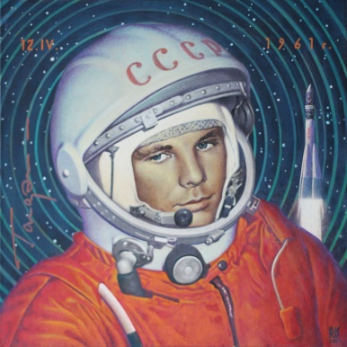 **Yury Gagarin**

On April 12, 1961, Yury Gagarin made history by being the first human to orbit the earth.  
As a precaution, engineers at the Soviet Academy of Sciences had an onboard computer, as well as mission control steer the craft, "Vostok 1". They did this because the feared that being in the weightlessness of space, you might be disabled or not be able to move very much. He wouldn't need any food for his single orbit trip, but scientists wanted to know if he could eat in the weightlessness of space.  
Before Gagarin climbed aboard the rocket, he made a speech. His speech said things such as how beautiful a moment this was, to go into space. He was glad to, "meet nature face to face, in an unprecedented encounter."  
As Gagarins rocket accelerated towards space, it reached a peak of 5 g's, meaning Gagarin felt five times heavier that his normal weight.  
As Gagarin passed through the lower atmosphere, the nose pointed canopy separated, exposing the "Vostok 1" capsule, allowing Gagarin to see the dark blue sky turn into a black space as he was shot into orbit, around the earth.  
14 minutes after liftoff, Gagarin reported," Separation from the carrier rocket completed" Gagarin tested his food and water samples. He reported no side effects to the weightlessness. As Gagarin passed over the Atlantic, he thought of his mother and how she would react to the news of the first space flight... especially since her son was the one up there flying it. She was unaware about Gagarin being involved in space exploration until the news broke.  
At about 10:15 a. m., just after Gagarin started passing over Africa, the autopilot turned "Vostok 1" around and fired the rocket, which would take Vostok 1 out of orbit. This was a very suspenseful and nervous time for Yury Gagarin and mission control, for two out of the five test flights, the rockets did not fire correctly and the flights ended in failure.  
Luckily, this time, it worked correctly and Vostok 1 came out of orbit and was slowed down by 350 miles per hour. As the capsule came out of orbit, the equipment section was dropped, because it was no longer needed. Now all that was left of the 125-ft. rocket, launched just over an hour ago, was a 7 1/2-ft diameter capsule. As it fell 17,000 mph. towards earth, Gagarin experienced 10 gs, and felt like a 1,500-pound brick falling from the sky.  
With a flight time of about 1 hour and 48 min., Gagarin landed safely in Siberia.  
Years later, Gagarin was tragically killed in a test plane crash.

**Questions:**  
1. What was Yuri Gagarin famous for?  
2. When was he born?  
3. What was Yuri like?  
4. What institutions did Gagarin finish?  
5. When did the great flight take place?  
6. Was the space journey successful?

**Test “Yuri Gagarin”**

When was Yuri Gagarin born?

a. 13 may 1958

b. 21 april 1929

c. 9 march 1934

How long did Yuri Gagarin spend in space?

a. 58 minute

b.1 hour

c.1 hour 48 minute (108 minute)

How old was Yuri Gagarin when he died?

a. 47 years

b. 32 years

c. 34 years

Where was Yuri Gagarin born?

a. Moscow

b. Omsk

c. Village Klushino

What was Yuri Gagarin’s call sign?

a. Lynx

b. Hawk

c. Cedar

What phrase did Yuri Gagarin say before takeoff?

a. Took off!

b. Well done!

c. Go!

What was the name of the spaceship on which Yuri Gagarin flew?

a. Dawn

b. Firework

c. East-1

Which country did Yuri Gagarin visit twice?

a. England

b. Egypt

c. Finland

What is Yuri Gagarin’s military rank?

a. Major

b. Sergeant

c. Colonel

What privileges did Yuri Gagarin receive from the state?

a. nothing

b. a lot of money

c. 15.000 rubbles, car “Volga”, four-room apartments and a lot of presents

**Famous scientists.**

The names of numerous Russian researchers and innovators are known in all parts of the world. The contribution that numerous Russian researchers, physicists, scientific experts, physiologists, and others made to the advancement of worldwide science is absolutely invaluable. The names of Lomonosov, Mendeleyev, Sechenov, Popov, Tsiolkovski, Korolev, Pavlov, Sakharov are globally acclaimed. There are a lot of subdisciplines of science in which the Russian innovators and researchers have made incredible revelations leading humanity to the unheard improvements and achievements.

The first university in Russia was founded by Lomonosov who was a pioneer in Russian philosophy of nature, a student of history and a painter. He composed numerous scientific works on various subjects: on history, astronomy, physics, geography, philology, biology, and others. He played a significant role as a statesman as well.

Mendeleyev is famous for discovering and ordering the Periodic Table of the Elements. It turned into the fundamental law for future disclosures in science.

The scientific hypothesis of space flights was worked out by the Russian scientist Tsiolkovski. He is also known as the creator of a new field – astronautic science.

For Russian people space became real earlier than in other countries. Gagarin, the Russian astronaut, was the first human who circled our planet in 1961.

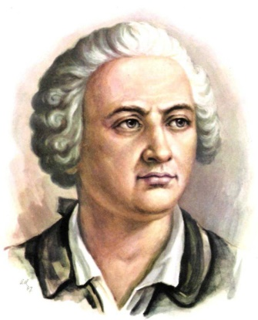**Mikhail Lomonosov**

Mikhail Lomonosov **was born** in 1711 in the family of a fisherman in the northern coastal village of Denisovka not far from Archangelsk. When he was ten years of age his father began to take him sea fishing. The dangerous life of a fisherman taught him to **observe the natural phenomena** more closely. During the long winter nights young Lomonosov studied his letters, grammar and arithmetic diligently.

**Being the son of a peasant**, he **was refused admission to** the local school. After some years, through **concealing his peasant origin**, he **gained admission to the Slavonic-Greek-Latin Academy** and for five years **lived a hand-to-mouth existence** on three kopecks a day. The **noblemen’s** sons studying with him made fun of the twenty-year-old giant who, in spite of the jeers and his own poverty, **made rapid progress**.

After five years came the chance of **entering the Academy of Sciences**, as there were not enough noble-born students to **fill the quota**. His **ability and diligence** attracted the attention of the professors and as one of three best students he **was sent abroad**. He spent all the time there studying the works of leading European scientists **in chemistry, metallurgy, mining and mathematics**. On his return to Russia in 1745 he was made a professor and was the first Russian scientist to become a member of the Academy of Sciences.

**For versatility** Lomonosov **has no equal in** Russian science. Many of his ideas and **discoveries** only **won recognition** in the nineteenth century. He was the first to discover **the vegetable origin of coal**, for instance, and as a poet and scientist he **played a great role in the formation of the Russian literary language, eliminating distortions** and unnecessary foreign words. He died in 1765. His **living memorial** is **the Moscow University**, which he **founded** in 1755.

***Topical Vocabulary***

**- to be born** родиться

**to observe the natural phenomena** наблюдать явления природы

**- to be the son of a peasant** быть сыном крестьянина

**to be refused admission to smth.** получить отказ в принятии в (какое-либо учреждение)

**to conceal one’s peasant origin** скрыть свое крестьянское происхождение

**to gain admission to the Slavonic-Greek-Latin Academy**

быть принятым в Славяно-греко-латинскую академию

**to live a hand-to-mouth existence** едва сводить концы с концами

**noblemen** знать, знатные люди

**to make rapid progress** делать быстрые успехи

**- to enter the Academy of Sciences** вступить в Академию наук

**to fill the quota** *зд.:* чтобы набрать нужное количество

**ability and diligence** способности и усидчивость

**to be sent abroad** послать за границу

**works in chemistry, metallurgy, mining and mathematics**

работы по химии, металлургии, горному делу и математике

**- for versatility** *зд.:* по количеству открытий

**to have no equal in smth.** не иметь равных в чем-либо

**a discovery** открытие

**to win recognition** получить признание

**the vegetable origin of coal** растительное происхождение угля

**to play a great role in smth.** играть большую роль в чем-либо

**the formation of the Russian literary language**

формирование русского литературного языка

**to eliminate distortions** устранить диспропорции

**one’s living memorial** «памятник», нечто, что увековечивает память

**to found the Moscow University** основать Московский университет

**Answer the questions:**

1. What kind of family was Lomonosov born in?  
   
2. What kind of childhood had he?  
   
3. How did he gain admission to the Slavonic-Greek-Latin Academy?  
   
4. What kind of existence did he live during his studies?  
   
5. Why was he able to enter the Academy of Sciences?  
   
6. What part did Lomonosov play in science?  
   

**Translate into English:**

1. Когда десятилетний Ломоносов стал выходить в море ловить рыбу, он научился наблюдать явления природы.
2. Ломоносову отказали в приеме в городскую школу.  
   
3. В течение пяти лет ему пришлось вести нищенское существование.  
   
4. Несмотря на возраст и бедность, Ломоносов делал быстрые успехи.  
   
5. Для заполнения вакансий в Академии наук было недостаточно знатных молодых людей, и Ломоносов поступил в Академию.  
   
6. За старательность и прекрасные способности Ломоносова послали за границу, где он изучал химию, металлургию, горное дело и математику.  
   
7. Ломоносову нет равных по количеству сделанных им открытий.  
   
8. Многие его открытия получили признание только в XX веке.  
   
9. Ломоносов сыграл большую роль в формировании русского литературного языка.

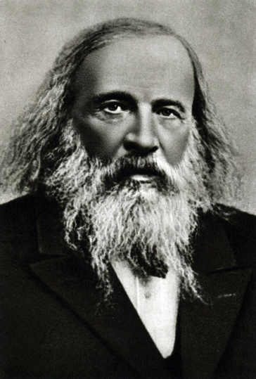**Dmitri Mendeleyev**

   In 1869 the great Russian scientist Dmitri Mendeleyev announced the discovery of the Periodic Law of elements. So science received the key to the secrets of matter.  
   All the greatest discoveries which have been made since then in the fields of chemistry and physics have been based on this law.  
   The elements in Mendeleyevs Periodic Table follow one another in the order of their atomic weights. They are arranged in periods and groups.  
   Mendeleyev s discovery made it possible for the scientists to find 38 new chemical elements to fill the empty spaces left in the Periodic Table.  
   At the same time they tried to find elements heavier than the last element in the Periodic Table.  
   In 1955 the American scientist Dr. Glenn Seabord obtained element No 101 and named it Mendelevium in honour of the creator of the Periodic Law.

1.Read and translate words and expressions, useyour dictionary. 1. inventor 2. periodic table of elements 3. approximately 4. blind 5. re-establish 6. belong 7. priest 8. Orthodox Church 9. science master 10. recovery 11. the capillarity of liquids 12.research 13.divorce 14.marriage 15.obtain

2.Read the text.If necessary, use a dictionary to betterunderstand the meaning of the text.  
  
Dmitri Ivanovich Mendeleev was born on 8 February 1834 near Tobolsk. He was a Russian inventor and chemist. The most famous invention of Mendeleev is periodic table of elements. Mendeleev’s parents were Maria Mendeleeva (nee Kornilieva) and Ivan Mendeleev. According to the different sources there were approximately seventeen children in their family. Mendeleev was the youngest child. His father worked as a teacher but he became blind and stopped working. As a result Maria Mendeleeva began to work and re-established the glass factory which belonged to her family. It is also known that Mendeleev’s grandfather was a priest of the Russian Orthodox Church. When Mendeleev was 13 when he entered the Gymnasium in Tobolsk. In 1849 his family moved to Saint Petersburg. In 1850 Mendeleev joined The Main Pedagogical Institute. Following the graduation he developed tuberculosis and was forced to relocate to the Crimean Peninsula. Living there, Mendeleev became a science master of the Simferopol gymnasium №1. In 1857 after recovery he arrived in Saint Petersburg. From 1859 to1861 Mendeleev worked in Heidelberg and researched the capillarity of liquids. In April 1862 he married Feozva Nikitichna Leshcheva. Two years later Mendeleev became a professor at the Saint Petersburg Technological Institute. In 1865 he became a professor at Saint Petersburg State University. The same year Mendeleev completed his dissertation «On the Combinations of Water with Alcohol». By 1871Saint Petersburg was known as a center for chemistry research. In 1876 Mendeleev fell in love with Anna Ivanovna Popova. In 1881 he made a proposal of marriage to her. The following year Mendeleev married her. The same year he divorced his first wife. Mendeleev had two children from his first marriage: Olga and Vladimir. His other children from the second marriage were Lyubov, a pair of twins and son Ivan.

In 1906 the Nobel Committee for Chemistry suggested to the Swedish Academy to award the Nobel Prize in Chemistry for 1906 to Mendeleev for his discovery of the periodic system. This proposal was approved. But at the full meeting of the Academy one of the members recommended the candidacy of Henri Moissan. More over Svante Arrhenius who had influence on the Academy also advised to reject the candidacy of Mendeleev. The contemporaries state that Arrhenius was against Mendeleev because of his critique of Arrhenius’s dissociation theory. As are result the candidacy of Mendeleev was rejected. Dmitri Mendeleev died of influenza in Saint Petersburg in 1907.  
  
3. Fill in the table:

|  |  |
| --- | --- |
| name |  |
| date of birth |  |
| place of birth |  |
| early years |  |
| later years |  |
| his family |  |
| famous for |  |
| date of death |  |

4. Answer the questions.

1. Who is  Dmitri Mendeleev?

2.How many children were there in Mendeleev`s family?

3. What do you know about Mendeleev`s father and grandfather?

4.What countries has Dmitri Mendeleev visited?

5.What do you know about Mendeleev`s wives  and his children?

Вставить слова в текст Dmitri Mendeleev is a great Russian scientist of the 19th century. He _____ as a great chemist who _____ the periodic classification of the elements Dmitri Mendeleev was born in Tobolsk in 1834.At school,Dmitri_____ in mathematics,physics,and geography but was not good at languages.In 1855 he graduated from the Pedagogical Institute in St Petersburg with a goid medal for his____.In 1856 , he_____in chemistry. Dmitri Mendeleev's contribution to the world's science was_____. He was the first____the dependence of the qualities of the elements on their atomic weight.He forecast that the gaps in the table of elements would be filled in by elements which______yet.Dmitri Mendeleev was greatl Element No 101 _____ him. It is called Mendelevium. Слова: Achievement create enormous member name after not discover receive a degree research succeed

Dmitri Mendeleev is a great Russian scientist of the 19th century. He is recognized as a great chemist who created the periodic classification of the elements. Dmitri Mendeleev was born it Tobolsk in 1834. At school, Dmitri succeed in mathematics, physics, and geography but was not good at languages. In 1855 he graduated from the Pedagogical Institute in St Petersburg with a gold medal for his achievements. In 1856, he received a degree in chemistry. Dmitri Mendeleev's contribution to the world's science was enormous. He was the first created the dependence of the qualities of the elements on their anatomic weight. He forecast that the gaps in the table of the elements would be filled in by elements which had not been discovered yet. Dmitri Mendeleev was greatly honoured as a member of academies in many countries. Elements No 101 was named after him.

**Писатели и поэты**

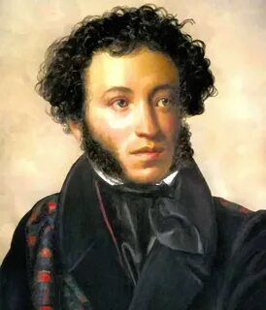Alexander Sergeevich Pushkin is a poet, writer, member of the Russian Academy of Sciences. He was born on May 26 (June 6), 1799 in Moscow.

Since 1811, he studied at the Tsarskoye Selo Lyceum near St. Petersburg, from which he graduated with the first graduation in 1817. After studying, he was appointed collegiate secretary to the College of Foreign Affairs, where he served until 1820.

He began writing poetry while still at the Lyceum, already then attracting the attention of the most prominent writers of that time. He was a member of the literary societies Arzamas and Green Lamp.

In 1820, Pushkin's poem "Ruslan and Lyudmila" was published, which was a huge success. In the same year, for his free—thinking poems, he was sent to the so-called "southern exile", exile - a forced business trip to the southern regions of the empire.

Since 1824, he was in exile at his mother's estate in the village of Mikhailovskoye near Pskov. He was friendly with many Decembrists, although he did not belong to their secret society. He was deeply worried about the arrest, death and exile of his comrad In 1831, Pushkin began researching the history of Peter I and the Pugachev rebellion, which formed the basis for the story "The Captain's Daughter". He re-joined the Board of Foreign Affairs with the right to work in the archives for his research.

In 1836, he founded the Sovremennik magazine, which published N.V. Gogol, P.A. Vyazemsky and others.

He died on January 29 (February 10), 1837 in St. Petersburg.

So let's see how you know Pushkin's biography.

Look at your sheets of paper. Choose the right answer.

Pushkin A.S. was born in:

A) 1811

B)1792

C) 1799

The family lived in:

A) St. Petersburg

B) Moscow

C)Boldino

The family was :

A) of upper-class

B) middle-class

C) poor

When Alexander was a boy he spent much time with:

A) his nurse

B) his mother

C) his granny

Pushkin studied in:

A) university

B) lyceum

C) school

After 6 years of study Pushkin began :

A) to work in a foreign office

B)military service

C) to teach children

In 1824 for his anti-tsarist poetry he was exiled (выслан) to :

A) Pskov

B) Novgorod

C) Mikhailovskoe

Pushkin fell in love with :

A) Anna Kern

B) Natalya Goncharova

C) Maria Volkonskaya

Pushkin died in 1837

A) after a serious illness

B) after a duel with Baron Georges d'Antes

And now check your answers. Look at the screen.

**4. Teacher:Your next task is to cross out the odd word:**

1) Alexander Sergeevich wrote:

|  |  |  |  |  |
| --- | --- | --- | --- | --- |
| Poems | poems in verse | stories | verse tales | fables |

2) The poet wrote about

|  |  |  |  |  |
| --- | --- | --- | --- | --- |
| Friends | love | Motherland | nature | space |

3)Pushkin was

|  |  |  |  |  |
| --- | --- | --- | --- | --- |
| Proud | lazy | curious | talented | hardworking |

4)A.Pushkin was influenced (находился под влиянием) by

|  |  |  |  |  |
| --- | --- | --- | --- | --- |
| Lord Byron | Zhukovsky | Batyushkov | Derzhavin | Shakespeare |

Let's check your answers.

**5. Чтение.**Read the titles of Pushkin's works (some of them are written in transcription) and translate them into Russian (work in pairs):

* Ruslan and Lyudmila
* The Robber Brothers
* The Fountain of Bakhchisarai
* The Gypsies
* Eugene Onegin
* Bronze Horseman
* The Tale about Tsar Saltan
* Little Tragedies
* The Stone Guest
* Boris Godunov
* Tales of the Late I.P.Belkin
* Dubrovsky
* The Captain's Daughter
* The Tale about Gold Fish

Please, read aloud these names.

Now divide these works by Pushkin into groups:

Prose works historical drama a novel in verse a verse tale poem.

Let's check your work.

Teacher: Well, we've revised some facts about Pushkin's life and his books. Now let's speak of what helped Pushkin to become such a good writer and poet. You will work in groups of four. Think it over and put down your ideas.

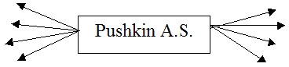

OK, it's time to discuss. (Students suggest their ideas)

To sum it up, Pushkin's family, a rich library at home, Alexander's nurse Arina Radionovna, study in the lyceum, good teachers, faithful friends, talent and persistence (настойчивость) influenced Pushkin.

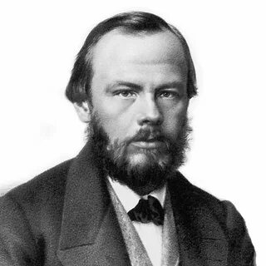 **Fiodor Dostoyevsky**

   Dostoyevsky is considered one of the greatest writers in world literature. Best-known for his novels "Crime and Punishment" (1866) and "The Brothers Karamazov" (1880), he attained profound philosophical and psychological insights which anticipated important developments in 20th century thought, including psychoanalysis and existentialism. In addition, Dostoyevsky s powerful literary depictions exerted a profound influence on modern writers, such as Franz Kafka, whose works further develop some of the Russian novelist's themes. The writers own troubled life enabled him to portray with deep sympathy characters who are emotionally and spiritually downtrodden and who in many cases epitomize the traditional Christian conflict between the body and the spirit.  
   Dostoyevsky grew up in a middle-class family in Moscow. His father, a doctor, was a tyrant toward his family, and his mother was a mild, pious woman who died before Dostoyevsky was sixteen.  
   Partly to escape the oppressive atmosphere of his father's household, the boy acquired a love of reading, especially the works of Nikolai Gogol, E. T. A. Hoffmann, and Honore de Balzac. At his fathers insistence, Dostoyevsky trained as an engineer in St. Petersburg. While the youth was at school, his father was murdered by his own serfs at the family's small country estate. Dostoyevsky rarely mentioned his father's murder, but Oedipal themes are recurrent in his work, and Sigmund Freud suggested that the novelist's epilepsy was a manifestation of guilt over his repressed wish for his fathers death.  
   Dostoyevsky graduated from engineering school but chose a literary career. His first published work, a translation of Balzac's novel "Eugenie Grander", appeared in a St. Petersburg journal in 1844. Two years later, he published his first novel, "Poor Folk" (1846), a naturalistic tale with a clear social message as well as a delicate description of life's tragic aspects as manifested in everyday existence.  
   The twenty-four-year-old author became an overnight celebrity when Vissa-rion Belinsky, the most influential critic of the day, praised Dostoyevsky for his social awareness and declared him the literary successor of GogoL Dostoyevsky joined Belinskys literary circle but later broke with it when the critic reacted coldly to his subsequent works. Belinsky judged the novel "The Double" (1846) and the short stories "Mr. Prokharchin" (1846) and "The Landlady" (1847) as devoid of a social message.  
   In 1848, Dostoyevsky joined a group of young intellectuals, led by Mikhail Petrashevsky, which met to discuss literary and political issues. In the reactionary political climate of mid-nineteenth-century Russia, such groups were illegal, and in 1849 the members of the so-called Petrashevsky Circle were arrested and charged with subversion. Dostoyevsky and several of his associates were imprisoned and sentenced to death.  
   As they were facing the firing squad, an imperial messenger arrived with the announcement that the Czar had commuted the death sentences to hard labor in Siberia. This scene was to haunt the novelist the rest of his life. Dostoyevsky described his life as a prisoner in "The House of the Dead" (1862), a novel demonstrating both an insight into the criminal mind and an understanding of the Russian lower classes.  
   While in prison the writer underwent a profound spiritual and philosophical transformation. His intense study of the "New Testament" the only book the prisoners were allowed to read, contributed to his rejection of his earlier liberal political views and led him to the conviction that redemption is possible only through suffering and faith, a belief which informed his later work.  
   Dostoyevsky was released from the prison camp in 1854; however, he was forced to serve as a soldier in a Siberian garrison for an additional five years. When Dostoyevsky was finally allowed to return to St. Petersburg in 1859, he eagerly resumed his literary career, founding two periodicals and writings articles and short fiction. The articles expressed his new-found belief in a social and political order based on the spiritual values of the Russian people.  
   These years were marked by further personal and professional misfortunes, including the forced closing of his journals by the authorities, the deaths of his wife and his brother, and a financially devastating addiction to gambling. It was in this atmosphere that Dostoyevsky wrote "Crime and Punishment". "Crime and Punishment" brought him acclaim but scant financial compensation. Viewed by critics as one of his masterpieces, "Crime and Punishment" is the novel in which Dostoyevsky first develops the theme of redemption through suffering. The protagonist Raskolnikov, whose name derives from the Russian word for schism or spiitis presented as the embodiment of spiritual nihilism.  
   The novel depicts the harrowing confrontation between his philosophical beliefs, which prompt him to commit a murder in an attempt to prove his supposed superiority, and his inherent morality, which condemns his actions.  
   In 1867, Dostoyevsky fled to Europe with his second wife to escape creditors. Although they were distressing due to financial and personal difficulties, Dostoyevsky's years abroad were fruitful, for he completed one important novel and began another. "The Idiot" (1869), influenced by Hans Holbein's painting "Christ Taken from the Cross" and by Dostoyevsky s opposition to the growing atheistic sentiment of the times, depicts the Christ-like protagonist and his experience of sin. Dostoyevsky s profound conservatism, which marked his political thinking following his Siberian experience provided the impetus for his great political novel "The Possessed" (1871-1872). Based on a true event, in which a young revolutionary was murdered by his comrades, this novel provoked a storm of controversy for its harsh depiction of ruthless radicals.  
   Dostoyevsky returned to Russia in 1871. In sympathy with the conservative political party, he accepted the editorship of a reactionary weekly, "The Citizen". In his "The Diary of a Writer" (1873-1877), initially a column in the "Citizen" Dostoyevsky published a variety of prose works, including some of his outstanding short stories.  
   Dostoyevski's last work was "The Brothers Karamazov" (1880), a family tragedy, which is viewed as one of the great novels of world literature. The novel recounts the murder of a father by one of his four sons. Initially, his son Dmytro is arrested for the crime, but as the story unfolds it is revealed that the illegitimate son Smerdyakov has killed the old man. Dostoyevsky envisioned this novel as the first of a series of works depicting the life of a great sinner, but early in 1881, a few months after completing "The Brothers Karamazov", the writer died at his home in St. Petersburg.  
   To his contemporary readers, Dostoyevsky appeared as a writer primarily interested in the terrible aspects of human existence. However, later critics have recognized that the novelist sought to plumb the depths of the psyche, in order to reveal the full range of the human experience, from the basest desires to the most elevated spiritual yearnings, Above all, he illustrated the universal human struggle to understand God and self.

1. Fill in the table:

|  |  |
| --- | --- |
| name |  |
| date of birth |  |
| place of birth |  |
| early years |  |
| later years |  |
| his family |  |
| famous for |  |
| date of death |  |

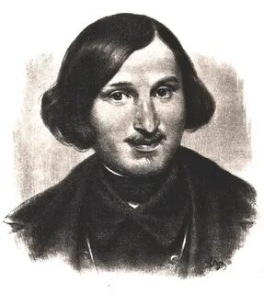**Nikolai Gogol**

   Nikolai Gogol was born in Sorochintsi, Ukraine, and grew up on his parent's country estate. His real surname was Ianovskii, but the writer's grandfather had taken the name "Gogol" to claim a nobel Cossack ancestry. Gogol's father was an educated and gifted man, who wrote plays, poems, and sketches.  
   Gogol started write while in high school. He attended Poltava boarding school (1819-1821) and Nezhyn high school (1821-1828). In 1829 he mowed to St. Petersburg. Gogol worked at minor governmental jobs and wrote occasionally for periodicals. Between the years 1831 and 1834 he taught history at the Patriotic Institute and worked as a private tutor.  
   In 1831, Gogol met Aleksander Pushkin who greatly influenced his choice of literary material, especially his "Dikan'ka Tales", which were based on Ukrainian folklore. Their friendship lasted until the great poet's death. In 1835, Gogol became a full-time writer.  
   Under the title "Mirgorod" (1835) Gogol published a new collection of stories. The book included the famous historical tale "Taras Bulba", which showed the influence of Walter Scott. The protagonist is a strong, heroic character, not very typical for the author's later cavalcade of bureaucrats, lunatics, swindlers, and losers.  
   "St. Petersburg Stories" (1835) examined disorders of mind and social relationships. "The Nose" was about a man who loses his nose and which tries to live its own life. In "Nevski Prospect" a talented artist falls in love with a tender poetic beauty who turns out to be a prostitute and commits suicide when his dreams are shattered. "The Diary of a Madman" asked why is it that "all the best things in life, they all go to the Equerries or the generals?" "The Overcoat" contrasted humility and meekness with the rudeness of the "important personage".  
   Gogol published in 1836 several stories in Pushkin's journal "Sovremennik" and in the same year appeared his famous play, "The Inspector General". It told a simple tale of a young civil servant, Khlestakov, who finds himself stranded in a small provincial town. By mistake, he is taken by the local officials to be a government inspector, who is visiting their province incognito. Khlestakov happily adapts to his new role and exploits the situation, but then arrives the real inspector.  
   Its first stage production was in St. Petersburg, given in the presence of the tsar. The tsar, as he left his box after the premiere, dropped the comment: "Hmm, what a play! Gets at everyone, and most of all at me!" Gogol, who was always sensitive about reaction to his work, fled Russia for Western Europe. He visited Germany, Switzerland, and France and settled then in Rome. He also made a pilgrimage to Palestine in 1848.  
  In Rome Gogol wrote his major work, "The Dead Souls". Gogol claimed that the story was suggested by Pushkin in a conversation in 1835. It depicted the adventures Pavel Ivanovich Chichikov, who arrives in a provincial town to buy "dead souls", dead serfs. By selling these "souls" with a cheaply-bought lands, Chichikov planned to make a huge profit. He meets local landowners and departs in a hurry, when rumours start spread about him.  
   Except for short visits to Russia in 1839-1840 and 1841-1842, Gogol was abroad for twelve years. The first edition of Gogol's collected works was published in 1842. It made him one of the most popular Russian writers. Two years before his return, Gogol had published "Selected Passages from Correspondence with Friends" (1847), in which he upheld the autocratic tsarist regime and the patriarchal Russian way of life. The book arose disappointment among radicals who had seen Gogol's works as examples of social criticism. In the play "Marriage" (1842) nearly everybody lies and the protagonist cannot make up his mind about marriage. He hesitates, agrees, then withdraws his promise.  
   In his later life Gogol came under influence of a fanatical priest, Father Konstantinovskii, and burned sequels for "Dead Souls", just 10 days before he died on the verge of madness on the 4th of March, 1852. Gogol had refused to take any food and various remedies were employed to make him eat. Rumors arise from time to time that Gogol was buried alive.

1. Fill in the table:

|  |  |
| --- | --- |
| name |  |
| date of birth |  |
| place of birth |  |
| early years |  |
| later years |  |
| his family |  |
| famous for |  |
| date of death |  |

**Художники**

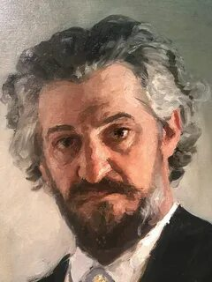**Ilia Repin**

   Ilia Efimovich Repin was born in 1844 in a small Ukrainian town of Tchuguev in the family of a military settler. As a boy he was trained as an icon painter. At the age of 19 he entered the St. Petersburg Academy of Arts. His arrival to the capital coincided with an important event in artistic life of the 60s, the so-called "Riot of the Fourteen" when 14 young artists left the Academy having refused to use mythological subjects for their diploma works. They stood on the point that art should be close to real life. Later Repin would be closely connected with some of them, the members of the Society of Peredvizhniky.  
   For his diploma work (1871) Repin was awarded The Major Gold Medal and received a scholarship for studies abroad. "Barge Haulers on the Volga" (1870-1873) was the first considerable work painted by Repin after graduation. It immediately won recognition. In 1873, Repin went abroad. For some months he had been travelling in Italy and then settled and worked in Paris up to 1876.  
   It was in Paris that he witnessed the first exhibition of the Impressionists, but, judging by the works created then and by his letters home, he didn't become the ardent follower of this new Paris school of painting, though he didn't share the opinion of some of his country-men who saw a dangerous departure from "the truth of life" in Impressionism.  
   After returning to Russia Repin settled in Moscow. He was a frequent visitor in Abramtsevo — the country estate of Sawa Mamontov, one of the most famous Russian patrons of art. It was a very fruitful period in his creative activity. During 10-12 years Repin created the majority of his famous paintings.  
   In 1877, he started to paint religious processions (krestny khod): "Khrestny Khod (Religious Procession) in Kursk Gubernia" (1880-1883). The composition was based on the dramatic effect of different attitude of the participants of the procession to the wonder-working icon carried at the head of the procession. There were two different versions of the picture. The second one, completed in 1883, became the most popular. At first glance, the spectator discovers an abundance of social types and human characters in the crowd.  
   A series of paintings devoted to the revolution theme deserves special attention. The artist was no doubt interested in creating the character of a fighter for social justice. The range of social, spiritual and psychological problems, which attracted Repin, is revealed in his works: "Unexpected Return" (1884) and "Refusal from the Confession" (1879-1885).  
   Repin is the author of many portraits, which are an essential part of his artistic heritage. Repin never painted faces, he painted real people, managing to show their natural state, to reveal their way of communicating with the world: "Portrait of the Composer Modest Musorgsky" (1881), "Portrait of the Surgeon Nikolay Pirogov" (1881), "Portrait of the Author Alexey Pisemsky" (1880), "Portrait of the Poet Afanasy Fet" (1882), "Portrait of the Art Critic Vladimir Stasov" (1883), and "Portrait of Leo Tolstoy" (1887) and many others are distinguished by the power of the visual characteristic and the economy and sharpness of execution.  
   Repin rarely painted historical paintings. The most popular in this genre is "Ivan the Terrible and his son Ivan" (1895). The expressive, intense composition and psychological insight in rendering the characters produced an unforgettable impression on the spectators. Another popular work of the genre is "The Reply of the Zaporozhian Cossacks to Sultan Mahmoud IV" (1880-1891). The faithfully rendered spirit of the Zaporoguus freemen, who, according to the artist, had a particularly strong sense of "liberty, equality and fraternity" undoubtedly gives the picture its significance. The contemporaries saw it as a symbol of the people throwing off their chains.  
   The last quarter of the 19th century is the best period in Repins work, though his creative activity continued in the 20th century (the artist died in 1930), he did not paint any masterpieces then. After the bolsheviks' revolution in 1917 he lived and worked in his estate Penates in Finland. There is a Repin museum. The museum visitors have the opportunity of gaining a knowledge of the artists life and work.

**Композиторы**

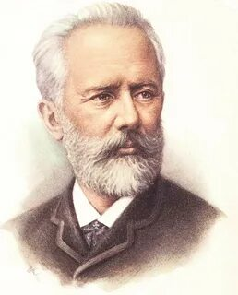**Peter Tchaikovsky**

Almost everybody knows "The Nutcracker Suite" with its "Dance of the Sugar Plum Fairy" and "Waltz of the Flowers" "The Nutcracker Suite" was written as a ballet, but many more people have heard the music than have seen the ballet. Some of Tchaikovsky's other compositions are well-known too. Among them are the "Swan Lake" and "Sleeping Beauty" (ballets), the "Romeo and Juliet" (overture), the "Eugene Onegin", "Mazzeppa" "Iolanta" "The Queen of Spades" (operas) and the Symphony N 6; called the "Pathetic".  
Many of Tchaikovsky's writings are very tuneful. Several popular songs have tunes borrowed from them.  
Tchaikovsky was born in a small town in the Ural mountains. His father was a mining engineer. As a boy Tchaikovsky loved music, but he did not think of giving his life to it. He planned to be a lawyer. When he was old enough, he began to study law.  
But at 21 he decided that music was much more interesting and entered the conservatory at St. Petersburg. After he graduated five years later, he was made a professor in Moscow Conservatory. Along with his teaching, he wrote a great deal of music.  
His compositions are so popular now that it is hard to believe that at first they were not at all popular. But for ten years all his operas were failures and no one paid much attention to anything else he wrote.  
As a result of his unhappiness and lack of success, he became ill and had to give up his teaching.  
At last his music won the praise it deserved. Tchaikovsky was only 53 when he died, but he lived long enough to know that his music was being played far and wide over the world.

Известные российские спортсмены.

** Ilia Kovalchuk**

1. **Read the words, try to remember their meanings:**

|  |  |  |
| --- | --- | --- |
| 1. **team** – команда  2. **probably** – возможно,вероятно  3. **invite** - приглашать  4. **sign** - подписывать  5. **win** (won, won) - выигрывать  6. **member** - член,участник | 7. **honor -**почитать,чтить,уважать,чествовать  8. **gain** – получить,достигнуть  9. **silver** – серебро  10. **savage** – дикий  11. **be afraid** – бояться  12. **respect** – уважать  13. **participate** –принимать участие | 14. **charity event** – благотворительное мероприятие  15. **celebrity** – знаменитость  16. **spectacular** - впечатляющий |

1. **Read and translate the text:**

Ilia Kovalchuk started his hockey career when he was 16 years old in Tver. At first time he was a player of the famous Moscow team ‘Spartak’. He is a fantastic hockey player and he is loved by Russians so much. Probably, it is because he is the first Russian player invited in NHL in 2001. Ilia played in such Russian hockey teams as “Spartak”, “Akbars” and “SKA”, but he also signed some contracts with teams of USA and played in “Atlanta” and “New Jersey”. Ilia is also known as a finalist of the Stanley Cup.

Besides, his team won a bronze medal at the 2002 Winter Olympic Games and Ilia has been a member of Russian Olympic team three times at least. Ilia has been honoured with the Master of Sports title. In 2015 he gained silver medals of the World Championship.

Ilia is a very handsome and charismatic man. He is really tall (191 cm) and big (100 kg) like a savage Russian bear. His position in the team is forward. Competitors are afraid of him, but he respected by his partners and hockey fans.

By the way, Ilia Kovalchuk participates in different charity events with other celebrities. He is favourable guest on every party. Ilia is known as an sociable sportsman. That’s why SKA twitter gets more than 100 000 followers.

Such people as Mr. Kovalchuk can make every game more spectacular and interesting. He is not only a clever, nice and charming man but a great professional in the hockey sphere.

1. **Answer the questions:**
2. Who is Ilia Kovalchuk?
3. Where did he start his hockey career?
4. Which Russian teams did Ilia Kovalchuk play in?
5. Which American teams did Ilia Kovalchuk play in?
6. What sports achievements of Ilia Kovalchuk did you learn about?
7. What does Ilia Kovalchuk look like?
8. What kind of person is Ilia?
9. **Mark the sentences True or False:**

1. Ilia Kovalchuk started his hockey career when he was sixty years old.

2. Ilia holds the title of Master of Sports.

3. Ilia is a very sociable person.

4. In 2015 he gained gold medals of the World Championship.

5. Ilia played in CSK.

1. **Think about what 2-3 questions would you like to ask Ilia Kovalchuk? Write them down.**
2. **Find the verbs used in Past Simple in the text and write them down in a table in two columnsas shown in the example.The first column is for regular verbs, the second for irregular verbs.**

|  |  |
| --- | --- |
| **Regular verbs** | **Irregular verbs** |
| **start (started)** | **be (was, were)** |
| **...** | **...** |
| **...** | **...** |

## Итоговый тест

## 1. Let's start with an easy one! This person was the first human to fly into space and orbit the earth in a man-made spacecraft, leading the world into the era of the space exploration.

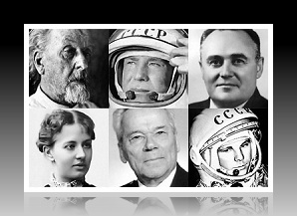

Начало формы

* Sergey Korolev
* Aleksey Leonov
* Yuri Gagarin
* Gherman Titov

## 2. This woman won her first Wimbledon Championship at the age of 17 and became the first Russian female tennis player to claim the #1 ranking in the world.

Начало формы

Anna Kournikova

Maria Sharapova

Anastasia Myskina

Alina Kabayeva

**3. This Russian writer is the world's greatest novelist of all time. His masterpieces vividly depict the 19th-century Russian life and attitudes. His later novels had a profound influence on the development of Christian anarchist thought.**

Начало формы

Mikhail Bulgakov

Vladimir Nabokov

Anton Chekhov

Leo Tolstoy

**4. This Russian-American computer scientist was born in Moscow on August 23, 1973 to a Jewish family. When he was six, his family emigrated to the USA. He studied at Stanford and co-founded a company that has grown to become the largest media company in the world.**Начало формы

Grigori Perelman

Yevgeny Kaspersky

Sergey Brin

Yuri Milner

**5. This Russian actor and theatre director is defined by many as the father of psychological realism in acting. His system has become known worldwide as one of the most effective in the study of the art of acting.**Начало формы

Andrey Tarkovsky

Konstantin Stanislavsky

Yury Nikulin

Andrey Konchalovsky

**6. This political leader is one of the most controversial and enigmatic figures in Russian history and is still the subject of fierce discussions. He created a cult of personality in the Soviet Union around him name. Many personality cults in history have been frequently measured and compared to his.**Начало формы

* Vladimir Lenin
* Nikita Khrushchev
* Mikhail Gorbachev
* Joseph Stalin

7. "This person was the most insightful and époque-making dramatist in Russia. Aside from many notable short stories, he produced a few dramas that strike with their originality and subtlety. In drama, he emerged as an innovator with the first of his four major plays, ''The Seagull''."

* Anton Chekhov
* Leo Tolstoy
* Vladimir Nabokov
* Fyodor Dostoevsky

8. This ballet dancer turned actor is widely considered to be one of the biggest names in the contemporary dance world. He made his cinema debut in the film The Turning Point in 1977. He also played a Russian artist in the a widely popular Sex and the City TV series.

* Nikolay Tsiskaridze
* Rudolph Nureyev
* Vatslav Nizhinsky
* Mikhail Baryshnikov

9. This woman is Russia's most successful rhythmic gymnast to date. Her career wins include 18 World Championship medals, 2 Olympic medals and 25 European Championship medals. Apart from being an impressively successful gymnast and an attractive woman, she is also an active public figure. After joining the United Russia party in 2001, her political career saw a steep ascent.

* Svetlana Khorkina
* Maria Sharapova
* Irina Tchashchina
* Alina KabayevaКонец формы

Конец формы

**10. This person is Russia's most famous fashion designer and the only Russian designer to be honored with membership in the Syndicate of High Fashion in Paris. In 1994 and 1996 he dressed Russia's Olympic team. He also designed the uniforms for the Russian air company Aeroflot and the staff of the Hotel Ukraine in Moscow. He is now working on creating new uniforms for the Russian Army.**

* Начало формы
* Slava Zaitsev
* Sergey Zverev
* Valentin Yudashkin
* Dima Bilan

## 11. This person is generally recognized as one of the greatest composers of the 20th century, known for his many symphonies and string quartets. He is the author of fifteen wide-ranging symphonies, from the First Symphony of 1925 to the embittered Thirteenth based on the poetry of Evgeny Yevtushenko.

* Начало формы
* Igor Stravinsky
* Feodor Chaliapin
* Dmitri Shostakovich
* Mikhail Glinka

Приложение 2

* Конец формы

Конец формы

Конец формы

Конец формы

Конец формы

Конец формы

Тема: «Выдающиеся люди зарубежных стран»

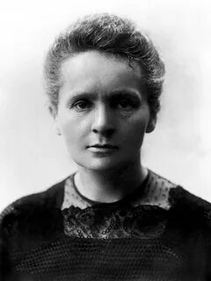**Marie Sklodowska Curie**

Marie Sklodowska Curie was a Polish and naturalized-French physicist and chemist who conducted pioneering research on radioactivity. She was the first woman and only woman to win twice, and the only person to win a Nobel Prize in two different sciences. She was part of the Curie family legacy of five Nobel Prizes. She was also the first woman to become a professor at the University of Paris, and in 1995 became the first woman to be entombed on her own merits in the Panthéon in Paris.

Her achievements included the development of the theory of radioactivity (a term that she coined), techniques for isolating radioactive isotopes, and the discovery of two elements, polonium and radium. Under her direction, the world's first studies into the treatment of neoplasms were conducted using radioactive isotopes. She founded the Curie Institutes in Paris and in Warsaw, which remain major centres of medical research today. During World War I she developed mobile radiography units to provide X-ray services to field hospitals.

Marie Curie died in 1934, aged 66, at a sanatorium in Sancellemoz (Haute-Savoie), France, of aplastic anemia from exposure to radiation in the course of her scientific research and in the course of her radiological work at field hospitals during World War I.

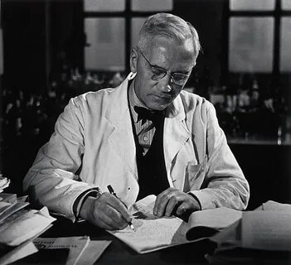**Alexander Fleming**

Alexander Fleming, the discoverer of penicillin, was born in Scotland in 1881 at a farm. He began to go to school when he was five. In 1895 he went to London and decided to dedicate his life to medicine. At first Fleming wanted to become a surgeon but soon he got interested in bacteriology and decided that he was to find his future in research. Sir Alexander Fleming did not have the life which was outwardly very exciting. He spent his working hours in hospitals and laboratories. He went from home to his laboratory every morning and went home from his laboratory every night. He sat in front of his fire and talked to his wife. He taught his son to swim and to fish. It was life that did not seem to be different from the life of the bank manager or the office worker. But it was not so. The great work that he did was done for the benefit of sick men and women. His discovery of penicillin did more to help suffering mankind than anything else for centuries. When he died in 1955 his old friend said: "…by his work he relieved more suffering than any other living man."

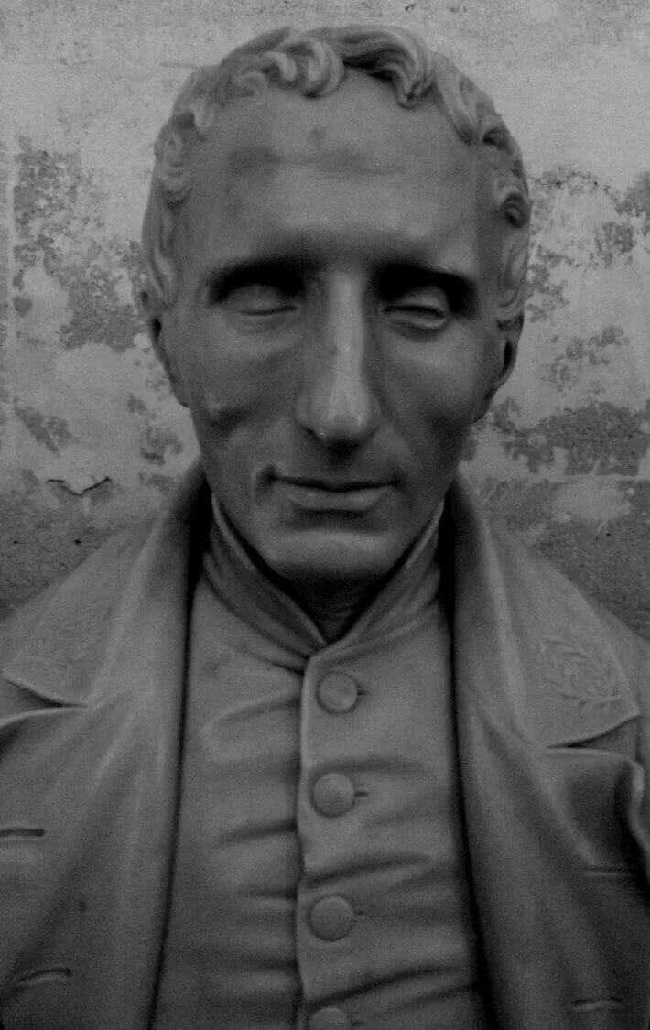 **Louis Braille**

Louis Braille was a French educator and inventor of a system of reading and writing for use by the blind or visually impaired. His system remains virtually unchanged to this day, and is known worldwide simply as braille.

Blinded in both eyes as a result of an early childhood accident, Braille mastered his disability while still a boy. He excelled in his education and received a scholarship to France's Royal Institute for Blind Youth. While still a student there, he began developing a system of tactile code that could allow blind people to read and write quickly and efficiently. Inspired by the military cryptography of Charles Barbier, Braille constructed a new method built specifically for the needs of the blind. He presented his work to his peers for the first time in 1824.

In adulthood, Braille served as a professor at the Institute and had an avocation as a musician, but he largely spent the remainder of his life refining and extending his system. It went unused by most educators for many years after his death, but posterity has recognized braille as a revolutionary invention, and it has been adapted for use in languages worldwide.

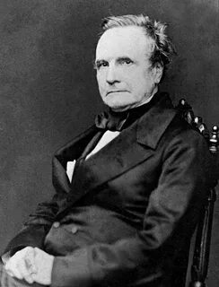**Charles Babbage**

British mathematician and inventor, who designed and built mechanical computing machines on principles that anticipated the modern electronic computer. Babbage was born in Teignmouth, Devon, and educated at the University of Cambridge. He became a Fellow of the Royal Society in 1816 and was active in the founding of the Analytical, the Royal Astronomical, and the Statistical Societies.

In the 1820s Babbage began developing his Difference Engine, a mechanical device that could perform simple mathematical calculations. Although Babbage started to build his machine, he was unable to complete it because of a lack of funding. In the 1830s Babbage began developing his Analytical Engine, which was designed to carry out more complicated calculations, but this device was never built, too. Babbage's book, «Economy of Machines and Manufactures» (1832), initiated the field of study known today as operational research.

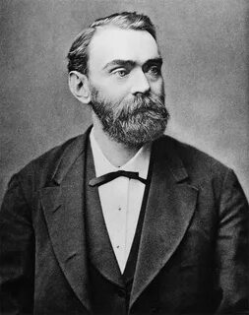 ALFRED NOBEL – MAN OF CONTRASTS

Alfred Nobel, the great Swedish inventor and industrialist, was a man of many contrasts. He was the son of a bankrupt, but became a millionaire, a scientist with a love of literature, an industrialist who managed to remain an idealist. He made a fortune but lived a simple life, and although cheerful in company he was often sad in private. A lover of mankind, he had a wife or family to love him; a patriotic son of his native land, he died alone on foreign soil. He invented a new explosive, dynamite, to improve the peaceful industries of mining and road building, but saw it used as a weapon of war to kill and injure his fellow men. World-famous for his works he was never personally well-known for throughout his life he avoided publicity.

Alfred Nobel was born in Stockholm on October 21, 1833 but moved to Russia with his parents in 1842, where his father, Inmanuel, made a strong position for himself in the engineering industry. But soon he went bankrupt and returned to Sweden where Alfred began his study of explosives in his father’s laboratory. He had never been to school or University but had studied privately and by the time he was twenty was a skilful chemist and excellent linguist, speaking Swedish, Russian, German, French and English. Like his father, Alfred was imaginative and inventive, but he had better luck in business and showed more financial sense. He was quick to see industrial openings for his scientific inventors and built up over 80 companies in 20 different countries. Indeed his greatness lay in his outstanding ability to combine the qualities of an original scientist with those of a forward-looking industrialist.

His greatest wish was to see an end of wars, and thus peace between nations, and he spent much time and money working for this cause until his death in Italy in 1896. His famous will, in which he left money to provide prizes for outstanding works in Physics, Chemistry, Physiology, Medicine, Literature and Peace is the memorial to his interests and ideas.

**Your task is to put Names, Country&Occupation, Inventions in right order.**

|  |  |  |
| --- | --- | --- |
| Name | Country&Occupation | Invention |
|  |  |  |
|  |  |  |
|  |  |  |
|  |  |  |

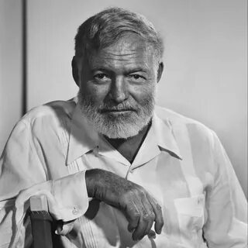**ERNEST HEMINGWAY**

When the sad news of Hemingway’s death was announced in July, 1961 many people left that the world last one of the most outstanding writers of the 20th century.

Hemingway was born in Oak Park near Chicago, USA in 1899. He began to write fiction in 1923, his first books were the reflection of his war experience. The novels “The Sun Also Rises”(1926) and “Farewell to Arms”(1929) in which the anti-war protest is a particularly powerful belong to this period.

As a boy, Hemingway spent much time hunting, finishing and exploring in the mild country of northern Michigan.

In later years, he was attracted to bullfighting in Spain, and big game-hunting in Africa.

Hemingway was a brave soldier. He fought in Italy during World War I. In 1936 – 1938 he took part in the Spanish Civil War as a war correspondent. More then anything else he hated war and fascism. His impressions and his sympathies which were on the side of the Republicans – found reflection in the famous play “The First Column” and in a number of short stories.

For many years Hemingway lived in Cuba and was a friend of the people of this beautiful island. His last works are “Across the River and Into the Trees” and

“The Old Man and the Sea” which was awarded the Nobel Prize.

Once he said: “The main critics of one’s work are the mind and the heart. Perhaps the heart even more than the mind … because the mind can sometimes agree to a compromise, but the heart – never! The truth – only the truth – that is what one must write ”.

Hemingway’s work have great truth in them; truth about people and the world.

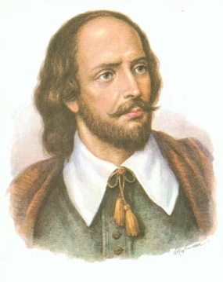**WILLIAM SHAKESPEARE**

William Shakespeare is the greatest of all playwright and poets of all times. Not much is known of his life. He was probably the son of a businessman and was born in 1564 in Stratford-upon-Avon. He probably attended the local grammar school and got a classical education. In 1582 he married Anne Hathaway and had three children. Little is known of his life before 1592, when he appeared as a playwright in London. Soon he became an actor playing supporting roles like the ghost in “Hamlet”. In 1599 Shakespeare became a part owner of the Globe Theatre in London.

Shakespeare’s work as a playwright is subdivided into three periods. Written in the first periods, Shakespeare’s plays are mostly history plays like “Henry VI”, and comedies with strong elements of farce (“The Comedy of Errors”). His masterpiece of this period is “Romeo and Juliet”. In the second period Shakespeare wrote a number of comedies where he moved away from farce towards romance.(“As You Like It”). In the third period, after 1600, appeared his major tragedies – “Hamlet”, “Othello”.

Shakespeare was a great poet and would be well known for his poetry alone. His major achievements as a poet in his sonnets, first published in 1609. A sonnet is a poem consisting of 14 lines, with a moral at the end. The sonnets are addressed to some “W. H.” And to the mysterious “Dark Lady of Sonnets”. The sonnets deal with the great themes of love, friendship, death, change and immorality. Shakespeare’s sonnets are excellent. They are full of harmony and music; they praise love, friendship and beauty.

Many centuries have passed since his death in 1616, but Shakespeare is still considered to be the greatest of all playwrights and poets.

*Answer the questions:*

1. What is Shakespeare famous for?
2. What is known of Shakespeare’s early years?
3. What kind of plays did he write during the first period of his work?
4. What kind of comedies did he create in the second period?
5. What kind of plays did he write during the third period?
6. What is Shakespeare’s major achievements as a poet?
7. How can you define a sonnet?
8. What themes do Shakespeare’s sonnets deal with?
9. Why is Shakespeare still considered the greatest of all poets?

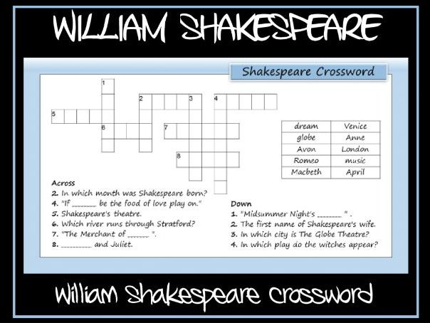

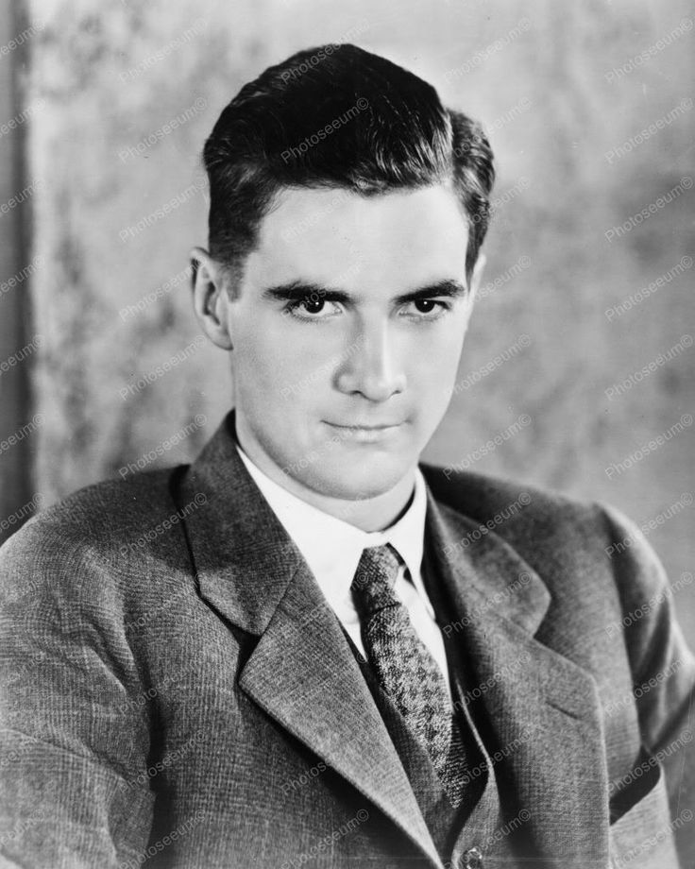 Howard Hughes

People say that money cannot buy happiness. This was true for Howard Hughes. He was one of the richest and most powerful men of his time. He had everything: good looks, charm, success, power, and a lot of money. But he didn't have love or friendship because he couldn't buy them. All his life he used his money to control everything and everyone around him. In the end, he lost control of everything, even himself.

Howard Hughes was born in 1905 in Houston, Texas. His father started the Hughes Tool Company. He was a *workaholic* and made a lot of money. He bought everything he wanted. He even gave money to schools so Howard could get into them. From his father, Howard learned to be a successful but *ruthless* businessman. Hughes's mother, Allene, also had a big influence on his life. Howard was her only child. She protected him and gave him everything. Unfortunately, Allene had mental problems. She was afraid of *germs* and disease. She *was* *obsessed* with Howard's health, and he became obsessed with it too.

Allene died when Howard was 16 years old. Two years later his father died. Hughes *inherited* Hughes Tool Company. Then he married Ella Rice. He and Ella moved to Los Angeles, California. It was there that Howard Hughes began to become a legend.

Hughes began to invest his money in movies. He became an important producer soon after he moved to California. He worked hard, but he also played hard. He became obsessed with power and control. When he couldn't get something legally, he gave money to politicians and businessmen so they would help him. He owned a lot of businesses, including airplane companies, a movie studio, Las Vegas hotels, gold and silver mines, and radio and television stations. Once he bought a television studio so he could watch movies all night. He also bought a hotel because he wanted to stay in his favourite room for one weekend.

Hughes loved the wild Hollywood life and dated many famous movie stars. Of course, his *marriage* ended very quickly. He asked every woman to marry him on the first date. Hughes used people for his pleasure and didn't *treat* them very well, so he had no real friends.

Howard Hughes loved fast cars and airplanes. He was a *daredevil* pilot and risked his life many times. He *set* many flying *records*, including the fastest flight around the world at the time. Reporters loved to write about the rich playboy pilot. But Hughes's love of adventure also hurt him. He was in many airplane and car *crashes* - 14 in all. Once he almost died when his plane crashed into a house. Hughes had serious physical and *mental* problems because of these accidents.

Hughes was very *eccentric*. Every day he got worse and worse. He had the same dinner every night: a steak, a baked potato, and 12 peas. As Hughes got older, his *behavior* became even more strange. Once he stayed in the same room for two and a half years. He was afraid of germs too. Howard Hughes died on an airplane in 1976. He was on the way to see a doctor. He was very sick from living such a strange life. Sadly, the rich, playboy lost his mind, his health, and his *dignity*. He loved no one and no one loved him. Howard Hughes had bought everything in his life, except happiness.

|  |  |
| --- | --- |
| *Workaholic*  *Ruthless*  *Germ*  *To obsess*  *To inherit*  *To treat*  *Daredevil*  *Crash*  *Mental*  *Eccentric*  *Dignity*  *Marriage*  *To set records*  *Behavior* | *- трудоголик*  *- безжалостный*  *- зародыш*  *- преследовать*  *- унаследовать*  *- обращаться, обходиться*  *- отчаянно смелый*  *- авария*  *- умственный, психический*  *- странный*  *- достоинство*  *- свадьба*  *- установит рекорды*  *- поведение* |

|  |  |  |  |
| --- | --- | --- | --- |
| **Чтение с пониманием основного содержания** | | | |
| 1.Предтекстовый | **Задачи этапа**  Побудить к прогнозированию содержания текста          Обеспечить осознание коммуникативной задачи, нацеливающей на то, как читать  Предоставить возможность снять часть трудностей | **Действия учителя**  - Today we will read the text about Howard Hughes. First of all look at the pictures and answer the questions. What is this text about?      - Now you will read this text. You should understand the main idea of this text and the hot facts.    - First of all let’s read the new words after the text. | **Действия учащихся**  Смотрят на картинки к тексту и предполагают о чем этот текст.  “I think this text is about famous person, his life and work”  “This text is about the life way of Howard Hughes”  “To my mind this text is about love, family and friends of Howard Hughes”          Читают новые слова после текста:   |  |  | | --- | --- | | *Workaholic*  *Ruthless*  *Germ*  *To obsess*  *To inherit*  *To treat*    *Daredevil*    *Crash*  *Mental*    *Eccentric*  *Dignity*  *Marriage*  *To set records*    *Behavior* | *трудоголик  безжалостный  зародыш преследовать унаследовать*  *обращаться, обходиться*  *отчаянно смелый*  *авария*  *умственный, психический странный достоинство свадьба*  *установит рекорды*    *поведение* | |
| 2. Текстовый | Нацелить на чтение текста с разной степенью проникновения в его содержание и смысл.  Нацелить на информационную переработку текста в процессе чтения с целью его лучшего понимания | - Now you will read this text one time, look at the new words and the pictures to understand the text. If you don’t know the words look through the dictionary.    - And now tell me. What is this text about? | Читают текст один раз, используя словарь при необходимости.        Говорят о чем этот текст:  “This text is about Howard Hughes, his life and work”  “This text is about the life way of Howard Hughes” |
| 3. Проверка понимания текста | Осуществить контроль полноты и адекватности понимания содержания и смысла текста в зависимости от смысла чтения | - Now I will read some facts about Hughes and you should agree or disagree with them:  He was one of the richest and most powerful men of his time.  He had everything: good looks, charm, success, power, and a lot of money.  Howard Hughes was born in 1905 in Canada.  From his father, Howard learned to be a successful but *ruthless* businessman.  He didn’t become an important producer after he moved to California.  Hughes loved the wild Hollywood life and dated many famous movie stars.  He *set* many flying *records*, including the fastest flight around the world at the time.  - Now I will read the sentences, if you agree with them you should raise your hand:  All his life he used his money to control everything and everyone around him.  Allene died when Howard was 20 years old.  When he couldn't get something legally, he gave money to politicians and businessmen so they would help him.  As Hughes got older, his *behavior* became even more strange.  Hughes hadn’t  bought everything in his life, except happiness. | Соглашаются / не соглашаются с фразами, зачитываемых учителем (I agree / disagree)    I agree. He was one of the richest and most powerful men of his time.  I agree. He had everything: good looks, charm, success, power, and a lot of money.    I disagree. Howard Hughes was born in 1905 in Houston, Texas.   I agree. From his father, Howard learned to be a successful but *ruthless* businessman.    I disagree. He became an important producer soon after he moved to California.    I agree. Hughes loved the wild Hollywood life and dated many famous movie stars.    I agree. He *set* many flying *records*, including the fastest flight around the world at the time.            Поднимают руку |
| 4. Информационная переработка текста | Повторно вернуться к тексту и информационно его переработать.  Присвоить информацию и языковые средства, необходимые для совершенствования иноязычной коммуникативной компетенции | - Now tell me, please, another name of this text.        - And now make up the plan of this text (5 points).          - Now answer the questions:  1. Was Hughes the richest man in the word? 2. What was his family? 3. What did he love?  4. Why wasn’t he happy? | Придумывают собственный заголовок текста:  “Howard’s life”  “A rich but a sad man”  “A strange man”  “Howard is the rich man”  Составляют план текста (5 пунктов):  1. His family  2. He is an important producer  3. He and his women  4. His dinner  5. His death  Yes, he was. He was the richest man.  His father started the Hughes Tool Company. He was a *workaholic* and made a lot of money. He bought everything he wanted. He even gave money to schools so Howard could get into them.  His mother protected him and gave him everything. Unfortunately, Allene had mental problems. She was afraid of *germs* and disease. She *was* *obsessed* with Howard's health, and he became obsessed with it too.  Hughes loved the wild Hollywood life and dated many famous movie stars.  He loved money.  He loved no one and no one loved him. Howard Hughes had bought everything in his life, except happiness. |
| 5.  Совершенствование иноязычной коммуникативной компетенции | Обеспечить осознание коммуникативной задачи, нацеливающей на совершенствования иноязычной коммуникативной компетенции на основе текста или в связи с текстом | - Tell me please your opinion of this text.              - What is the main idea of this text?        - And now tell me about this man, only main ideas. | Высказывают свое мнение о тексте:  “I like this text. It’s very interesting. It teaches us how to live”.  “I like this text, too. I want to be like Hughes”.  “I have learnt new information about this man”.  Говорят основную мысль текста:  “The main idea of this text is to know the prize of big money”.  “The main idea of this text is to show the grief of the rich man”.  Howard Hughes was born in 1905 in Houston, Texas. His father started the Hughes Tool Company. Allene died when Howard was 16 years old. Two years later his father died. Hughes *inherited* Hughes Tool Company. Then he married Ella Rice. He and Ella moved to Los Angeles, California. It was there that Howard Hughes began to become a legend. He owned a lot of businesses, including airplane companies, a movie studio, Las Vegas hotels, gold and silver mines, and radio and television stations. Howard Hughes loved fast cars and airplanes. He was a *daredevil* pilot and risked his life many times. He *set* many flying *records*, including the fastest flight around the world at the time. Howard Hughes died on an airplane in 1976. |