TIME TEST
- Write the time in numbers.
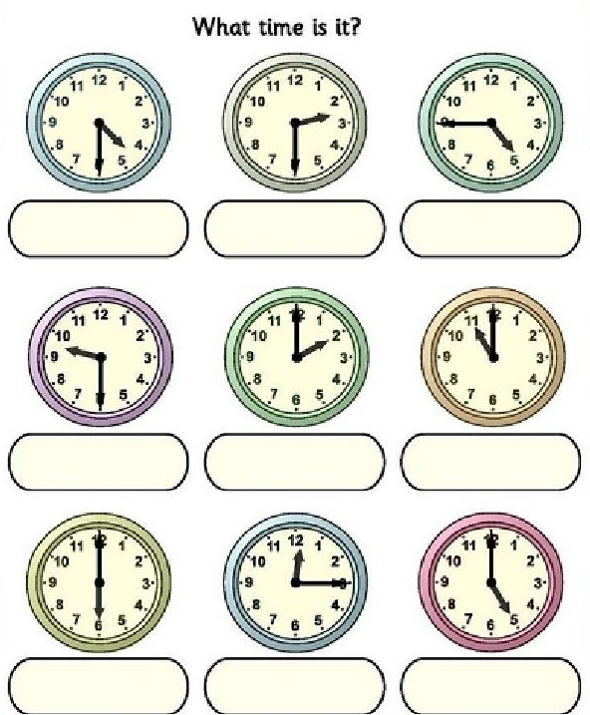
- Read, look and write the letters.
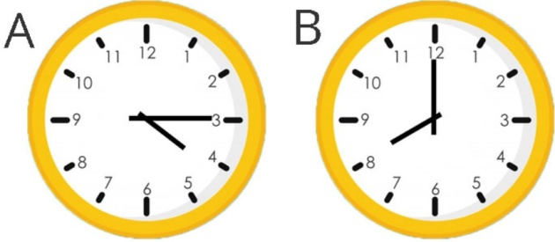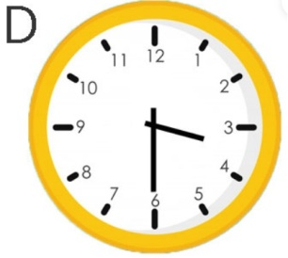  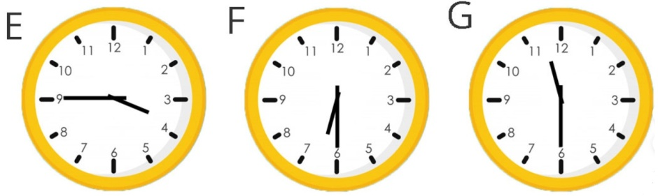 | - It's quarter to four. ____  - It's half past eleven. ____  - It's half past six. ____  - It's quarter past four. ____  - It's eight o'clock. ____  - It's half past three. ____

- Look at the timetable and match the questions with the time
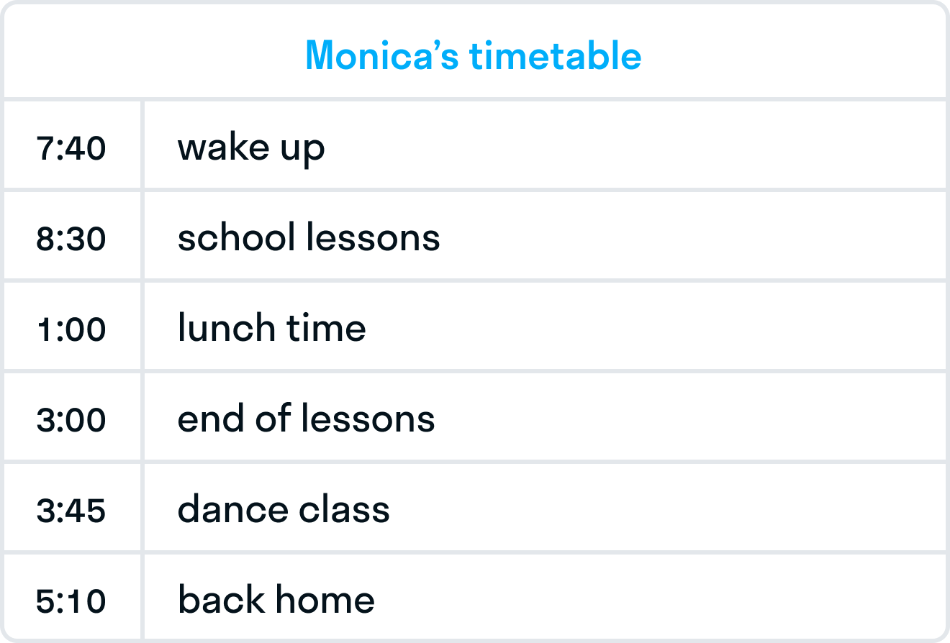
- When do Monica's lessons finish?  - What time does Monica wake up?  - What time do lessons start?  - What time does Monica have dance class?  - What time does she come home?  - What time does she have lunch? | At one o'clock.  At twenty to eight.  At quarter to four.  At half past eight.  At ten past five.  At three o'clock.

- Look at the to-do list and fill in the gaps.
Mike's to-do list:
✘ call a friend;
✔ go to the greengrocer's;
✘ buy some bread at the baker's;
✘ help sister to do a project;
✔ watch a volleyball game with parents;
✔ check the tennis club timetable;
✘ go to a doctor.
Example: Mike doesn't have to call a friend (✘). Mike has to go to the greengrocer's(✔).
- Mike __________________________ to buy some bread at the baker's.
- Mike __________________________ to help his sister to do a project.
- Mike __________________________ watch a volleyball game with his parents.
- Mike __________________________ check the tennis club timetable.
- Mike __________________________ go to a doctor.

