Куриленко О. А.
учитель английского языка высшей категории
МБОУ «СШ№27 города Мариуполя»
е-mail:olga20906@mail.ru

INTERNATIONAL MUSEUM DAY: LESSON IDEAS
LEVEL: PRE-INTERMEDIATE, INTERMEDIATE, UPPER-INTERMEDIATE, ADVANCED

INCORPORATE CULTURAL AWARENESS INTO YOUR LESSONS AND HELP YOUR STUDENTS TO IMPROVE THEIR ENGLISH THROUGH INTERESTING TOPICS.
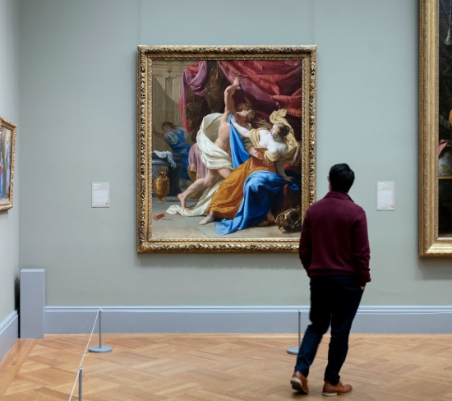
Here you can find more ideas about how to use virtual museums in the lessons.
Every year since 1977 International Museum Day (IMD) is held all over the world on the 18th of May. The event is organized by the ICOM (International Council of Museums). Each year IMD has a specific theme based on free events and activities participating museums organize for their societies. Its main idea is to highlight the importance of museums in society.
Because of COVID-19 IMD 2021 will go digital. The theme of this year is “Museum for equality: diversity and inclusion”. It is devoted to gender, ethnicity, religious beliefs, and other disparities. ICOM wants museums to become a unifying platform that through their expositions will reflect the diversity of museum communities and will create tools to identify and overcome bias.
We’ve prepared some activities and ideas related to this event, which will make the lesson informative and interesting.
Task 1 – IMD Discussion
Discuss with the student International Museum Day asking the following questions:
- When is IMD? (18th of May)
- Who is the coordinator of this event? (ICOM)
- Have you ever participated in this event?
- What type of museums do you know/like? (for example, archaeology, art, history, etc.)
- Do you think that museums have an important role in the life of society?
Tell the student that each year the event has a different theme.
Task 2 – Digital Museum
Show him/her the poster of this year and ask what he/she thinks the theme is.
You can make-up a poster with the help of the digital resource: coggle.it
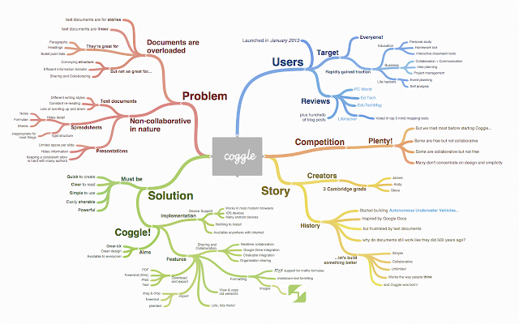
Coggle is a freeware mind mapping web application. Coggle produces hierarchically structured documents, like a branching tree. This contrasts with other collaborative editors, like Google Docs, which provide either linear (text document), or tabular (spreadsheet) document formats.
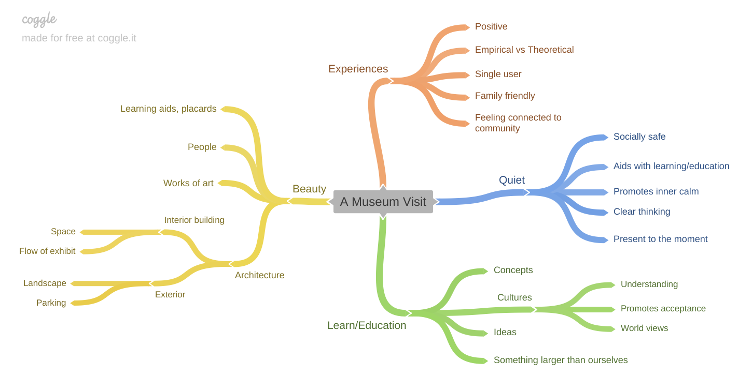
Nowadays technologies give a lot of opportunities to explore our world without leaving home. One of them is a digital museum. Ask the student what he/she thinks about digital museums, if he/she has ever made a tour to a virtual museum, if it can replace a real visit, what advantages and disadvantages of digital museums are.
If the student doesn’t know what it looks like, you can give him/her a https://www.theguardian.com/travel/2020/mar/23/10-of-the-worlds-best-virtual-museum-and-art-gallery-tours to one of the sites of the museums, which he/she has never been to and would like to visit. Explore the site with the student distinguishing good and bad aspects and make a tour.
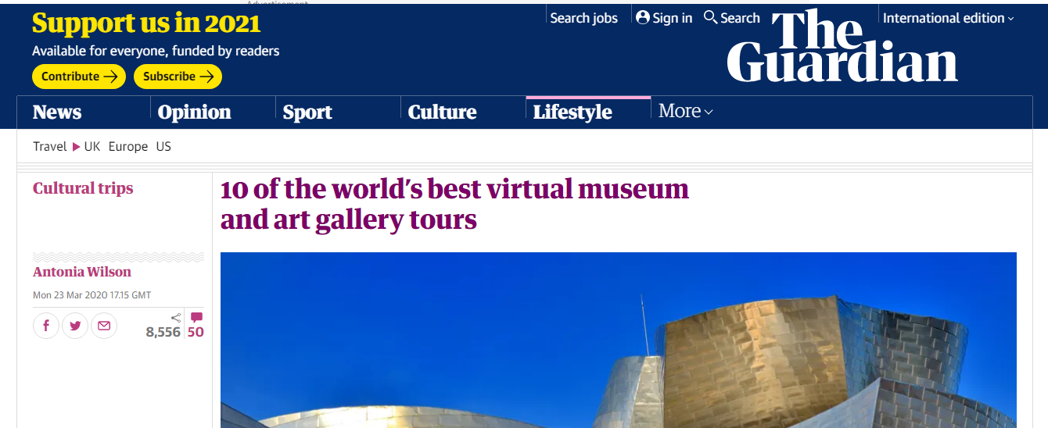
Modern technologies provide dizzying opportunities to gain new knowledge and impressions without leaving your home. The field of art is also no exception: in many sites of museums in different countries virtual tours have been created, which can be used during lessons with students as an interesting interactive experience.
A museum is like a small city with its own laws, phrases and words, and especially for those students who wish to become guides, a virtual tour of museums will be a good practice to expand vocabulary, develop listening and speaking skills.
We have compiled a list of virtual museums and useful materials that you will need during these activities.
VIRTUAL MUSEUMS

British Museum, London https://www.britishmuseum.org/
There are 3,212 panes of glass in the domed ceiling of the British Museum’s Great Court, and no two are the same – and the 360-degree view in this virtual tour lets viewers examine each and every one. Beyond this magnificent space, viewers can find the Rosetta Stone, Egyptian mummies and other ancient wonders. The museum’s interactive infographic platform, History Connected, goes into further depth of various objects with curators, along a timeline.

National Gallery, London https://www.nationalgallery.org.uk/
A backdrop to London’s four lions in Trafalgar Square, the National is home to 2,300 publicly-owned paintings, watercolours, drawings and other European art from the 13th to the mid-20th century. There are seven exhibition spaces of Renaissance art and the Central Hall to explore in its 360-view virtual touring pages, from portraits to large dramatic altarpieces.

Natural History Museum, London https://www.nhm.ac.uk/
From the diplodocus to the dodo, botany to butterflies, giant crystals to specimens in
jars … the Natural History Museum’s vast collection has long been a favourite of both Londoners and tourists. Get lost in the corridors and gallery spaces – one treat is Dippy the dino, who despite recently going on tour still makes an appearance in the entrance hall
in this interactive online guide.

Musée d’Orsay, Paris https://m.musee-orsay.fr/en/home.html
In the former Gare d’Orsay, a Paris railway station and hotel, the musée is home to Cézanne, Monet and other French masters. Under a 138m-long curved glass roof, sits the largest collection of impressionist and post-Impressionist works in the world. The virtual tour also includes an online exhibition charting the history of the building. And over on Tourist Tube there’s a 360-degree view of the magnificent exterior.
In addition to virtual museums, during the lesson, you can also watch a video tour, which contains useful words and phrases that are often used during excursions in museums. For example, the YouTube channel Britlish – Learn British English has a video about museums that explains each word separately.
For example:
– Exhibit - an exhibit is an interesting object shown in a public exhibition
– Artefact - an artefact is a historical object made by man
– Relic - a relic is a historical object made interesting because of its age or associations with past, etc.
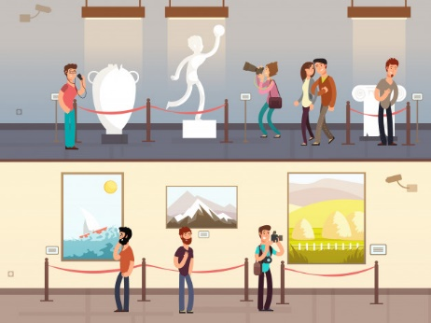
Task 3 – In a museum
Show the student a picture of a museum and ask him/her what is allowed and what is not allowed to do in a museum. Let him/her share his/her opinion about it, ask if it is necessary to have such rules for visitors.

Task 4 – Describing a visit to a museum
Ask the student to think about his/her experience with visiting museums in the home country and in a foreign county. Ask such questions as:
What was the first/favourite museum you have ever visited? Where was it?
Who did you go with?
What did you see?
How did you feel after going there?
Do you remember how much it cost? Have the prices changed since your last visit?
Is there a difference between museums in your home country and in a foreign country?
Ты можешь описать свою экскурсию с помощью проекта и выложить его в онлайн с помощью http://linoit.com. Linoit – виртуальная доска для учебных материалов и обратной связи. Существует возможность работать над полотном (canvas) совместно, осуществляя проектную деятельность, указывающую на социальный характер ресурса. Преимуществом ресурса является и то, что он имеет неограниченное количество бесплатных досок.

Task 5 – The World of Painting
Lesson 1:

icon-painting – иконопись |  | an artist – художник
portrait painting – портретная живопись |  | a masterpiece – шедевр
landscape – пейзаж |  | fame – слава
still life – натюрморт |  | prominent – известный
rural scenery – сельский пейзаж |  | topical – ведущий
seascape – морской пейзаж |  | baroque – барокко
to depict – изображать |  | to dedicate посвящать
mosaic – мозаика |  | to devote – посвящать
frescos – фреска |  | to propagate – пропагандировать
a sitter – натурщик |  | to represent – представлять
an exhibit – экспонат |  | to capture – захватывать
an exponent – тип, образец; экспонат |  | to portray – писать портрет
an exposition – выставка, экспозиция |  | to contain – вмещать
an item – вопрос; отдельный предмет |  | to display – показывать
a portrait – портрет |  | to hold – держать, поддерживать интерес
a theme – тема |  | to include – включать в себя
an image – образ, изображение |  | to offer – предлагать
a representative – представитель |  | to be on display- быть в показе
a phenomenon – явление |  | to be available – быть доступным
a genre – жанр |  | to be influenced by – быть под влиянием
a scene – сцена (епизод) |  | to be inspired by – быть вдохновленным
a tendency – тенденция

1. Match the words and the definitions:

1. a painter | a. a thin board on which a painter lays and mixes his colours
2. a studio | b. a rough, quickly made drawing
3. a sitter | c. a well-lit workroom of a painter or sculptor
4. a palette | d. a thing to paint with
5. a masterpiece | e. something made or done with very great skill
6. a sketch | f. a person who paints pictures
7. a brush | g. a person who poses for painters and sculptors

2. Match the pictures and the words:

a. a landscape | b. a still life | c. a portrait | d. a seascape | e. a battle scene

3. Use words from task 1 to fill in the gaps:
- The s-___________ was a large well-lit room.
- A man sitting on a raised platform is a s-________.
- The p-_________ was mixing p-_________ on his p-________.
- Michelangelo took his b___________ and drew a p-________ of the scene.
4. Match the synonyms:
a palette |  | paint
an artist |  | a workroom
a studio |  | a drawing board
colours |  | a painter
a painting |  | a sketch album
a sketch book |  | a picture

HOMEWORK
5. Sort out the words according to the categories below:
constructivism, brilliant, to depict, baroque, still life, distinguished, to reflect, impressionism, prominent, to portray, seascape, an artist, icon painting, a master, landscape, a painter, avant-garde, outstanding, portraitist, to describe, landscape, social realism, famous, to capture, primitive painting, portrait painting
a person who creates painting | a genre of painting | a trend in painting | characteristic | to create
an artist

В каких жанрах можно писать картины?
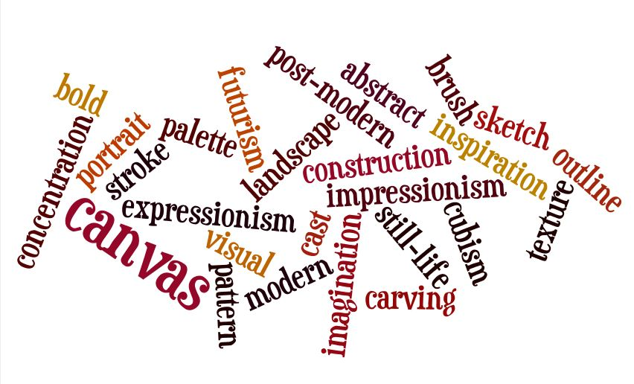
Portrait, still life, animals (wildlife), landscape
(а также морские пейзажи seascapes и городские – cityscapes).
a busy scene – сложная композиция
foliage – листы
work / paint en plein air (painting outdoors / on location) – работать на пленэре
paint from life – рисовать с натуры
render – передавать, изображать
work large – работать в большом формате
underpainting – подрисунок
painterly – живописный (часто не в смысле picturesque – красивый и живописный,
а в значении «выглядит так, как в (масляной) живописи)
fix mistakes – исправлять ошибки
overwork – "переделать" (т. е. лишние доработки, которые делают картину хуже,
чем была)
do commissions – рисовать на заказ
student grade / artist grade – ученические материалы и художественные (профессиональные)
open stock – поштучно
techniques – техники
Кстати! Многие глаголы образуются путем сложения -en к прилагательному: soften – смягчить, darken – затемнить, harden – затвердеть, и т.д.
На чем можно рисовать? Поверхности, на которых можно рисовать, называют общим словом supports или surfaces (как правило, это полотно / бумага).
Один из самых популярных surfaces - это, конечно, акварельная бумага.Watercolor paper продается in sheets (листами), pads (альбомы, блокноты), blocks (склейки), rolls (рулоны).
Популярная плотность акварельной бумаги – 300 gsm будет часто встречаться вам в другой степени измерения –– 140 lb.
canvas board / canvas panel – холст на картоне (или другой, более прочной поверхности)
stretched canvas – холст на подрамнике
cardstock / cardboard / cartridge paper – картон (cardstock – общее название, и обычно это более тонкий картон,а cardboard часто грубый и толстый упаковочный картон)
sanded paper / sandpaper – наждачная бумага
masonite / hardboard – оргалит
rough / coarse paper – грубая (зернистая, фактурная) бумага
tooth ("toothy") – фактура (с заметной фактурой)
archival – обладает архивным качеством, долговечен
warp, buckle – коробиться, деформироваться
acrylic primer (acrylic gesso) – акриловая грунтовка
primer coating – слой грунтовки, грунтовка
sizing – проклеивание
Инструменты художника:easel – мольберт
palette knife – мастихин
x-acto knife – нож, резец (X-acto - это название торговой марки)
tissue / paper towel – салфетка, бумажное полотенце
tracing paper – калька
glassine / wax paper – пергамин / вощеная бумага
q-tip, cotton buds – ватные палочки
baby wipes – детские влажные салфетки
Масляная живопись – Oil paintings:
solvents – растворители
thinners – разбавители
to thin / dilute paint – разводить краску
a wash – тонкий слой (краски)
a glaze – глазирование
scumbling – лессировка
toxic / non-toxic – токсичный / нетоксичный
crack – потрескаться
varnish – лак, лакировка
Encouraging comments:
You are off to a great start! – отличное начало!
Great going – хорошо получается, хорошо идет
It's coming along nicely - хорошо получается
Love your work – Шикарно получилось; я в восторге (love здесь означает не "люблю«, а» мне реально нравится")
Beautiful palette – красивая цветовая гамма
Convincing, believable – убедительный / убедительно(выглядит)
Well handled - отлично нарисовано / сделано; отлично справился
You did a great job on ... – У тебя хорошо получилось ... (называют, что именно)
Have a ... (impressionistic) feel about it - имеет ... (импрессионистическое) впечатление / ощущение / атмосферу. Это звучит коряво, но по-английски часто так высказывают мнение, что картина несет в себе такую-то атмосферу или отголоски такого-то направления.
Pulls you in – ты будто оказываешься в самой картине (не дословно, но смысл таков)
Do not be too hard on yourself - ты слишком строго себя критикуешь
To get a great handle on smth – так обычно говорят о том, кто хорошо изучил какой-то medium или жанр, хорошо его понимает и применяет
Feel free to - не стесняйся ...; смело (делай что-то)
dabble in ... – заниматься чем-либо поверхностно, по-любительски. Это слово употребляют, чтобы небрежно высказаться о своем увлечении рисованием, подчеркнуть, что не претендуешь на уровень профи:
I have been dabbling in watercolor for a few years now. – Я уже несколько лет злоупотребляю акварелью.

Task 6 – 10 most famous paintings in the world
Match the pictures with their names
Here you can find a description of these paintings in English https://edition.cnn.com/style/article/most-famous-paintings/index.html
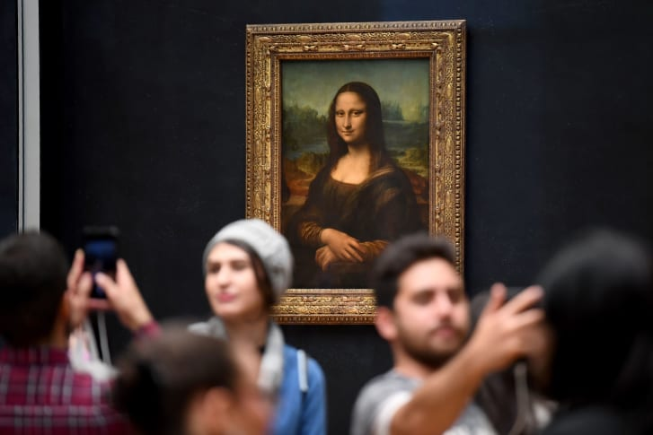  1 | 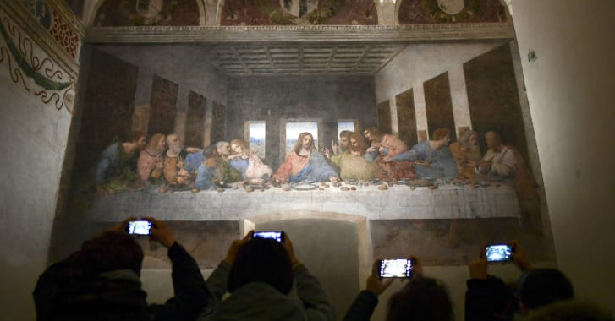  2
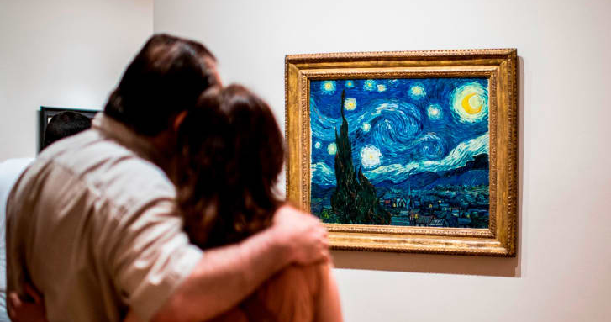 | 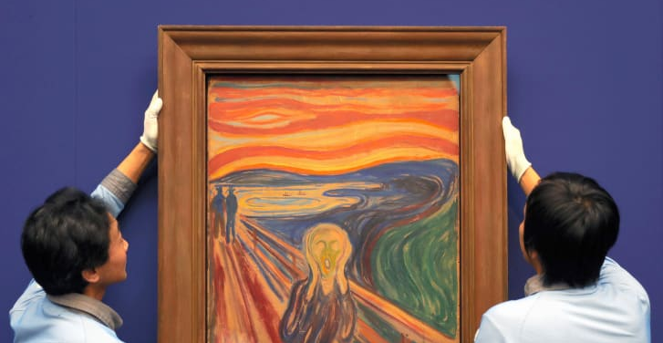  4  3
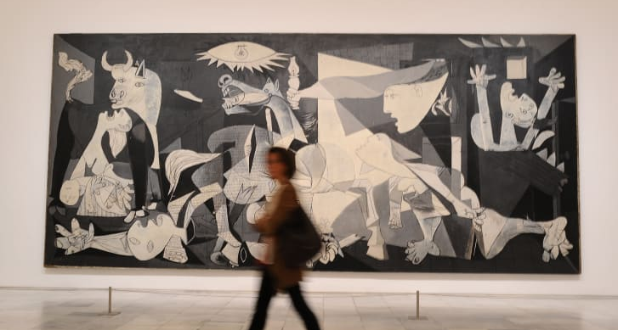 | 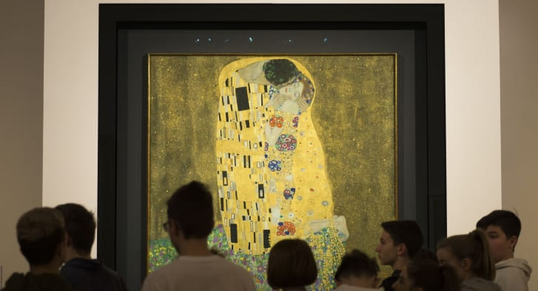  6  5
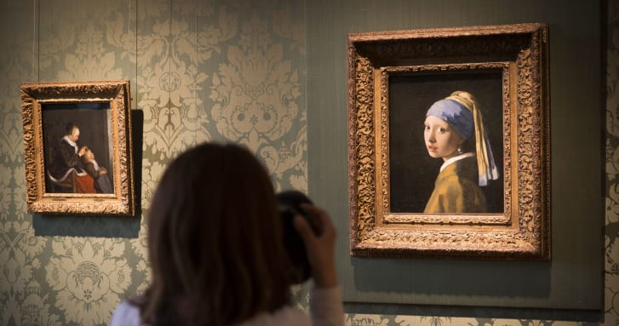 | 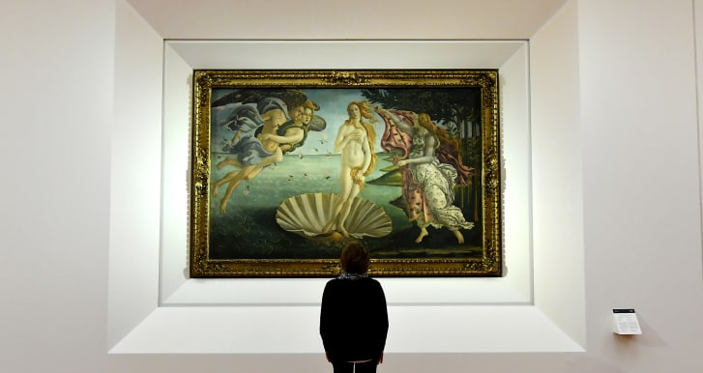  7  8
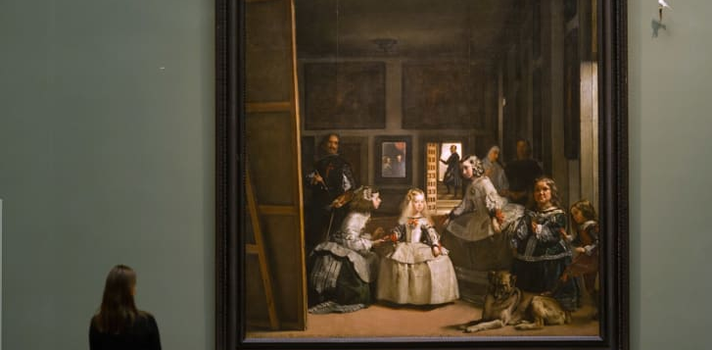 | 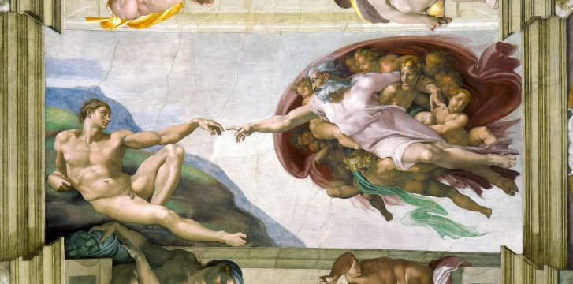  10  9

A) Mona Lisa | B) The Last Supper | C) The Starry Night | D) The Scream | E) Guernica
F) The Kiss | G) Girl With a Pearl Earring | H) The Birth of Venus | I) Las Meninas | J) Creation of Adam

Five more paintings that came close
Here are five more famous paintings that came close to breaking into the top 10 list:
- “American Gothic” (Grant Wood, Art Institute of Chicago)
- “Water Lilies” series (Claude Monet, various museums around the world)
- “The Persistence of Memory” (Salvador Dali, Museum of Modern Art in New York)
- “The Night Watch” (Rembrandt, Rijksmuseum in Amsterdam)
- “The Garden of Earthly Delights” (Hieronymus Bosch, Museo del Prado, Madrid)

Task 7 – Recreating Art Using Random House Objects
As nearly a third of the world’s population lives under coronavirus-related restrictions, people are starting to get bored. But during this challenging time, the J. Paul Getty Museum, based in Los Angeles, has found a way to keep people engaged with their art—even though they can’t see it in person. They’ve challenged their social media followers to “recreate a work of art with objects (and people)” from the comfort of their own homes.
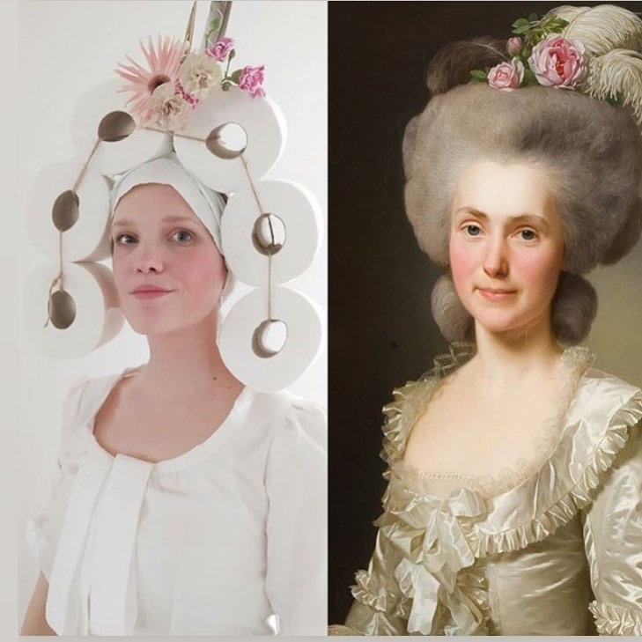
Challenge your students to do the same. Alternatively, show them famous masterpieces and ask to make a list of things at home that might be used to recreate the paintings.

Happy making an excursion / visiting museums / painting / drawing – and learning English! :)

Список использованной литературы
1. International Museum Day Resource Guide (Professional Practice Series) Paperback – November 1, 2001
2. Музейная педагогика-проблемы, настоящее, перспективы. Материалы пятой научно-практической конференции (28-29 сентября 2017 г.) / Национальный Киево-Печерский историко-культурный заповедник. - К., 2017 – - 132 с.
3. Левитас Ф. Л., Дудар О. В. элементы музейной педагогики в системе патриотического воспитания. - [Электронный ресурс]. - Режим доступа: http://www.ukrreferat.com/index.php?referat=81443
4.Яремин В. детский праздник в музее. - [Электронный ресурс]. - Режим доступа: http://kosivart.if.ua / 2017/06/04/8352/

