План- конспект урока Spotlight 4 класс
Тема: «Past Simple Tense, regular verbs»
Цели:
1.Знакомство с простым прошедшим временем Past Simple (правильные глаголы);
развиватие навыков аудирования, чтения, говорения и письма.
2. Тренировка навыков устной речи, развитие языковой компетенции учащихся.
3. Введение и закрепление времени Past Simple в утвердительных предложениях.
Задачи:
1.Рассказывать о событиях, произошедших в прошлом, используя Past Simple.
2.Научиться произносить окончания правильных глаголов в Past Simple.
3.Употребленре наречий в Past Simple.
4. Употребление правильных глаголов в письменной и устной речи.
Тип урока: урок открытие новых знаний
Формы работы: индивидуальная, фронтальная, групповая
Оборудование:
Компьютер, проектор, электронная презентация по теме урока, раздаточный материал.
Ход урока
1.Приветствие.Good morning, children. How are you today? (На доске карточка настроений)
2. Интерактивное задание. Устная работа. Let*s remember «to be» in Past Simple.
(Учащиеся вместе с учителем выполняют интерактивное задание, ссылка в доп. материалах)
3. Постановка целей и задач: (слайд 1) The topic of the lesson isn*t written on the blackboard. Let*s fill the cards.
Составление кластера «Спутники времени Past Simple» На доске дети заполняют диаграмму

yesterday
last week 2 years ago
Past Simple

in 2023 the day before yesterday
Вопросы учителя: -What actions do the satellites of the time talk about?Ответы учеников, один учащийся выходит к доске и вписывает в середину кластера название прошедшего времени.
4. Учитель рассказывает детям, что во времени Past Simple глаголы делятся на правильные и неправильные. Дети получают карточки(см.доп.материалы),время на самостоятельную работу с заданием 2 мин, затем вместе с учителем разбирают текст. Наводящие вопросы - What common feature do we see in all verbs? Дети отмечают и выделяют во всех глаголах окончание –ed. Учитель объясняет, что такие глаголы называются правильными. Далее учащиеся читают и переводят текст.
5. Слайд 3 На доске правило (раздать индивидуально учащимся на карточках,см.доп.материалы) прибавления окончания –ed
6. Слайд 4 Rule of reading ending –ed . Работа с учителем, ученики дружно повторяют со слайда особенности чтения окончания –ed у правильных глаголов в прошедшем времени.
7. Работа на карточках. Карточка № 4 «About family»
8. Работа на карточках. Задание с правильными глаголами. (см. доп. материалы)
9. Если останется время, ученикам можно предложить выполнить упр. 4 и 5 в сборнике упражнений на стр. 83.
10. Рефлексия Подведение итогов урока:
-What did we talk about today?
-What kind of verbs can be in Past Simple?
-What ending should we add to regular verbs?
- Your marks for today are ….. (Выставление оценок ученикам)
Домашнее задание: сборник упр. стр. 84 упр. 6,7
Our lesson is over, thank you for your work! See you soon!
Дополнительные материалы:

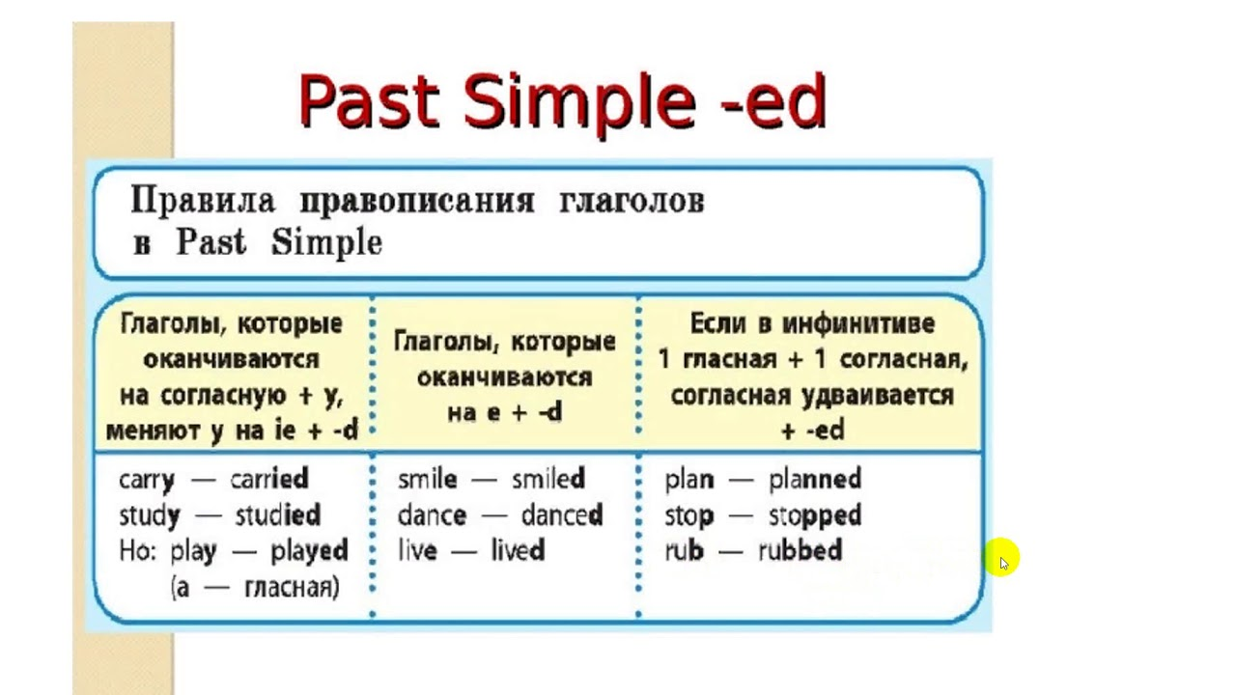
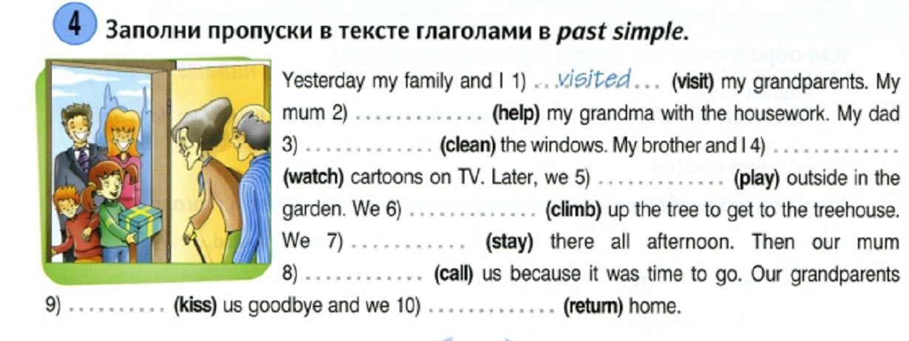
Mr Smith washed his car yesterday morning. Mrs Smith watered plants in the garden. Then they cleaned the yard and played chess. In the evening their boys listened to music and watched TV. Their little sister played with her dolls and then cried a little. In the evening the children brushed their teeth and went to bed.
Mr Smith washed his car yesterday morning. Mrs Smith watered plants in the garden. Then they cleaned the yard and played chess. In the evening their boys listened to music and watched TV. Their little sister played with her dolls and then cried a little. In the evening the children brushed their teeth and went to bed.
Mr Smith washed his car yesterday morning. Mrs Smith watered plants in the garden. Then they cleaned the yard and played chess. In the evening their boys listened to music and watched TV. Their little sister played with her dolls and then cried a little. In the evening the children brushed their teeth and went to bed.
Mr Smith washed his car yesterday morning. Mrs Smith watered plants in the garden. Then they cleaned the yard and played chess. In the evening their boys listened to music and watched TV. Their little sister played with her dolls and then cried a little. In the evening the children brushed their teeth and went to bed.
Mr Smith washed his car yesterday morning. Mrs Smith watered plants in the garden. Then they cleaned the yard and played chess. In the evening their boys listened to music and watched TV. Their little sister played with her dolls and then cried a little. In the evening the children brushed their teeth and went to bed.
Mr Smith washed his car yesterday morning. Mrs Smith watered plants in the garden. Then they cleaned the yard and played chess. In the evening their boys listened to music and watched TV. Their little sister played with her dolls and then cried a little. In the evening the children brushed their teeth and went to bed.
Mr Smith washed his car yesterday morning. Mrs Smith watered plants in the garden. Then they cleaned the yard and played chess. In the evening their boys listened to music and watched TV. Their little sister played with her dolls and then cried a little. In the evening the children brushed their teeth and went to bed.
Mr Smith washed his car yesterday morning. Mrs Smith watered plants in the garden. Then they cleaned the yard and played chess. In the evening their boys listened to music and watched TV. Their little sister played with her dolls and then cried a little. In the evening the children brushed their teeth and went to bed.

Ссылка на интерактивное задание:
TO BE in Past Simple - Правда или ложь (wordwall.net)
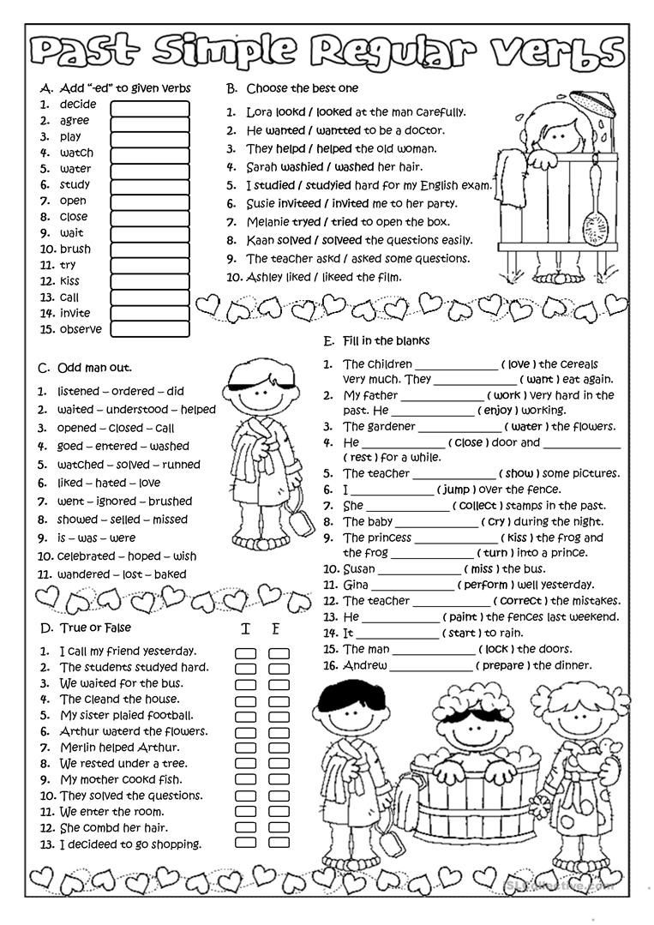

Файлы для презентации:

