**Методическая разработка урока по развитию читательской грамотности для 7-9 классов**

**на тему “FOOD and DRINKS”**

**Кальченко Наталия Викторовна,**

**Муниципальное бюджетное общеобразовательное учреждения г.Владимира «Средняя общеобразовательная школа №13 им.Героя Советского Союза Д.Д.Погодина»**

**МБОУ «СОШ №13»**

**учитель английского языка**

**Pre-Reading task**

**TASK 1**

1. Do you like to eat ?

What do you usually have for lunch?

How often do you eat out?

1. What do you think the text is about?
2. Look at the words and guess in what way they are connected to the text: *Cheddar, instant coffee, five o’clock tea, game, hotpot.*

***TASK 2***

Look at these pictures. They are all connected by a theme. What do you think they have in common?

|  |  |
| --- | --- |
|  |  |
|  |  |

**Food and Drink**

Many typical English dishes focus on roast meat – beef, pork, lamb, poultry and game. Roast beef is accompanied by roast potatoes and Yorkshire pudding.

Mint sauce is usually served with lamb, and currant jelly with poultry. Pork is normally complimented by apple sauce.

A treat is salmon, also smoked, as are haddock and mackerel. Regional sea specialties include Cheddar, Cheshire, Stilton, Double Gloucester, Red Leicester, Derbyshire, Lancashire and Wensleydale.

The most famous British takeaway is still the fish and chip shop. *Wimpy* is a trade mark for a fast food chain in Britain. Wimpy was a friend of cartoon character Popeye who loved hamburgers.

Tea is the national drink. Children have tea about 5 or 6 p.m. “Five o’clock tea” is the meal and not drink. It is often meet or fish with vegetables and then a dessert. Cream teas are very popular. You may have scones /cake/ with cream and jam. Coffee enjoys almost equal popularity. Beer might be one of brews: mild, bitter, stout or lager. Pubs serve a wide range of nonalcoholic and alcoholic beverages. Permitted drinking hours are generally 11 am to 11 pm Monday to Saturday; noon to 3 pm and 7 pm to 10:30 pm on Sunday, Good Friday and December 25.

For breakfast most people have cereal or toast and tea or coffee. People have tea with cold milk. Some people prefer instant coffee, made just with hot water. Many visitors to Britain find this coffee disgusting.

Lunch is a quick meal. It is very light, usually a sandwich and some fruit. There are a lot of sandwich bars with a wide choice of bread, salad, fish and meat which go for sandwiches. Pubs serve good, cheap food, both hot and cold. School children can have a hot meal at school but many take a lunch bag from home-a sandwich, a drink, apples or bananas. On Sundays many families have a traditional lunch: roast meat with potatoes, vegetables and gravy- a sauce made from the meat juices.

People have dinner at 7 or 8 p.m. The evening meal is the main meal of the day. Usually the whole family eats together.

Supper must be very light- a sandwich or toast, or just some biscuits. Those who haven’t eaten dinner may eat supper at 9 p.m.

At the restaurant you will have a starter, a main course and a dessert. The starter includes a vegetable, tomato or chicken soup, prawn cocktail, melon and ham or fruit juice. Main courses give a choice of chicken casserole, roast beef, fish pie served with new potatoes and fresh vegetables. Desserts may include Black Forest Gateau (a chocolate cake), an apple pie with cream or ice cream, cheese and biscuits.

The British like food from other countries. From the time immemorial foreign trade was a major influence on British cooking. English cooks used ingredients from all over the world though good English weather, plenty of rains help them produce fine fruit, vegetables and meat. Probably, a famous quotation of the writer and humorist George Mikes “On the Continent people have good food; in England people have good table manners“ will soon be forgotten. Nowadays British pubs are becoming the places where you can eat well and cheaply. British steak and mushroom pie, Lancashire hotpot are the gastronomic wonders of the world.

**WHILE-READING TASKS**

1. Make notes while reading. Put “?” if you don’t understand the information, “!“ if you are surprised.
2. **Identify** the main idea of paragraphs.
3. Try to find all the names of food and discuss in pairs if you would like to taste it.

**AFTER-READING TASKS**

1. Try to find the places which are mentioned in the text and correspond them to the food which is eaten there.
2. Work in pairs. One of you asks a “thick” question and the other asks a “thin” question. Then read them aloud. The table will help you.

|  |  |
| --- | --- |
| ***Thick questions*** | ***Thin questions*** |
| Explain why…? | What? Who? |
| Why do you think…? | When? Where? |
| Guess what happens if…? | Can…? Could…? |
| What is the difference…? | Do you agree…? |
|  | Is it true….? |

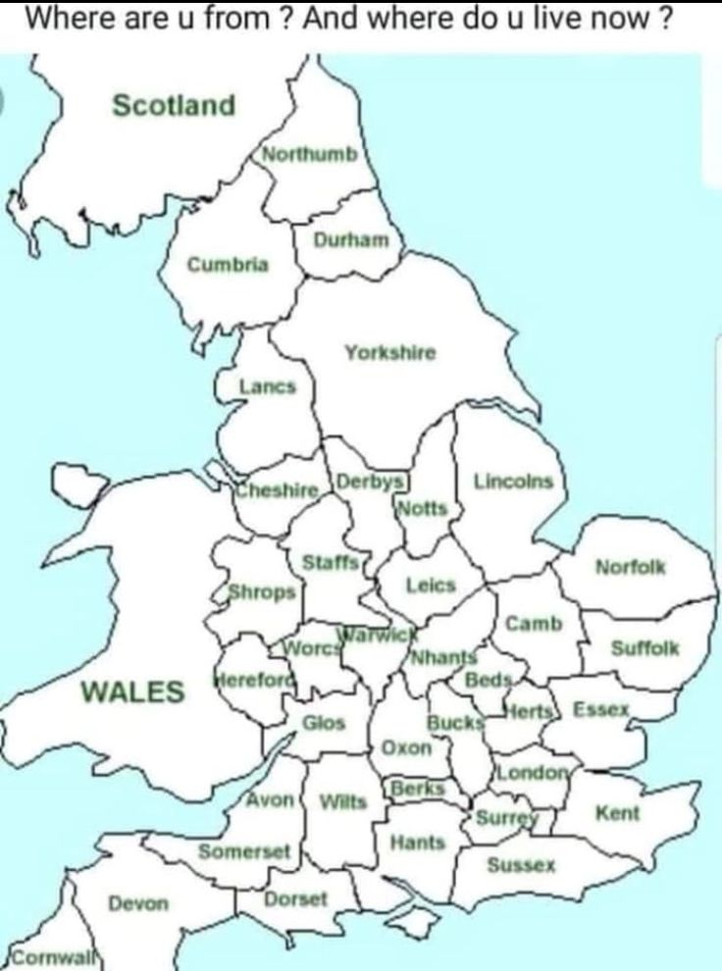

LINKS

Текст взят из пособия “English Speaking Countries” А.Полупан., Харьков 2001

<https://yandex.ru/images/search?img_url=https%3A%2F%2Fi.pinimg.com%2F736x%2Fa9%2F5c%2Fe4%2Fa95ce4be6cb7dcd228b48c6c6e9fff47.jpg&lr=192&pos=0&rpt=simage&text=rfhnf%20fyukbb%20c%20uhfacndfvb>