LESSON  Unit 3: Holidays and Travel |  |  | School: #34
Date: 17.11.23 |  |  | Teacher name: Nuralieva D.H
Grade: 7 |  |  | Number present: 15 |  | Number absent:0
Theme of the lesson: |  | An unforgettable journey
Learning objectives |  | 7.1.9.1 use imagination to express thoughts, ideas, experiences and feelings  7.6.16.1 use conjunctions if , when, where, so, and, or, but, because , before, after to link parts of sentences in short texts on a growing range of familiar general and curricular topics  7.6.10.1 use present continuous forms with present and future meaning and past continuous forms for background and interrupted past actions on a limited range of familiar general and curricular topics
Lesson objectives |  | All learners will be able to:  Recognise the meaning of text and answer the questions  Most learners will be able to:  Make sentences with new vocabulary and use the pronouns  Some learners will be able to:  Can give their opinion to a given tasks  Act out the given information with support
Assessment criteria |  | Checks and finds the words  Reads and recognises the text  Uses the vocabulary in making sentences and their speech  Analyzes, compares and collects information
Values |  | intention
Indicator |  | - Desire to learn, experience and achieve new things  - learns to think critically and creatively
Expected Result |  | All learners will be able to r ecognise the meaning of text and answer the questions, can make sentences with Present Simple and Present Continuous  can give their opinion to a given tasks
Plan
Planned  timings | Planned activities |  |  | Learners’ activities | Evaluation | Resources
Beginning  5 min | GREETING!  When I do like this  you will clap your hands softly  okay and when I raise my hand you will clap your hands loudly and when I say  finish |  |  | Learners ask each other this questions and answer | Verbal evaluation
Middle  30 min | I show you a random picture  then I take it away and you say what  was in the picture what did you see and  you have to remember what it was  Working with the vocabulary  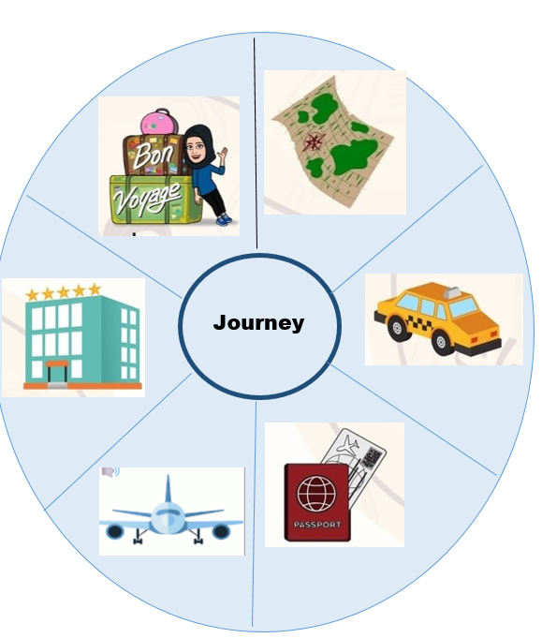  Task 1  Write the full answers.  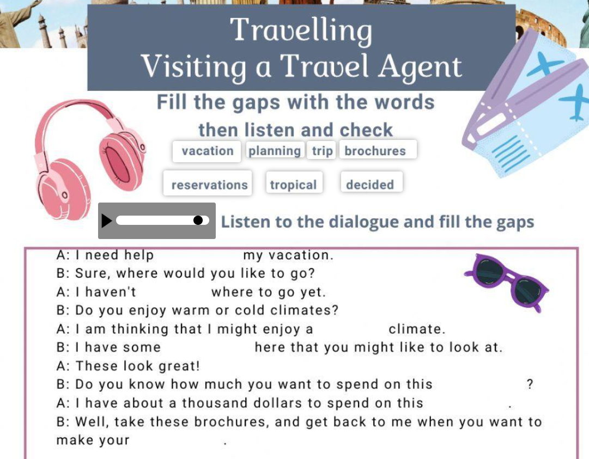  Task 2.  Working in pairs. Read the text maze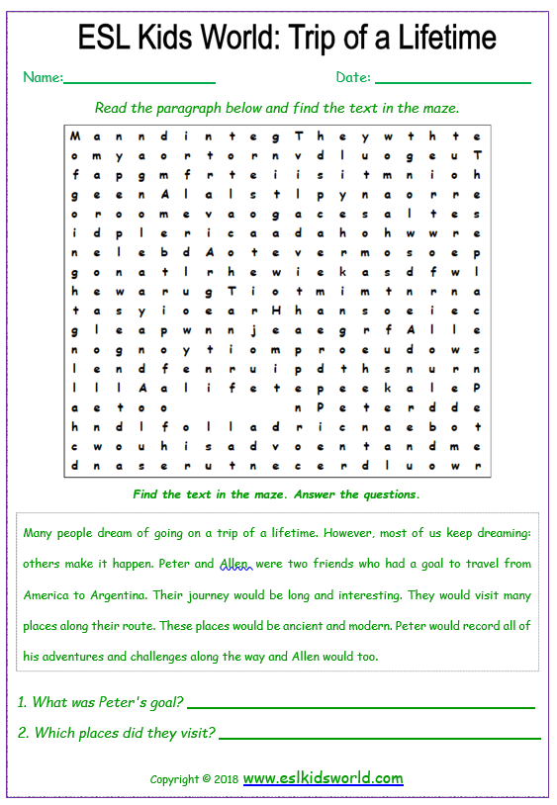  Task 3  Wordwall  Revise Present Simple and Present Continuous  https://wordwall.net/ru/create/editcontent?guid=bd6b7b06d3fa4caab8bd5a8e8d8d9824  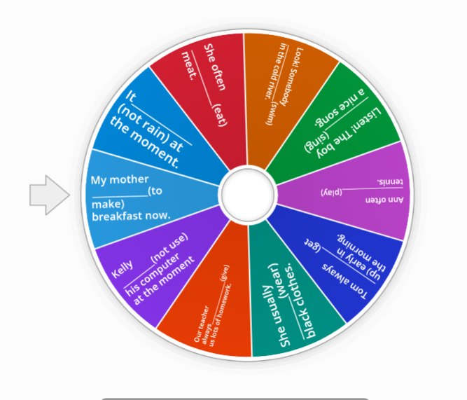  Task 4  Throw the ball and you get the score which team will get the more scores they get the point |  |  | Learners look and then say  Revise the words in your vocabulary  Learners write the full answers.  Learners fill in the gaps  Learners read the text  Learners spin the wheel and give the correct of the verbs | Individual avaluation  Mutual avaluation
End  5 min | Feedback of students. They put their messages and send to Instagram evaluate their work and the work of their classmates in accordance with the certain criteria.  Home task: do ex 2, 3 p 95 WB.  Saying goodbye |  |  |  | Self-assessment | Stickers

