Муниципальное автономное общеобразовательное учреждение «Лицей №13»

**Тема научно-исследовательской работы:**

**«Educational videos»**

**Выполнил**а: Ланкина Арина Сергеевна

учитель английского языка

первой квалификационной категории

Контактный номер: +7-923-224-12-08

**Новосибирск 2022**

**Content**

**Introduction** …………………………………………………………………..2

**Chapter 1.** ……………………………………………………………………..3

**1.1** How can educational video clips help to learn English? …………………..3

**1.2** Educational websites and their functions………………………….………..4

**Chapter 2……………………………………………………………………...**.6

**2.1** The methodology of the study ……………………………………………..6

**2.2** The results of the students’ survey…………………………………………7

**Conclusion** …………………………………………………………………….8

**Literature………………………………………………………………………9**

**Introduction**

Learning a foreign language is hard. So today, I want to share a few tips on learning English with the help of educational videos. Our research has an aim to find answers for the questions: “Can educational videos help us to learn English better, and can we make our own educational videos?”.

**The novelty**of my work consists in attempt to examine educational videos like a way that helps to learn English.

**The aim of my work** is to find out how the educational videos influence on the level of knowledge of my students

**The practical value of** the research is the possibility to use its materials in the process of learning English.

**Chapter 1**

* 1. **How can educational videos help us to learn English better?**

Textbooks are great for learning vocabulary or grammar, but nothing is better than listening to real native English. By watching British and American educational videos, you can listen to native English actors speaking the language in a natural way. This will help you learn modern English and [sound more like a native speaker](https://onlineteachersuk.com/english-conversation/) .

**BETTER PRONUNCIATION –** Sometimes it can be hard to know how an English word is pronounced. Hearing native speakers in educational videos will teach you the correct way to say things. Dialogues also provide good examples of how sounds in words change in connected speech.

**LIVE CONTEXT –** When you learn a word, it can be difficult to remember what it means or how to use it. In educational videos, words are used as part of a story and this context helps you to learn and remember them more effectively.

**EXPLORE CULTURE –** You can learn about the culture behind the language when you watch educational movies in English. Language and culture are closely connected. Why not study both at the same time by watching educational videos?

**1.2** Educational websites and their functions

The internet now offers students the opportunity to improve their lexical, listening and speaking skills through watching educational clips and films. There are a number of such websites. Here are some of them

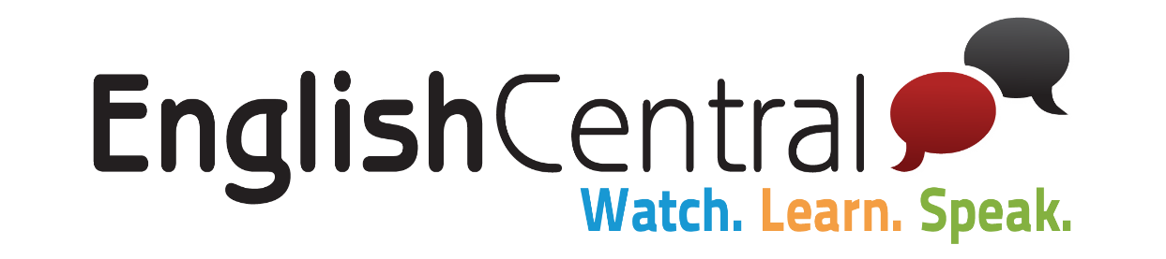

Possibly the best website for students to improve their speaking and pronunciation. This site provides students with videos with subtitles. The students watch the videos, practice vocabulary used in the video, record themselves repeating what they hear, and then get feedback on their pronunciation.

[](https://www.brightstorm.com/)

[**Brightstorm**](https://www.brightstorm.com/)

Short-form online video lessons by professional educators.

brightstorm.com

### 3. Videos from English speakers [engvid.com](http://www.engvid.com/)

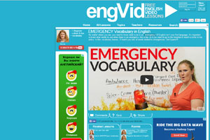

The resource engvid.com is a training video on various topics. One of the most popular resources for learning English among students around the world.

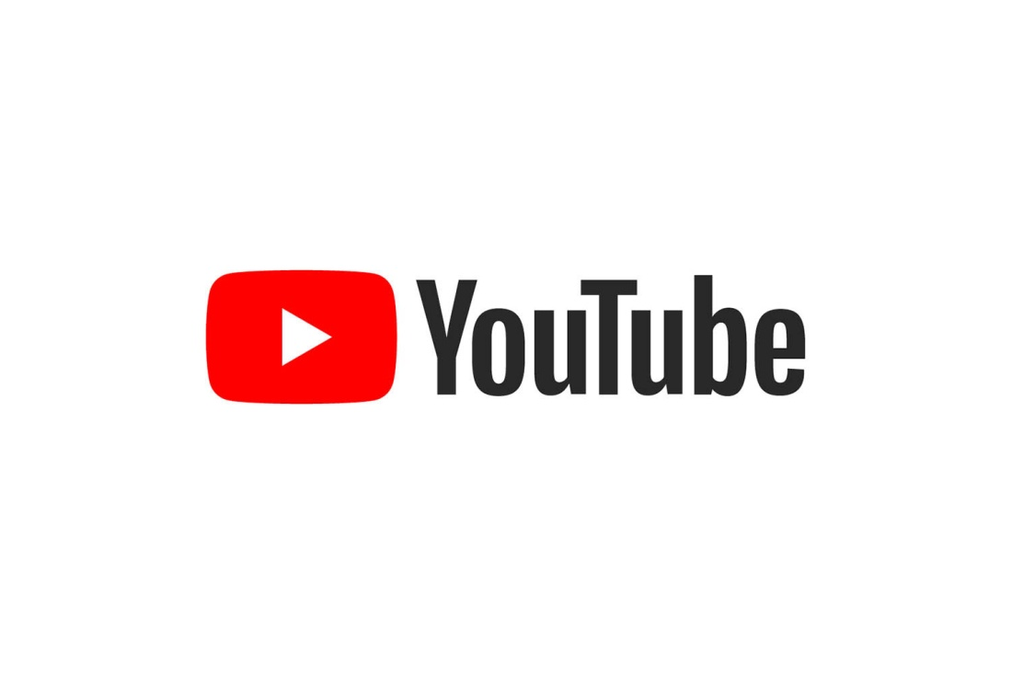

There are so many opportunities to learn English on YouTube . For example, you can watch educational videos every day.

[](https://cosmolearning.org/)

[**CosmoLearning**](https://cosmolearning.org/)

Free, online video lessons and documentaries.

cosmolearning.org

[](https://www.apple.com/apps/itunes-u/)

[**iTunes U**](https://www.apple.com/apps/itunes-u/)

Free lectures, language lessons, audiobooks, and more accessible via Apple iTunes.

apple.com

**CHAPTER 2**

**2.1 Methodology of the study**

We have made our study by the next way:

1. We watched English video clips.

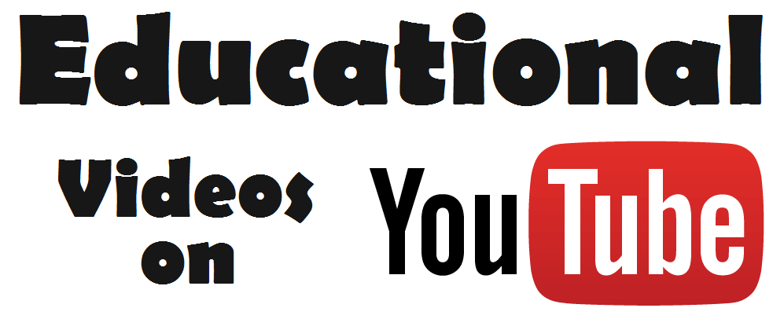

1. Learned the vocabulary of these videos.

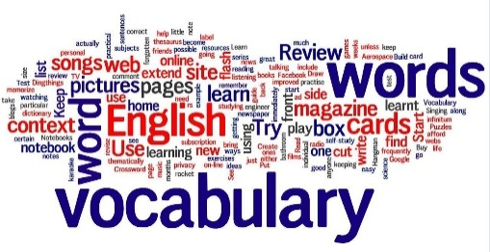

1. Discussed the video clips.
2. At home my students made their own video clips and discussed them at the lesson.

Then I asked some questions to my classmates:

1. - Did you like to watch English video clips?
2. - Did you like to make your own videos?
3. -Can video clips help to learn English?
4. - Will you watch video clips at home?

**2.2 The results of the students’ survey**

According to our research, the majority of students like watching educational videos and make their own videos. In their mind, educational videos help to learn English. And they are going to watch them at home to improve English.

Our research helps to understand that educational videos are a good way to learn English.

**Conclusion**

Undoubtedly, each person has a right to watch what he or she likes. However, it seems abnormal that the majority of people, who prefer study English, do not watch educational videos in English.

Nowadays English is everywhere: on goods and signboards of shops, on the electrical goods, clothes, on the Internet. It is taught at schools, universities, specialized courses. But how is it easier and faster to learn English?  Educational videos can be an express way that helps to enrich the students’ vocabulary and their pronunciation.

It is important to be responsible for the information that we hear. Our survey encouraged my schoolmates to make educational videos, which help them to motivate students to learn English better.

According to our survey we have come to the conclusion that the video clips influence on the level of knowledge of students. With the help of educational videos students can learn English words or English pronunciation. And Do you watch educational videos?

**Literature**

1. Булыко А.Н. Большой словарь иностранных слов.- Мартин, 2007
2. [http://www.uni-erfurt.de/eestudies/eese/artic20/witte/6_2000.html#comp](http://infourok.ru/go.html?href=http%3A%2F%2Fwww.uni-erfurt.de%2Feestudies%2Feese%2Fartic20%2Fwitte%2F6_2000.html)
3. <http://www.english-uk.ru/31.php>
4. <https://onlineteachersuk.com/learn-english-movies-films/>
5. <https://www.youtube.com/>
6. <https://www.britishcouncil.org/voices-magazine/how-can-film-help-you-teach-or-learn-english>