Министерство образования Иркутской области
Государственное автономное профессиональное образовательное учреждение Иркутской области «Иркутский технологический колледж»

Методическая разработка урока
английского языка в 8 классе
по теме: «What can we do to save the Earth?»

подготовила
учитель английского языка
Моисеева Олеся Сергеевна

г. Иркутск
2022
Цель: расширить знания учащихся по теме «What can we do to save the Earth?;
закрепить изученный лексико-грамматический материал в игровой форме.

Задачи:
1) Развивать интеллектуальные, познавательные и творческие способности учащихся;
2) Учить анализировать эмоциональные состояния, полученные от успешной (неуспешной) деятельности;
3) Совершенствовать навыки учащихся в чтении, говорении и аудировании по теме;
4) Формировать коммуникативную компетентность в общении и сотрудничестве со сверстниками;

Ход мероприятия
Мотивационный этап
This lesson is the last on the topic «The world's best friend is you». Today you have to discuss ecological problems and show how we can help nature.
This competitions will show your achievements and your knowledge. Be active, honest, lucky and industrious.
The motto of our competition is “Think Globally, Act Locally”

ДЕЛЕНИЕ НА КОМАНТЫ по рядам

- The first task is to name the main ecological problems:
water pollution;
job stress;
air pollution;
terrorism;
obesity;
youth problems;
throwing litter away;
cutting down of forests;
alcoholism;
erosion;
drought;
overpopulation;
extinction;
crimes;
global warming;
war conflicts

Give me your answers, please.
The next task is to find antonyms.

- Find antonyms. Match two parts

1) to cut down
2) to kill
3) to throw away
4) to destroy
5) to harm
6) to pollute
7) to damage
a) to plant, to grow
b) to preserve
c) to collect
d) to restore
e) to care about
f) to reduce, recycle, reuse
g) to defend, to protect

3. The riddles are liked by everybody. Guess these riddles and you have a chance to receive some more points.
1) Long ears, long ears
Hop, hop, hop
Long ears, long ears
Never stop
They like carrots
They like hay
Their ears grow longer
From day to day
(a rabbit)

2) What always goes to sleep wearing his shoes? (a horse)

3) What is the name of the insect: it gets up early; it works all day if it is not raining; it likes flowers; it lives in a hive? (a bee)
4) He lives in a forest. He is the king of the jungle because he is very strong. When he is hungry, he begins to roar very loudly. What is it? (a lion)

5) My beautiful tail is bushy,
And the colour of it is red
I hate the idea of it being worn
Round your neck or upon your head. (a fox)

6) It can be big or small
It is white or bright
It has a smell
There are many of them in spring and summer
It is a good present
Girls and women like them very much
What is it? (a flower)
7) Red or rosy
In summer I grow
I'm a fine flower
Is all you know. (a rose)

8) In winter and in summer they stand in one colour. What are they? (a fir-tree, a pine-tree)
4. When we speak about ecology, we may also use proverbs, which make our speech more lively. Look at these proverbs. Can you match their parts?
Actions speak louder…
a) by its fruit.
A drop…
b) pain.
A tree is known…
c) and you'll get to the sea.
As you sow…
d) than words.
Every dark cloud…
e) what you can do (can be done) today.
Follow the river…
f) handsome does.
It never rains…
g) in the ocean.
Nature abhors (syn. can’t stand, hates)…
h) with nature
Never put off till tomorrow…
i) a vacuum.
Live in harmony ...
j) has a silver lining.
Release peace...
k) so shall you reap.
No gain without...
l) but it pours.
Handsome is that...
m)and increase.

5. Read the text and put the parts in the right order.
A. But fur Americans, fuг is still a part of the way of life. The fur trade is one of the oldest businesses in North America. Europeans started buying furs from the Indians over 350 years ago. Today it is a $2 billion industry.

B. For some people, fur is a symbol of luxury, wealth and success. For others, it's a cruel and stupid business. In many European countries, there have been long campaigns against the fur trade. Often these have been very successful - in Britain fur sales have fallen by 75%.

C. The second way is getting fur from farmers. Farmers keep animals in special fur farms and then kill them when they want their fur.

D. The industry gets fur in two ways. The first way is getting fur from trappers who set traps to catch and kill wild animals.

E. Now some Americans want to stop the fur trade. Their strongest argument is that there are many natural alternatives to fur. It is easy to produce wool and cotton without cruelty to animals or damage to the environment. But still there are others who strongly support the idea of increasing fur farms and animal hunting. What do you think?

F. Last year in North America, people killed nearly 13 million animals because of their fur.

6. Listen to the song and formulate 3 rules for how to save the earth "The song of the promise to save the Earth for a child" https://www.youtube.com/watch?v=EoQpdCaqBPw«Saving Earth promise song for kid» https://www.youtube.com/watch?v=EoQpdCaqBPw

7. Today we are speaking about one of the greatest problems that humanity has been providing for many years. What is it? Try to make the crossword. Let’s start, be very attentive!
1. Вероятность, возможность того, что может произойти какое-то нежелательное событие (опасность).
2. Герметичный жестяной контейнер для долгосрочного хранения пищевых продуктов (консервная банка).
3. Синоним слова rubbish.
4. Существительное, образованное от слова запрещать (запрет).
5. Человек, человеческое существо.
6. Многолетний режим погоды (климат).
7. Отрицательное воздействие на окружающую среду (загрязнение).

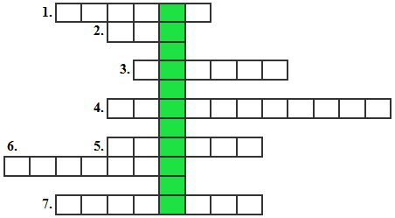

ОТВЕТЫ

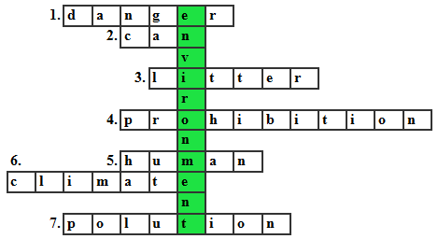

Заключительный этап
Students, now you know how dangerous the ecological situation on our Earth is.You are future engineers, scientists, workers, teachers, ecologists. You will solve the ecological problems which concern everyone. The positive results depend on serious attention of the whole world to this problem. You will work out new projects, new slogans. You will be active members of the movement for protecting the environment from further pollution. Be kind to nature. Don’t pollute the air, the water, the land. Take care of our towns and our country.

Рефлексия
How do you like the lesson? Give me the smiles:
Желтый – урок понравился не очень
Красный – плохо
Синий – очень хорошо

Список использованных источников:
https://otvetkin.info/reshebniki/7-klass/angliyskiy-yazyk/vaulina-spotlight-uchebnik/spotlight-on-russia-nomer-3
https://znanija.org/angliiskii-yazyk/34392736.html
https://infourok.ru/urokkvn-dlya-klassa-ecological-problems-803412.html
https://znanija.com/task/39646008

