АРТИКУЛЯЦИОННАЯ ГИМНАСТИКА

[](https://ok.ru/dk?cmd=PopLayerPhoto&st.layer.cmd=PopLayerPhotoOuter&st.layer.type=GROUP&st.layer.revNav=off&st.layer.limitedUi=false&st.layer.sphotoIds=839313370233;839313370489;839313370745;839313371001;839313371257;839313371513;839313371769;839313372025&st.layer.showNav=on&st.layer.photoAlbumId=52205150142585&st.layer.epm=off&st.layer.photoId=839313370233&st.layer.opl=off&st.layer.navStartPhotoId=839313370233&st.layer.sbd=off&st.cmd=userMain&st._aid=GroupTopicLayer_openPhotoLayer)

[](https://ok.ru/dk?cmd=PopLayerPhoto&st.layer.cmd=PopLayerPhotoOuter&st.layer.type=GROUP&st.layer.revNav=off&st.layer.limitedUi=false&st.layer.sphotoIds=839313370233;839313370489;839313370745;839313371001;839313371257;839313371513;839313371769;839313372025&st.layer.showNav=on&st.layer.photoAlbumId=52205150142585&st.layer.epm=off&st.layer.photoId=839313370489&st.layer.opl=off&st.layer.navStartPhotoId=839313370489&st.layer.sbd=off&st.cmd=userMain&st._aid=GroupTopicLayer_openPhotoLayer)

[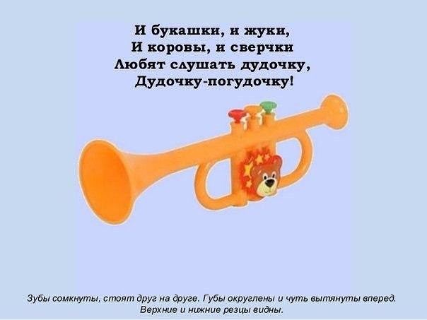](https://ok.ru/dk?cmd=PopLayerPhoto&st.layer.cmd=PopLayerPhotoOuter&st.layer.type=GROUP&st.layer.revNav=off&st.layer.limitedUi=false&st.layer.sphotoIds=839313370233;839313370489;839313370745;839313371001;839313371257;839313371513;839313371769;839313372025&st.layer.showNav=on&st.layer.photoAlbumId=52205150142585&st.layer.epm=off&st.layer.photoId=839313370745&st.layer.opl=off&st.layer.navStartPhotoId=839313370745&st.layer.sbd=off&st.cmd=userMain&st._aid=GroupTopicLayer_openPhotoLayer)

[](https://ok.ru/dk?cmd=PopLayerPhoto&st.layer.cmd=PopLayerPhotoOuter&st.layer.type=GROUP&st.layer.revNav=off&st.layer.limitedUi=false&st.layer.sphotoIds=839313370233;839313370489;839313370745;839313371001;839313371257;839313371513;839313371769;839313372025&st.layer.showNav=on&st.layer.photoAlbumId=52205150142585&st.layer.epm=off&st.layer.photoId=839313371001&st.layer.opl=off&st.layer.navStartPhotoId=839313371001&st.layer.sbd=off&st.cmd=userMain&st._aid=GroupTopicLayer_openPhotoLayer)

[](https://ok.ru/dk?cmd=PopLayerPhoto&st.layer.cmd=PopLayerPhotoOuter&st.layer.type=GROUP&st.layer.revNav=off&st.layer.limitedUi=false&st.layer.sphotoIds=839313370233;839313370489;839313370745;839313371001;839313371257;839313371513;839313371769;839313372025&st.layer.showNav=on&st.layer.photoAlbumId=52205150142585&st.layer.epm=off&st.layer.photoId=839313371257&st.layer.opl=off&st.layer.navStartPhotoId=839313371257&st.layer.sbd=off&st.cmd=userMain&st._aid=GroupTopicLayer_openPhotoLayer)

[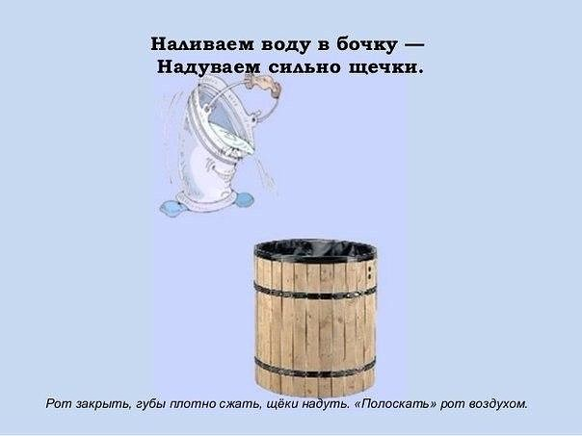](https://ok.ru/dk?cmd=PopLayerPhoto&st.layer.cmd=PopLayerPhotoOuter&st.layer.type=GROUP&st.layer.revNav=off&st.layer.limitedUi=false&st.layer.sphotoIds=839313370233;839313370489;839313370745;839313371001;839313371257;839313371513;839313371769;839313372025&st.layer.showNav=on&st.layer.photoAlbumId=52205150142585&st.layer.epm=off&st.layer.photoId=839313371513&st.layer.opl=off&st.layer.navStartPhotoId=839313371513&st.layer.sbd=off&st.cmd=userMain&st._aid=GroupTopicLayer_openPhotoLayer)

[](https://ok.ru/dk?cmd=PopLayerPhoto&st.layer.cmd=PopLayerPhotoOuter&st.layer.type=GROUP&st.layer.revNav=off&st.layer.limitedUi=false&st.layer.sphotoIds=839313370233;839313370489;839313370745;839313371001;839313371257;839313371513;839313371769;839313372025&st.layer.showNav=on&st.layer.photoAlbumId=52205150142585&st.layer.epm=off&st.layer.photoId=839313371769&st.layer.opl=off&st.layer.navStartPhotoId=839313371769&st.layer.sbd=off&st.cmd=userMain&st._aid=GroupTopicLayer_openPhotoLayer)

[](https://ok.ru/dk?cmd=PopLayerPhoto&st.layer.cmd=PopLayerPhotoOuter&st.layer.type=GROUP&st.layer.revNav=off&st.layer.limitedUi=false&st.layer.sphotoIds=839313370233;839313370489;839313370745;839313371001;839313371257;839313371513;839313371769;839313372025&st.layer.showNav=on&st.layer.photoAlbumId=52205150142585&st.layer.epm=off&st.layer.photoId=839313372025&st.layer.opl=off&st.layer.navStartPhotoId=839313372025&st.layer.sbd=off&st.cmd=userMain&st._aid=GroupTopicLayer_openPhotoLayer)