- What is the number of phonemes in the sound system of English?

In English, there are 20 vowel sounds and 24 consonants,3 diphthongs,and 42 phonemes. The same letter can form different sounds depending on the position in the word and the combination with other letters in the word. For example, the letter y in the word type is read as [ai].

- What large groups of sounds do the phonemes of any language fall into?

Phonemes of any language are divided into 4 large groups-vowels, sonors,voiced and deaf.

- How are vowels and consonants produced?
Vowels are sounds in the formation of which the air passes freely through the oral cavity, without encountering any obstacle. Therefore, vowel sounds consist only of the voice. Vowel sounds form syllables in the Russian language (they are syllable-forming).When consonant sounds are formed, the air meets some obstacle in the oral cavity (closed lips, tongue pressed to the teeth, etc.). Consonant sounds consist of voice and noise (voiced) or only noise (deaf). Consonants in the Russian language are not able to form syllables.Soft consonants are formed with the participation of the middle part of the language and have a special, "soft" sound. Hard consonants are formed without the participation of the middle part of the language and have a "hard" sound.
- What groups of English vowels and consonants do phoneticians distinguish?
In Russian, there are six vowel sounds: a, u, o, e, i, y. They make up the rest of the vowels. For example, buva yu consists of the sounds "y" and "y". In English, everything is even more complicated. For example, the words "cart" and "cut", "bad" and " bed "in the Russian" voice-over " would be the same. The meaning of the word depends on the sound quality (wide sound [a] or normal sound [e]), so all sounds must be pronounced clearly and in accordance with the rules;
The longitude of the sound is also a very important characteristic, which, as we know, is not present in the Russian language. Here, too, you need to be careful not to confuse, for example, "ship" and "sheep"; In English, there are diphthongs and triphthongs — combinations of two or three sounds that need to be pronounced as one. At the same time, they have a main component (the core), which sounds louder and clearer, and a secondary component (sliding), which is less pronounced.Almost all consonants in English are pronounced firmly, regardless of what sound follows them.Unlike Russian, English does not deafen the consonants in the Sounds [p], [t], [k] are pronounced with an exhalation, that is, with a slight exhalation, as if with a hint of the sound [h]. the end of the word.Sounds like [t], [d], [n], [l] are formed a little differently. Behind the upper teeth we have bumps-alveoli, on which you need to put your tongue when pronouncing these sounds.

- Enumerate the English phonemes
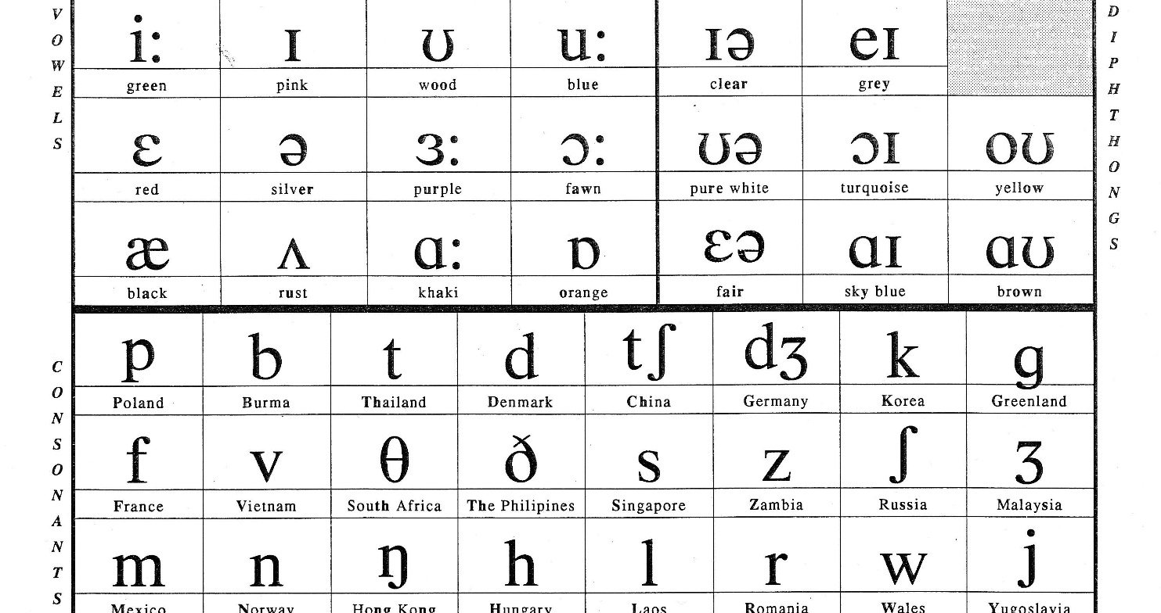

- What is the difference between phonemes and allophones?
Аll variants of the phoneme differ from each other, as they appear in different phonetic conditions and are caused by different positional, combinatorial and accentuational circumstances.Replacing one phoneme with another changes the meaning of the word or distorts the sound of the word. Replacing one phoneme variant with another does not change the meaning of the word, but it is perceived as an accent – dialect or foreign. :for hard consonants-before the stressed " a»;
for soft consonants-before the stressed "and".Allophone (sound) - the implementation of a phoneme, its variant, due to a specific phonetic environment. Unlike a phoneme, it is not an abstract concept, but a concrete speech sound.The main allophone is an allophone whose properties minimally depend on the position and phonetic environment. Basic allophones:
Combinatorial allophones are implementations of phonemes associated with a particular phonetic environment of sounds.for vowels — isolated pronunciation; nasalization (nasal pronunciation);
labialization (coarseness).Positional allophones are realizations of phonemes associated with their phonetic position. The phonetic position is usually understood as:

is the sound at the absolute beginning of the word (after a pause);
whether the sound is at the absolute end of the word (before the pause); the
position of the sound in relation to the accent.
7. What is the difference between the two consonants [b] in the
word bob?
Transcription of the word: [bop]. b — [b] - consonant, voiced paired, solid (paired) o - [ o ] - vowel, stressed b - [ p ] - consonant, deaf paired, solid (paired). The word has 3 letters and 3 sounds. At the end of the word, you can hear the sound of a deaf consonant (p), and a short, broken pronunciation.
8.Is the vowel [ɪ] longer in lit or lid?
Of all the vowels, the long [i:] has the most forward articulation, that is, the bulk of the tongue is in the front of the mouth. This is a closed sound, which is formed by the middle part of the tongue, raised high to the hard palate. The distance between the jaws is narrow, in a clear utterance, the lips are slightly stretched, as in a smile, or neutral and expose the front lower and, partly, upper teeth, the tip of the tongue is strongly pressed against the lower teeth. It differs from the English briefly pronounced sound [ɪ] by a slightly larger stretching of the lips and a large extension of the lower jaw forward. i - in a closed syllable; y – in the closed syllable and in the unpaired position at the end of the word; e, y, y - in the unpaired position.In words, lit-lid is not a long sound,it is closed syllables, behind the phoneme are consonant letters.

9. Is the diphthong longer in laid or in late?
Late- the diphthong shorter(ei)(ai)(oi)
Laid- the diphthong longer(au)(ou)
10. Is the diphthong longer in pear or in pears?
Pears- the diphthong shorter(plural number(s) consonant closed syllable
Pear- the diphthong longer(ie)
11. Is the vowel shorter in nod or not?
Not-shorter
Nod-longer(ou)
12. Give examples where [æ] is the longest.
east air
eald chair
bear rare
repair bare
care their

13. State the allophonic differences of the phonemes: [t] – table- football;
Bottle-written, stone; [b] – labour- bee, cab- stabbed, table-
ribbon; [k] – come- baker- sky; deck -tickle chair- taken ; [d] – day, leader-middle,
mad, good dog- admit; [ɡ] – again, gain, big- begged, dragon,
eagle.
14. What articulatory feature of the opposed consonants makes the
meanings of the following words different:
rip – rib, (occlusive — constrictive)tear – dear, (occlusive — constrictive) pick – pig, (occlusive — constrictive)park – bark (occlusive — constrictive)
15. State which of the pairs illustrate (a) forelingual vs. mediolingual
and (b) forelingual vs. backlingual oppositions:
tless – yes, rudder – rugger, bitter – bicker, bad – bag, rung – young.
forelingual vs. backlingual oppositions:
sung – young, day -gay, tame – came,
16. Sort out the oppositions under the following headings:
(a) labialvs. Forelingual- man – map, pat – cat
(b) labial vs. mediolingual- seem – seen, wield – yield
(c) labial vs. backlingual- coming – cunning, leap – leak,
pat – cat, leap – leak, wield – yield, seem – seen, man – map,
coming – cunning

