Пояснительная записка
Эффективность образовательного процесса и качество результатов обучения напрямую зависят от мотивации учащихся. Страноведческие знания не только расширяют кругозор учащихся, но и повышают мотивацию в дальнейшем изучении иностранного языка. Знания по страноведению актуальны всегда.
Цели: – активизация лингвострановедческого материала по теме «Достопримечательности Лондона», «Еда»;
– развитие интереса к изучению иностранного языка.
Задачи: – повторить страноведческий материал по теме «Великобритания».
– расширить кругозор обучающихся.

Викторина по теме "All about London"» (9 класс)

1.Who built the first part of the Tower?
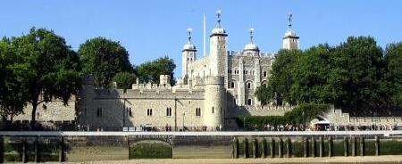
a)Edward the Confessor
b)Harold II
c)William the Conqueror
d)Henry III
2.Which bridge can you see in the picture?
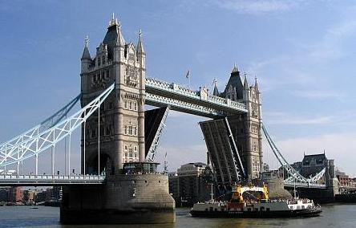
a)Tower Bridge
b)Millennium Bridge
c) Waterloo Bridge
d)London Bridge
3.How much of London did the Great Fire destroy?
a)half of London
b)three quarters of London
c)all of London
d)some streets and houses

4.In the 19th century, the Docklands were the world's ...
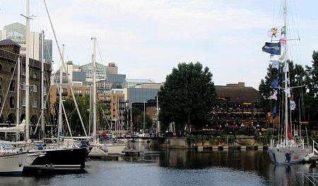
a)most famous wax museum
b)most important prison
c)largest port
d) shopping center
5.Why are the Houses of Parliament also called Palace of Westminster?
a)Because the royal family once lived in the palace.
b)Because the Earl of Westminster once built the palace.
c)Because the Earl of Westminster still lives there.
d) Because all people decided to call it so.
6.When is the Queen's real birthday?
a)in February
b)in April
c)in June
d)in May
7.What can you see in the picture?

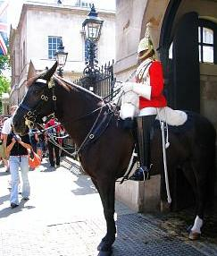
a)a Beefeater
b)a Lollipop man
c)a London Bobby
d)a Horse Guard
8.What number of the capsule can`t you see on the London Eye?
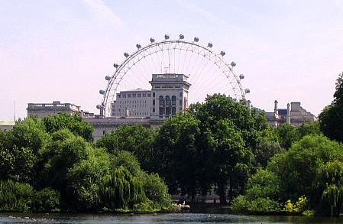
a) 6
b) 13
c) 3
d) 9
9. What colour are the roofs of London buses?
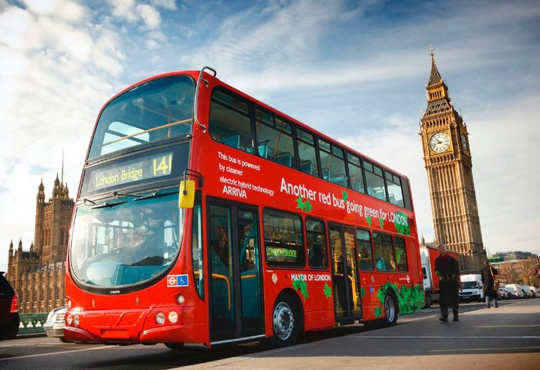
- black
- red
- white
- yellow
10.Which bridge can you see in the picture?
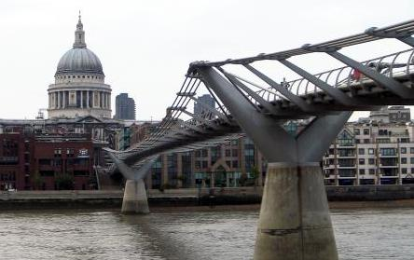
a)Millennium Bridge
b)London Bridge
c)Tower Bridge
d) Hammersmith Bridge
11.Which of the following is NOT usually part of a full English breakfast?
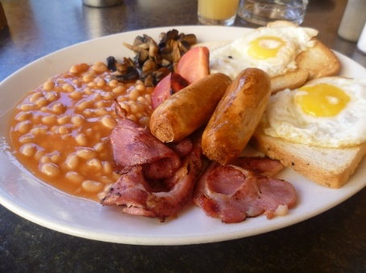
a) bacon
b) cheese
c) egg
d) mushrooms

12. Sometimes people eat black pudding as part of an English breakfast. It’s a kind of sausage. What’s the main ingredient?

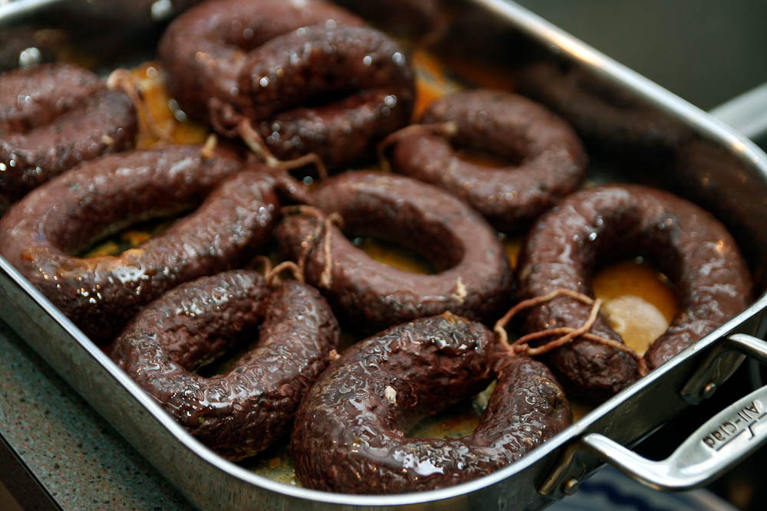

a) pork
b) beef
c) blood
d) onion

13.The biggest green area in London is…
a) Hyde Park
b) St. Jame`s Park
c) St. George Park
d) Greenwich Park

14.The main church in London is…
a)) St. Leonard`s Church
b) Westminster Abbey
c) St. Jame`s Church
d)St. Paul`s Cathedral

15. Where can you see the monument to Admiral Nelson ?
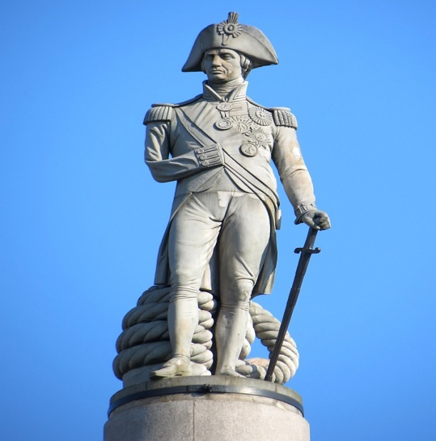
a) ) Parliament Square
b) St.Jame`s Park
c)Trafalgar Square
d)Hyde Park

Answers

1.c

2.a

3.a

4.c

5.a

6.b

7.d

8.b

9.c

10.a

11.b

12.c

13.a

14.d

15.c

