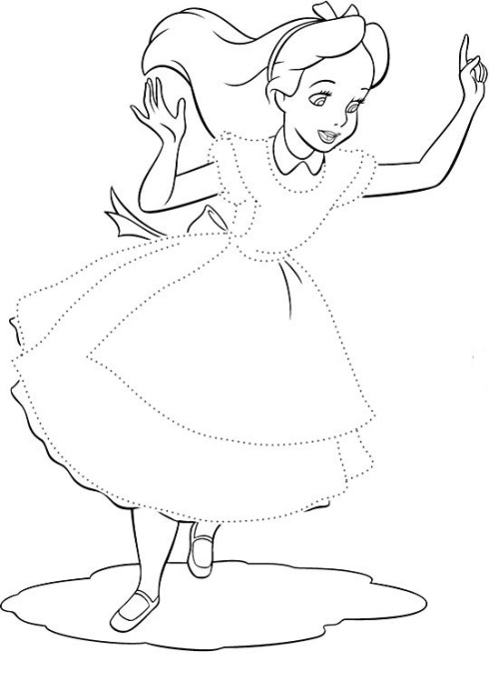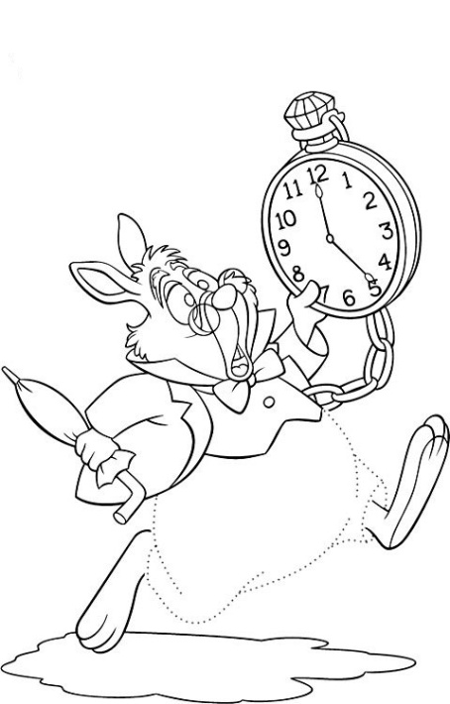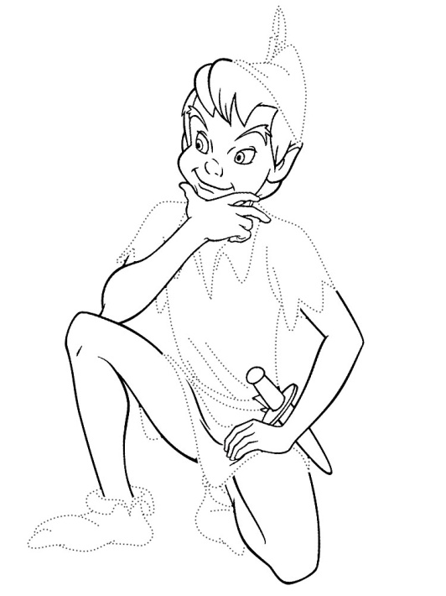

**Can** Peter Pan *sing* ?

____, he __________.

**Can** Alice *hunt* ?

____, she __________.

**Can** Alice *hunt* ?

____, she __________.

**Can** Peter Pan *sing* ?

____, he __________.

**Can** Peter Pan *sing* ?

____, he __________.

**Can** Alice *hunt* ?

____, she __________.

**Can** the March Hare *run* ?

____, he __________.

**Can** the March Hare *run* ?

____, he __________.

**Can** the March Hare *run* ?

____, he __________.

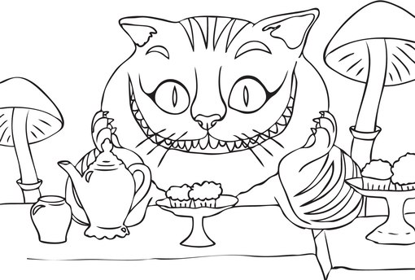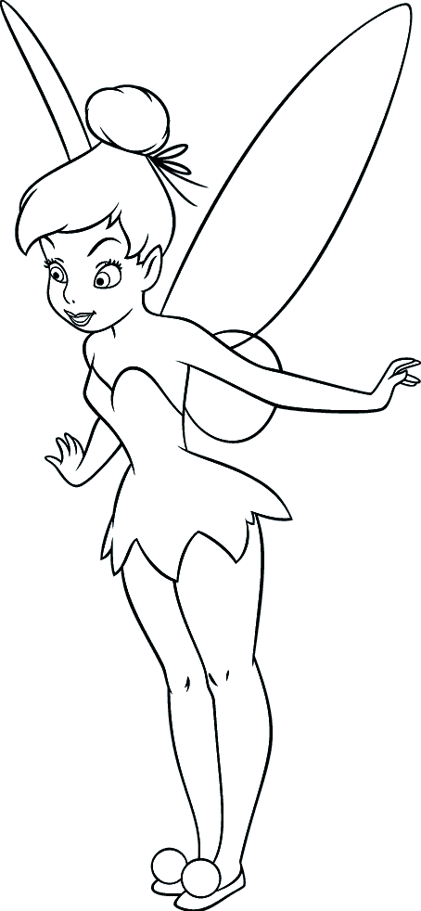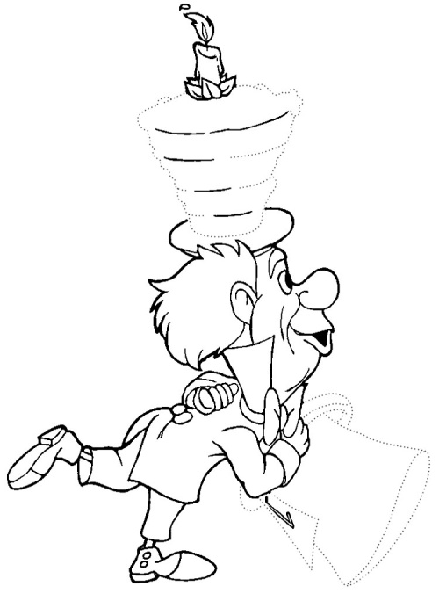



**Can** Tinker Bell *fly* ?

____, she __________.

**Can** the Mad Hatter *read* ?

____, he __________.

**Can the** Cheshire Cat *say* ?

____, he __________.

**Can** Tinker Bell *fly* ?

____, she __________.

**Can** the Mad Hatter *read* ?

____, he __________.

**Can the** Cheshire Cat *say* ?

____, he __________.

**Can the** Cheshire Cat *say* ?

____, he __________.

**Can** the Mad Hatter *read* ?

____, he __________.

**Can** Tinker Bell *fly* ?

____, she __________.