Lesson plan «Furry friends»
Учебник: Н. Быкова, В.Эванс, М. Поспелова, Spotlight – 3.
Unit 5 “Animals”
Lesson 10a
Практическая цель: Совершенствование полученных лексико-грамматических навыков по темам «Пушистые друзья», «Части тела» («Furry friends», «Parts of the body»).
Задачи урока: Образовательные:
- Закрепление полученных знаний лексики и грамматики по теме «Пушистые друзья».
- Повторение лексики по теме «Части тела».
- Формирование у учащихся навыков общения в рамках речевой ситуации «Пушистые друзья».
Развивающие:
- Развитие умений и навыков чтения и письма.
- Развитие коммуникативных навыков: умения вести диалог и монолог на английском языке.
- Тренировка памяти и мышления у учащихся.
- Тренировка внимания.
- Развитие навыков понимания англоязычной речи.
Воспитательные:
- Поддержание интереса к учению на английском языке и формирование познавательной активности.
- Формирование у учащихся умения работать в парах, группах, слушать других и помогать друг другу.
Тип урока: комбинированный. Формы и виды работы: индивидуальная, групповая, фронтальная.
Оборудование урока:
- раздаточный материал;
- мультимедийный проектор;
- презентация;
- учебники;
- доска.

Stage | Aim | Teacher does (says) | Pupils do | Notes
Организационный момент ( 2 min) | Motivation for learning activities | T. Good morning!  What a fine morning!  The day is sunny and so bright.  My dear friends, am I right?  T. Are you ready for the lesson? | Cl. Hello!  Cl. Yes, you are right.  Cl. Yes, we are.
Целеполагание и мотивация (3 min) | To introduce the topic. | T: Let’s listen to the sounds, please. What do you hear?  T: Yes, the dog is barking.  -What do you hear?  - What’s it?  - Now, listen to the next.  T: What do you think we are going to speak about?  T: -Yes, you are right. We are going to speak about different animals and describe them.  - Children, do you want to know about my favourite animal? Look at the board. You can see a puzzle. If you do my tasks, you’ll know about it. | PP: -It’s a dog.  -It’s a cow.  -It’s a cat.  -It’s a kitten.  -It’s a pig.  -It’s a sheep.  -It’s a donkey.  -It’s a horse.  PP:- About animals  PP: -Yes, we do.  The children answer the question. | Sounds of animals.  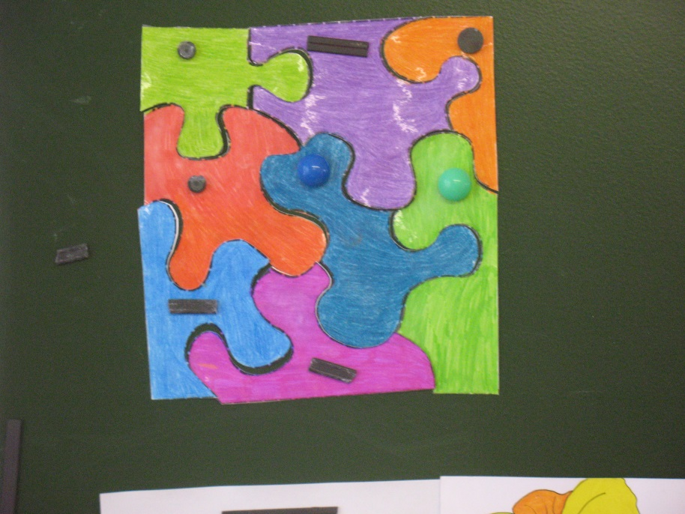
Фонетическая разминка (5 min)  Речевая зарядка. | To revise the colours, names of animals and motion verbs | (Tongue-twister).  Let’s train our tongue.  Let’s say our tongue-twister about the quick brown fox: The quick brown fox jumps over the lazy dog.  Ask: What colour is the fox? Say what can the fox do?  T: Do you like animals? T: What animals do you know? T: What can animals do?  Let’s sing a song «What can…» (Track №35) | Pp answer teacher’s questions.  -It’s brown.  -It can jump.  P1: Yes, I do P2: I know … P3: Caws, pigs, goats, horses, dogs, sheep P4: They can…  Children sing a song | Can do this work in pairs and small groups.  A song «What can…»
 |  | T:The first task  Look and match.  (Приложение 1)  T: Now, we can open the first part of our puzzle. |  | Pictures of animals and the words are on the blackboards.  The teacher opens the first part of the puzzle.
Опрос по ранее изученному материалу (проверка д/з)  (15 min) | Revise the new words:  long tail, thin legs, big eyes, small nose, fat body, big ears, small head, short tail  To give instructions  To develop listening skills | T: The second task  I’ve got an elephant, a monkey and a bear. Now, describe them, please.  T: That’s right. Good job. Thank you.  Now, we open the second part of the puzzle.  T: The next task is listening.  You will listen and choose A or B  Let’s check your answers.  (Звукозапись Test 5)  T: We open the third part of the puzzle. | P1: It’s an elephant.  It’s big and grey. It has got a big head, a long nose, small eyes and big ears. It has got a short tail. It likes to eat the grass.  P2: It’s a monkey. It’s a funny animal. It lives at the zoo. It has got big black eyes, a small nose, a big mouth and a long tail. It can climb a tree. It likes bananas very much.  P3: It’s a dog. It’s brown. It has got a small head and body. It’s got small ears, brown eyes and a black nose. It can run very well. It likes meat.  P: (says answers)  1a, 2b, 3a, 4b, 5a | Toys of animals are on the desks.  The teacher opens the second part of the puzzle.  Pps have copies with pictures, they have to tick A or B.  The teacher opens the third part of the puzzle.
Этап закрепления нового материала | To revise the  words:  crawl, fly, jump, swim, walk, talk | T: Let’s continue our lesson. The next task is translation.  I’ll give you cards. You’ll have to translate into English.  (Приложение 2, Сборник стр 73 упр 13)  T: Let’s open the fourth part of the puzzle. | Look at the cards and answer | If Pps have problems with the words, revise its again  The teacher opens the fourth part of the puzzle.
Динамическая пауза (2 min) | Let’s have a rest | Teacher says a poem What can I do | Pps repeat after teacher and do movements | I can jump like a frog,  I can swim like a fish,’  I can run like a horse,  I can dance like a chimp,  I can sing like a bird  You can do, we can do,  I can do too.  As a variant can play a game “Circus”
Развитие навыков чтения (3 min) | To check understanding | T: Now, go on. The next task is Reading.  Says: You are going to read the text and answer the questions (SB p79 ex 3)  Explain activities: Read very carefully and try to answer the questions.  T: We open the fifth part of the puzzle. | Pps read the text and find the answer | If children have problems with this task pay attention of children on the keywords.  The teacher opens the fifth part of the puzzle.
Развитие навыков диалогической речи (5-7 min) |  | T: Now, the last task.  Look at the board and guess the crossword, please.  - Голова  - Нос  - Хвост  - Рот  - Уши  - Ноги  T: Let’s open the last part of our puzzle.  T: What’s the key word? | Pps guess the crossword.  H E A D  N O S E  T A I L  M O U T H  E A R S  L E G S  -Animals | The teacher opens the sixth part of the puzzle
End of lesson  (5-7 min) | To explain HW  To personalize | T:Good job! What’s my favourite animal?  Now your home task. You will have to write a letter to your friend about your favourite pet. (Сборник стр 74 упр15)  Asks if Pps like their work at the lesson, what they do, what task they like more. To assess their work in the classroom | P: It’s a dog.  Pps see and explain what they will do.  Give their opinions, and marks  Pps: Now I can…  -talk about animals  -describe animals  -talk about ability | If children have problems to explain the task, revise the words

