***Занимательная грамматика***

***Ребусы***

[](http://1.bp.blogspot.com/-2Z4V_I52-3I/TzamHrdGwsI/AAAAAAAAAKA/Ybe_61fqOXE/s1600/%D1%80%D1%83%D1%81%D1%81%D0%BA%D0%B8%D0%B9.jpg)

[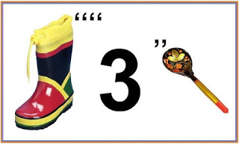](http://1.bp.blogspot.com/-029RHpgAt9g/Tzal2EKk61I/AAAAAAAAAJ0/LPJCqNcVrJY/s1600/%D1%81%D0%B0%D0%BF%D0%BE%D0%B3.jpg)  
[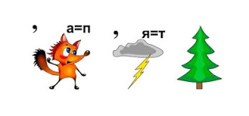](http://1.bp.blogspot.com/-N9shFDM5oXw/TzalbB3AWpI/AAAAAAAAAJQ/f7IOS9lb0zs/s1600/%D1%91%D0%BB%D0%BA%D0%B0.jpg)  
  
[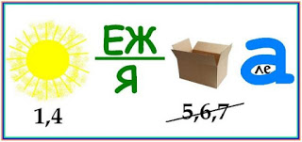](http://4.bp.blogspot.com/-oL09aBciyb0/TzalaRgyn3I/AAAAAAAAAJI/00NqBQCYg9Y/s1600/%D1%81%D0%BE%D0%BB%D0%BD%D1%86%D0%B5.jpg)

[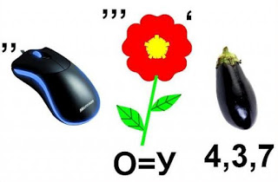](http://2.bp.blogspot.com/-Sx12GGVTPhE/TzalZ-s2VTI/AAAAAAAAAJA/KbtxDq0Dgt4/s1600/%D1%86%D0%B2%D0%B5%D1%82%D0%BE%D0%BA.jpg)

[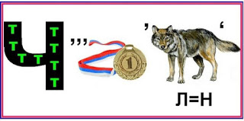](http://1.bp.blogspot.com/-qYyIMggsnvU/TzalZcmD5_I/AAAAAAAAAIw/7iGJE9uUAug/s1600/%D0%B2%D0%BE%D0%BB%D0%BA.jpg)  
[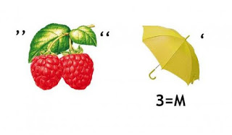](http://1.bp.blogspot.com/-PHz9T_M64-0/TzalbSqjd-I/AAAAAAAAAJg/_MrRUMD5L00/s1600/%D0%BA%D0%BB%D1%83%D0%B1%D0%BD%D0%B8%D1%87%D0%BA%D0%B0.jpg)  
[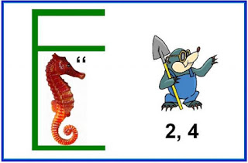](http://2.bp.blogspot.com/-6b4zXpmFBRE/Tzakxvp_JnI/AAAAAAAAAIc/Vy-BLEBGBSM/s1600/%D0%BA%D1%80%D0%BE%D1%82.jpg)

[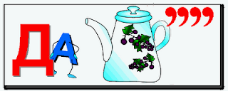](http://3.bp.blogspot.com/-cifnoN15YKQ/TzakxcE1lEI/AAAAAAAAAIM/N75DhvE08Ns/s1600/%D1%87%D0%B0%D0%B9%D0%BD%D0%B8%D0%BA.png)

[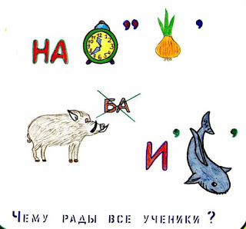](http://2.bp.blogspot.com/-EZwh6WRhHTM/Tzakww6mR1I/AAAAAAAAAIA/16_AF6Fez-w/s1600/%D0%BB%D1%83%D0%BA.jpg)

[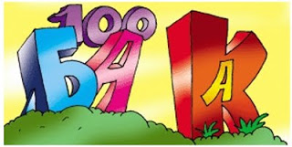](http://3.bp.blogspot.com/-aokP6zO7gvA/TzakwnIgBiI/AAAAAAAAAH0/BhbNjoMiAl8/s1600/%D0%B7%D0%B0%D0%B1%D0%B0%D1%81%D1%82%D0%BE%D0%B2%D0%BA%D0%B0.jpg)

[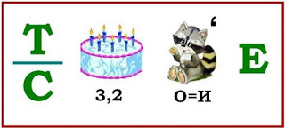](http://1.bp.blogspot.com/-iRO7UPuFt94/TzakyZbbFxI/AAAAAAAAAIk/KLukuuvZ7d0/s1600/%D1%82%D0%BE%D1%80%D1%82.jpg)

[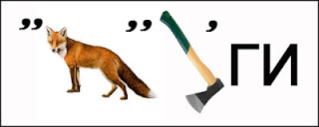](http://4.bp.blogspot.com/-eNriSoDZa4E/TzakAC-bWVI/AAAAAAAAAHY/OzdTILcw3T0/s1600/%D0%BB%D0%B8%D1%81%D0%B0.jpg)

**Прочтите название русской народной сказки:**  
[](http://4.bp.blogspot.com/-YQ_0KFTIRH4/Tzaj_gMRXBI/AAAAAAAAAHM/Xx-8eN0DiVI/s1600/%D0%B7%D0%B0%D0%BC%D0%BE%D0%BA.png)  
[http://2.bp.blogspot.com/-xdVf1RWfdh4/Tzaj_L0xtuI/AAAAAAAAAHA/GGdRDlffHvI/s320/%25D0%25BC%25D0%25BE%25D0%25BB%25D0%25BE%25D1%2582%25D0%25BE%25D0%25BA.png](http://2.bp.blogspot.com/-xdVf1RWfdh4/Tzaj_L0xtuI/AAAAAAAAAHA/GGdRDlffHvI/s1600/%D0%BC%D0%BE%D0%BB%D0%BE%D1%82%D0%BE%D0%BA.png)

**Прочитайте имя сказочного персонажа:**

[http://2.bp.blogspot.com/-F8-wl-O5UYg/Tzaj-w9yhhI/AAAAAAAAAG0/syyHJy5dy2g/s320/%25D0%25B8%25D0%25BC%25D1%258F%2B%25D1%2581%25D0%25BA%25D0%25B0%25D0%25B7%2B%25D0%25B3%25D0%25B5%25D1%2580%25D0%25BE%25D1%258F.png](http://2.bp.blogspot.com/-F8-wl-O5UYg/Tzaj-w9yhhI/AAAAAAAAAG0/syyHJy5dy2g/s1600/%D0%B8%D0%BC%D1%8F+%D1%81%D0%BA%D0%B0%D0%B7+%D0%B3%D0%B5%D1%80%D0%BE%D1%8F.png)

ОТВЕТЫ: СТРИЖКА, ЛИМОН, ИСПОЛНИТЕЛЬ, СНЕЖНАЯ КОРОЛЕВА, ШКАТУЛКА, ПОЧТАЛЬОН, НАСТРОЕНИЕ, КОНВЕРТ, ДАЧА, НАЧАЛУ КАНИКУЛ, ЗАБАСТОВКА, РУССКИЙ, САПОГИ, ТЕРЕМОК, КОЛОБОК, БУРАТИНО.

