***ГКОУ РО «Зерноградская специальная школа-интернат» Шубина Ольга Валерьевна.***

***Rostov oblast overview***

**Rostov oblast** (**Rostovskaya**) is a federal subject of Russia located in the south of the European part of the country, part of the Southern Federal District. Rostov-on-Don is the capital city of the region. The population of Rostov oblast is about 4,232,000 (2015), the area - 100,967 sq. km.**[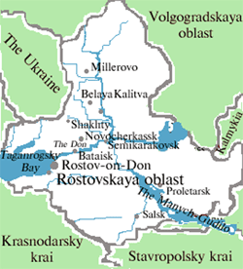](https://russiatrek.org/images/map/rostov-oblast-map.gif)**Rostov oblast is located in the southern part of the East European Plain and partly in the North Caucasus region, occupying a vast area in the river basin of the Lower Don. The region stretches for 47 km from north to south and 455 km from west to east.The climate is temperate continental. The nature of the region is diverse. Steppes, forests, the Don River, the coast of the Azov Sea are inhabited by more than 100 species of animals and fish.The largest cities are Rostov-on-Don, Taganrog ,Shahty, Volgodonsk, Novocherkassk, Bataisk, Novoshahtinsk.The main treasure of the region is its fertile black soil occupying almost 65% of the territory. Rostov oblast is the second largest producer of agricultural products in Russia (wheat, maize, rice, millet, buckwheat, soybeans, vegetables, fruits, and berries).

Sunflower is the main industrial crop. This region produces more than 20% of all sunflower seeds in Russia.The federal highways E115 - M4 “Moscow - Novorossiysk”, E50 - M19, E58 - M23 “Kishinev - Rostov”, E40 - M21 “Volgograd - Kishinev” pass through the territory of the Rostov region.

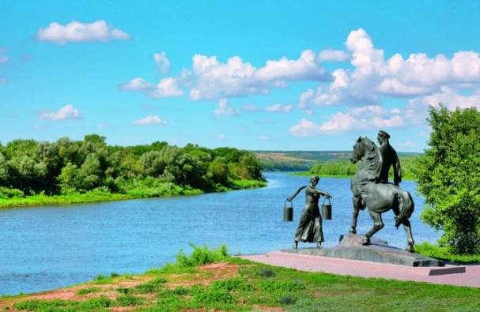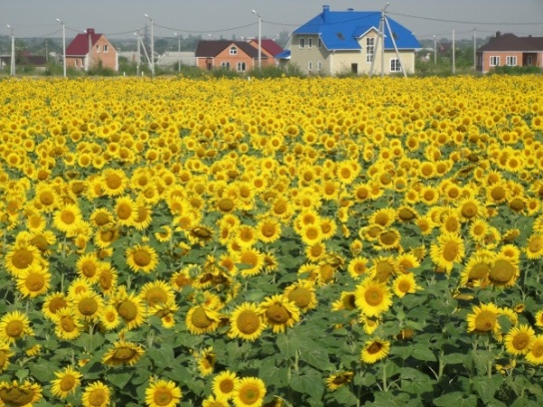

The railway routes to the south of Russia pass through the province - to Krasnodar krai (the Azov and Black Seas) and Ukraine. The main waterways are the Don and Seversky Donets. Taganrog, Azov and Rostov-on-Don are large sea ports.